**Important note: Before going further you are requested to go through theory of spring bean lifecycle methods mentioned in JavaLive Notes on Spring Core thoroughly so that you can understand the concept very well. (**This activity i.e. going through theory part of respective subject is applicable for each of our project.)**

**Also go through some more notes in initial comment section of file com.javalive.main.App.java.**

**What this project does??**

This project explains InitializingBean and DisposableBean callback interfaces in spring bean life cycle.

**Note that this is xml based spring project having configuration file viz. ' spring-config.xml' in resources folder.**

**Steps to create project:-**

1. Create quick start maven project. Refer file 'CreateQuickStartMavenProjectInEclipse.docx' in 'SprinDIWithAutowiring' project for more details.

2. Add require dependencies for spring as shown in pom.xml file.

3. Create required packages and add the files.

**Structure of created project is as follows:-**

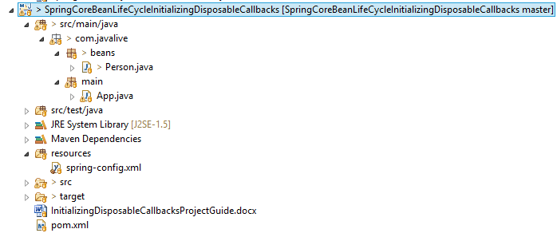

**Functioning of the project**

This project is mainly divided in three parts:

1. com.javaLive.beans package contains a file Person.java which declared as bean in spring-config.xml file. This class implements InitializingBean and DisposableBean callback interfaces.

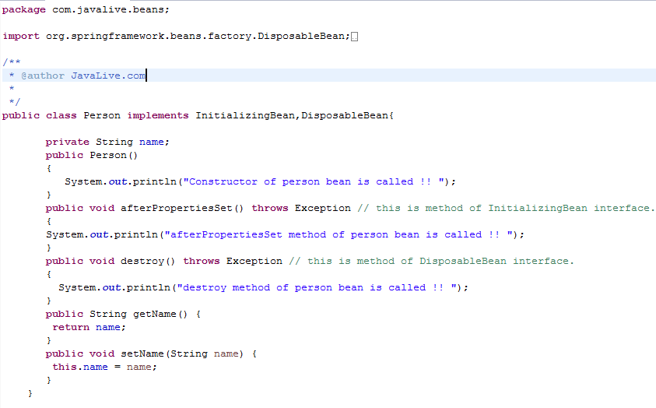

2. spring-config.xml file in resources folder contains bean definition for above class.

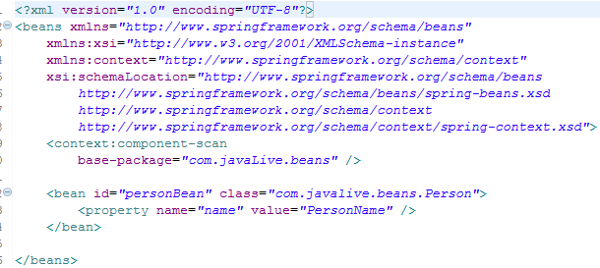

3. com.javaLive.main package contains App.java class which get the bean from spring application context and displays its attribute viz .name.

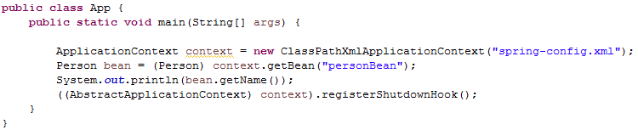

When we run this file, we will come to know in which sequence methods of these callback interfaces get called.

