**Important note: Before going further you are requested to go through theory of spring bean lifecycle methods mentioned in JavaLive Notes on Spring Core thoroughly so that you can understand the concept very well. (**This activity i.e. going through theory part of respective subject is applicable for each of our project.)**

**What this project does??**

This project explains BeanNameAware, BeanFactoryAware and ApplicationContext Aware interfaces in spring bean life cycle.

**Note that this is xml based spring project having configuration file viz. ' spring-config.xml' in resources folder.**

**Steps to create project:-**

1. Create quick start maven project. Refer file 'CreateQuickStartMavenProjectInEclipse.docx' in 'SprinDIWithAutowiring' project for more details.

2. Add require dependencies for spring as shown in pom.xml file.

3. Create required packages and add the files.

**Functioning of the project**

This project is mainly divided in three parts:

1. com.javaLive.beans package contains a file AwareBean.java which declared as bean in spring-config.xml file. This class implements BeanNameAware, BeanFactoryAware and ApplicationContext Aware interfaces in spring bean life cycle.

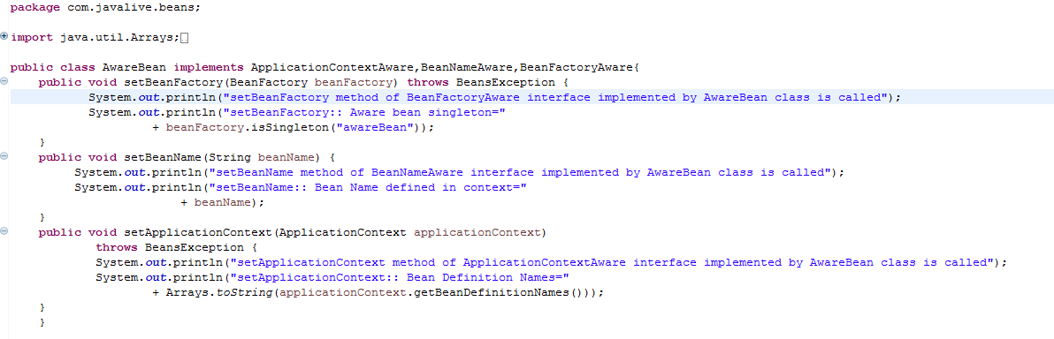

2. spring-config.xml file in resources folder contains bean definition for above class.

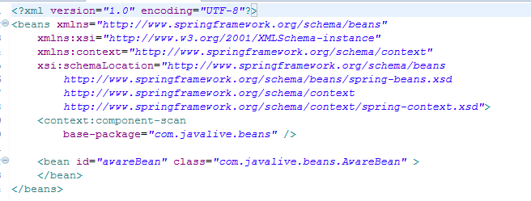

3. com.javaLive.main package contains App.java class which get the bean from spring application context. 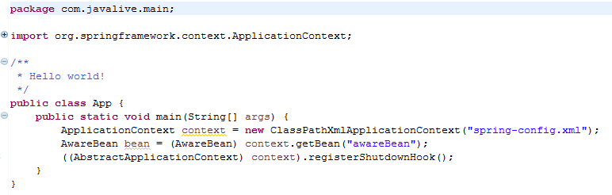

When we run this file, we will come to know in which sequence methods of these interfaces get called.

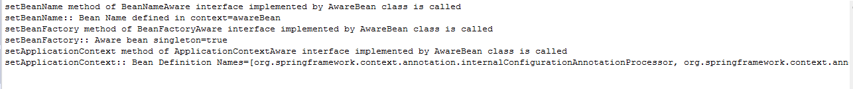

The sequence is method of BeanNameAware, BeanFactoryAware and ApplicationContextAware.