**Important note: Before going further you are requested to go through theory of Spring Bean Scope mentioned in JavaLive Notes on Spring Core thoroughly so that you can understand the concept very well. (**This activity i.e. going through theory part of respective subject is applicable for each of our project.)**

**\*\*Also go through initial comment section of file 'com.javaLive.main.App.java' very carefully.**

**What this project does??**

This project explains **core level** scopes of beans in spring framework. These scopes are

i) Singleton

ii) Prototype

**Note that this is xml based spring project having configuration file viz. ' spring-config.xml' in resources folder.**

**Steps to create project:-**

1. Create quick start maven project. Refer file 'CreateQuickStartMavenProjectInEclipse.docx' in 'SprinDIWithAutowiring' project for more details.

2. Add require dependencies for spring as shown in pom.xml file.

3. Create required packages and add the files.

**Project Structure:-**

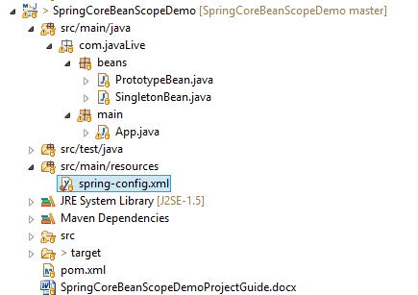

**Functioning of the project**

As mentioned earlier, this project deals with core level scopes of spring bean. In this project please carefully go through packages com.javaLive.beans (which contains bean definition).

And com.javaLive.main which contains App.java class this is the main class which demonstrates us how bean scope works.

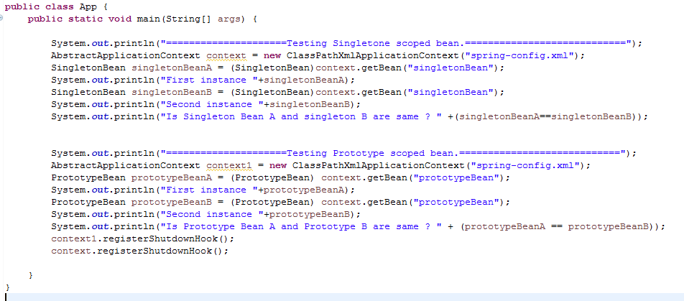

Also carefully go through the initial comment section of this class

Along with above packages, also go through spring-config.xml file to study how we declared the spring beans.

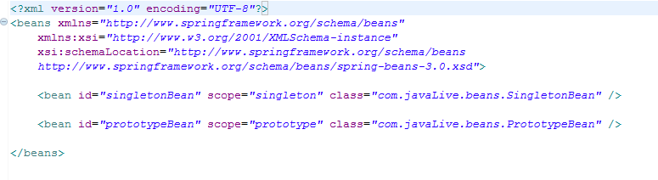

Following is the final output of App.java file:

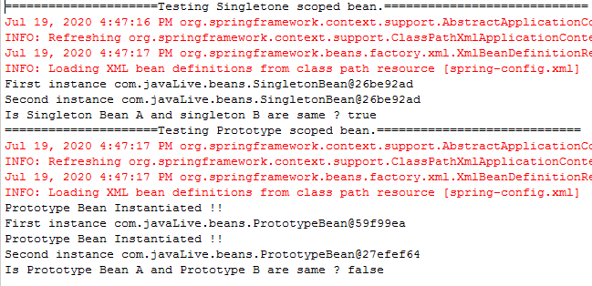

Now please carefully study the output of the file. In case of Singletone bean we got same instance on calling second time whereas in case of Prototype bean, we got different instance on second call.

(Note that we have used '==' operator to check whether the instances are same of different.)