**Creating a Simple Quickstart Maven Project in Eclipse**

Go to **File -> New -> Project** and it will open the new project wizard. Select “Maven Project” as shown in the below image and click on “Next” button.

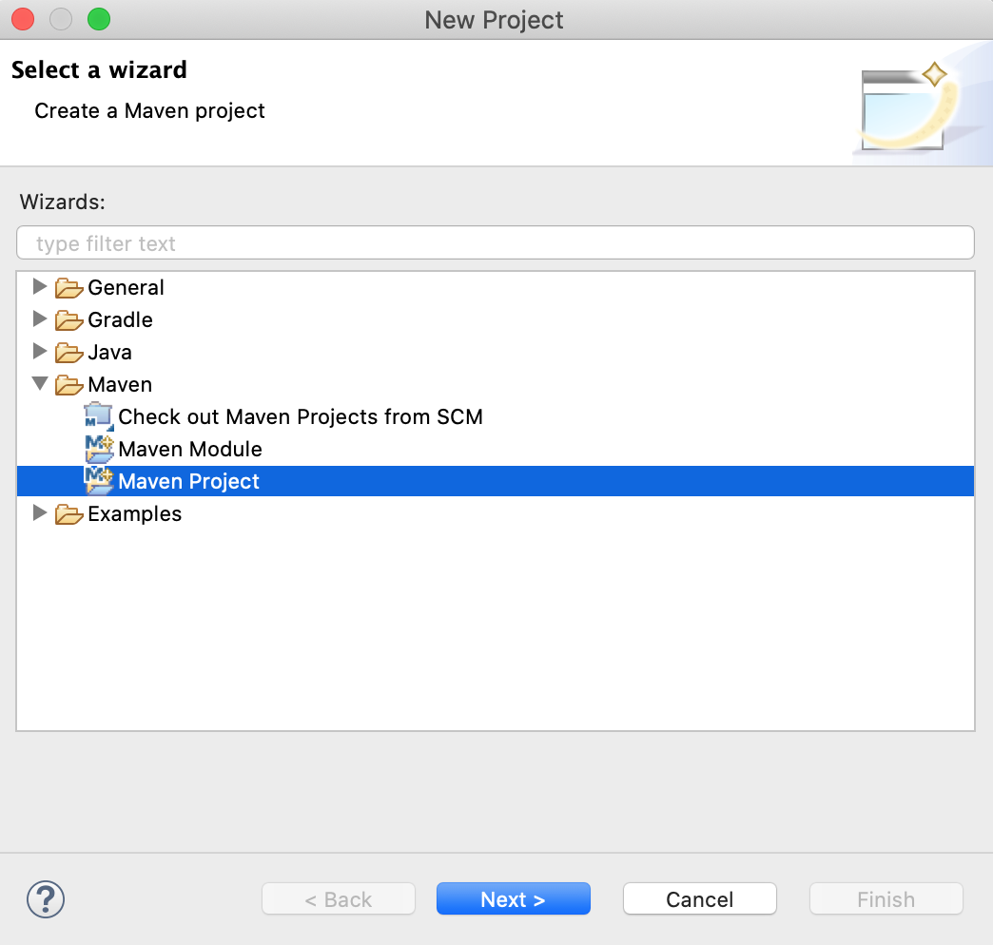

Eclipse New Maven Project

In the next screen, we have the option to specify the project location and add it to any working set. We will not make any changes to it.

There is also an option to skip archetype selection and create a simple project. But, we will use the archetype to create the template project.

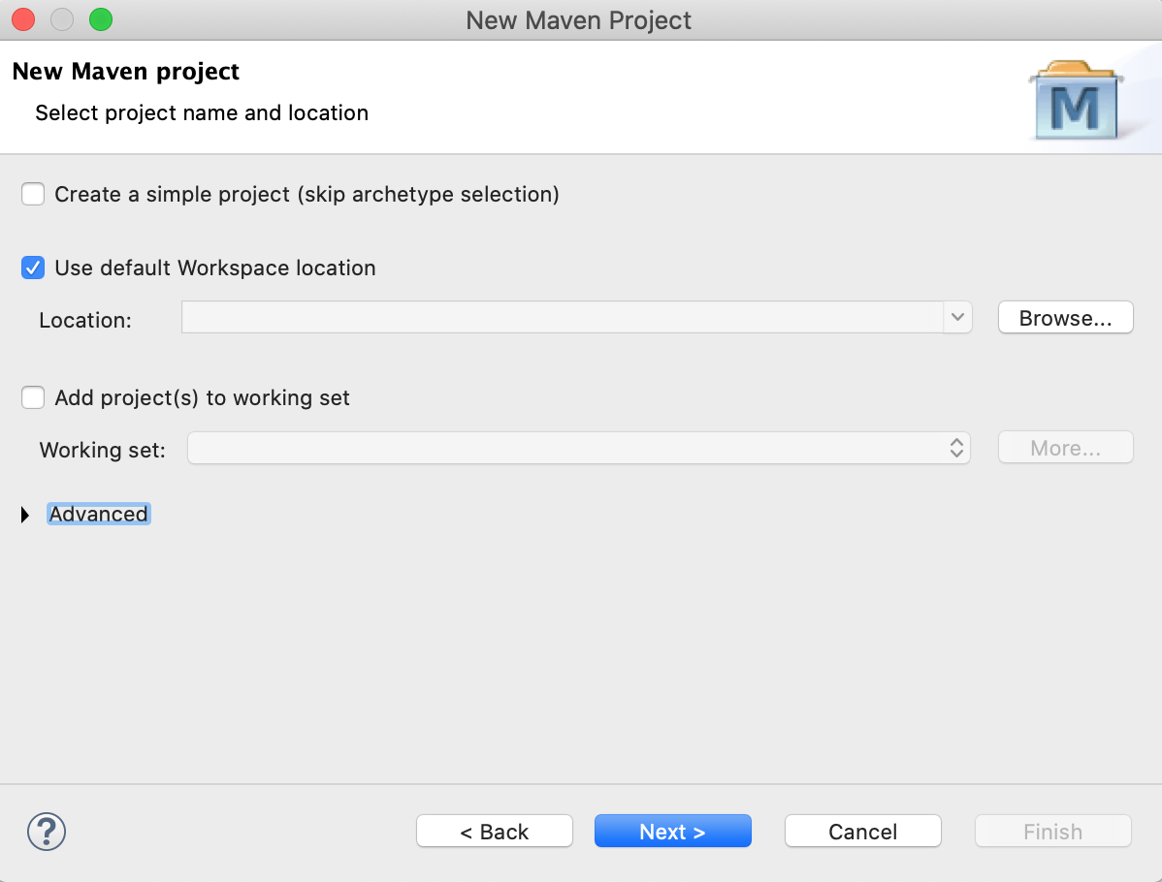

In the next screen, we have to select the archetype of the project. This is the most important step in creating the project. We want a simple maven JAR based application. So, we will choose the “maven-archetype-quickstart” artifact to create the project.

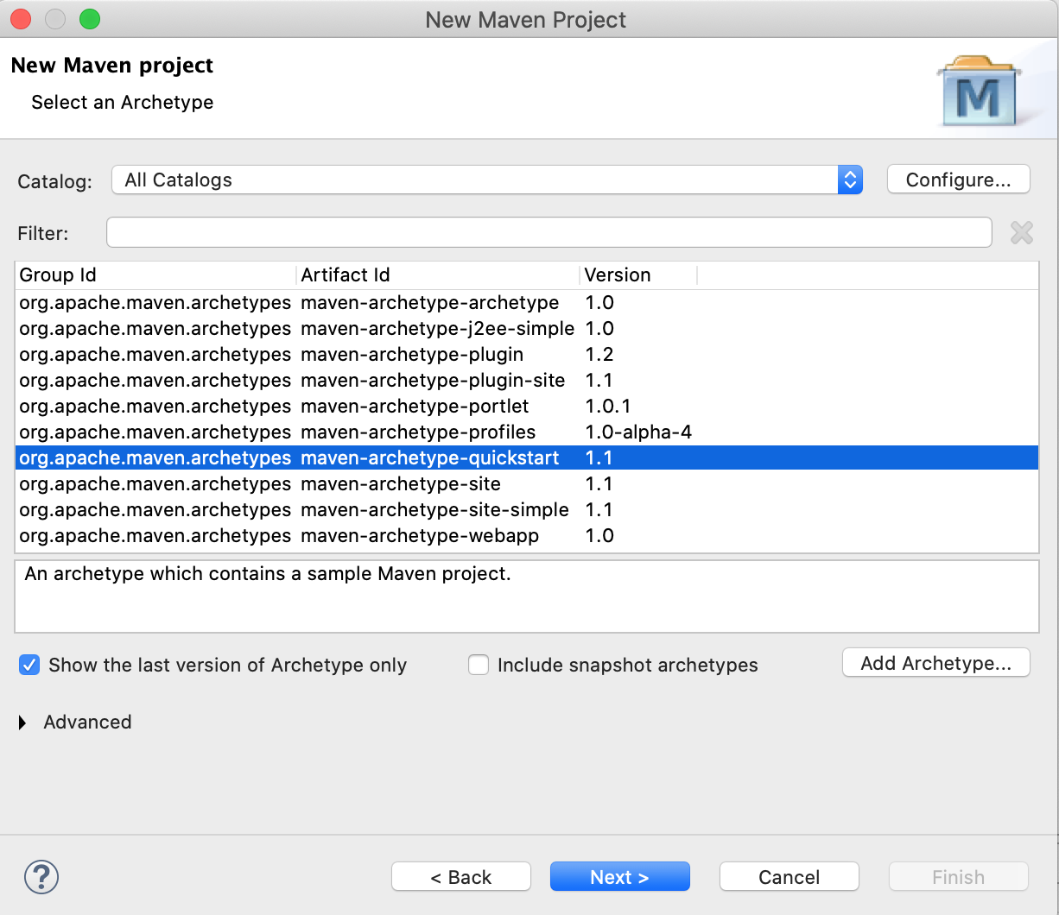

In the next screen, we have to specify the groupId, artifactId, and base package of the project. You can use the values from the image below or enter any values you want in your project.

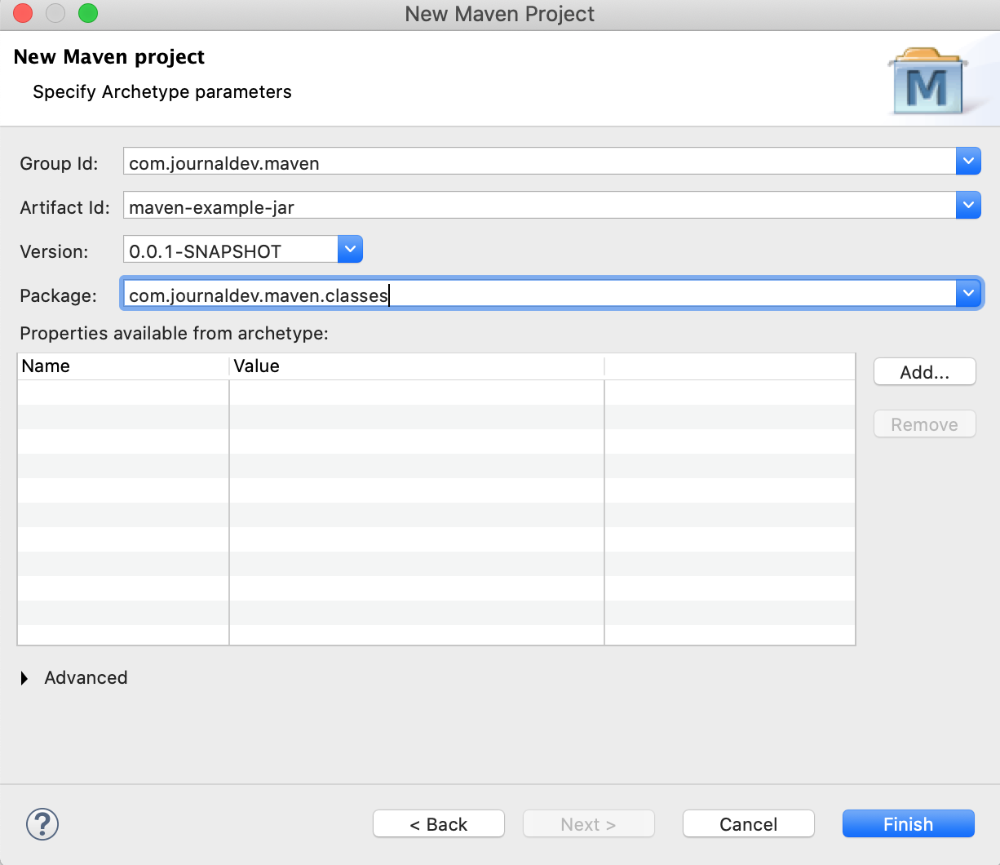

After clicking the Finish button, the popup wizard will close and the project will get created. It will be visible in the project explorer. The below image shows all the directories and the pom.xml of the newly created project.

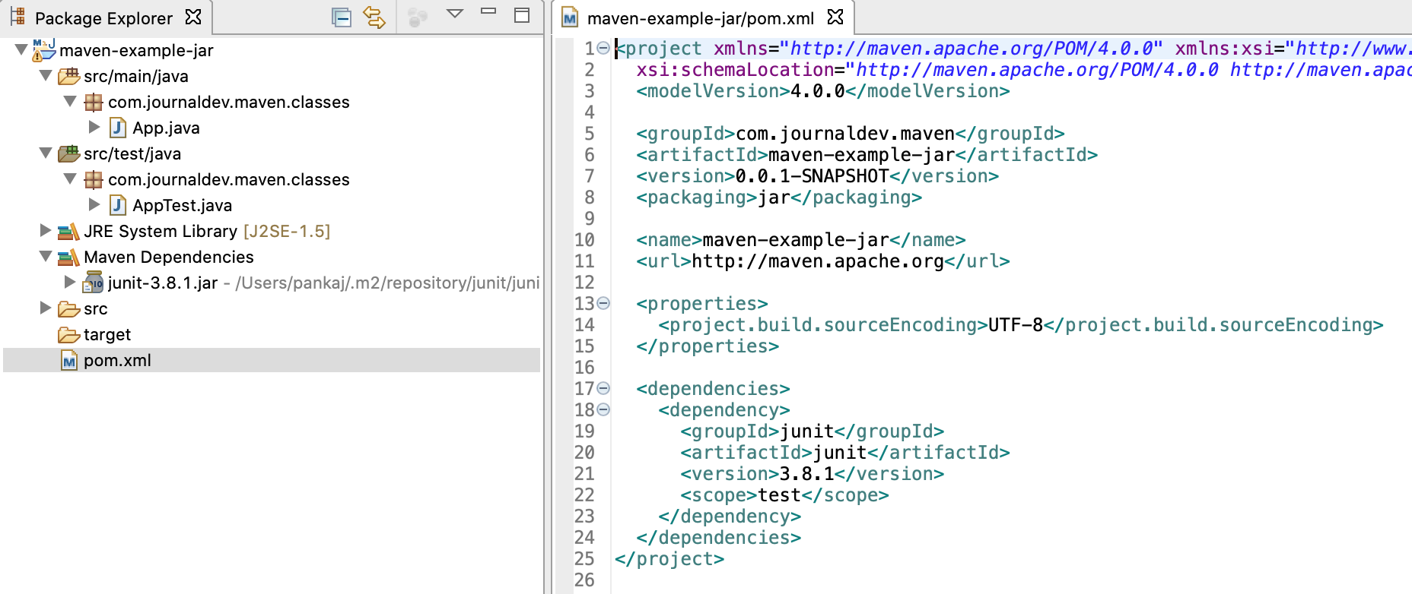

Eclipse Maven Project Package Explorer