Before moving forward please go through theory part of Spring MVC Interceptor from our notes, so that you can understand the concept of Spring MVC Interceptor well. For introductory theory part you can also refer comment section of file 'com.javaLive.controller.EmployeeController.java'

**What this project does??**

This is seventh project of Spring MVC project series.

**This is Full Spring MVC application with XML configuration which demonstrates how to define Interceptors in Spring and how they work.**

This is web based maven project.

**Also note that here we are focusing on explanation of Spring Interceptor functionality only. Please go through project one to four of Spring MVC project series before this project so that you can understand the project structure and flow of request in the project well.**

' SpringMVCApplicationFlow': explains functionality of 'spring-servlet.xml' in Spring MVC context

' SpringMVCHelloWorld': explains how controller layer functions in Spring MVC

'SprinArithematicOperation': explains how controller layer and service layer functions in Spring MVC

'SpringMVCHibernateWithXMLFull' : explains full Spring+Hibernate database table CRUD operation **with full XML configuration** which includes all three layers of Spring MVC viz. Controller, Service and DAO.

**Note that this is xml based spring MVC project. We have web config file web.xml and spring configuration file spring-servlet.xml. (Location of these files are shown in screen shot of project structure below.)**

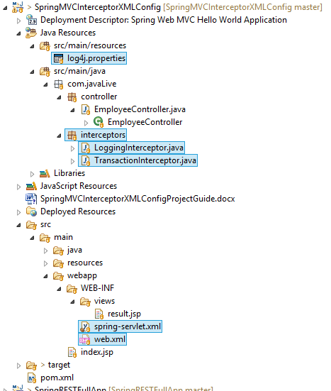

**In above project please go through files, packages and folders as follows:**

Packages controller which contains controllers.

Package interceptor contains Interceptor classes.

Folder WEB-INF/views which contains various JSP files.

Files WEB-INF/spring-servlet.xml and WEB-INF/web.xml.

File index.jsp which is welcome file of this project.

**Steps to create project:-**

1. This is web based maven project. Create webapp maven project. Please refer the file **'CreateWebBasedMavenProjectInEclipse.docx'** in this project to know more about creation of web based maven project.

2. Add require dependencies for spring as shown in pom.xml file.

3. Create required packages and add the files.

**Functioning of the project**

Here we are focusing on three parts only

1. How to define Interceptor?

For this purpose please go through theory of Spring MVC Interceptor in the notes and in comment section of file 'com.javaLive.controller.EmployeeController.java'**.**

Now please go through the files in the package 'com.javaLive.interceptors' to study how to define Spring Interceptors.

Here in this package we have two interceptors viz. 'LoggingInterceptor' and 'TransactionInterceptor'. These interceptors do simple logging and displays various messages to console. But in real time application they plays vital role as:

Some Real-Time Usage of Interceptor :

* Maintaining Session / Session Management.
* Email Shoot & Database Check/logging.
* Authentication & Authorization Validations.
* Request Time Calculations. / Performance tunning. Etc.

2. How to configure Interceptor?

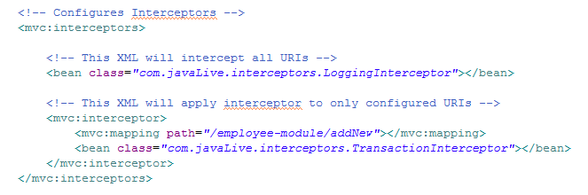

Above is the screen shot of part of spring-servlet.xml file which shows how to configure the Spring interceptors.

3. How Interceptor get executes during request flow?

**Note a important difference between configuration of these two interceptors. In first configuration we haven't mentioned any path hence it is applicable to all the URIs of the application. Whereas second interceptor is specific to '/employee-module/addNew' URI only.**

If there are multiple spring interceptors configured, preHandle() method is executed in the order of configuration whereas postHandle() and afterCompletion() methods are invoked in the reverse order.

Flow of request in the project:

Right click on the project -> Run As -> Run On Server

It will shows following pageviz. index.jsp. Now click 'Proceed' button.

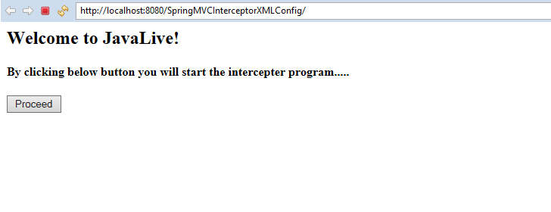

It shows result.jsp page as follows:

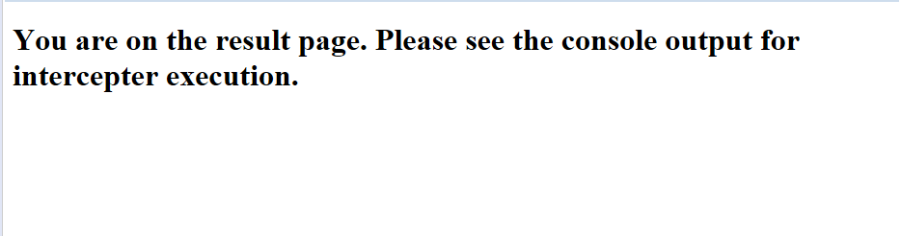

Now we have to look console output to study actual working of interceptors as they works behind the scene.

Please refer below screen shot of the console.

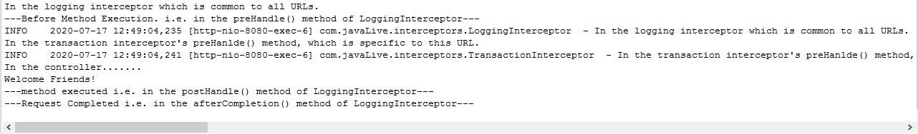

As you can see logging interceptor is first and is common interceptor for all URI, get executed first and TransactionInteceptor which is specific to given URI is get executed afterwards.

Sequence of method execution of interceptor

* All global interceptors gets executed first and then the mapped interceptor. Among them, the same order in which the interceptor are declared, the execution is also done.
* If true is returned, the execution chain continues and for false, the execution stops for that request with that interceptor.

Now please check the logging configuration file viz.src/main/resources/log4j.properties and logging messages in the specified file.

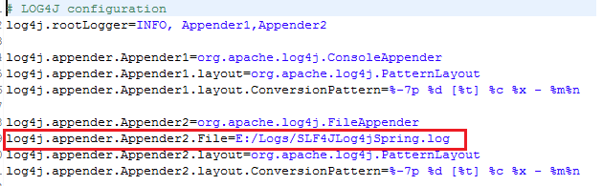

Output of logging file in above specified location.

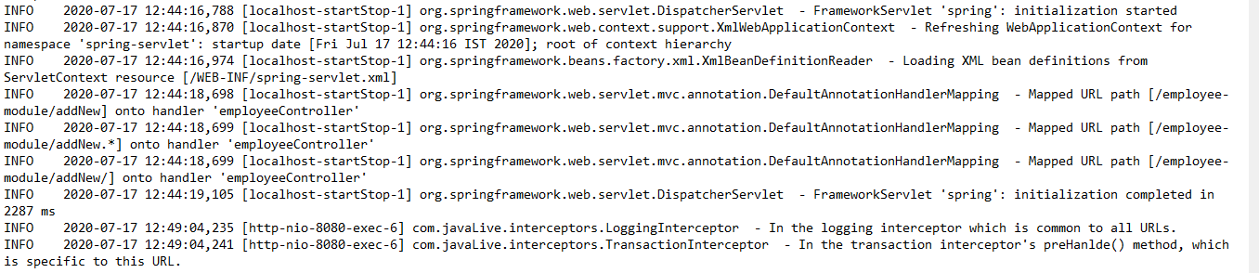

**During this project also look how logging mechanism works in Spring.**