Input channel 1 is the force and input channel 2 is the gravity. The impulse response on the *force* will affect the angular and linear displacement of our rotating and mass element. It can be noted that the angular displacement and linear displacement show little feedback from the impulse.

On the contrary, an impulse response on the input gravity seems to affect the system more. The frequency of force response is much less than the gravity response. Also, since gravity is a continuous input, a sudden impulse can easily distort the system.

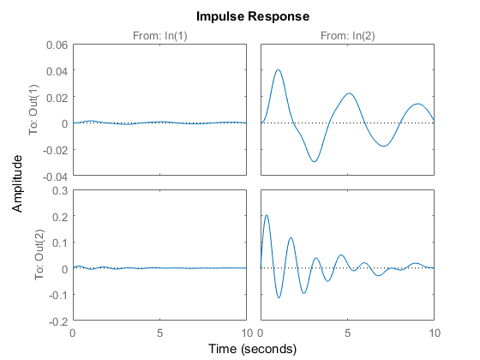

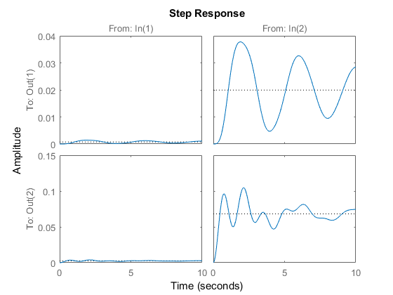In the step response, the response is just the like the original response but is translated up. What we observe in all our graphs is the transient response of the system after a disturbance. A steady state is observed by increasing the T_Final value.

The bode diagram is the frequency response of our system. For each input, two sets are data are observed. They are the magnitude and phase for the mass and inertia element. We are not entirely sure what the magnitude or phase suggests in terms of our system response due to our gravity and force input. However, we notice that the frequency of each plot is negative

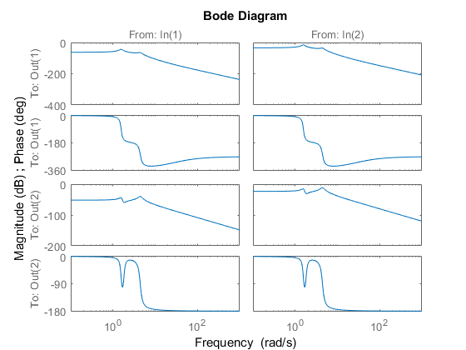

Transfer Function

