**Assessing the seasonal effects combined with a neonicotinoid insecticide (imidacloprid) exposure-associated population decreasing risk for honey bees**

**Introduction**

We adopted the wide used dynamic model

**Materials and Methods**

**Results**

**Discussion**

**Appendix**

Exposure

**Reference**

**Table 1**

Dynamic equation for the present proposed models in this study

|  |  |
| --- | --- |
| Description | Equation |
| Food storages (*f*) |  |
| Brood population (*B*) |  |
| Hive bee numbers (*H*) |  |
| Forager numbers (*F*) |  |
| Brood survival function |  |
| Recruitments function |  |

**Table 2**

Summary for parameter values used in the present dynamic models

|  |  |
| --- | --- |
| Meaning and symbol (unit) | Default value |
| Rate parameter |  |
| Maximum food collection rate, *c* (gram per forager per day) | 0.1a |
| Food consumption rate for adult bees, *γ*A (gram per forager per day) | 0.007 a,b |
| Food consumption rate for broods, *γ*B (gram per forager per day) | 0.018 a,b |
| Maximum egg laying rate, *l* (eggs per day) | 2000 a |
| Emergence rate, *ϕ* (per day) | 0.11 a |
| Minimum forager transition rate, *α*min (per day) | 0.25 a |
| Maximum forager transition rate, *α*max (per day) | 0.25 a |
| Social inhibition rate, *σ* (per day) | 0.75 a |
| Maximum forager natural death rate, *m* (per day) | 0.1 a,b |
| Imidacloprid-induced forager death rate, *m*d (per day) | ­–c |
| Control constant and time lag |  |
| Food impact constant, *b* (#) | 500 a |
| Hive bees impact constant, *v* (#) | 5000 a |
| Lag time of adult bees emerge from pupation, τ (day) | 12 a |

a Adopted form Khoury et al. (2013).

b Seasonal parameters used in this model.

c Imidacloprid dose-dependent parameter.

**Table 3**

Software versions and packages used in the model development and risk analysis

|  |  |  |
| --- | --- | --- |
| Tool | Description | Version |
| Software | |  |
| R | Statistical programing software by R language | 3.2.2 |
| RStudio | User interface for R | 0.98.1103 |
| Package | |  |
| desolve | General solvers for differential equation | 1.11-1 |
| devtools | Development tools to install rsconnect by github | 0.4.1.9 |
| ggplot2 | Graphing tool | 1.0.1 |
| mc2d | Two-Dimensional Monte-Carlo Simulations | 0.1-15 |
| rsconnect | Deploying shiny applications | 0.4.1.4 |
| shiny | Building interactive web applications | 0.12.2 |
| fitdistplus | Choosing and fitting of univariate distributions | 1.0-6 |

**Table 4**

Fitted model parameters for honeybees population dynamics

|  |  |  |  |  |  |  |
| --- | --- | --- | --- | --- | --- | --- |
|  | Chronic dose and mortality rate | | Chronic dose and mortality | Rate ratio | | |
| Food collection (c) | Laying (l) | Death (m) |
| Equation | | | | | | |
|  | $$a∙dose+b$$ |  | |  | | |
| Parameter | | | | | | |
| a | 4.475e-5(1.5e-6) | |  | 0.448 (0.0415)b | 0.588 (0.0356) | 0.584 (0.0274) |
| b | 0.0048a | |  | 0.090 (0.0598) | 0.149 (0.0513) | -0.139 (0.0395) |
| c |  | |  | -0.386 (0.0576) | -0.422 (0.0494) | -0.248 (0.0381) |
| *r*2 | 0.99 | |  | 0.65 | 0.77 | 0.69 |

a Fixed value

b Mean (s.e.).

**Figure Captions**

**Fig.1** Schematic representations of the honeybee population dynamic model in present study.

**Fig. 2** Predicted the dose-response relationships of imidacloprid dose and adverse effects of bee (a) missing and (b) mortality rate under and subleathal exposure conditions. (c) Fitted the seasonal variation of parameter rate ratios with 95% CI for food collection, egg laying, and mortality.

**Fig.3** Predicted environmental exposure dose of imidacloprid in European countries and simulated the imidacloprid-induced bee population stress and decline under the exposure dose of 50, 75, 90, 95 percentile.

**Fig. 4** Risk estimations of imidacloprid-induced honeybee missing and lifespan decreasing under the predicted exposure dose of 50, 75, 90, 95 percentile.

Estimated extinction risk of honey bee population.

**Fig. 5** Sensitivity analysis of

Figure 1

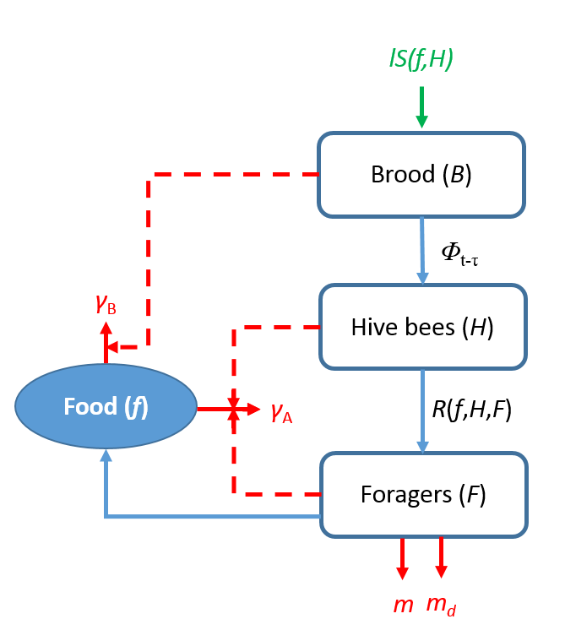

Figure 2

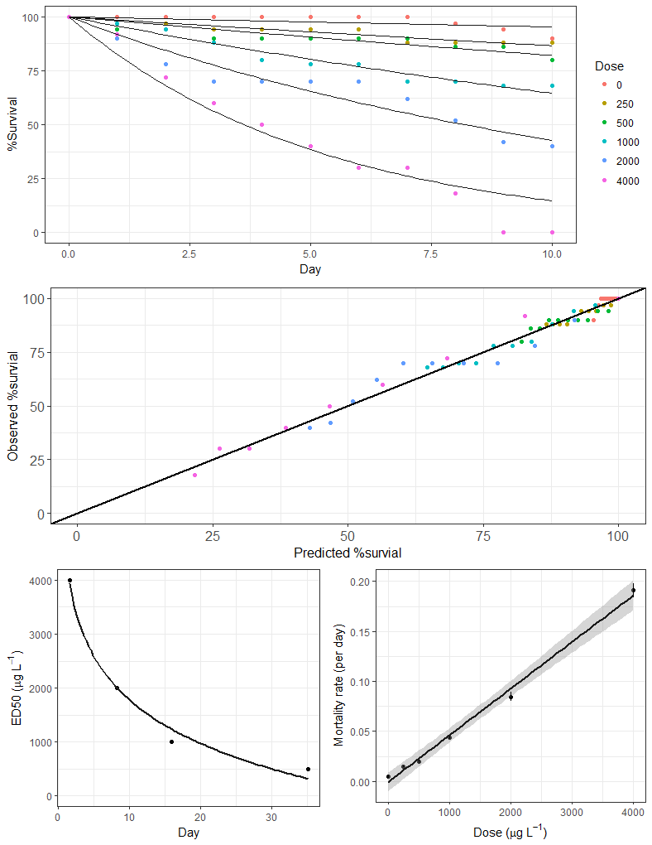

**d**

**c**

**b**

**a**

**c**

**b**

Figure 3

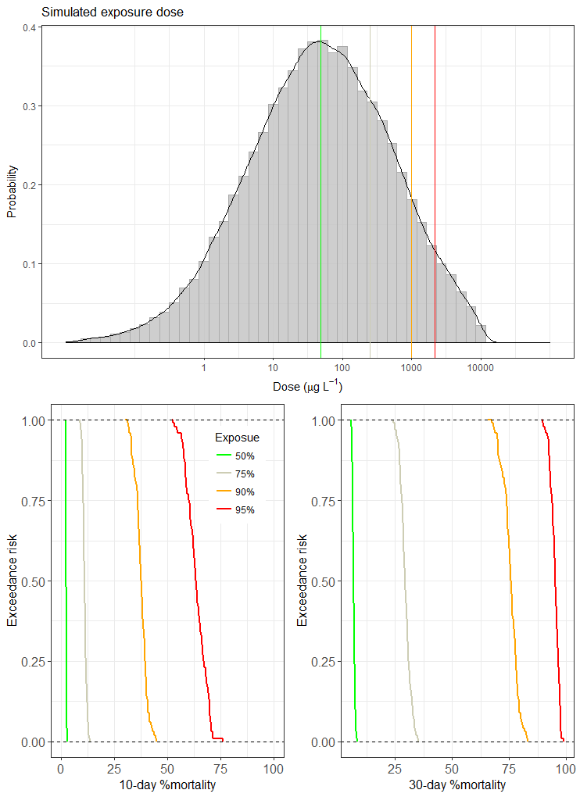

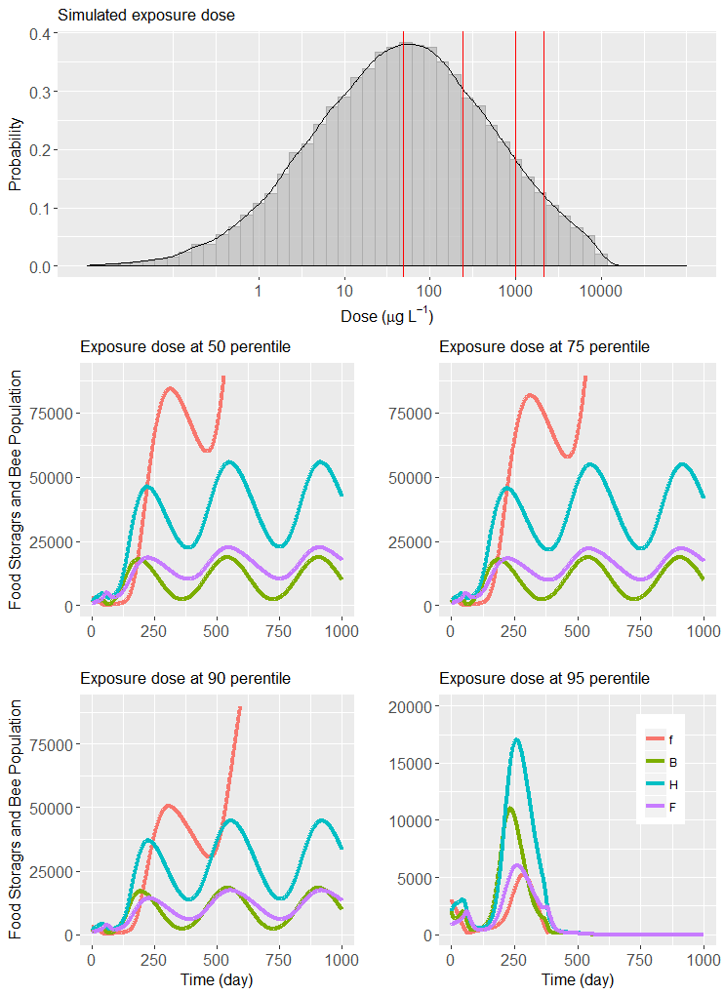

Figure 4

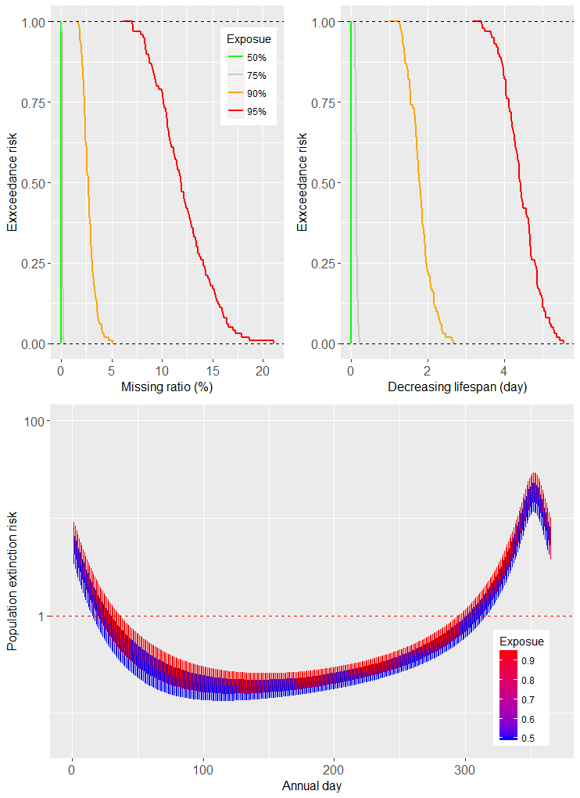

Fig. 5

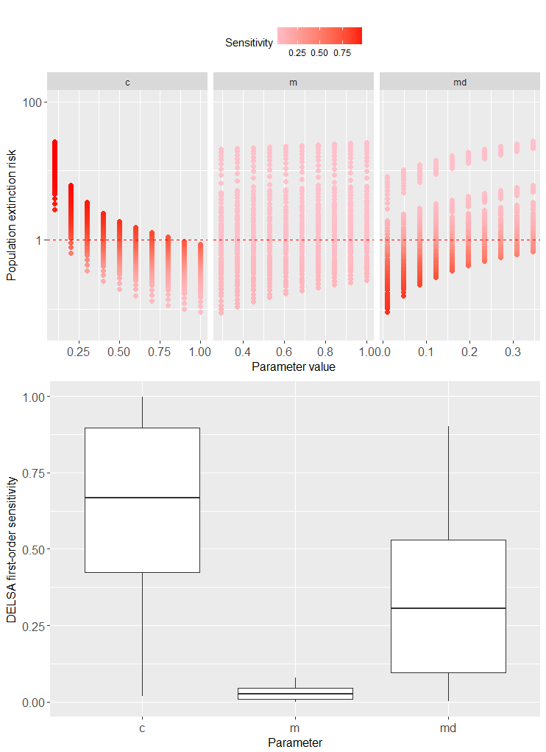

Fig. A1

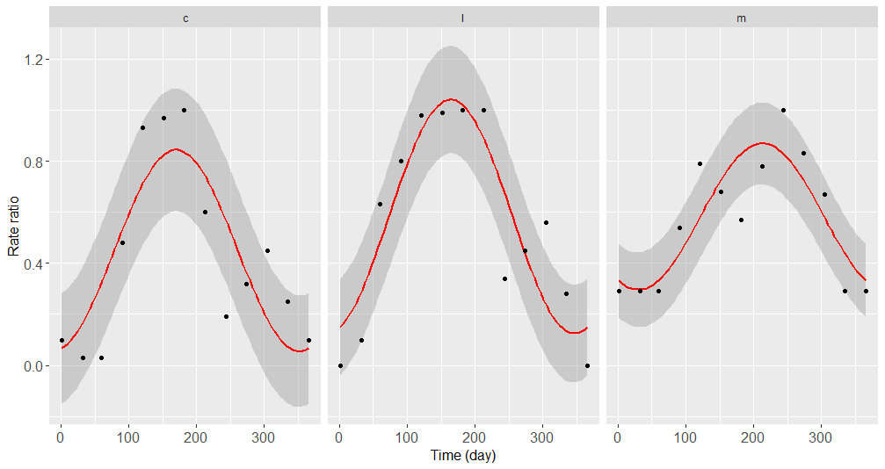

Fig. A2