General enquiries on this form should be made to:

Defra, Science Directorate, Management Support and Finance Team,
Telephone No. 020 7238 1612
E-mail: research.competitions@defra.gsi.gov.uk
 | SID 5 | Research Project Final Report

● Note
In line with the Freedom of Information Act 2000, Defra aims to place the results of its completed research projects in the public domain wherever possible. The SID 5 (Research Project Final Report) is designed to capture the information on the results and outputs of Defra-funded research in a format that is easily publishable through the Defra website. A SID 5 must be completed for all projects.
- This form is in Word format and the boxes may be expanded or reduced, as appropriate.
● ACCESS TO INFORMATION
The information collected on this form will be stored electronically and may be sent to any part of Defra, or to individual researchers or organisations outside Defra for the purposes of reviewing the project. Defra may also disclose the information to any outside organisation acting as an agent authorised by Defra to process final research reports on its behalf. Defra intends to publish this form on its website, unless there are strong reasons not to, which fully comply with exemptions under the Environmental Information Regulations or the Freedom of Information Act 2000.
Defra may be required to release information, including personal data and commercial information, on request under the Environmental Information Regulations or the Freedom of Information Act 2000. However, Defra will not permit any unwarranted breach of confidentiality or act in contravention of its obligations under the Data Protection Act 1998. Defra or its appointed agents may use the name, address or other details on your form to contact you in connection with occasional customer research aimed at improving the processes through which Defra works with its contractors.

Project identification

1. Defra Project code | PS2322
2. Project title
Assessment of the risk posed to honeybees by systemic pesticides

3. Contractor  organisation(s) | CSL  Sand Hutton  York  YO41 1LZ

 | 54. Total Defra project costs | £ 45,773
(agreed fixed price)
 | 5. Project: start date | 01 February 2005

 | end date | 31 March 2007

6. It is Defra’s intention to publish this form.
Please confirm your agreement to do so. YES NO
(a) When preparing SID 5s contractors should bear in mind that Defra intends that they be made public. They should be written in a clear and concise manner and represent a full account of the research project which someone not closely associated with the project can follow.
Defra recognises that in a small minority of cases there may be information, such as intellectual property or commercially confidential data, used in or generated by the research project, which should not be disclosed. In these cases, such information should be detailed in a separate annex (not to be published) so that the SID 5 can be placed in the public domain. Where it is impossible to complete the Final Report without including references to any sensitive or confidential data, the information should be included and section (b) completed. NB: only in exceptional circumstances will Defra expect contractors to give a "No" answer.
In all cases, reasons for withholding information must be fully in line with exemptions under the Environmental Information Regulations or the Freedom of Information Act 2000.
(b) If you have answered NO, please explain why the Final report should not be released into public domain

Executive Summary
7. The executive summary must not exceed 2 sides in total of A4 and should be understandable to the intelligent non-scientist. It should cover the main objectives, methods and findings of the research, together with any other significant events and options for new work.

There has been increasing concern over the last few years about the potential risk posed to honeybees by systemic seed treatments used on flowering crops, e.g. imidacloprid, fipronil. Such use of pesticides with systemic properties has advantages through reducing spray applications of pesticides to growing crops but provides a concern over the potential exposure of non-target species feeding on pollen and nectar. This has been raised as an issue and was a main focus of an ICPBR working group on the hazards of pesticides to bees at a meeting held in October 2005. This project aimed to provide a UK perspective on the issue and a review of changes proposed, including an assessment of the recommendations resulting from the meeting and subsequent working group meetings, to identify possible approaches to risk assessment for systemic pesticides to honeybees by reviewing available data on systemic pesticides and approaches taken by other countries to risk assessment for these types of compounds; assessing the applicability of current toxicity testing methodology and data gaps and identifying risk assessment methodology that is suitable for these types of compounds.
Systemic pesticides are primarily applied as granules or seed treatments but many spray applications, e.g. dimethoate, also have systemic properties. Systemic pesticides are transported through the plant to their target site, e.g. to control sucking or leaf consuming insects, and may be expressed in the nectar consumed by pollinating insects including honeybees. Many insecticides applied as systemics are highly toxic and it is the targeted delivery within the plant which reduces the exposure within the environment associated with spray applications. Risk assessment for honeybees and non-systemic pesticides is well established through EU91/414 and the EPPO and OECD guidelines for testing. In addition, exposure to spray applications of compounds with systemic properties is likely to be far higher than that through systemic action in flowering crops and therefore is taken into account in EU91/414. However, the current EU 91/414 approach (revision due late 2007) is not applicable to systemic pesticides applied as granules, seed treatments or soil drenches as risk assessment is based on a hazard quotient approach which relies on application rate and acute toxicity for sprays. The exposure of bees to systemic pesticides is dependent on levels in nectar and pollen and feeding rates rather than application rate. The proposed revisions to 91/414 identify the issue but provide little guidance on how to address risk assessment for systemic compounds.
The ICPBR working group on systemic pesticide risk assessment is currently developing a risk assessment scheme which will incorporate information on the pesticide Kow, solubility, residues in the green part of the plant and likely intake of nectar and pollen by bees to determine the level of exposure and the LC50 to allow the development of a toxicity exposure ratio (TER) approach. The criteria proposed by the ICPBR working group for a pesticide to be considered systemic is a Kow<4. The triggers for the TER will be based on the evaluation of the scheme using case study pesticides to ensure that the scheme will identify possible causes of concern whilst minimising the number of false positives.

Toxicity
Currently accepted honeybee acute toxicity test guidelines (OECD) are less applicable to assessing the effects of long term exposure to pesticides. There are no guidelines on their use to assess long term effects, e.g. adaptations such as suitable test units, renewal of test feed, extension of exposure time. Longer-term exposure to low levels of pesticide may result in a toxic accumulated dose (LC50) which is likely to differ from the single dose oral LD50 currently used in risk assessment. One recent concern is the wide range of methods used to assess this LC50 value, e.g. duration of exposure, resulting in widely varying estimates of toxicity. There is, therefore, a need to develop methodology for longer-term exposure of bees to pesticides than in the current OECD methods. Published methods were compared and the selected test evaluated experimentally to provide recommendations on appropriate test methodology for systemic pesticides in the laboratory. A longer-term chronic toxicity test (10 day) for adult honeybees was developed in which the selected concentrations of offered dose and the uptake over time and effects were assessed daily for 7 selected pesticide active ingredients.The data shows an apparent correlation between the LD50 and LC50 suggesting a 10 fold adjustment factor may be applied to the LD50 to calculate an LC50 in ug/bee/day. However, further work is required to confirm this with a wider range of compounds. The apparent repellency/anti-feedant of imidacloprid was demonstrated by significantly lower consumption of treated sucrose at dose rates well below the LC50 (bees fed on 2 ug/ml). Such reduced food consumption, when there is no other available food source in such studies, suggests that effects on food consumption may have a compounding effect on survival.
In vitro larval rearing systems were established based on the methods of Aupinel et al (2005) and the relative acute (single dose) toxicity of range of pesticides to larvae were assessed. The aim of these studies were to allow comparison with adult honeybee LD50 data to establish whether separate larval studies are required for systemic pesticides or whether their sensitivity is similar on a weight basis.
There were problems in establishing the larval assays due to high levels of control mortality over the 4 day exposure period. This was thought to be due to the rapid decline in brood rearing during the season due to scarcity of nectar. Therefore assessments were made of the mortality 24hrs after dosing. This showed the relative sensitivity of larvae exposed to a dose calculated to kill approx 50% of adult honeybees. It should be borne in mind that the exposure of the larvae is significantly different to those of adult honeybees in an LD50 test. Adult honeybees receive either a single contact dose or consume treated sucrose for a maximum of 4 hrs. In the larval study the individuals are dosed within their cells with a mixture of royal jelly, sucrose and the pesticide and receive both a contact and oral dose over the following 24 hrs. Thus the exposure of the larvae is far higher than that of the adults during what are regarded as comparable tests. For the majority of the pesticides, despite the fact that the exposure may be regarded as far higher than that for the adult bees, the larvae were less sensitive with the exception of pirimicarb and metaxalyl. The differences in sensitivity may be due differences in both the activity of enzyme systems required to activate pesticides such as dimethoate and in the sensitivity of the target sites. However, before firm conclusions over the sensitivity of the larvae can be drawn further data are required and the problems with control mortality overcome.
Exposure
In order to determine possible exposure levels the data on levels of systemic pesticides in nectar and pollen was collated and uptake of nectar and pollen by bees was reviewed. Due to the problems in analysing pesticides at low levels in pollen and nectar which are only available in small amounts there is only very limited data available. It is suggested that scenarios are developed for worker larvae, nurse bees and nectar foraging workers as these represent the highest intake of pollen and nectar for larvae and adults.

Risk assessment
In terms of first tier risk assessment the most appropriate approach is to develop a TER for adults and for larvae it is likely that a brood study approach will be required until a laboratory test is validated or until it can be confirmed whether larvae are less sensitive and therefore risk assessment for adults is protective. In the adult TER approach the toxicity to adults over a 10 day period should be compared to intake based on residues in the green parts of plants (preferably near flowering) and the intake data for pollen and nectar. A risk assessment scheme based on this approach is currently being developed in an ICPBR working group and more detailed information has been supplied to PSD.
It has also been suggested that long-term low-level exposure to toxic pesticides is likely to result in significant sublethal effects even if the threshold for a lethal dose is not reached. It is considered that many of the sublethal effects reported may be artefacts of laboratory experimentation or are difficult to interpret in relation to effects at colony level. Rather than the development and validation of a range of laboratory studies to assess sublethal effects it is proposed that sublethal effects are incorporated into semi-field and field studies. Therefore key endpoints to be included in semi-field and field studies have been identified and guidance developed on key criteria to be used in the design and interpretation of field studies for systemic compounds.

Project Report to Defra

8. As a guide this report should be no longer than 20 sides of A4. This report is to provide Defra with details of the outputs of the research project for internal purposes; to meet the terms of the contract; and to allow Defra to publish details of the outputs to meet Environmental Information Regulation or Freedom of Information obligations. This short report to Defra does not preclude contractors from also seeking to publish a full, formal scientific report/paper in an appropriate scientific or other journal/publication. Indeed, Defra actively encourages such publications as part of the contract terms. The report to Defra should include:
● the scientific objectives as set out in the contract;
● the extent to which the objectives set out in the contract have been met;
● details of methods used and the results obtained, including statistical analysis (if appropriate);
● a discussion of the results and their reliability;
● the main implications of the findings;
● possible future work; and
● any action resulting from the research (e.g. IP, Knowledge Transfer).

1. Review current data available and approaches to systemic risk assessment for honeybees, e.g. for imidacloprid, fipronil
There has been increasing concern over the last few years about the potential risk posed to honeybees by systemic seed treatments used on flowering crops, e.g. imidacloprid, fipronil. Such use of pesticides with systemic properties has advantages through reducing spray applications of pesticides to growing crops but provides a concern over the potential exposure of non-target species feeding on pollen and nectar. The current requirements for assessing the risk of pesticides to honeybees provides a system suitable only for evaluation of the risks posed by spray applications as it compares the application rate with the LD50. There is therefore an urgent need to review the possible approaches to risk assessment for systemic pesticides. This has been raised as an issue and was a main focus of an ICPBR working group on the hazards of pesticides to bees at a meeting held in October 2005. This project aimed to provide a UK perspective on the issue and a review of changes proposed, including an assessment of the recommendations resulting from the meeting and subsequent working group meetings, to identify possible approaches to risk assessment for systemic pesticides to honeybees by reviewing available data on systemic pesticides and approaches taken by other countries to risk assessment for these types of compounds; assessing the applicability of current toxicity testing methodology and data gaps and identifying risk assessment methodology that is suitable for these types of compounds.

Systemic pesticides are primarily applied as granules or seed treatments but many spray applications, e.g. dimethoate, also have systemic properties. Thus systemic pesticides are transported through the plant to their target site, e.g. to control sucking or leaf consuming insects, and may be expressed in the nectar consumed by pollinating insects including honeybees. Many insecticides applied as systemics are highly toxic and it is the targeted delivery within the plant which reduces the exposure within the environment associated with spray applications. Risk assessment for honeybees and non-systemic pesticides is well established through EU91/414 and the EPPO and OECD guidelines for testing. In addition, exposure to spray applications of compounds with systemic properties is likely to be far higher than that through systemic action in flowering crops and therefore is taken into account in EU91/414. However, the current EU 91/414 approach (revision due late 2007) is not applicable to systemic pesticides applied as granules or seed treatments as risk assessment is based on a hazard quotient approach which relies on application rate and acute toxicity for sprays. The exposure of bees to systemic pesticides is dependent on levels in nectar and pollen and feeding rates rather than application rate. The proposed revisions to 91/414 identify the issue but provide little guidance on how to address risk assessment for systemic compounds.

There is a significant amount of data available for new systemic compounds in terms of behaviour in plants and more limited data on residues in nectar and pollen. Almost all herbicides and all “systemic” pesticides are weak electrolytes (Trapp 2003). Systemic transport means both movement upward in the xylem and downwards in the phloem which occurs inside plants. For neutral compounds the relationship between lipophilicity and plant uptake was first established by Collander (1954 cited by Trapp 2003) and shown to be log linear between cell membrane permeability and the octanol-water partition coefficient. The translocation of neutral compounds into shoots has been shown to be most efficient for compounds with intermediate lipophilicity.

The criteria proposed by the ICPBR working group for a pesticide to be considered systemic is a Kow<4. The uses of greatest concern are those applied as seed treatments, granules or as soil drenches. For the UK this provides a short-list of the pesticides currently registered in the UK (Table 1).

Table 1. Pesticides used in the UK as granules, seed treatments and soil drenches (highlighted= compounds identified for use in laboratory assessments)
 | Compound type | Log Kow | LD50 ug/bee
Dodine | Guanidine fungicide | 1.28-1.32 | >100
Prothioconazole | Triazole fungicide | 2.0-4.32 | >71
Fosetyl-aluminium | Aluminium salt Fungicide | -2.7 | 200
Propamocarb hydrochloride | Carbamate fungicide | -2.6 | >100
Guazatine | Guanidine fungicide | -1.2 | >200
Oxamyl | Carbamate nematicide | -0.4 | 0.078
Aldicarb | Carbamate nematicide | 0.053
Hymexazol | fungicide | 0.48 | >100
Imidacloprid | Nitroguanidine insecticide | 0.57 | 0.008
Metalaxyl-M | Phenylamide fungicide | 1.7 | 25
Pirimicarb | Carbamate insecticide | 1.7 | 51
Thiram | Dimethyldithiocarbamate fungicide | 1.7 | 73.7
Thiabendazole | Benzimidazole fungicide | 2.4 | >100
Fluquinconazole | Azole fungicide | 3.2 | >100
Etridiazole | Fungicide | 3.37
Flutolanil | Fungicide | 3.7 | >100
Iprodione | Dicarboximide fungicide | 3.7 | >400
Silthiofam | Allyl amide fungicide | 3.7 | >837
Tebuconazole | Azole fungicide | 3.7 | >100
Imazalil | Azole fungicide | 3.8 | 40
Fipronil | Phenylpyrazole insecticde | 4.0 | 0.004
Fludioxonil | Phenylpyrrole fungicide | 4.1 | >100
Prochloraz | Azole fungicide | 4.1 | 50
Deltamethrin | Pyrethroid insecticide | 4.6 | 0.051
Tolclofos-methyl | OP fungicide | 4.6 | >100
Chlorpyrifos | OP insecticide | 4.7 | 0.059
Pencycuron | Fungicide | 4.7 | >100
Clothianidin | Nitroguanidine insecticide | 5.0 | 0.0439
Beta-cyfluthrin | Pyrethroid insecticide | 5.9 | 0.05
Tefluthrin | Pyrethroid insecticide | 6.5 | 0.28

Concerns amongst beekeepers over the potential for effects of systemic insecticides in honeybees has resulted in the removal of imidacloprid and fipronil from use in France. In the absence of any agreed EU approach to risk assessment for systemic pesticides, the French authorities (CST) undertook a review of available data and risk assessment based on the Technical Guidance Document for New and Existing Chemicals (Halm et al 2006). The proposed risk assessment approach, based on evaluation of the imidacloprid data was based on a PNEC (predicted no effect concentration) and a PEC (predicted environmental concentration) based on a residue data from pollen (Halm et al 2006). PNECs were calculated from data on acute, chronic and sublethal toxicities of imidacloprid to honeybees to which selected assessment factors were applied. These assessment factors were originally selected within the TGD to protect ecosystems but the CST authors defined the colony as “a superorganism which functions in a similar way to that of an ecosystem”. Since the assessment factors in the TGD were not based on a scientific appraisal it is unclear how valid it is to use these same factors to apply to the different castes within the same species and how any assessment factors whould be adjusted to take account of this. The assessment factors used by the CST varied from 100 for the extrapolation of acute data (lowest LD50, 3.7 ng/bee) to 10 for the PNEC for chronic data (lowest LC50, 0.012 ng/bee). They applied an assessment factor of 50 to a sublethal NOEC (based on knockdown, 0.94 ng/bee) and a factor of 10 was applied to the NOEC for proboscis extension (0.2 ng/bee). For a semi-field study they applied a factor of 10 to the LOEC for time spent feeding (0.075 ng/bee) and for field studies a factor of 5 based on dance tests (0.25 ng/bee). They supported the use of a factor >1 as the feeders were artificial. This approach resulted in PNECs from 1.2 to 50 pg/bee compared with NOECs of 200-940 pg/bee and an LD50 of 3700 pg/bee (the LC50 data is controversial as no other study has replicated such a low value (Schmuck 2004).

In addition, the French authorities have recently published guidance on risk assessment for honeybees (SSM Versailles 2004) which requires the use of tests which have sublethal endpoints, including laboratory rearing of larvae, for which there are no agreed guidelines. There have been a number of publications on the effects of sublethal exposure on endpoints such as learning and memory (proboscis extension reflex). There are a number of issues about such an approach – including the use of sublethal no-observed-effect levels with no information on their potential impact on the population and the use of safety factors without supporting data. There is a need to identify sublethal effects for use in pesticide risk assessment which can be related to adverse impacts at the individual or population level. A previous report (PN0944) reviewed the possible sublethal effects on honeybees and their potential impact on the colony and, more recently, project PN0936 has suggested that sublethal effects may affect the ability of colonies to over-winter (Thompson et al 2005).

In Canada the approach for spray applications is a variation of that used in the EU (Hemendra Mulye
pers.comm.). It involves the use of an acute contact toxicity endpoint (LC50 expressed in µg/bee) which is converted to a "field rate" using the Atkins' conversion factor (Atkins et al. 1981). This field rate is then compared with the product label rate to calculate a risk quotient to determine if the proposed use will pose a risk to honey bees. For example,if the acute LC50 of a pesticide is 100 µg a.i./bee, then using the Atkins' conversion factor of 1.12, the "field rate" would be 112 kg a.i./ha. If the proposed label rate is 0.1 kg a.i./ha, then the risk quotient would be 0.001 i.e. no risk. For systemic insecticides, where residues of the chemical are expected to be secreted in the nectar and pollen of flowering plants, a more direct approach is used where empirical data on the concentration of residues in pollen and nectar of the host crop is factored into literature-reported values for consumption of pollen and nectar by foraging bees to calculate a risk quotient. For example, if the acute oral NOEL of a pesticide is 1 µg a.i./bee, and the concentration of that pesticide in nectar is 100 µg a.i./kg, then based on the rate of consumption of nectar by the bee (average daily nectar load of 40 mg per bee) the concentration of the pesticide to which the bee would be exposed, and the risk quotient (in this example, 0.004), can be calculated.

The ICPBR working group on systemic pesticide risk assessment is currently developing a risk assessment scheme which will incorporate information on the pesticide Kow, solubility, residues in the green part of the plant and likely intake of nectar and pollen by bees to determine the level of exposure and the LC50 to allow the development of a TER approach. The triggers for the TER will be based on the evaluation of the scheme using case study pesticides to ensure that the scheme will identify possible causes of concern whilst minimising the number of false positives.

2. Identify possible methods for assessing longer-term toxicity due to chronic low-level exposure scenarios and identify suitable test systems to address these
Currently accepted honeybee acute toxicity test guidelines (OECD) are less applicable to assessing the effects of long term exposure to pesticides; however, there are no guidelines on their use, e.g. renewal of test feed, exposure time. Longer-term exposure to low levels of pesticide may result in a toxic accumulated dose (LC50) which is likely to differ from the single dose oral LD50 currently used in risk assessment. One recent concern is the wide range of methods used to assess this LC50 value, e.g. duration of exposure, resulting in widely varying estimates of toxicity. There is, therefore, a need to develop methodology for longer-term exposure of bees to pesticides than in the current OECD methods. Published methods were compared and the selected test evaluated experimentally to provide recommendations on appropriate test methodology for systemic pesticides in the laboratory.
A longer-term chronic toxicity test (10 day) for adult honeybees was developed in which the selected concentrations of offered dose and the uptake over time and effects were assessed daily for 7 selected pesticide active ingredients. The offered dose was diluted in sucrose and the fresh treated feed was provided each day. During these studies the effect of pattern (duration and dose) of exposure on toxicity and observed sublethal effects, e.g. reduction in food intake, was recorded as this may affect the risk assessment, e.g. reduced longevity due to effects on food intake. The data was used to determine the importance of the pattern of exposure compared with acute exposure data for the same chemicals. The data developed are shown in Table 2 and Figure 3. At the same time data were generated for a single oral LD50 for the same range of compounds to provide a direct comparison.

All compounds were used as the active ingredient to ensure co-formulants were not responsible for effects.

Table 2. LD50 (48hr) and LC50 (10 day) for pesticide active ingredients offered in 50% w/v sucrose.
 | LD50 ug/bee |  | LC50 ng/bee | CL | LC50 ug/bee | LC50 ng/bee/day | CL
Dimethoate | 0.13 | 0.10-0.15 | 112 | 54-151 | 0.112 | 13.3 | 8.3-17.4
Deltamethrin | 0.21 | 0.16-0.26 | 253 | 38-790 | 0.253 | 26.9 | 16-39.6
Pirimicarb | 19.5 | 14-26 | 5008 | 2697-9999 | 5.01 | 508 | 282-960
Chlorpyrifos methyl | 0.15 | 0.138-0.165 | 293 | 108-513 | 0.293 | 36.2 | 17.7-55.9
Imidacloprid | 0.49 | 0.33-0.67 | 189 | 154-232 | 0.189 | 18.9 | 15.4-23.1
Fipronil | 0.123 | 0.09-0.16 | 2.9 | 1.0-4.0 | 0.0029 | 0.26 | 0.037-0.38
Imazalil | 90 | 77.1-104 | 10245 | 3287-16885 | 10.245 | 1043 | 373-1703

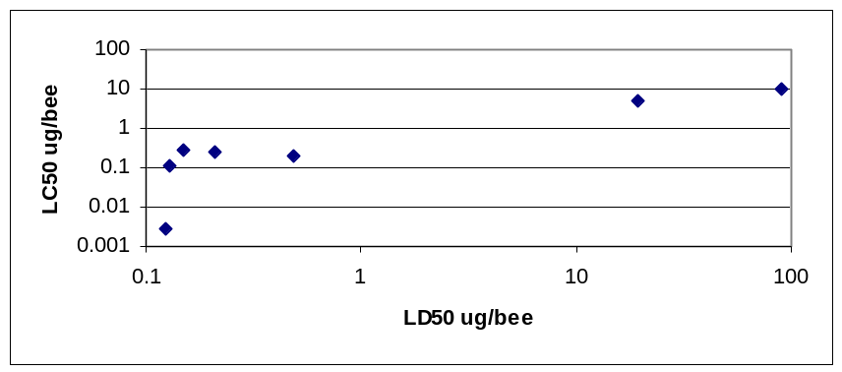
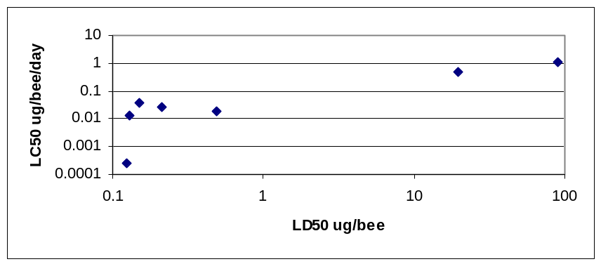

Figure 1. Comparison of the LC50 and LD50 for the pesticides assessed.

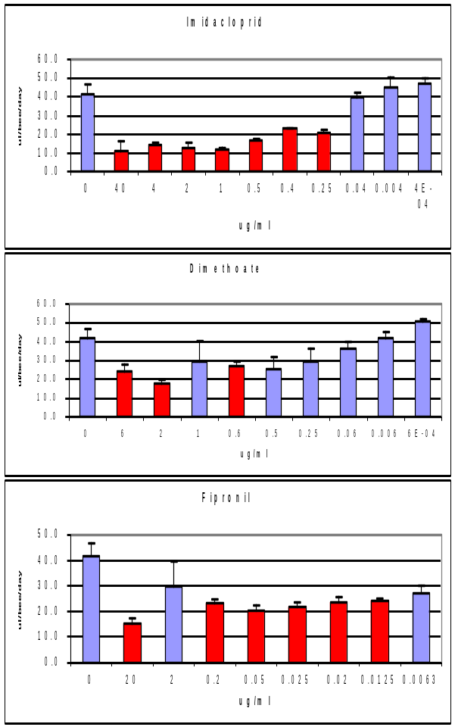
Figure 2. Effect of offered dose on the intake of treated feed by honeybees in the chronic studies (bars coloured red show intake significantly differing from controls (p<0.05) (3 replicates per dose).

The data shows an apparent correlation between the LD50 and LC50 suggesting a 10 fold adjustment factor may be applied to the LD50 to calculate an LC50 in ug/bee/day (Figure 1). However, further work is required to confirm this with a wider range of compounds. Figure 2 shows the apparent repellency/anti-feedant of imidacloprid in that at dose rates well below the LC50 (bees fed on 2 ug/ml) there was significantly lower consumption of treated sucrose. Such reduced food consumption, when there is no other available food source in such studies, suggests that effects on food consumption may have a compounding effect on survival.

Interestingly the publication which has caused greatest controversy due to an extremely low LC50 is that by Suchail et al (2001). They reported an LD50 of 57ng/bee at 48hrs and in the chronic study over 10 days with 0.1, 1.0 and 10 ug/L sucrose there was no dose response and >50% of the bees died in all doses. However, in this study the bees consumed only 12 ul/day of the treated sucrose which compared to the 40 ul/day consumed in this study is far lower and may in itself have resulted in mortality.

Figure 3. Mortality-time curves for varying doses of pesticides showing mean % mortality with offered dose with time after first exposure (3 replicates per dose) (dose levels are given in ug/ml)
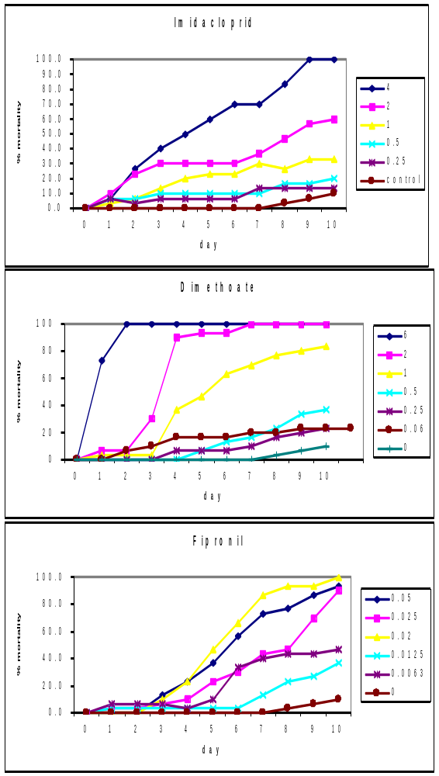
Larval studies
In vitro larval rearing systems were established based on the methods of Aupinel et al (2005) and the relative acute (single dose) toxicity of range of pesticides to larvae were assessed. The aim of these studies were to allow comparison with adult honeybee LD50 data to establish whether separate larval studies are required for systemic pesticides or whether their sensitivity is similar on a weight basis.
There were problems in establishing the larval assays due to high levels of control mortality over the 4 day exposure period. This was thought to be due to the rapid decline in brood rearing during the season due to scarcity of nectar. Therefore assessments were made of the mortality 24hrs after dosing and the data are summarised in Figure 4. This shows the relative sensitivity of larvae exposed to a dose calculated to kill approx 50% of adult honeybees. It should be borne in mind that the exposure of the larvae is significantly different to those of adult honeybees in an LD50 test. Adult honeybees receive either a single contact dose or consume treated sucrose for a maximum of 4 hrs. In the larval study the individuals are dosed withn their cells with a mixture of royal jelly, sucrose and the pesticide and receive both a contact and oral dose over the following 24 hrs. Thus the exposure of the larvae is far higher than that of the adults during what are regarded as comparable tests.

Figure 4 shows that for the majority of the pesticides, despite the fact that the exposure may be regarded as far higher than that for the adult bees, the larvae are less sensitive with the exception of pirimicarb and metaxalyl. The differences in sensitivity may be due differences in both the activity of enzyme systems required to activate pesticides such as dimethoate and in the sensitivity of the target sites. However, before firm conclusions over the sensitivity of the larvae can be drawn further data are required and the problems with control mortality overcome. This is likely to be a result of the upcoming ICPBR ring-testing of the larval toxicity test method due to be undertaken in Spring/Summer 2008.
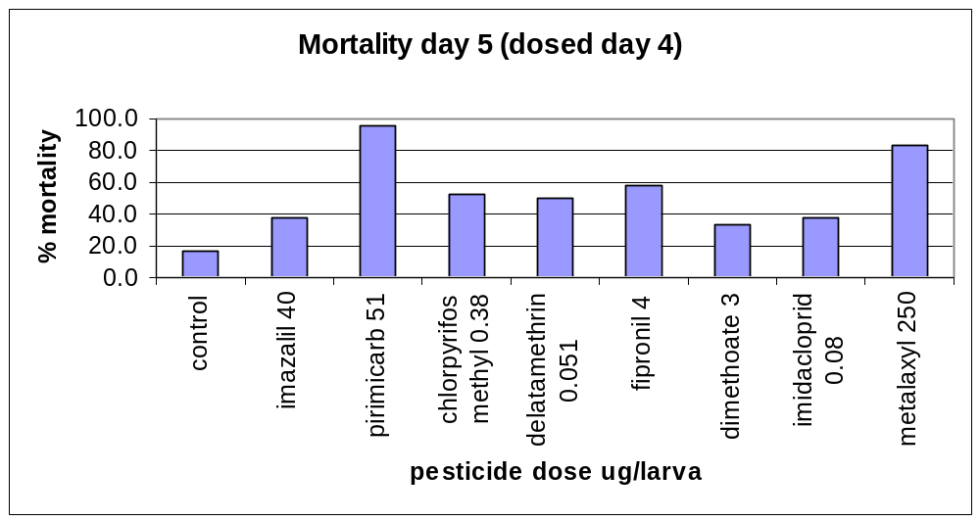
Figure 4. Percentage mortality over a 24 hr period after dosing of larvae treated with an adult LD50 dose of pesticides
3. Assess the feasibility of risk assessment for systemic pesticides and honeybees based on chronic low-level exposure.
The data collated above was used to evaluate a range of pesticides with differing systemic properties to determine the impact on the risk assessment compared with current methods and the implications of initial ICPBR recommendations

Exposure assessment

In order to determine possible exposure levels the data on levels of systemic pesticides in nectar and pollen was collated and uptake of nectar and pollen by bees was reviewed.

Systemic pesticides in pollen and nectar
Due to the problems in analysing pesticides at low levels in pollen and nectar which are only available in small amounts there is only very limited data available.
Davis et al (1988) investigated the effect of the structure of the nectary vascular supply on the distribution of the systemic insecticides carbofuran and dimethoate. The vascular supply is direct when vascular bundles enter the nectary tissue or indirect when the final material transfer depends on diffusion from vascular traces. Almost half of the plant species studied have floral nectaries supplied by phloem only. Similarly extrafloral nectaries may or may not be vascularised; those with vascularisation are usually supplied by both xylem and phloem. Davis et al (1988) summarised data on the movement of systemic pesticides into nectar and showed that the direct xylem supply to the nectaries is not necessary for insecticide secretion and thus movement must occur within intercellular spaces and or cell walls. The structure of the nectaries may affect the levels of the pesticide in the nectar with apparent selective transport of insecticides into the nectar.

Loper et al (1987) reported the levels of a gametocide (potassium 3,4-dichloro-5-isothiazolecarboxylate) in the nectar of cotton plants following a foliar applied systemic gametocide at rates up to 110 g ai/ha in the field and through irrigation in the glasshouse at rates up to 2 mg ai/ l. Levels in floral nectar in the field and in floral and bracteal nectar in glasshouse studies ranged up to 542 mg/l one day after spraying and 151 mg/l respectively. The effects on honeybees fed on sucrose solutions containing the gametocide at the same level were assessed and showed no effects in the laboratory or on visitation to treated flowers in the field. The authors also reported that the gametocide and a metabolite was detected in ripened honey collected from the colonies around the field but did not report the residue levels.

Most reported data are for the newer neonicotinoid pesticides based on perceived problems due to their possible secretion into nectar and pollen. Decourtye et al (2003) summarised the available data on residues of imidacloprid. In a greenhouse assay with radiolabelled imidacloprid residues were detected in pollen and nectar of sunflowers at 1.9 and 3.3 μg/kg respectively. Nectar collected from the gut of honeybees foraging on Phacelia treated with imidacloprid contained residues between 3 and 10 μg/kg. Bonmatin et al (2003) reported levels of imidacloprid in sunflower pollen of 1-11 μg/kg and in maize pollen of 1-3 μg/kg.

Rossi et al (2005) reported levels of imidacloprid in pollen in corn sown following dressing with Gaucho 350FS and also the levels on grass and flowers and honeybees collected around the field on which the application was made. They showed the levels in honeybees were very low with only 2 of 10 samples showing levels between in the LOD and LOQ (0.002 mg/kg). The levels of imidacloprid in grass (0.021 mg/kg) and flowers (0.032 mg/kg) collected around the treated field were similar with the simplest explanation that this was due to dust from the seed expelled by the fans on the pneumatic seed drill (after 2hrs of application the levels on filter paper placed over fan exhausts was 125 mg/kg).

Schmuck et al 2001reported the residues in sunflowers seed treated with radiolabelled imidacloprid at 0.7 mg as/seed. Only the parent compound was detected in pollen and nectar at 3.9 μg/kg in pollen and 1.9 μg/kg in nectar (LOD 1 μg/kg). However, imidacloprid and its metabolites were below the limit of detection (1.5 μg/kg parent, 3 μg/kg hydroxyl and olefin-metabolites) in the nectar and pollen collected from field-grown sunflowers grown from seed treated at the same rate.

Bonmatin et al (2005) reported the results of survey work on the levels of imidacloprid in pollen from maize grown from treated seed (1 mg / seed Gaucho formulation). The pollen was collected both directly from flowers and from pollen collected from bees using pollen traps fitted to hives. 47 samples of maize pollen collected and 87% of these had residue levels above the LOD of 0.3 μg/kg. 38% of the maize pollen collected contained levels between 0.3 μg/kg and 1 μg/kg (the LOQ) and 45% between 1 and 10 μg/kg. Only 4% (2 samples) had levels over 10 μg/kg and the maximum was 18 μg/kg. Overall the mean residue was 2.1 μg/kg and the standard deviation 2.7 μg/kg. Of the 11 pollen samples collected from traps on colonies 46% were below the 0.3 μg/kg LOD, 18% between 0.3 μg/kg and 1 μg/kg (LOQ) and 36% between 1 and 10 μg/kg. No samples had levels above 10 μg/kg. The mean level was 0.6 μg/kg and microscopic examination showed that the pollen loads contained between 20 and 40% maize pollen. Bonmatin et al (2005) compared the data with that they had generated for sunflowers which showed the levels in plant collected pollen and pollen collected from pollen traps (which was 90-100% sunflower pollen) was 3.0 μg/kg and that cited for rape of 4.4-7.6 μg/kg in pollen and 0.6-0.8 μg/kg in nectar.

Laurent and Rathahao (2003) investigated the distribution of radiolabelled imidacloprid in sunflowers following seed treatment with 1mg/seed (30% higher than the recommended application rate and grown in outdoor lysimeters. The plants absorbed less than 10% of the radiolabelled imidacloprid and 75% of this was detected in the cotyledons with residues in the upper leaves 20 times lower than those in the lower leaves. Imidacloprid accounted for 50% of the radioactivity with the other 50% being accounted for by four major metabolites. As observed in other plants 2 pathways were responsible for metabolism in the sunflower: the denitrification pathway resulting in low levels of the urea metabolite and imidazolidine oxidation leading to the formation of the 4- or 5-hydroxylimidacloprid and subsequently to olefinic residues both of which have been reported to have insecticidal properties. The levels of imidacloprid detected in pollen were 13 ng/g. The distribution of the pesticide within the plant is consistent with its high polarity with a low Kow of 0.57. Briggs et al (1983) cited by Laurent and Rathahao showed that molecules with such a log Kow were xylem mobile transported only by the transpiration stream. Translocation from the leaves may also occur to nectar and pollen via the phloem. Differences in the uptake of the pesticide may thus be due to the water uptake by plants and soil conditions and also may differ between varieties of the species. Half lives of imidacloprid in cropped soil have been reported to be greater than 45 days. Sunflowers have a root distribution with a shallow fibrous root mass (fascicular roots) which grow horizontally in the superficial layer of soil and a deeper roots spreading down to approx 1.5m. The limited leaching of imidacloprid in soil means that the fascicular root system is a more likely uptake system. The relative development of the two types of root systems due to soil structure of climatic conditions may thus affect the uptake and absorption of imidacloprid.

Calculations have been made which suggest that the concentration of nectar to form honey through water loss increases the concentration of imidacloprid residues. However Schmuck et al 2001reported levels of 8 μg/ kg or less in honey stores in colonies fed sugar solutions containing 10 μg/ kg imidacloprid and Wallner et al (1999) reported no differences in the residues in sampled nectar and stored honey in colonies foraging on Phacelia grown from imidacloprid treated seed.

Castle et al (2005) reported levels of imidacloprid and thiamethoxam in xylem of citrus trees after application through the irrigation system. Peak mean titres of imidacloprid (25 μg/l in xylem after application of 561 g ai/ha) occurred 6-8 weeks after application compared with 2 weeks for thiamethoxam (43 μg/l in xylem after application of 139 g ai/ha). Imidacloprid was persistent for another 6-10 weeks whereas thiamethoxam declined more rapidly (it was applied at a lower rate). Within tree distributions appeared similar throughout the trees with no differences with height of the sampling points.

For pesticides to be present in nectar and pollen they do not need to be systemic, direct overspray can also result in contamination of food sources although obviously this is limited to flowers that are open at the time of application. Tasei et al (1994)monitored residues of deltamethrin in the pollen and nectar of oilseed rape plants after overspray at 12.5 g ai/ha. Residues ranged from 0.002 to 0.006 mg/kg in honey and 0.012-0.019 mg/kg in nectar with no residues detected in nectar 6 days after spraying. Levels in foraging bumble bees were 0.149-0.932 mg/kg. Contamination of sugar syrup by 0.1 –0.2 mg/kg deltamethrin resulted in a decrease in uptake by worker bumble bees by 40-100% with no deleterious effect on longevity. Similarly Barker et al (1980) determined the levels of dimethoate in pollen and nectar of alfalfa oversprayed at 304ppm to run off. In plants where the racemes had been covered at spray application the levels in nectar were 5ppm were one day later but 3ppm in nectar one week later and 1 ppm two weeks later. In uncovered racemes the levels in pollen were 0.5ppm and the nectar levels were 16ppm one day after application with a first order decay of approx 25% per day in the nectar levels. Barker et al assessed the effect of concentration of dimethoate in sucrose on the LT90 (time to 90% mortality) and showed that at levels of 2ppm and below the LT90 was greater than 7 days whereas at 5ppm it was 3 days, at 10 ppm 2 days and 20ppm less than 1 day. The study design was such that the bees had a choice between treated and untreated sucrose and the food was weighed daily to assess the dose taken. However the LD50, LD90 did not vary with survival time suggesting that there was no increased uptake with time of survival indicating metabolism of toxins, i.e. the LD50 was similar when calculated at low doses where bees survived for longer or at high doses where bees survived for a shorter period.

Glynne Jones and Thomas (1953) investigated the residues in nectar and honey after overspraying borage and mustard plants with Schradan. This showed levels of up to 5ppm in mustard nectar and 2.5 ppm in borage nectar3 days after spraying and declined over a 4 week period. Workers were also fed on schradan contaminated sucrose and allowed to convert it to honey which showed less than 5% decrease in Schradan residues after storage for 2.5 months at 30ºC.

Waller et al (1984) investigated the levels of dimethoate in lemon flowers after a spray application of dimethoate and showed residues of up to 0.1ppm in nectar up to 8 days after application with residues in nectar samples taken from colonies within the groves with similar levels whereas stored honey had no detectable residues 2 months after the application.

Waller and Barker (1979) undertook a similar study in which onion plants were oversprayed with dimethoate at 300ppm dimethoate to run off and showed residues in nectar of up to 7 ppm.

As part of the multi-factorial study on the decline in honeybee colonies in France, Chauzat, et al (2006) reported the results of a field survey of five colonies in five apiaries at five sites across France (i.e. a total of 125 colonies) and pollen collected four times per year to identify the pesticides and residue levels present. Of the 73 samples analysed (Table 3) only 9 had none of the 36 pesticides analysed for using multi-residue methods. 19 pesticides were detected with coumaphos and tau-fluvalinate (which may both be used as varroacides) were present at the highest levels.

Table 3 Pesticide residues in pollen from colonies in a French field survey from , Chauzat, et al (2006)
Pesticide | No. positive samples | Max residue  μg/kg | Mean residue  μg/kg | Log Kow | Other published residue values
Imidacloprid | 40 | 5.7 | 1.2 | 0.57
6-chloronicotinic acid | 36 | 9.3 | 1.2
Fipronil | 10 | <2.0 | 1.2 | 4.0
Fipronil desulfynil compound | 9 | 1.5 | 1.3
Fipronil sulfone compound | 3 | 3.6 | 1.2
Penconazole | 8 | 126.0 | 27.6 | 3.72
Carbaryl | 3 | 265.0 | 218.7 | 1.59 | 390-1200
Endosulfan | 5 | 340.0 | 81.2 | 4.79
Tau-fluvalinate | 5 | 2020.0 | 487.2 | 4.26 | 5-260
Flusilazole | 4 | 71.0 | 26.1 | 3.74
Parathion-methyl | 4 | <39.5 | 24.8 | 3.0 | 40-17800
Carbofuran | 3 | 14.0 | 10.9 | 1.52
cyproconazole | 3 | <10.0 | 7.5 | 2.91
Myclobutanil | 2 | 20.3 | 13.9 | 2.94
coumaphos | 2 | 1700.0 | 925.0 | 4.13
Oxamyl | 1 | 38.4 | 38.4 | -0.44
tebuconazole | 1 | 12.3 | 12.3 | 3.7
Hexaconazole | 1 | 18.0 | 18 | 3.9
Parathion ethyl | 1 | 19.2 | <8.0 | 3.83
Azinphos-methyl |  |  |  | 2.96 | 260-590
Cyhalothrin |  |  |  | 6.8 | 10-500
Cypermethrin |  |  |  | 6.6 | 70-1900

Intake of nectar and pollen
In order to calculate the possible exposure of honeybees to systemic pesticides the uptake of pollen and nectar by worker and larval honeybees is required. Barker et al (1980) reported data on the uptake of pollen and nectar by bees. They reported that foragers collected 200 μl nectar per day, and may forage for up to 30 days. In colonies rearing brood the nurse bees use 190mg of pollen in 31 days. Rortais et al (2005) collated data for use in the risk assessment of systemic pesticides and these are shown below (Table 4). These data can be used with plant residue data and sugar content of differing sources of nectar. Therefore, it may not be necessary to specifically monitor residues in nectar and pollen but use whole plant or leaf residues as a worst-case scenario at the first tier together with knowledge of the uptake of pollen and nectar for the scenario. Babendrier et al (2004) reported that the amount of pollen ingested by a larva during development was 1.52-2.04 mg maize pollen during their complete development. This data together with that of Simpson (1955) with red clover pollen suggests that pollen only provides a low proportion of the total protein requirements of larvae compared with that calculated by Rortais. In contrast the pollen intake of adult workers is likely to be higher as they ingest pollen not only for their own requirements but also for rearing brood. It is suggested that scenarios are developed for worker larvae, nurse bees and nectar foraging workers as these represent the highest intake of pollen and nectar for larvae and adults.

Table 4. Sugar and pollen intake by different classes of larval and adult honeybees (Rortais et al 2005)
Class of bee | Number of days used for assessment | Sugar intake mg/ bee/day | Pollen intake mg/ bee/day
Worker larvae | 5 | 11.9 | 1.1
Drone larvae | 6.5 | 15.1 | No data
Nurse bees | 10 |  | 6.5
Wax-producing bees | 6 | 18.0
Brood-attending bees | 8 | 34-50
Winter bees | 90 | 8.8
Nectar foragers | 7 | 32-128.4
Pollen foragers | 7 | 10.4-15.6

Risk assessment
It has also been suggested that long-term low-level exposure to toxic pesticides is likely to result in significant sublethal effects even if the threshold for a lethal dose is not reached. A wide range of sublethal effects have been reported for systemic pesticides, from reduced feeding/foraging activity, which may be related to repellent properties, to apparent inability to return directly to the colony. Current approaches have used the lowest NOEL for any sublethal effect. There is a need for an assessment of the relative importance of the sublethal effects reported for these types of compounds and how these types of effects can be assessed, e.g. incorporated into standard laboratory methodology, only possible in specific laboratory test methods, or can be incorporated into semi-field or field test protocols, and how they may be incorporated into the risk assessment process. It is considered that many of the sublethal effects reported may be artefacts of laboratory experimentation or are difficult to interpret in relation to effects at colony level. Rather than the development and validation of a range of laboratory studies to assess sublethal effects it is proposed that sublethal effects are incorporated into semi-field and field studies. Therefore key endpoints to be included in semi-field and field studies have been identified and guidance developed on key criteria to be used in the design and interpretation of field studies for systemic compounds (Table 5).

In terms of first tier risk assessment the most appropriate approach is to develop a TER for adults. For larvae it is likely that a brood study approach will be required until a laboratory test is validated or until it can be confirmed whether larvae are less sensitive and therefore risk assessment for adults is protective. In the adult TER approach the toxicity to adults over a 10 day period should be compared to intake based on residues in the green parts of plants (preferably near flowering) and the intake data for pollen and nectar. A risk assessment scheme based on this approach is currently being developed in an ICPBR working group and more detailed information has been supplied to PSD.

Tables 6 and 7 show the TER values for the available exposure data for nurse bees consuming pollen and foragers consuming nectar. This assumes a nurse bee consumes 6.5mg pollen per day and a foragers consumes 128mg sugar which based on a 40% sugar content of nectar is 320mg nectar per day. The TER vary widely for the compounds from 0.1 to over 150,000. In Table 7 the residue values for deltamethrin and dimethaote are for oversprayed plants which unsurprisingly give high residue values and with their inherently high toxicity result in low TER values.. Currently it is unclear where the triggers should be set as a requirement for further studies.

Table 6. TER values for nurse bees calculated based on intake of reported contaminated pollen values for pesticides with Log Kow<4 and assuming 6.5mg pollen intake per bee per day.
Pesticide | Max residue | Mean residue | Other published residue values | nurse bees | LC50 | LD50/10¹ | TER based on Chauzet et al max value | TER based on max data
Pesticide | μg/kg | μg/kg | Other published residue values | exposure ug/bee/day | ug/bee/day |  | TER based on Chauzet et al max value | TER based on max data
Imidacloprid | 5.7 | 1.2 |  | 0.00003705 | 0.0189 |  | 510
Fipronil | <2.0 | 1.2 |  | 0.000013 | 0.00029 |  | 22
Penconazole | 126 | 27.6 |  | 0.000819 |  | >0.5 | 611
Carbaryl | 265 | 218.7 | 390-1200 | 0.0017225 |  | 0.1 | 58 | 13
Flusilazole | 71 | 26.1 |  | 0.0004615 |  | >15 | 32503
Parathion-methyl | <39.5 | 24.8 | 40-17800 | 0.00025675 |  | 0.011 | 43 | 0.10
Carbofuran | 14 | 10.9 |  | 0.000091 |  | 0.015 | 165
cyproconazole | <10.0 | 7.5 |  | 0.000065 | >10 |  | 153846
Myclobutanil | 20.3 | 13.9 |  | 0.00013195 | >10 |  | 75786
Oxamyl | 38.4 | 38.4 |  | 0.0002496 | 0.0078 |  | 31
tebuconazole | 12.3 | 12.3 |  | 0.00007995 |  | 10 | 125078
Hexaconazole | 18 | 18 |  | 0.000117 | >10 |  | 85470
Parathion ethyl | 19.2 | 8 |  | 0.0001248 |  | 0.018 | 144
Azinphos-methyl |  |  | 260-590 |  |  | 0.043 |  | 11
¹ no LC50 data therefore approximation used of LD50 divided by ten

Table 7 TER values for foraging worker bees calculated based on intake of reported contaminated nectar values (320 mg nectar intake per day
 |  | ug/kg nectar |  | LC50 |  | forager bees exposure ug/bee/day |  | TER
deltamethrin osr (Tasei et al 1994) |  | 19 |  | 0.0253 |  | 0.00608 |  | 4.2
dimethoate alfalfa (Barker et al 1980) |  | 5000 |  | 0.0112 |  | 1.6 |  | 0.01
dimethoate lemon (Waller et al 1984) |  | 100 |  | 0.0112 |  | 0.032 |  | 0.4
dimethoate onion (Waller and Barker 1979) |  | 7000 |  | 0.0112 |  | 2.24 |  | 0.01
imidacloprid sunflower (Decourtye et al 2003) | 3.3 |  | 0.0189 |  | 0.001056 |  | 17.9
Imidacloprid Phacelia (Decourtye et al 2003) | 10 |  | 0.0189 |  | 0.0032 |  | 5.9
Imidacloprid sunflower (Schmuck et al 2001) | 1.9 |  | 0.0189 |  | 0.000608 |  | 31.1
Imidacloprid osr (Bonmatin et al 2005) | 0.8 |  | 0.0189 |  | 0.000256 |  | 73.8

The ICPBR working group on systemic pesticides and honeybees has raised a number of issues that require addressing before the risk assessment scheme can be completed.

The current revision of 91/414 EEC makes reference to particular issues with respect to honeybees with systemic pesticides applied as soil or seed treatments but provides no further guidance on how the risk assessment should be performed. The ICPBR group has developed an outline scheme which requires further development and validation through case studies and some additional data to be generated. Further work should evaluate the proposed scheme - through the use of case studies for pesticides used in the UK as seed treatments and soil drenches and identify whether existing data can be used or new data should be generated for these classes of chemicals.

Exposure - The group has proposed that at the first tier residues in green parts of the crop at around the time of flowering are used as a surrogate for levels in nectar and pollen as they are likely to be higher and thus offer a degree of conservatism whilst minimising the problems of residue analysis in small, difficult to analyse, samples. AFFSA are intending to review existing data to determine whether this is indeed the case.

Toxicity - The current project has shown that the LC50 for pesticides based on a 10-day exposure period may be correlated with the LD50 thus limiting the level of additional testing required. This proposal aims to extend the number of compounds tested to provide confidence in ability to extrapolate and to determine the role of reduced feeding on the mortality in the test, i.e. by limiting food availability, which may confound results for compounds with anti-feedant properties.

In addition initial studies on larval toxicity were limited due to problems in establishing the assay. Therefore these studies need to be repeated/extended (in collaboration with the larval toxicity testing group of the ICPBR) to determine whether such an assay can be routinely undertaken and whether the additional data show higher toxicity to larvae. The ring-testing with 10 laboratories is currently planned for spring 2008.
The working group also considered it important to provide an updated review and validation of the current hazard quotient approach for spray applications to provide confidence that such approaches are valid. This is important as the previous review was not published in the peer-reviewed literature and is therefore not widely available.

The results will assist PSD by providing better information risk assessment for systemic pesticides and honeybees and enable them to determine whether additional data are required for pesticides with these properties. These will lead to improved risk assessment procedures and hence assist in understanding the risk to wildlife from pesticide use.

Table 5. Identification of sublethal endpoints identified in laboratory studies and how they may be covered by semi-field or field tests
Study type | Type of sublethal effect | Supposed impact of the effect | Endpoint covered in semi-field/field study by the assessment of:
PER (proboscis extension reflex) test | Impairment of associative learning | Impairment of orientation capacity, bees disappearing | Colony strength, foraging in the crop (field); bees at tunnel walls and ceiling (semi-field)
Chronic toxicity (laboratory) | Shortened lifespan | Effects to colony vitality | Colony strength
Observation of bee dance and orientation ability | Impact to bee dance, reduced orientation ability | Recruitment of foragers, and thereby foraging activity, reduced, bees disappearing | Foraging activity, food store and brood development, honey yield; colony strength (field); bees at tunnel walls and ceiling (semi-field)
Video-supported behavioral study (tunnel) | Effects on foraging behavior | Effect to colony vitality | Foraging activity, food store and brood development, colony strength, honey yield
Study on associative learning (tunnel) | Effects on orientation, foraging behavior | Orientation, food storage, foraging impaired | Foraging activity, food store and brood development, colony strength
Laboratory study on behavior | Effects on overall activity, mobility, social behavior | Foraging and recruiting activity, brood care impaired | Foraging activity, flight activity, brood development
Field study on homing and orientation behavior | Effects on orientation, foraging activity | Bees disappearing, reduced foraging actvity | Colony strength, foraging in the crop (field); bees at tunnel walls and ceiling (semi-field)
Study on long-term colony development | Reproductive success, breeding activity, prematurely ageing | Dwindling of colonies, loss of colony strength and vitality | Prolonged observation of tested colonies after exposure phase (at least one generation cycle)

References to published material
9. This section should be used to record links (hypertext links where possible) or references to other
published material generated by, or relating to this project.

Atkins E (1981) Reducing pesticide hazards to honey bees. Mortality prediction techniques and integrated management strategies. Division of Agricultural Sciences, University of Caifornia, Leaflet 2883
Aupinel P, Fortini D, Dufour H, Tasei J-N, Michaud B, Odoux, F, Pham-Delegue M-H (2005) Improvement of artificial feeding in a standard in vitro method for rearing Apis mellifera larvae Bulletin of Insectology 58 (2) 107-111
Babendrier D, Kalberer, N, Romeis, J., Fluri, P, Bigler, F (2004) Pollen consumption in honey bee larvae: a step forward in the risk assessment of transgenic plants Apidologie 35 293-300
Barker R J, Lehner Y, Kunzmann M R (1980) Pesticides and honeybees: Nectar and pollen contamination in alfalfa treated with dimethoate Arch Environ Contam Toxicol 9 125-133
Bonmatin J M, Marchand P A, Charvet R, Moineau I, Bengsch E R, Colin M E (2005) Quantification of imidacloprid uptake in maize crops J Agric Fd Chem 53 5336-5341
Bonmatin JM, Moineau I, Charvet R, Fleche C, Colin M E, Bengsch E R (2003) A LC/APCI-MS/MS method for analysis of imidacloprid in soils, in plants and in pollens Anal Chem 75, 2027-2033
Castle S J, Byrne, F J, Bi J L, Toscano N C (2005) Spatial and temporal distribution of imidacloprid and thiamethoxam in citrus and impact on Homalodisca coagulate populations Pest Managemnt Sci 61 75-84
Chauzat, M-P, Faucon J-P, Martel, A-C, Lachaize J, Cougoule N, Aubert M (2006) A survey of pesticide residues in pollen loads collected by honey bees in France J Econ Entomol 99 (2) 253-262
Davis AR, Shuel RW, Peterson RL (1988) Distributionof carbofuran and dimethoate in flowers and their secretion in nectar as related to nectary vascular supply. Can J Bot 66 1248-1255
Decourtye A, Lacassie E, Pham-Delegue M-H (2003) Learning performances of honeybees (Apis mellifera L) are differentially affected by imidacloprid according to the season Pest Mgmt Sci 59 269-278
Glynne Jones GD, Thomas WDE (1953) Experiments on the possible contamination of honey with Schradan
Halm, M-P, Rortais, A, Arnold, G, Tasei, J-N, Rault, S (2006) New risk assessment approach for systemic insecticides: the case of honeybees and imidacloprid (Gaucho) Environ Sci Technol 40, 2448-2454
Laurent F M, Rathahao E (2003) Distribution of [¹⁴C]Imidacloprid in sunflowers (Helinathus annuus L) following seed treatment J Agric Fd Chem 51 8005-8010
Loper GM, Olvey J, Berdel R L (1987) Concentration of the systemic gametocide TD-1123 in cotton nectar and honeybee response Crop Sci. 27 558-561
Rortais, A, Arnold, G, Halm, M-P, Touffet-Briens, F (2005) Modes of honeybees exposure to systemic insecticides: estimated amounts of contaminated pollen and nectar consumed by different categories of bees. Apidologie 36, 71-83
Rossi, S, Sabatimi A G, Cenciarini R, Ghini S, Girotti S (2005) Use of high performance liquid chromatography-UV and gas chromatography-mass spectrometry for determination of the imidacloprid content of honeybees, pollen, paper filters, grass and flowers Chromatographia, 61 189-195
Schmuck , R (2004) Effects of a chronic dietary exposure of the honey bee Apis mellifera (Hymenoptera: Apidea) to imidacloprid. Arch Environ Contam Toxicol. 47 471-478
Schmuck R, Schoning R Stork A, Schramel O (2001) Risk posed to honeybees (Apis mellifera L. Hymenoptera) by an imidacloprid seed dressing of sunflowers Pest Mgmt Sci 57 225-238
SSM Versailles (2004) Evaluation du risque environmental des produits phytopharmaceutiques. Commission d’etude de la toxicite des produits antiparasitaires a usage agricole et des produits assimiles des matieres fertilisantes et des supports de culture, SSM, Versailles
Suchail S, Guez, D, Belzuncs L P (2001) Discrepancy between acute and chronic toxicity induced by imidaclorpid and its metabolites in Apis mellifera Enviro Toxicol and Chem 20 (11) 2482-2486
Tasei J-N, Sabik H, Pirastru L, Langui E, Blanche J M, Fournier J, Taglioni JP (1994) Effects of sublethal doses of deltamethrin (Decis Ce) on Bombus terrestris J Apic Res. 33 (3) 129-135
Thompson H M, Wilkins S, Battersby A H, Waite R J, Wilkinson D (2005) The effects of four insect growth-regulating (IGR) insecticides on honeybee (Apis mellifera L) colony development, queen rearing and drone sperm production Ecotoxicology 14 757-759
Trapp S (2003) Plant uptake and transport models for neutral and ionic chemicals Environ Sci and Polltn Res 11 (1) 33-39
Wallner K, (1999) Tests regarding effects of imidacloprid on honeybees ICPBR Hazards of pesticides to bees Avignon France, Ed INRA, Paris 2001
Waller GD, Barker, RJ (1979) Effects of dimethoate on honeybee colonies J Econ Entomol 72 549-551
Waller G D, Erickson, B J, Harvey, J, Martin, J H (1984) Effects of dimethoate on honeybees (Hymenoptera: Apidae) when applied to flowering lemons J Econ Entomol 77 70-74
Villa S, Vighi, M, Finizio A, Serini G B (2000) Risk assessment for honeybees from pesticide exposed pollen Ecotoxicology 9 287-297

