mid-term-q21

Pradeep Paladugula

2/23/2020

library('ggplot2')  
library('e1071')  
library('datasets')  
data(mtcars)  
mtcars

## mpg cyl disp hp drat wt qsec vs am gear carb  
## Mazda RX4 21.0 6 160.0 110 3.90 2.620 16.46 0 1 4 4  
## Mazda RX4 Wag 21.0 6 160.0 110 3.90 2.875 17.02 0 1 4 4  
## Datsun 710 22.8 4 108.0 93 3.85 2.320 18.61 1 1 4 1  
## Hornet 4 Drive 21.4 6 258.0 110 3.08 3.215 19.44 1 0 3 1  
## Hornet Sportabout 18.7 8 360.0 175 3.15 3.440 17.02 0 0 3 2  
## Valiant 18.1 6 225.0 105 2.76 3.460 20.22 1 0 3 1  
## Duster 360 14.3 8 360.0 245 3.21 3.570 15.84 0 0 3 4  
## Merc 240D 24.4 4 146.7 62 3.69 3.190 20.00 1 0 4 2  
## Merc 230 22.8 4 140.8 95 3.92 3.150 22.90 1 0 4 2  
## Merc 280 19.2 6 167.6 123 3.92 3.440 18.30 1 0 4 4  
## Merc 280C 17.8 6 167.6 123 3.92 3.440 18.90 1 0 4 4  
## Merc 450SE 16.4 8 275.8 180 3.07 4.070 17.40 0 0 3 3  
## Merc 450SL 17.3 8 275.8 180 3.07 3.730 17.60 0 0 3 3  
## Merc 450SLC 15.2 8 275.8 180 3.07 3.780 18.00 0 0 3 3  
## Cadillac Fleetwood 10.4 8 472.0 205 2.93 5.250 17.98 0 0 3 4  
## Lincoln Continental 10.4 8 460.0 215 3.00 5.424 17.82 0 0 3 4  
## Chrysler Imperial 14.7 8 440.0 230 3.23 5.345 17.42 0 0 3 4  
## Fiat 128 32.4 4 78.7 66 4.08 2.200 19.47 1 1 4 1  
## Honda Civic 30.4 4 75.7 52 4.93 1.615 18.52 1 1 4 2  
## Toyota Corolla 33.9 4 71.1 65 4.22 1.835 19.90 1 1 4 1  
## Toyota Corona 21.5 4 120.1 97 3.70 2.465 20.01 1 0 3 1  
## Dodge Challenger 15.5 8 318.0 150 2.76 3.520 16.87 0 0 3 2  
## AMC Javelin 15.2 8 304.0 150 3.15 3.435 17.30 0 0 3 2  
## Camaro Z28 13.3 8 350.0 245 3.73 3.840 15.41 0 0 3 4  
## Pontiac Firebird 19.2 8 400.0 175 3.08 3.845 17.05 0 0 3 2  
## Fiat X1-9 27.3 4 79.0 66 4.08 1.935 18.90 1 1 4 1  
## Porsche 914-2 26.0 4 120.3 91 4.43 2.140 16.70 0 1 5 2  
## Lotus Europa 30.4 4 95.1 113 3.77 1.513 16.90 1 1 5 2  
## Ford Pantera L 15.8 8 351.0 264 4.22 3.170 14.50 0 1 5 4  
## Ferrari Dino 19.7 6 145.0 175 3.62 2.770 15.50 0 1 5 6  
## Maserati Bora 15.0 8 301.0 335 3.54 3.570 14.60 0 1 5 8  
## Volvo 142E 21.4 4 121.0 109 4.11 2.780 18.60 1 1 4 2

head(mtcars)

## mpg cyl disp hp drat wt qsec vs am gear carb  
## Mazda RX4 21.0 6 160 110 3.90 2.620 16.46 0 1 4 4  
## Mazda RX4 Wag 21.0 6 160 110 3.90 2.875 17.02 0 1 4 4  
## Datsun 710 22.8 4 108 93 3.85 2.320 18.61 1 1 4 1  
## Hornet 4 Drive 21.4 6 258 110 3.08 3.215 19.44 1 0 3 1  
## Hornet Sportabout 18.7 8 360 175 3.15 3.440 17.02 0 0 3 2  
## Valiant 18.1 6 225 105 2.76 3.460 20.22 1 0 3 1

The Null Hypothesis is the number of miles per gallon of the cars does not depend on the number of cylinders, hors power and gear(transmission type)  
  
The Alternative Hypotheses is the number of miles per gallon of the cars has the direct correlation with the number of cylinders used, the vehiclehorse power and gear(transmission type)  
  
Dependant Variable: Miles per Gallon  
Independent Variables: Cylinders, Horse Power, Type of Gear  
  
Apart from the dependant and Independant variables, the rest of the data is not considered in this research work.   
  
From looking the data, I noticed any missing data, NA's and error is the data. the data seems to be pretty good.

mtcars$am = factor(mtcars$am, levels = c(0,1), labels = c("automatic", "manual"))  
  
hist(mtcars[mtcars$am == "automatic",]$mpg, main = "Mileage of automatic transmission cars", xlab = "Miles", ylab = "Frequency")

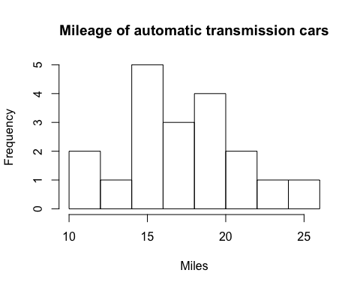

hist(mtcars[mtcars$am == "manual",]$mpg, main = "Mileage of automatic transmission cars", xlab = "Miles", ylab = "Frequency")

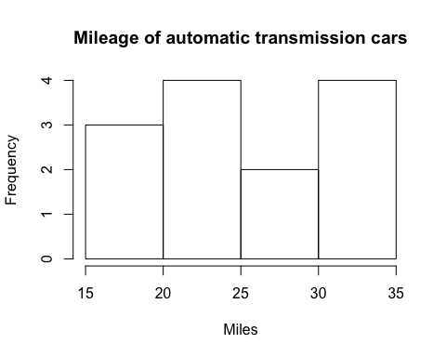

summary(mtcars[mtcars$am == "automatic",]$mpg)

## Min. 1st Qu. Median Mean 3rd Qu. Max.   
## 10.40 14.95 17.30 17.15 19.20 24.40

summary(mtcars[mtcars$am == "manual",]$mpg)

## Min. 1st Qu. Median Mean 3rd Qu. Max.   
## 15.00 21.00 22.80 24.39 30.40 33.90

ggplot(mtcars, aes(hp, mpg)) + geom_point()+geom_smooth(method = "lm", se = FALSE) + ggtitle("Relation between mpg and HP") + xlab("hp") + ylab("mpg")

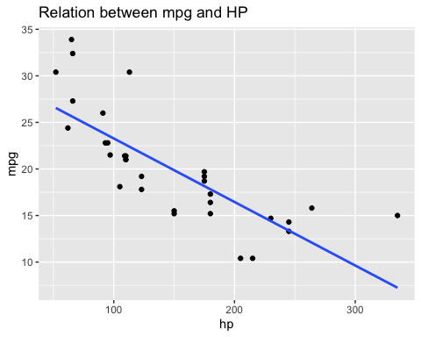

ggplot(mtcars, aes(am, mpg)) + geom_point()+geom_smooth(method = "lm", se = FALSE) + ggtitle("Relation between mpg and transmission type") + xlab("am") + ylab("mpg")

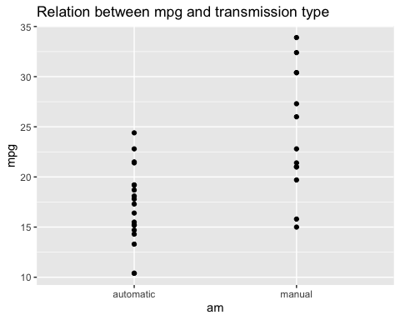

ggplot(mtcars, aes(cyl, mpg)) + geom_point()+geom_smooth(method = "lm", se = FALSE) + ggtitle("Relation between mpg and cyl") + xlab("cyl") + ylab("mpg")

