Statistical Modeling and Graphing

Pradeep Paladugula

2020-02-16

*Citation*: Trends in Internet-based business-to-business marketing

*Abstract*: The Internet is changing the transactional paradigms under which businesses-to-business marketers operate. Business-to-business marketers that take advantage of the operational efficiencies and effectiveness that emerge from utilizing the Internet in transactions are out performing firms that utilize traditional transactional processes. As an example, Dell computers, by utilizing business-to-business processes that take advantage of the Internet, has gained the largest market share in the PC business when compared to traditional manufacturers such as Compaq. This paper first examines the genesis of the Internet movement in business-to-business markets. The long-term impact of the increase of business-to-business utilization of the Internet on the marketing theory and marketing process is then discussed. Finally, managerial implications and directions for future research are highlighted.

Dataset includes:

1) Business marketing focus - traditional or forward thinking.  
  
2) Internet use - low, medium, or high levels of business marketing use on the internet.  
  
3) Time _ 1 - sales scores at the first measurement time.  
  
4) Time _ 2 - sales scores at the second measurement time

On all of these questions, be sure to include a coherent label for the X and Y axes. You should change them to be “professional looking” (i.e. Proper Case, explain the variable listed, and could be printed in a journal). The following will be assessed:

1) Is it readable?  
  
2) Is X-axis labeled appropriately?  
  
3) Is Y-axis labeled appropriately?  
  
4) Is it the right graph?  
  
5) Do the labels in the legend look appropriate?  
  
6) Are there error bars when appropriate?

We won’t grade for color of bars or background color, but you should consider that these things are usually printed in black/white - so be sure you know how to change those values as well as get rid of that grey background.

Please note that each subpoint (i.e. a, b) indicates a different chart.

data <- read.csv('05_data.csv')  
library('ggplot2')  
library('reshape')  
time1 <- data$time.1  
time2 <- data$time.2  
biz_focus <- data$biz_focus  
internet <- data$internet

1. Make a simple histogram using ggplot:
   1. Sales at time 1

salestime1 <- hist(data$time.1, xlab = 'Sales at Time 1', main = 'Histogram of Sales at time 1', labels = TRUE, col = '#75F4C2')

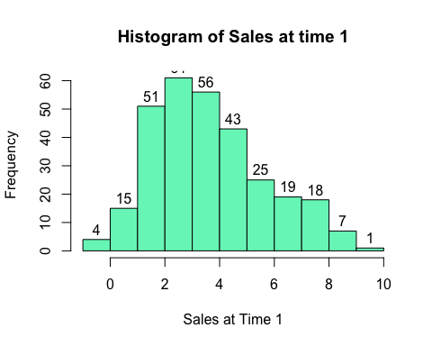

b. Sales at time 2

salestime2 <- hist(data$time.2, xlab = 'Sales at Time 2', main = 'Histogram of Sales at time 2', labels = TRUE, col = '#B8BDF2')

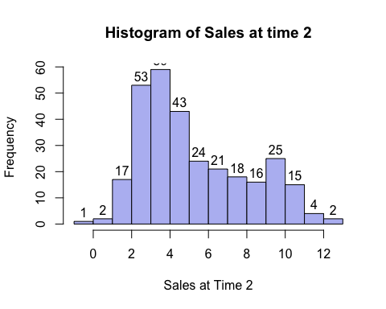

1. Make a bar chart with two independent variables:
   1. Business focus, internet, DV: sales at time 2

#Refernce = https://github.com/rstudio/cheatsheets/blob/master/data-visualization-2.1.pdf  
library('ggplot2')  
barplot_bf_int_time2 <- ggplot(data, aes(internet, time2, fill = biz_focus))  
barplot_bf_int_time2 + stat_summary(fun.y = "mean", geom = "bar", position = "dodge") + labs(x = "Internet Usage", y = "sales at Time2") + scale_fill_discrete(name = "Business Focus") + stat_summary(fun.data = "mean_cl_boot", geom = "errorbar", position = "dodge", width = 0.3)

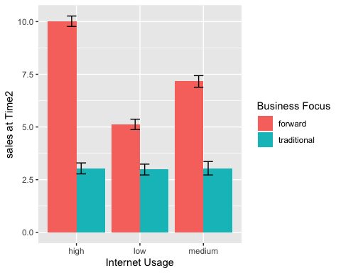

1. Make a bar chart with two independent variables:
   1. Time (time 1, time 2), Business focus, DV: is sales from time 1 and 2

barplot_bf_time1_time2 <- ggplot(data, aes(time1, time2, fill = biz_focus))  
barplot_bf_int_time2 + stat_summary(fun.y = "mean", geom = "bar", position = "dodge") + labs(x = "Internet Usage", y = "sales at Time2") + scale_fill_discrete(name = "Business Focus") + scale_x_discrete(labels = c("time1", "time2")) + stat_summary(fun.data = "mean_cl_boot", geom = "errorbar", position = "dodge", width = 0.3)

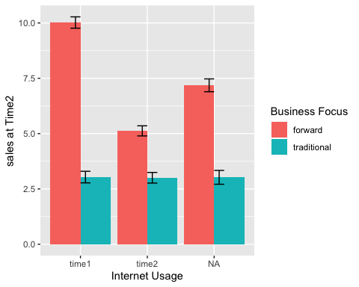

1. Make a simple line graph:
   1. Time (time 1, time 2), DV: is sales from time 1 and 2

#reference = https://stackoverflow.com/questions/3777174/plotting-two-variables-as-lines-using-ggplot2-on-the-same-graph  
id <- data$id  
ggplot() + geom_line(aes(x='', y = time1, group = 1, colours = "red")) + stat_summary(fun.data = "mean_cl_boot", geom = "errorbar", width = 0.3 ) + geom_line(aes(x='', y = time2, group = 2, colours = "blue"))

## Warning: Ignoring unknown aesthetics: colours  
  
## Warning: Ignoring unknown aesthetics: colours

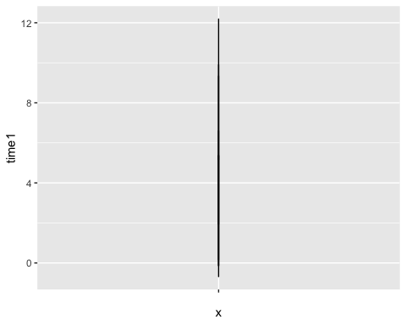

1. Make a simple scatterplot:
   1. Sales at Time 1, Time 2

library('reshape')  
scatterplottimes <- ggplot(data, aes(time1, time2))  
scatterplottimes + geom_point(postition = "jitter") + labs(title = "Sales at Time 1 and Time 2", x = "Sales at Time 1", y = "Sales at Time 2")

## Warning: Ignoring unknown parameters: postition

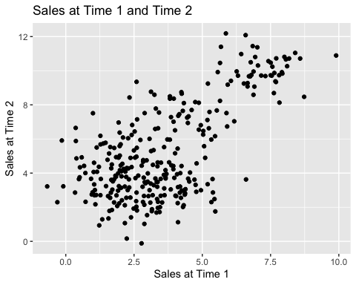

1. Make a grouped scatterplot:
   1. Sales at time 1 and 2, Business focus

groupedsp <- ggplot(data, aes(time1, time2, color = biz_focus))  
groupedsp + labs(x = "Sales Time 1", y = "Sales Time 2", title = "Scatterplot of Biz_focus at Time1 and Time2") + geom_point()

