
VASAVI COLLEGE OF ENGINEERING (AUTONOMOUS)
Affiliated to Osmania University | Hyderabad, Telangana
Department of Information Technology

NETWORK INTRUSION DETECTION SYSTEM
( NIDS )

DATABASE MANAGEMENT SYSTEMS
Course Project Report | B.E. IV Semester | Academic Year 2024–25

PROJECT TEAM
S.No. | Name | Roll Number
1 | T. Sneha | 1602-24-737-176
2 | P. Sravan | 1602-24-737-178

Guide / Faculty In-charge: Department of Information Technology

1. Problem Statement
Modern enterprise networks generate millions of packets per second, making manual traffic inspection infeasible. Signature-based firewall tools alone fail to detect novel attack patterns, while raw packet logs go unanalysed without a structured storage and querying layer. There is a need for a database-centric system that can persist network logs, match them against configurable intrusion rules, automatically raise alerts, and provide analysts with a review workflow — all backed by a well-normalised relational schema with triggers, stored procedures, and referential integrity.

2. Abstract
The Network Intrusion Detection System (NIDS) is a DBMS course project that demonstrates the design and implementation of a relational database at the core of a real-time security-monitoring application. The system ingests network traffic logs from registered devices, evaluates each log entry against a library of intrusion rules, and automatically generates severity-tagged alerts via SQL triggers. Security analysts can log in, browse the alert queue, and record review decisions, forming a complete audit trail stored in a normalised MySQL database.

The database schema comprises six entities — Device, Intrusion Rule, Network Log, Alert, Analyst, and Alert Review — modelled in Chen-notation ER and translated to 3NF-compliant relational tables. Advanced database features including stored procedures, triggers, views, and indexes are implemented to automate alert generation and optimise query performance. A Spring Boot REST API serves as the middleware, and a React-based dashboard provides real-time traffic visualisation.

3. Project Flow
# | Stage | Database Activity
1 | Device Registration | INSERT into DEVICE table; device_id PK generated
2 | Log Ingestion | INSERT into NETWORK_LOG; device_id FK validated; trigger fires
3 | Rule Matching | Stored procedure scans INTRUSION_RULE; matches by protocol/pattern
4 | Alert Generation | AFTER INSERT trigger on NETWORK_LOG inserts into ALERT table
5 | Analyst Authentication | Login checked against ANALYST table; role-based access
6 | Alert Review | INSERT into ALERT_REVIEW; weak entity linked via alert_id FK
7 | Reporting / Dashboard | SQL VIEWs aggregate log counts, alert severity distribution

Data Flow Summary
Network devices push raw log records to the REST API endpoint, which validates and persists them in the NETWORK_LOG table. An AFTER INSERT trigger immediately evaluates the new log against all active INTRUSION_RULE entries; if a pattern match is found, an ALERT row is automatically created with the appropriate severity level. Analysts access the web dashboard, authenticate via the ANALYST table, and submit review decisions that are persisted in the ALERT_REVIEW weak entity table — completing the end-to-end audit lifecycle.

4. Entity-Relationship Diagram
Chen Notation · DBMS Course Project · Vasavi College of Engineering
Relationships & Cardinality
Relationship | From Entity | To Entity | Cardinality | Notes
GENERATES | DEVICE | NETWORK LOG | 1 : N | One device generates many network log entries
MATCHES | INTRUSION RULE | NETWORK LOG | 1 : N | One rule can match multiple log entries
TRIGGERS | NETWORK LOG | ALERT | 1 : N | A log entry can trigger multiple alerts
REVIEWS | ALERT | ALERT REVIEW | 1 : N | Identifying relationship — Alert Review is a weak entity
PERFORMS | ANALYST | ALERT REVIEW | 1 : N | Each analyst can perform many alert reviews

Entity Attribute Specifications
DEVICE
Attribute | Type | Constraint | Description
device_id | INT | PK, AUTO_INCREMENT | Unique device identifier
hostname | VARCHAR(100) | NOT NULL | Device hostname on the network
ip_address | VARCHAR(45) | NOT NULL | IPv4/IPv6 address
mac_addr | VARCHAR(17) | UNIQUE | Hardware MAC address
dev_type | VARCHAR(50) | NOT NULL | Router / Switch / Server / Endpoint
location | VARCHAR(100) | DEFAULT NULL | Physical or logical location label

INTRUSION RULE
Attribute | Type | Constraint | Description
rule_id | INT | PK, AUTO_INCREMENT | Unique rule identifier
rule_name | VARCHAR(100) | NOT NULL, UNIQUE | Human-readable rule name
pattern | VARCHAR(255) | NOT NULL | Regex / keyword pattern to match
severity | ENUM | NOT NULL | Critical / High / Medium / Low
category | VARCHAR(100) | NOT NULL | DoS / Port-Scan / SQLi / Brute-Force
is_active | TINYINT(1) | DEFAULT 1 | Rule enabled flag (1 = active)

NETWORK LOG
Attribute | Type | Constraint | Description
log_id | INT | PK, AUTO_INCREMENT | Unique log entry identifier
protocol | VARCHAR(10) | NOT NULL | TCP / UDP / ICMP / HTTP
src_ip | VARCHAR(45) | NOT NULL | Source IP address
dest_ip | VARCHAR(45) | NOT NULL | Destination IP address
timestamp | DATETIME | DEFAULT NOW() | Packet capture timestamp
device_id | INT | FK → DEVICE(device_id) | Originating device

ALERT (Central Entity)
Attribute | Type | Constraint | Description
alert_id | INT | PK, AUTO_INCREMENT | Unique alert identifier
alert_time | DATETIME | DEFAULT NOW() | Time alert was raised
status | ENUM | NOT NULL | Open / Acknowledged / Closed
description | TEXT | DEFAULT NULL | Human-readable alert description
log_id | INT | FK → NETWORK_LOG(log_id) | Log that triggered the alert
rule_id | INT | FK → INTRUSION_RULE(rule_id) | Rule that matched the log

ANALYST
Attribute | Type | Constraint | Description
analyst_id | INT | PK, AUTO_INCREMENT | Unique analyst identifier
username | VARCHAR(50) | NOT NULL, UNIQUE | Login username
email | VARCHAR(100) | NOT NULL, UNIQUE | Analyst email address
role | VARCHAR(50) | NOT NULL | Admin / Senior / Junior Analyst
department | VARCHAR(100) | NOT NULL | Security Operations / IT / NOC
last_login | DATETIME | DERIVED | Computed from session history

ALERT REVIEW (Weak Entity — Identifying via REVIEWS)
Attribute | Type | Constraint | Description
review_id | INT | PK (partial), AUTO_INCREMENT | Unique review identifier
review_time | DATETIME | DEFAULT NOW() | Time of review action
action_taken | VARCHAR(255) | NOT NULL | Block IP / Escalate / False Positive / Resolved
notes | TEXT | DEFAULT NULL | Analyst notes and observations
alert_id | INT | FK → ALERT(alert_id), NOT NULL | Alert being reviewed (identifying owner)
analyst_id | INT | FK → ANALYST(analyst_id), NOT NULL | Analyst performing the review

5. Relational Schema
All six entities from the ER diagram are translated to 3NF-compliant relational tables. Referential integrity is enforced via foreign key constraints with ON DELETE CASCADE and ON UPDATE CASCADE policies.

Table | Relational Schema (Underlined = PK, Italic = FK)
DEVICE | device_id, hostname, ip_address, mac_addr, dev_type, location
INTRUSION_RULE | rule_id, rule_name, pattern, severity, category, is_active
NETWORK_LOG | log_id, device_id*, protocol, src_ip, dest_ip, timestamp
ALERT | alert_id, log_id*, rule_id*, alert_time, status, description
ANALYST | analyst_id, username, email, role, department
ALERT_REVIEW | review_id, alert_id*, analyst_id*, review_time, action_taken, notes

6. Advanced Database Features

6.1 Triggers
An AFTER INSERT trigger (trg_generate_alert) fires on every new NETWORK_LOG row. It iterates active INTRUSION_RULE entries and, where a pattern match is detected, inserts a corresponding ALERT record with the matched rule's severity — automating the entire intrusion detection pipeline without application-layer intervention.

6.2 Stored Procedures
Procedure | Purpose
sp_daily_summary(date) | Returns per-day count of logs, alerts, and open alerts for the reporting dashboard
sp_rule_match_check(id) | Validates and re-runs rule matching for a given log entry; returns matched rules
sp_close_alert(id, action) | Updates alert status and inserts a review record in a single atomic transaction

6.3 Views
View | Description
vw_open_alerts | Joins ALERT + NETWORK_LOG + DEVICE — returns all open alerts with device context
vw_severity_summary | Aggregates alert counts grouped by severity level for dashboard charts
vw_analyst_workload | Counts reviews per analyst; used for assignment balancing

6.4 Indexes
- idx_log_device on NETWORK_LOG(device_id) — accelerates per-device log queries
- idx_log_ts on NETWORK_LOG(timestamp) — speeds up time-range report queries
- idx_alert_status on ALERT(status) — fast open/closed alert filtering
- idx_rule_active on INTRUSION_RULE(is_active) — efficient active-rule scans in trigger

6.5 Normalisation
The schema satisfies Third Normal Form (3NF): all attributes are atomic (1NF), every non-key attribute depends on the full primary key (2NF), and there are no transitive dependencies (3NF). ALERT_REVIEW is a weak entity; its existence depends on both ALERT and ANALYST, modelled with a composite identifying relationship.

7. Technologies Used
Layer | Technology | Role in Project
Database | MySQL 8.x | Primary RDBMS — all schema, triggers, procedures, views
Database | SQL (DDL / DML) | Schema definition, data manipulation, reporting queries
Backend | Spring Boot 3.x | REST API layer — CRUD endpoints for all six entities
Backend | Java 17 + JPA | ORM mapping of relational tables to entity classes
Backend | Maven | Dependency management and build lifecycle
Frontend | React (Vite) | Single-page dashboard with real-time charts
Frontend | Recharts | Protocol pie-chart, severity bar-chart visualisations
Frontend | Axios | HTTP client for REST API communication
Dev Tools | VS Code | Primary IDE for development
Dev Tools | Postman | API testing and endpoint validation

8. System Architecture
The application follows a three-tier architecture with a clear separation of concerns:

Tier | Components & Responsibilities
Presentation (Client Tier) | React SPA — Login Page, Dashboard (live charts, metric cards), Alert Queue, Log Viewer, Alert Review Form. Auto-polls backend every 3 seconds for real-time updates. Role-restricted views.
Application (API Tier) | Spring Boot REST API — exposes 15+ endpoints: /api/logs, /api/alerts, /api/rules, /api/devices, /api/analysts, /api/auth/login, /api/simulate/*, /api/dashboard/summary, /api/reports/daily-summary. Handles authentication, business logic, and DB transaction management.
Data (Database Tier) | MySQL 8 — 6 normalised tables, 4 indexes, 3 stored procedures, 1 AFTER INSERT trigger, 3 views. All relational integrity enforced at DB level. Simulation engine inserts test logs to exercise the trigger pipeline.

9. REST API Endpoints
Key endpoints exposed by the Spring Boot backend:

Method | Endpoint | Description
GET | /api/dashboard/summary | Total logs, alerts, open alerts, active rules, recent alert list
GET | /api/logs | Fetch all network log entries
POST | /api/logs | Ingest new log record — triggers alert generation
GET | /api/alerts | Fetch all alerts with linked rule and device info
POST | /api/alerts/{id}/review | Submit analyst review for a specific alert
GET | /api/rules | Retrieve all intrusion rules
PUT | /api/rules/{id}/status | Enable or disable an intrusion rule
POST | /api/auth/login | Validate analyst credentials against ANALYST table
POST | /api/simulate/start | Begin automated traffic simulation for testing
GET | /api/reports/daily-summary | Invoke sp_daily_summary stored procedure

10. System Outputs
Output / Screen | Description
Login Page | Role-based login screen; credentials validated against ANALYST table in MySQL
Security Dashboard | Real-time metric cards: Total Logs, Total Alerts, Open Alerts, Active Rules; auto-refreshes every 3 s
Protocol Distribution | Doughnut chart showing traffic split across TCP, UDP, ICMP, HTTP protocols
Alerts by Severity | Colour-coded bar chart — Critical (red), High (orange), Medium (yellow), Low (green)
Recent Alerts Panel | Latest high-priority alerts table with Source IP, Device, Protocol, Status, Investigate button
Active Rules Panel | Rule cards with live toggle switches to enable/disable rules via PUT /api/rules/{id}/status
Alert Queue Page | Full paginated alert list with matched rules column and Review link per alert
Log Viewer Page | Complete NETWORK_LOG table view — all persisted log entries with timestamps
Alert Review Form | Investigation form; analyst submits action_taken and notes — persisted to ALERT_REVIEW
Simulation Control | Start/Stop live traffic simulation button; auto-generates test logs to exercise trigger pipeline

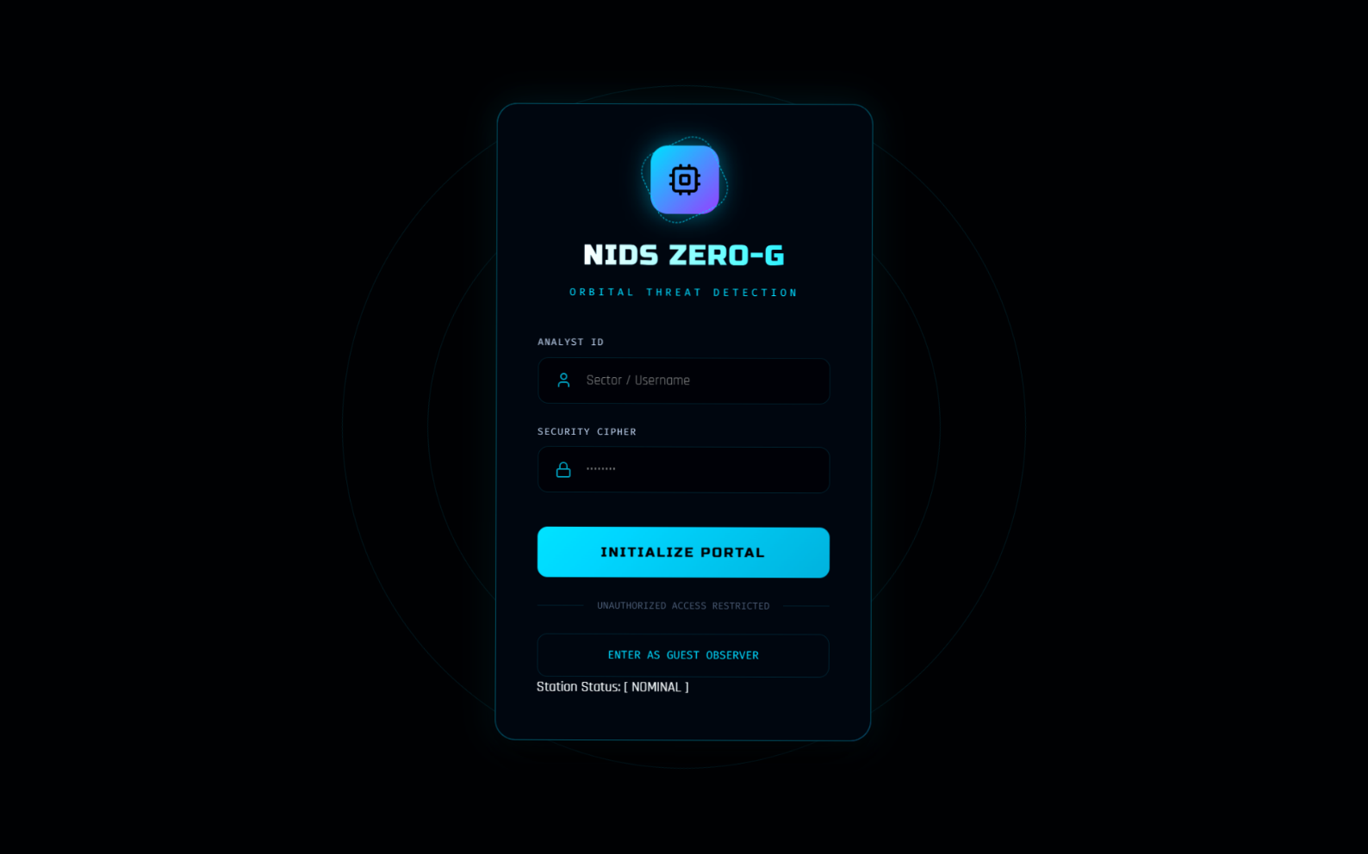

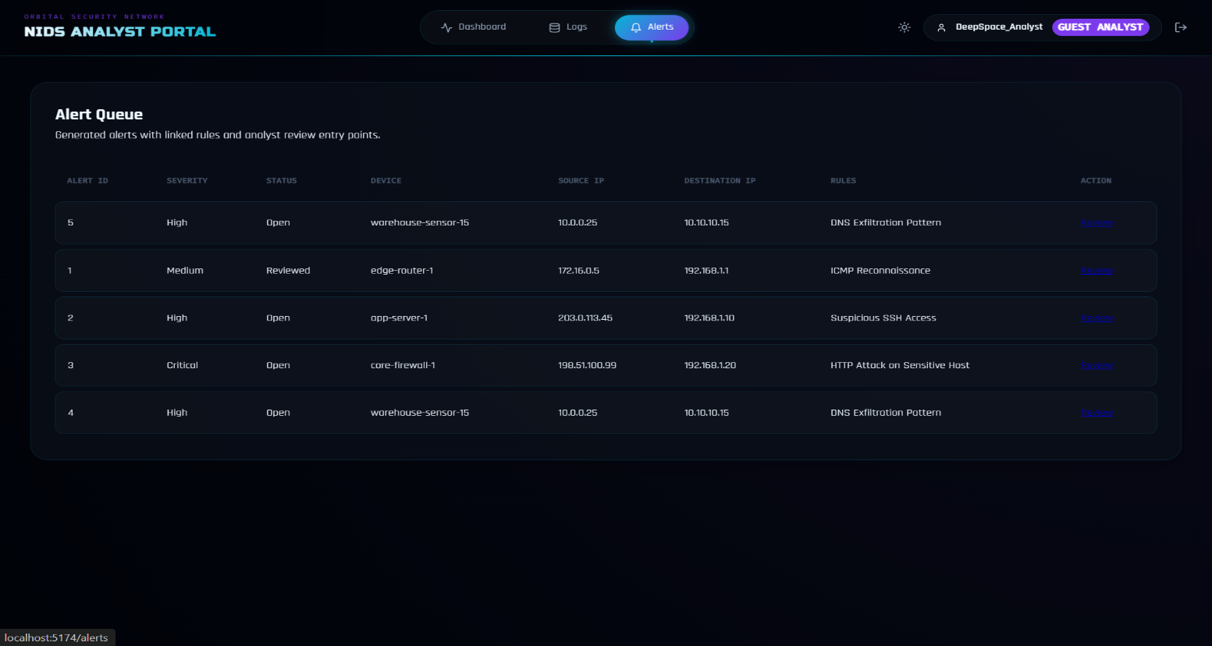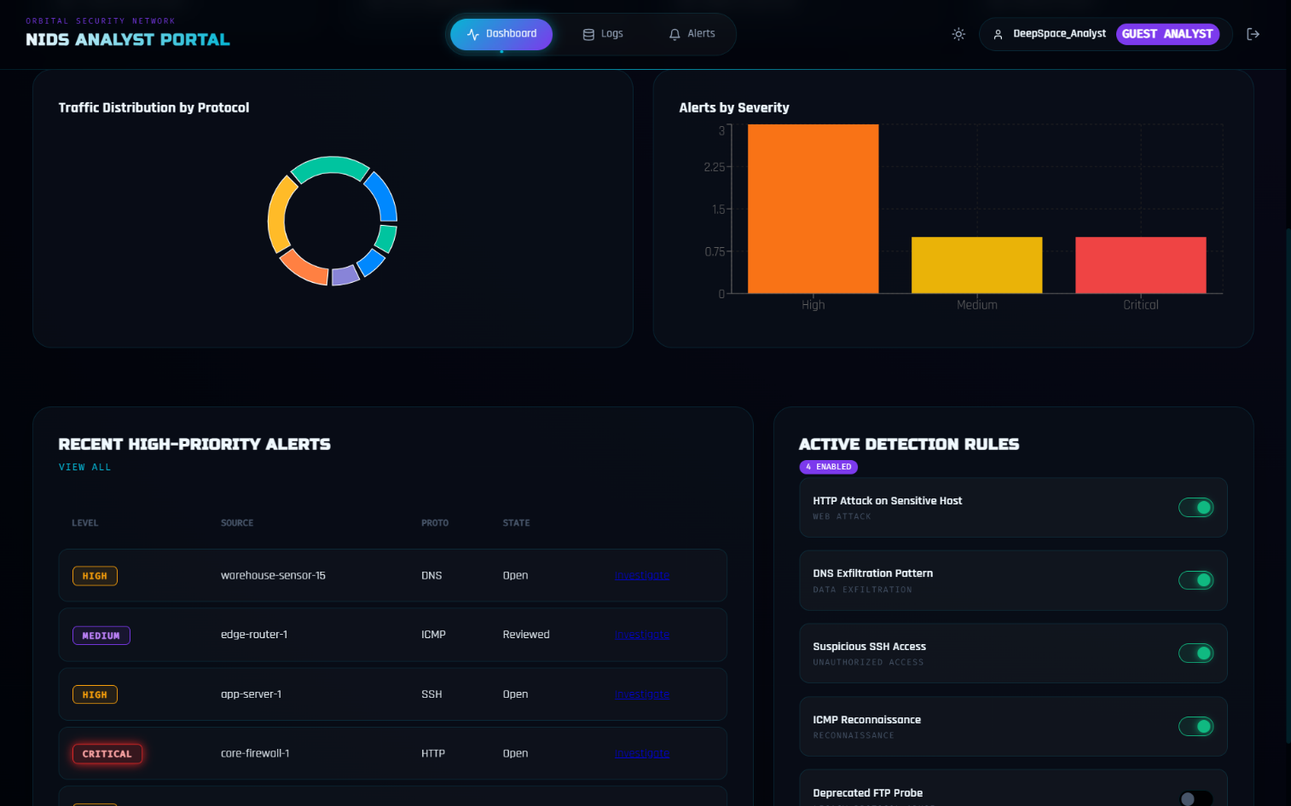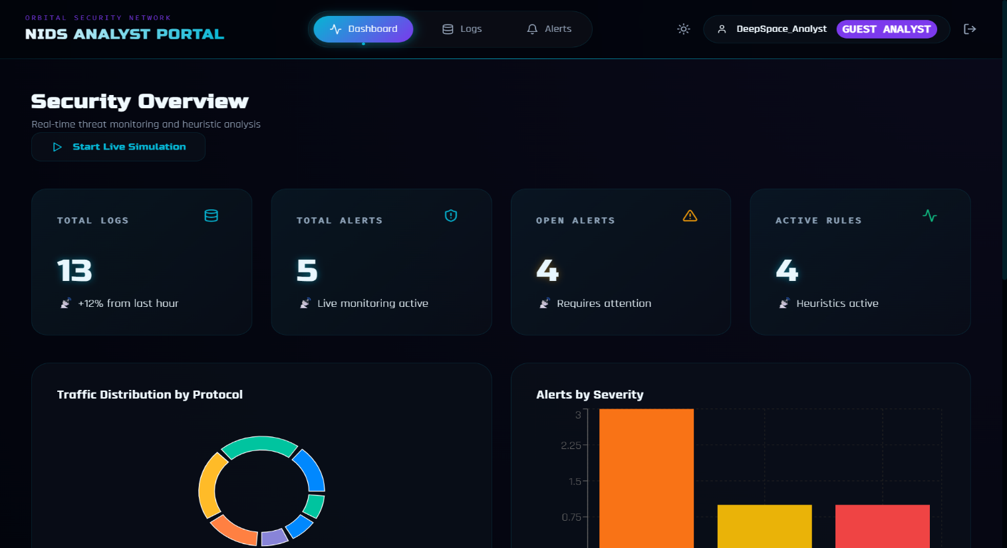

11. Project Summary
The NIDS project successfully demonstrates a complete database-centric application lifecycle — from ER modelling and relational schema design through to an operational web interface. The relational database is the heart of the system: a single AFTER INSERT trigger eliminates any need for application-layer pattern matching; stored procedures encapsulate reporting logic; views provide efficient denormalised access for the dashboard; and indexes maintain sub-millisecond query performance even under simulation load.

From a DBMS course perspective, the project covers: Entity-Relationship modelling (Chen notation), relational schema design (1NF, 2NF, 3NF), DDL and DML, triggers, stored procedures, views, indexes, referential integrity, and transaction management — a comprehensive practical implementation of the full DBMS curriculum.

12. Future Improvements
Improvement | Description
ML-Based Anomaly Detection | Integrate a Python ML model (Isolation Forest / LSTM) to detect zero-day attacks not covered by signature rules
BCNF / 4NF Refinement | Audit current schema for any multi-valued dependencies and elevate to BCNF where applicable
Partitioned Log Table | Range-partition NETWORK_LOG by month for query performance at scale (millions of rows)
Role-Based Access Control | Implement DB-level roles (Admin, Senior Analyst, Junior Analyst) with GRANT / REVOKE privileges
Real Packet Capture | Replace simulation with libpcap / Wireshark PCAP ingestion for live network traffic analysis
Alert Escalation Workflow | Add multi-level escalation: Junior → Senior → Admin, with SLA timers stored in the DB
Audit Log Table | CREATE TABLE audit_log to track all DML changes (who changed what and when) via triggers
Dashboard Drill-Down Reports | Clickable chart segments that query the DB for filtered log/alert subsets

— End of Project Report —
Vasavi College of Engineering (Autonomous) | Department of Information Technology | 2024–25

