Hospital Readmission Risk Prediction Using MLP
Structured Error Analysis and Business Findings Report

1. Summary
We built a Multi-Layer Perceptron (MLP) model that predicts whether a diabetic patient will come back to the hospital within 30 days after going home.
- On the test data, the model catches about 65% of the patients who really came back (Recall = 0.65).
- A simple rule that always says "No" catches 0% of them, even though it has 91% accuracy.
- Patients the model puts in the High risk group came back about 6 times more often than patients in the Low group (35% vs 6%).
- The model misses patients who look "healthy" on paper, especially first-time patients with no previous hospital visits.

2. Model Results on Test Data
The test set has 10,499 patients, of which 943 came back within 30 days (about 9%). We used a decision threshold of 0.45, chosen on the validation data so that Recall is at least 60%.
Metric | Score | What it means in simple words
Recall | 0.65 | Of the patients who really came back, we caught 65%
Precision | 0.13 | Of the patients we flagged, 13% really came back (normal rate is 9%)
F1-score | 0.22 | Balance between Recall and Precision
ROC-AUC | 0.65 | How well the model ranks risky patients above safe ones (0.5 = random guessing)
Accuracy | 0.57 | Lower on purpose: we accept more false alarms to catch more risky patients

Generalization: Training ROC-AUC (0.67) and validation ROC-AUC (0.66) are very close, so the model is not overfitting. Dropout and EarlyStopping helped keep this gap small.

3. Structured Error Analysis
Error analysis shows where and why the model makes mistakes. We studied the errors in five steps:
- Count each type of error and its business cost.
- Compare missed patients (False Negatives) with caught patients (True Positives).
- Compare false alarms (False Positives) with correct "No" predictions (True Negatives).
- Check errors by patient group (age and previous visits).
- Check how confident the model was when it was wrong.

Types of Errors and Their Cost
 | Predicted: No | Predicted: Yes
Actual: No | True Negative: 5,399 | False Positive: 4,157
Actual: Yes | False Negative: 327 | True Positive: 616

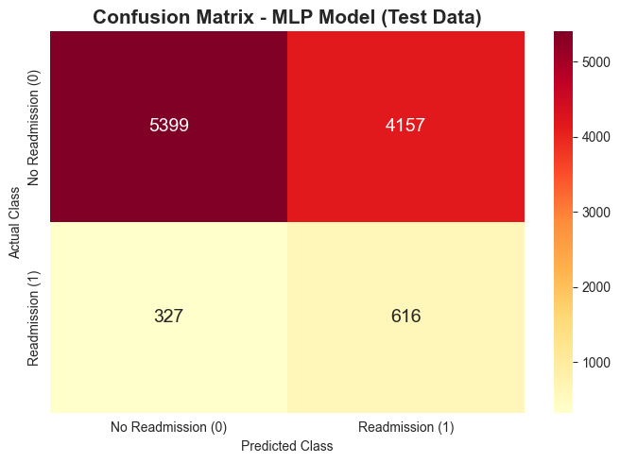
Figure 1: Confusion matrix on test data
Error type | Count | Meaning | Business cost
False Negative (missed) | 327 | Patient came back, but the model said low risk | HIGH: patient goes home without extra support and may return sicker. A new admission costs money and a bed.
False Positive (false alarm) | 4,157 | Patient did not come back, but the model said high risk | LOW: some extra effort, such as a phone call or an appointment the patient did not really need.

Why missing a high-risk patient is costly: a follow-up phone call costs very little, but a readmission means another hospital stay, an occupied bed, higher costs and a sicker patient. That is why we focus on Recall and accept more false alarms.

Missed Patients (FN) vs Caught Patients (TP)
Both groups really came back to the hospital. The table compares their average values:
Feature (average) | Missed (FN) | Caught (TP)
Days in hospital | 3.2 | 5.5
Number of lab tests | 40.8 | 47.8
Number of medicines | 14.4 | 18.2
Previous inpatient visits | 0.03 | 0.56
Previous emergency visits | 0.04 | 0.19
Number of diagnoses | 6.9 | 7.9

Finding: Missed patients look "healthy" on paper: short stays, fewer medicines and almost no previous visits. The model depends a lot on visit history, so first-time patients who come back are hard to catch.

False Alarms (FP) vs Correct "No" Predictions (TN)
Both groups did not come back. The table compares their average values:
Feature (average) | False alarm (FP) | Correct No (TN)
Days in hospital | 5.7 | 3.1
Number of lab tests | 47.7 | 39.0
Number of medicines | 17.7 | 14.0
Previous inpatient visits | 0.34 | 0.02
Previous emergency visits | 0.18 | 0.04
Number of diagnoses | 7.9 | 6.6

Finding: False alarms look "sick" on paper: long stays, many medicines and previous visits, just like patients who came back. Things that are not in the data, such as family support or good follow-up care, may have kept them out of the hospital.

Errors by Patient Group
Recall here means: of the patients in this group who came back, how many did the model catch?
Age group | Patients who came back | Recall
30-40 | 30 | 33%
40-50 | 82 | 44%
50-60 | 150 | 49%
60-70 | 204 | 61%
70-80 | 256 | 77%
80-90 | 184 | 81%
90-100 | 21 | 81%

Previous inpatient visits | Patients who came back | Recall
0 | 748 | 58%
1 | 106 | 92%
2 | 53 | 100%
3 or more | 36 | 100%

- Younger patients are missed more often. The model catches about 77-81% of older patients (70+) but only 33-49% of patients aged 30-60.
- Visit history matters most. Every patient with 2 or more previous inpatient visits was caught, but only 58% of patients with no previous visits.
- Most patients who came back (748 of 943) had no previous inpatient visits, so this is the group where better detection would help the most.

How Confident Was the Model When It Was Wrong?
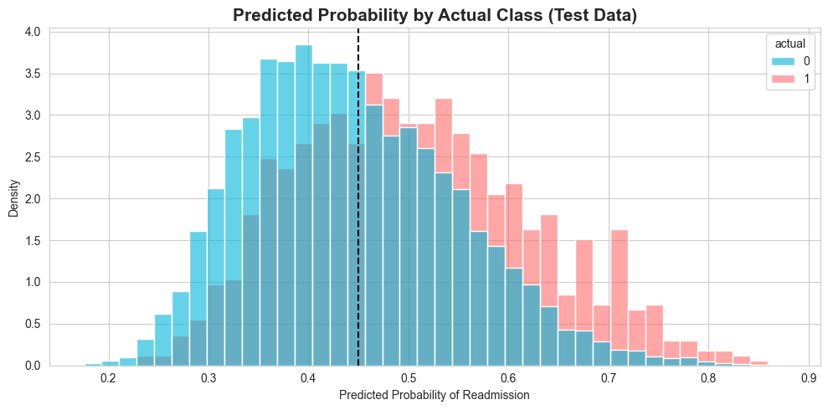
Figure 2: Predicted probability for patients who came back (1) and did not (0)
- The two groups overlap a lot. Many patients who came back and many who did not get similar scores. This explains the moderate ROC-AUC of 0.65.
- Most confident misses: patients aged 20-60 with 1-3 days in hospital and zero previous visits got a low score (about 0.24) but still came back.
- Most confident false alarms: patients with many previous visits (for example 7-8 inpatient visits, or 25 emergency visits) got a high score (about 0.85-0.88) but did not come back.

Error Analysis Conclusion
- The model misses 327 patients (about 35% of those who came back). Most of them are first-time, short-stay patients.
- False alarms are mostly patients with a heavy medical history. These errors are cheap, because the action is only a follow-up call or appointment.
- Ideas to reduce errors: collect social and after-discharge information (family support, distance to hospital, taking medicines correctly), add features about patient history over time, and add extra checks for patients with no previous visits.

4. Short Business Findings Report

Business Problem
When patients come back to the hospital soon after going home, it increases costs, fills limited beds and can mean the patient needed more support. Hospital management wants to find the patients who are most likely to come back within 30 days, so they can get extra care before and after discharge.

Key Findings
- Readmission within 30 days is rare. Only about 9% of patients (after cleaning) come back, so Accuracy is a misleading metric. Recall is the most important metric.
- Previous inpatient visits are the strongest warning sign. It is the top feature in both the correlation analysis and the model's feature importance.
- Where the patient goes after discharge matters. Discharge destination (home, nursing facility, rehab) is the second most important feature group.
- Number of diagnoses and days in hospital also increase the risk.
- The model meets the goal. It catches about 65% of patients who come back (target: at least 60%), with ROC-AUC 0.65.
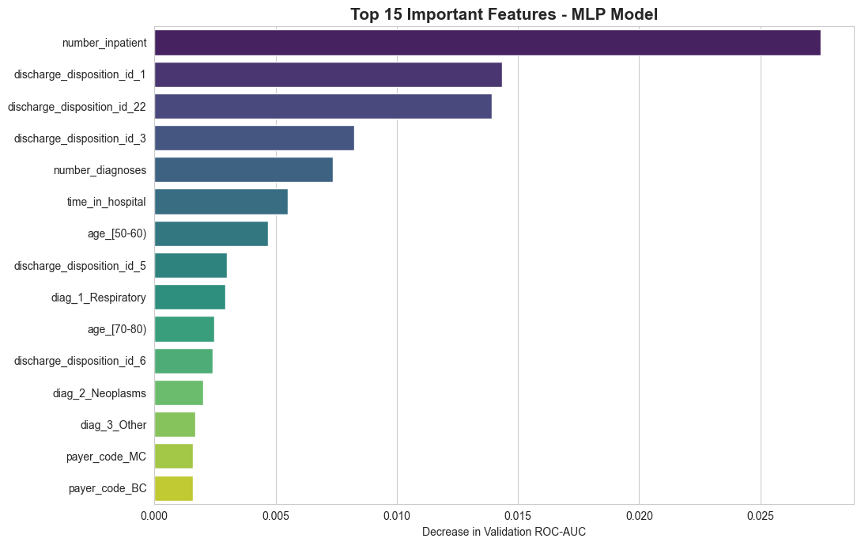
Figure 3: Top 15 most important features (permutation importance)

Risk Levels Work
Each test patient gets a risk probability and a risk level. The actual readmission rate in each level shows that the levels separate patients well:
Risk level | Rule | Patients | Actually came back | Readmission rate
High | Probability 0.70 or more | 201 | 70 | 34.8%
Medium | Probability 0.45 to 0.70 | 4,544 | 543 | 12.0%
Low | Probability below 0.45 | 5,754 | 330 | 5.7%

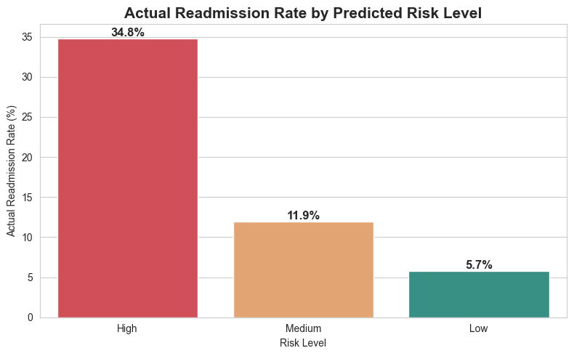
Figure 4: Actual readmission rate by predicted risk level

Example Patient-Level Prediction Report
The full report for all 10,499 test patients is saved as patient_readmission_risk_report.csv. A few examples:
Patient ID | Actual | Predicted | Risk probability | Risk level
TestPatient_00022 | Yes | Yes | 0.54 | Medium
TestPatient_00003 | No | No | 0.37 | Low
TestPatient_00035 | Yes | No | 0.40 | Low
TestPatient_00002 | No | Yes | 0.61 | Medium
TestPatient_04527 | Yes | Yes | 0.85 | High
Patient IDs are pseudonymous row numbers, not real hospital identifiers.

Recommendations: How to Prioritize Follow-Up
Risk level | What the hospital should do
High | Before discharge: detailed discharge plan, medicine review with a pharmacist, and teaching for the patient and family. After discharge: phone call within 48 hours and a doctor appointment within 7 days. Consider home health visits.
Medium | Phone call within one week and a scheduled outpatient appointment. Make sure the patient understands their medicines.
Low | Normal discharge process and normal follow-up.

- Watch frequent visitors: patients with several hospital or emergency visits in the past year should automatically get extra attention.
- Work with care facilities: share discharge notes and care plans directly with nursing and rehab facilities.
- Match the threshold to staff capacity: with more follow-up staff, lower the threshold to catch more patients; with limited staff, focus on the High group first.
- Do not ignore first-time patients: the model often misses them, so add a simple checklist (for example medicines, support at home) for patients with no previous visits.
- Collect better data: social support, distance to the hospital and medicine use after discharge would likely improve the model.

Limitations
- The data is from 1999-2008; patients and treatments may have changed since then.
- The model has moderate power (ROC-AUC 0.65). It should support doctors' decisions, not replace them.
- Precision is low, so many flagged patients will not come back. This is acceptable only because the follow-up action is cheap.
- This is an educational prototype. Before real use it needs testing on recent local data, fairness checks across patient groups and approval from clinical experts.

Conclusion
The MLP model can help the hospital rank patients by readmission risk at discharge. It catches about 65% of patients who come back, and its High risk group is about 6 times riskier than the Low group. Used together with clinical judgement, it can help the hospital spend limited follow-up time on the patients who need it most.

