**## Make sure telegraph and influxdb services are up at masters**

**## Make sure telegrapf service is up on EPs**

**Step 1: Install InfluxDB**

sudo tee /etc/yum.repos.d/influxdb.repo <<EOF

[influxdb]

name=InfluxDB Repository

baseurl=https://repos.influxdata.com/rhel/9/x86_64/stable/

enabled=1

gpgcheck=1

gpgkey=https://repos.influxdata.com/influxdb.key

EOF

sudo yum install influxdb -y

sudo systemctl start influxdb

sudo systemctl enable influxdb

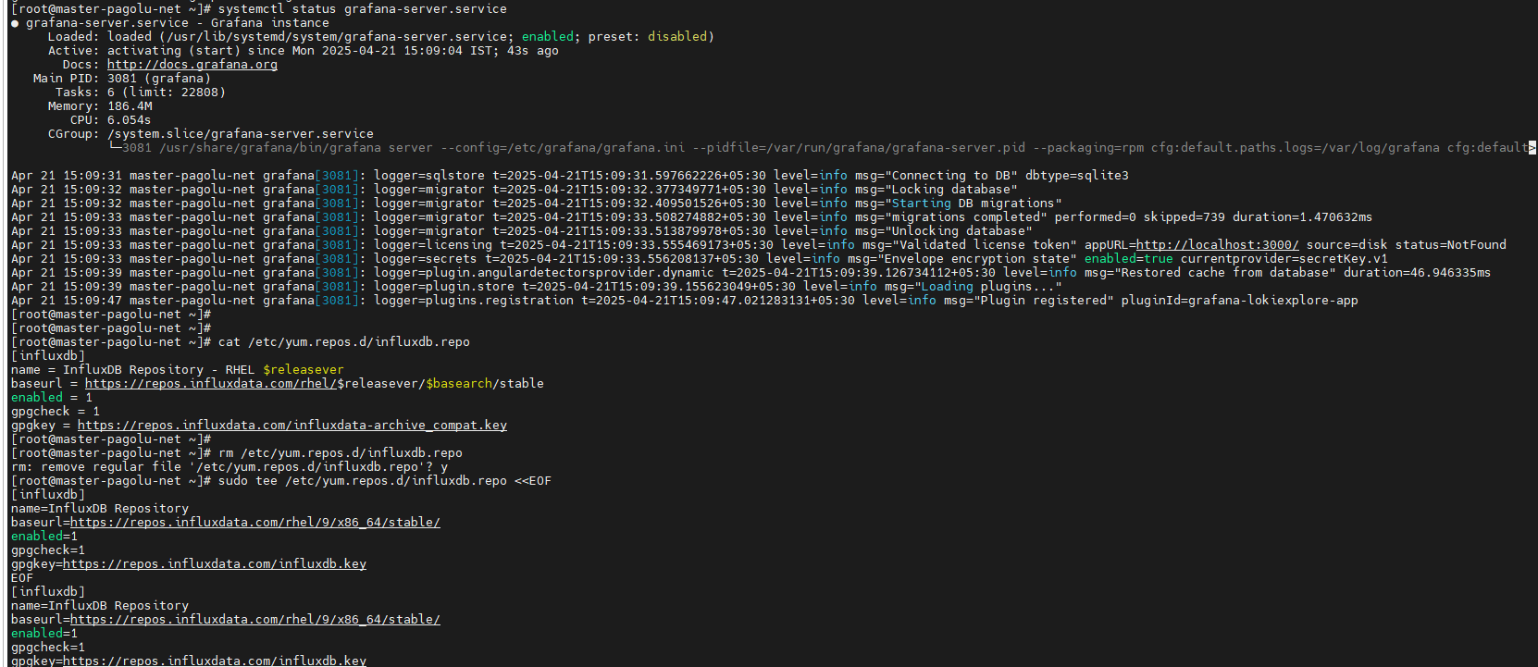

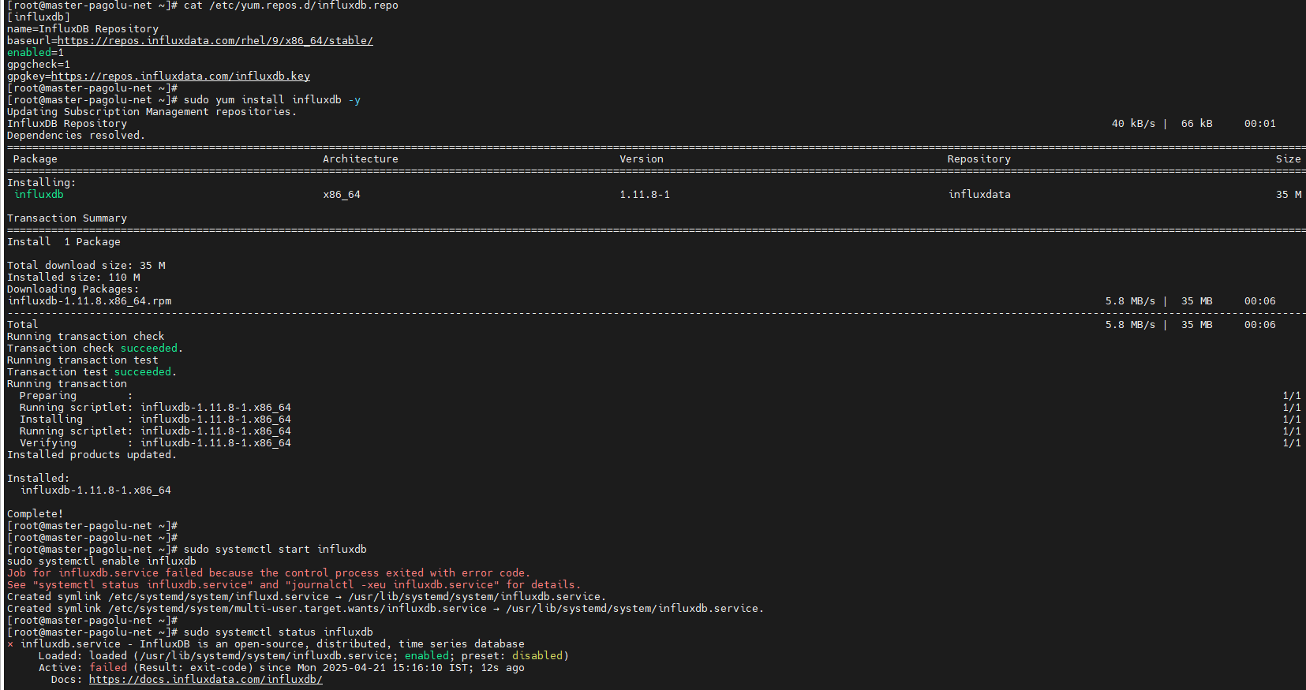

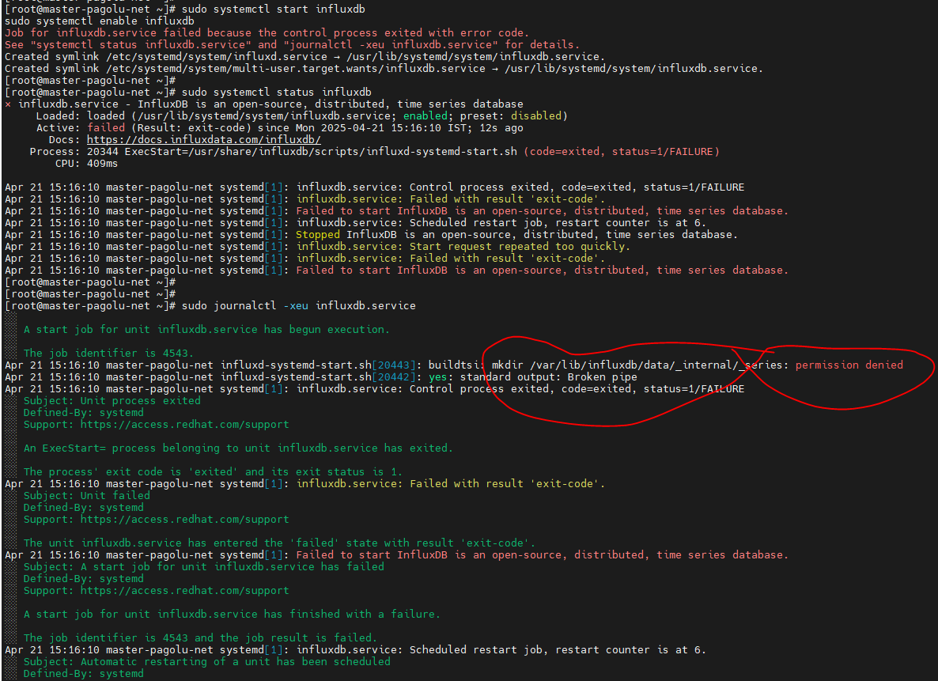

# influx service start failure due to permission issues

#chown -R influxdb:influxdb /var/lib/influxdb

#chmod -R 755 /var/lib/influxdb

* Restarted service and they are started

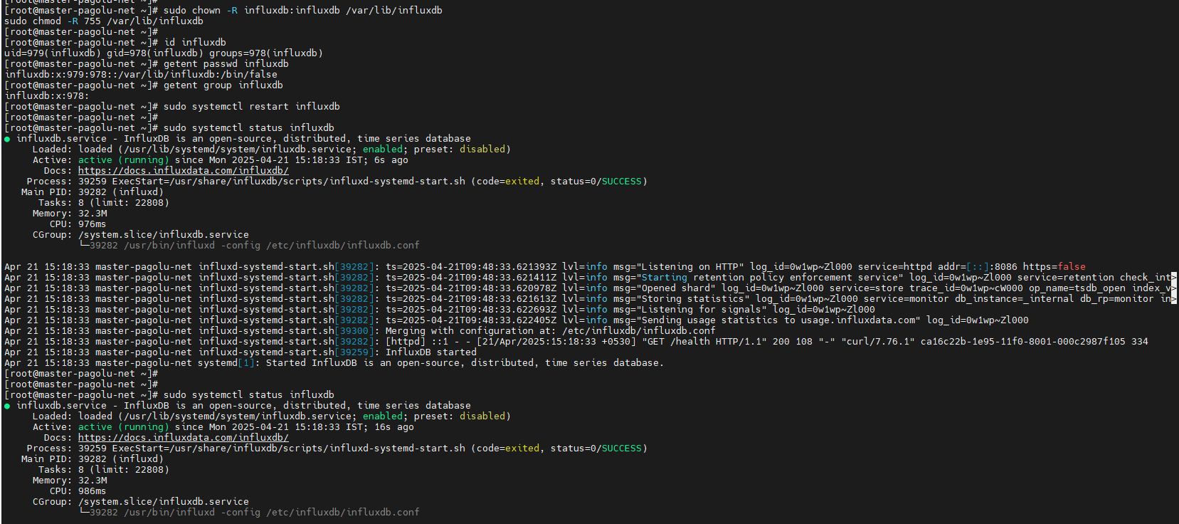

sudo systemctl start influxdb

sudo systemctl enable influxdb

**Step 2: Configure InfluxDB**

influx

CREATE USER admin WITH PASSWORD 'yourpassword' WITH ALL PRIVILEGES;

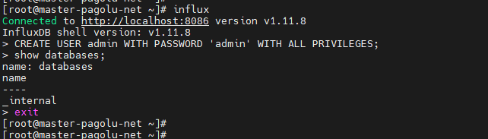

### add auth-enabled = true to file /etc/influxdb/influxdb.conf



#systemctl restart influxdb

**Step 3: Install Telegraf**

Add repo

sudo tee /etc/yum.repos.d/telegraf.repo <<EOF

[telegraf]

name=Telegraf Repository

baseurl=https://repos.influxdata.com/rhel/9/x86_64/stable/

enabled=1

gpgcheck=1

gpgkey=https://repos.influxdata.com/influxdb.key

EOF

sudo yum install telegraf -y

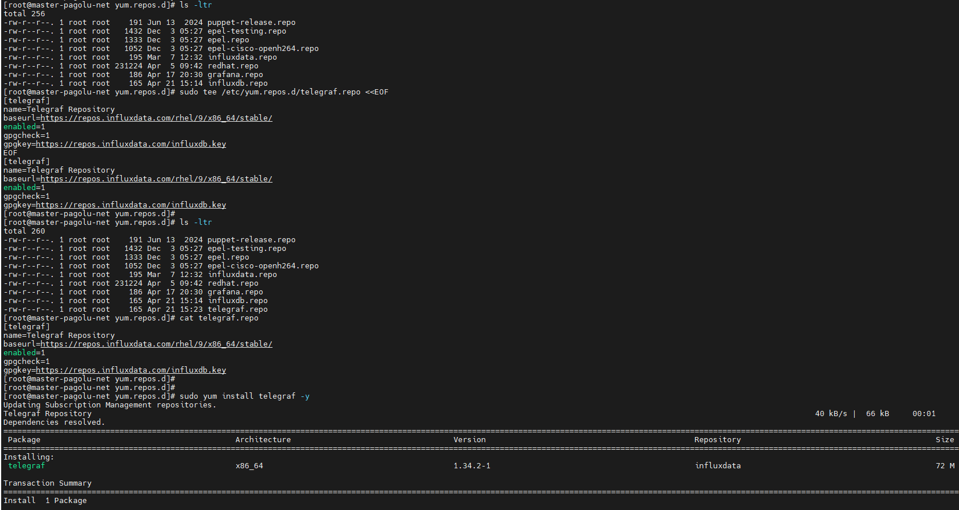

## service telegraph failed

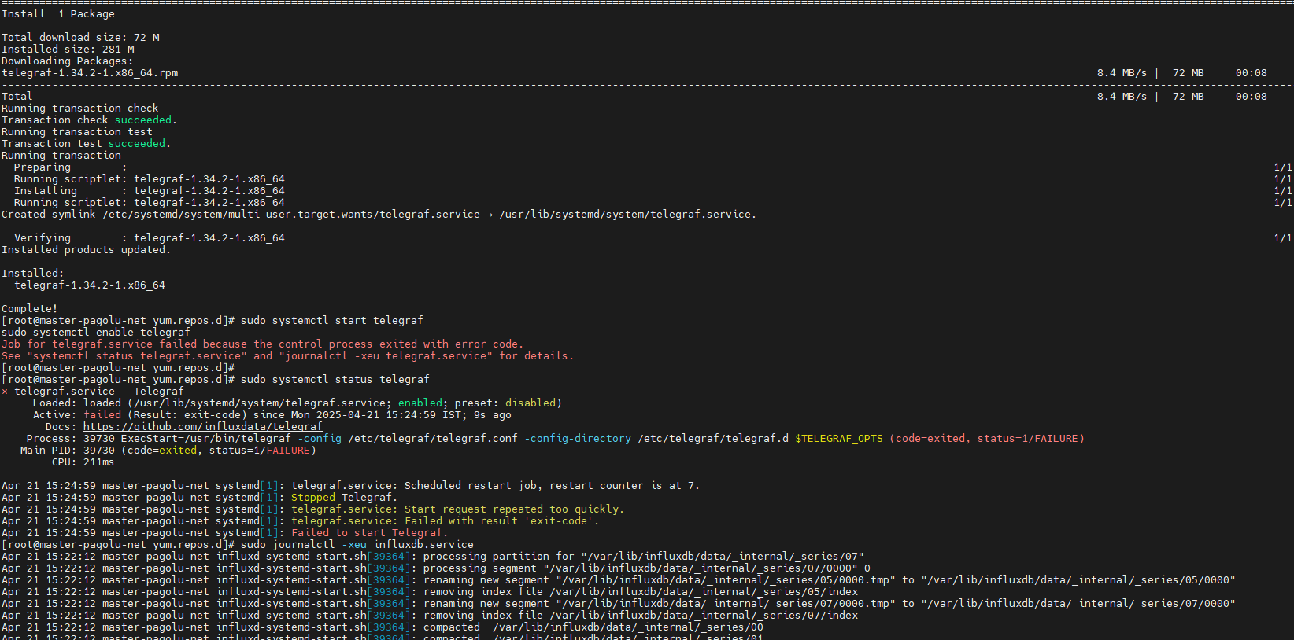

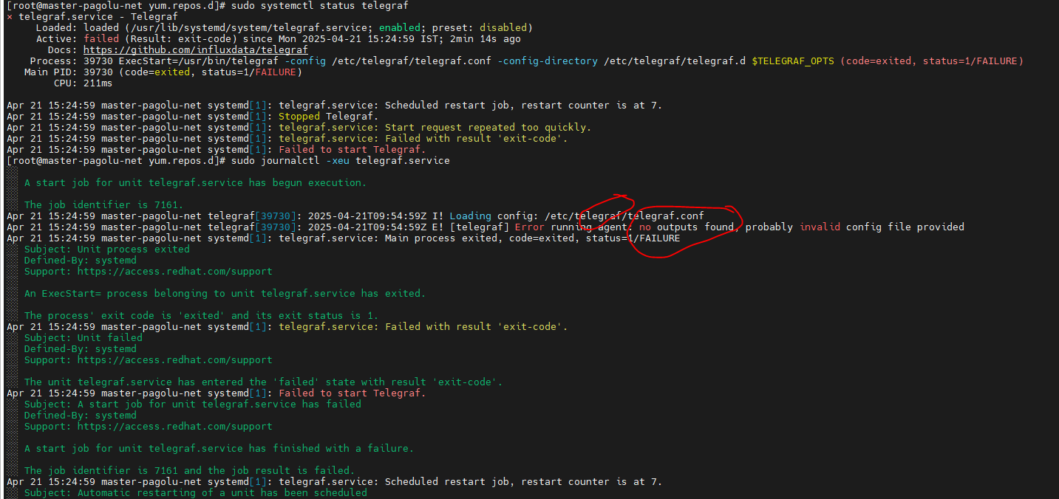

## service failed as no outputs.influxdb found in /etc/telegraf/telegraf.conf

**Step 4: Configure Telegraf to Send Data to InfluxDB**

Add the content as shown below in /etc/telegraf/telegraf.conf

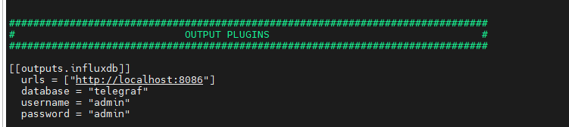

Test the config

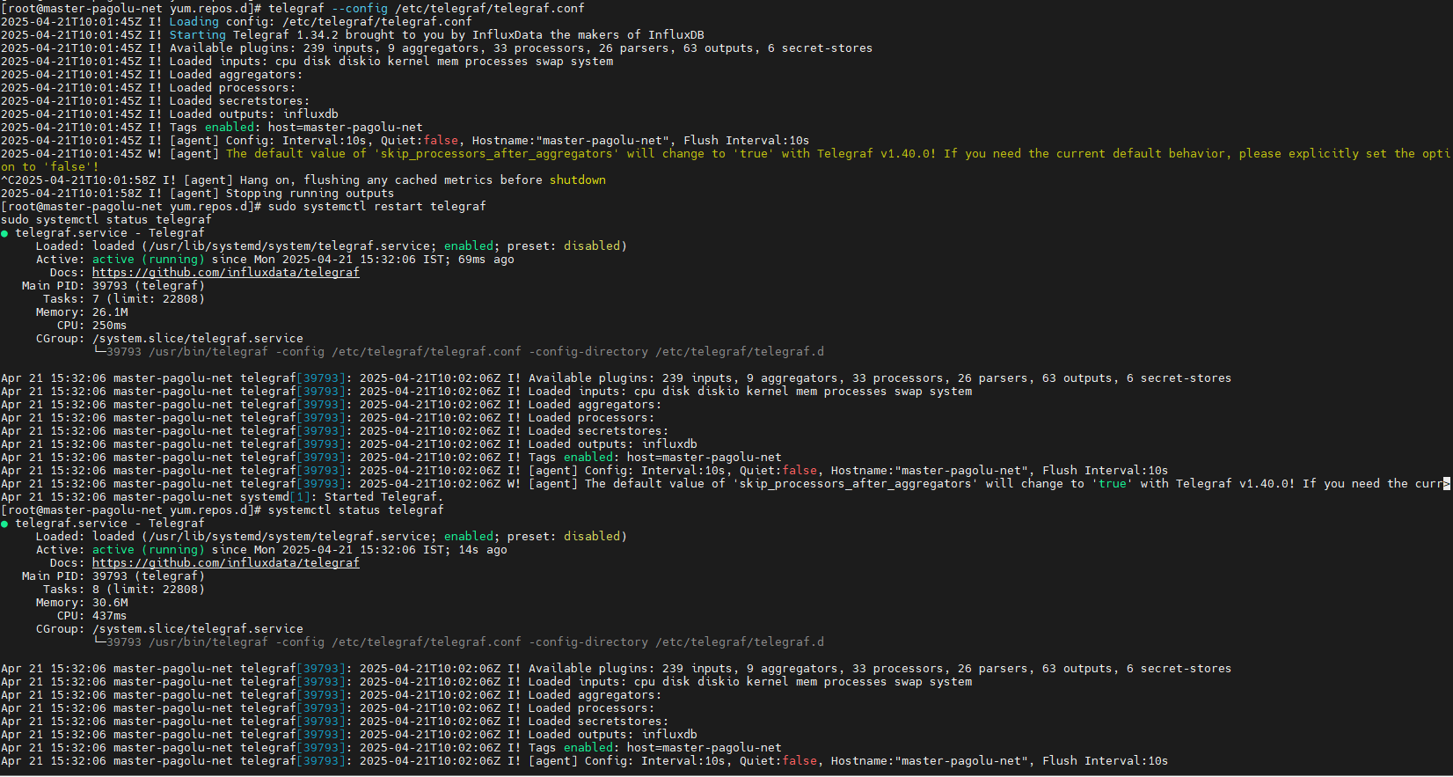

**Step5 :Verify data is being written to InfluxDB**:

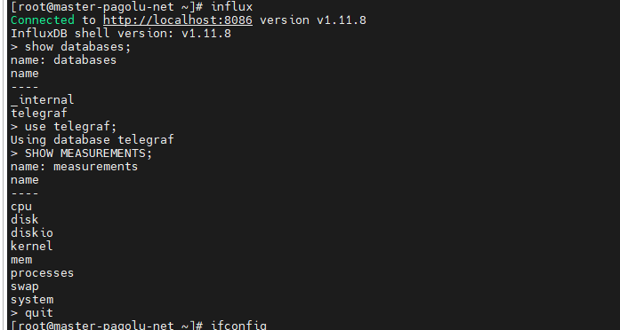

Checking incoming data from influxdb

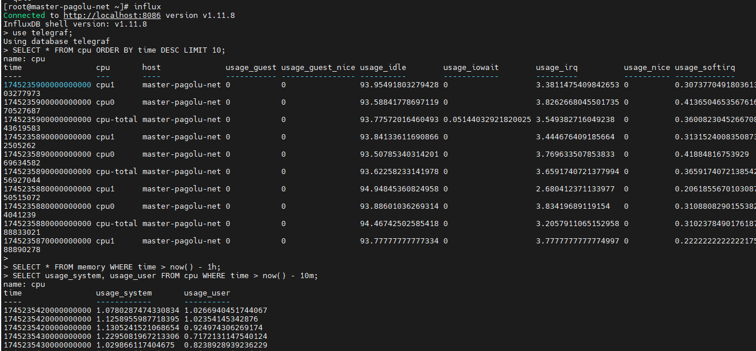

SELECT mean(usage_system) FROM cpu WHERE time > now() - 1h GROUP BY time(5m);

returns **5-minute averages** of system CPU usage for the past **hour**.

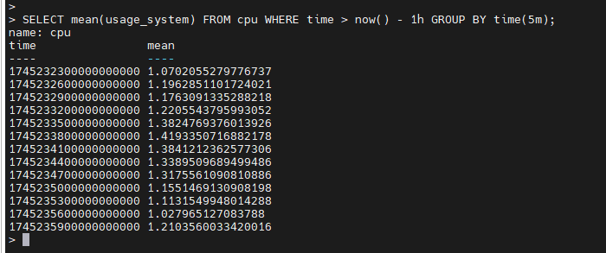

SELECT count(*) FROM disk;

**Count the number of entries per measurement**:



SELECT * FROM cpu WHERE host = 'master-pagolu-net' AND time > now() - 1h;

gets CPU metrics only for 'master-pagolu-net

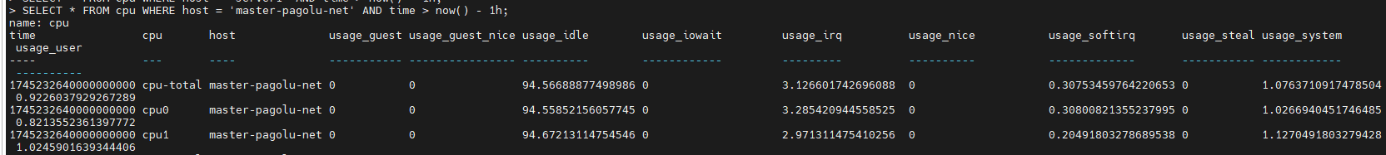

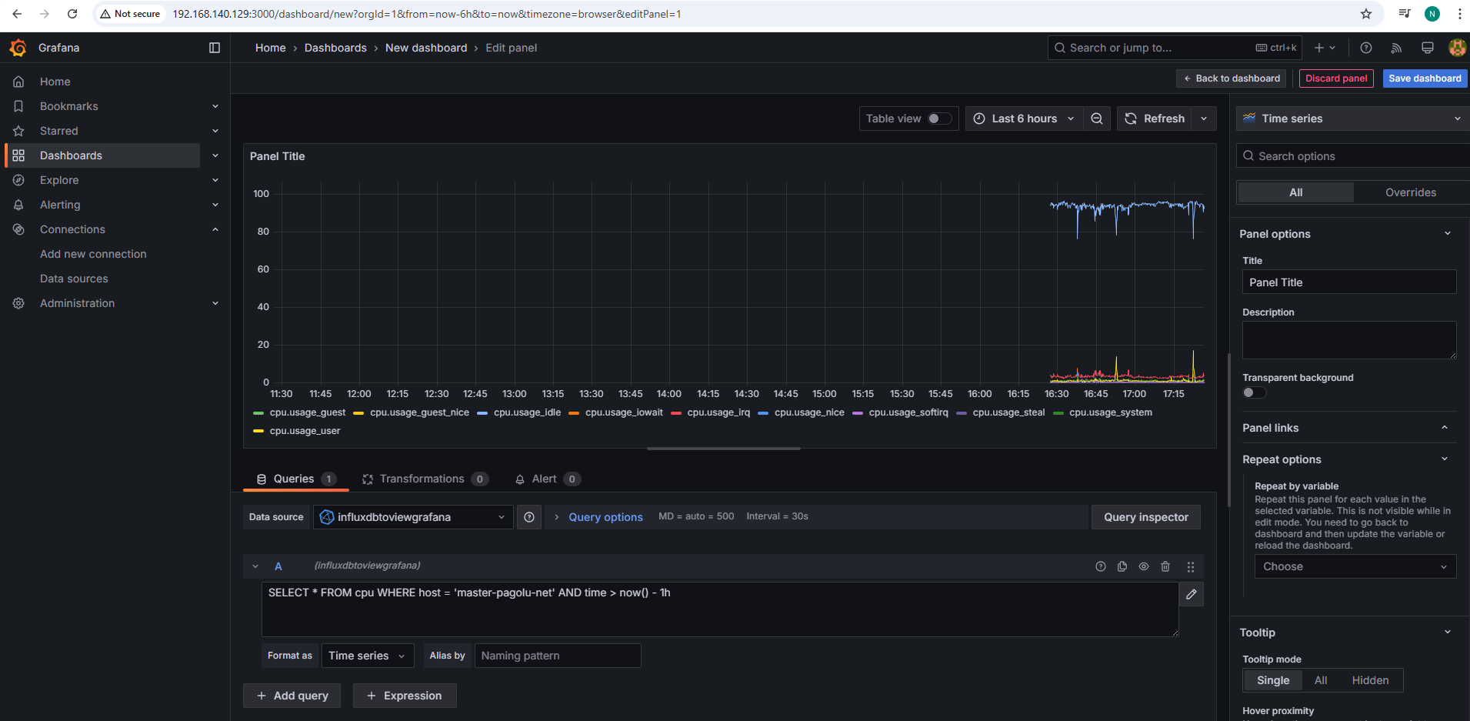

Updated IP of telegraf config

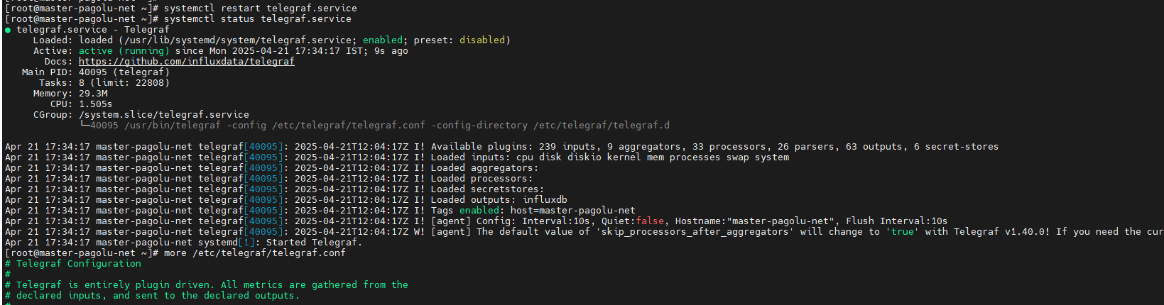

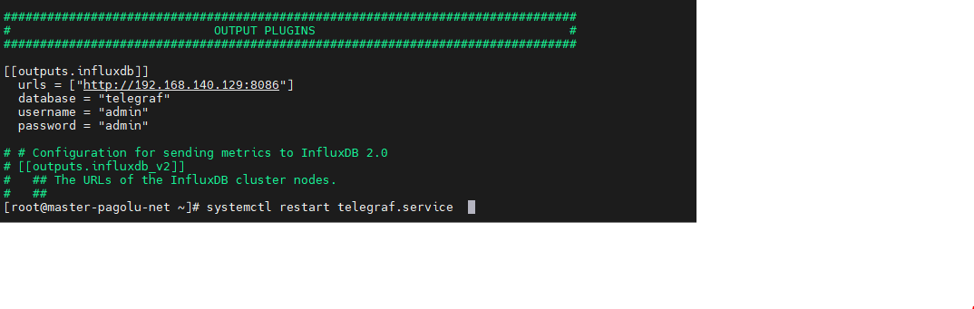

**Step6: Access data on Grafana**

sudo tee /etc/yum.repos.d/grafana.repo <<EOF

[grafana]

name=Grafana Repository

baseurl=https://packages.grafana.com/oss/rpm

enabled=1

gpgcheck=1

gpgkey=https://packages.grafana.com/gpg.key

EOF

**sudo yum install grafana -y**

sudo systemctl start grafana-server

sudo systemctl enable grafana-server

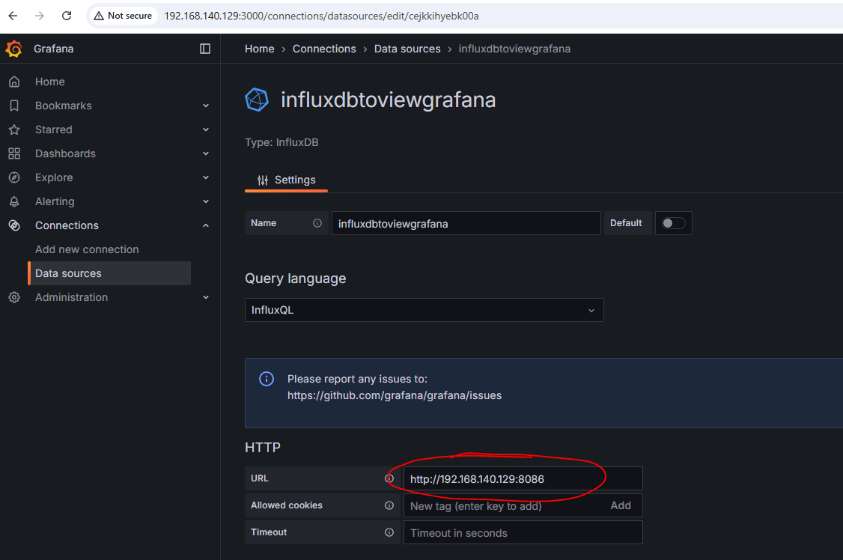

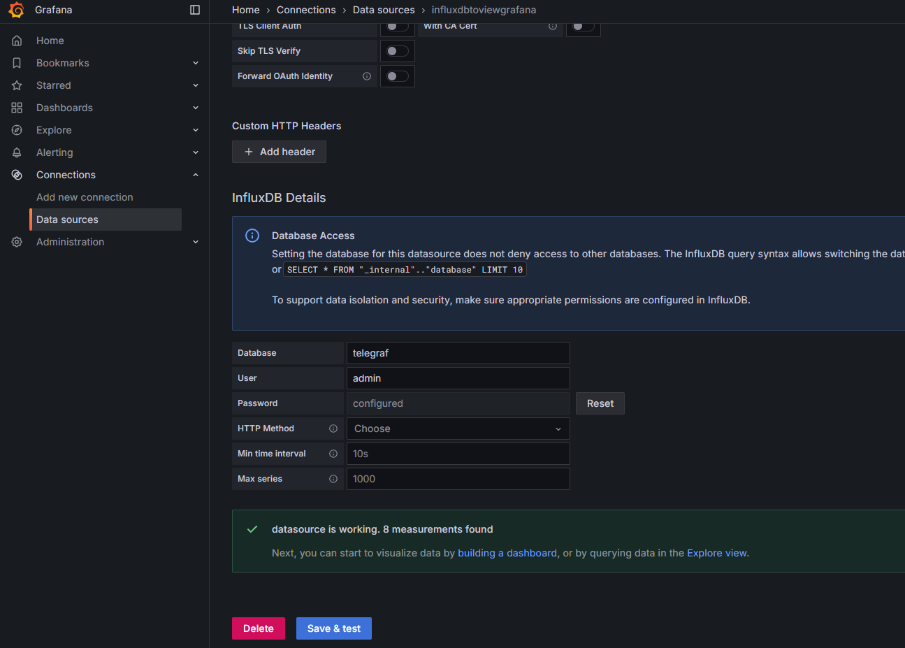

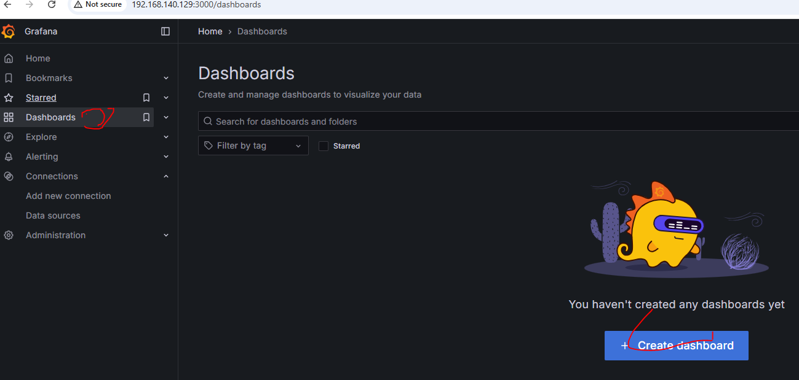

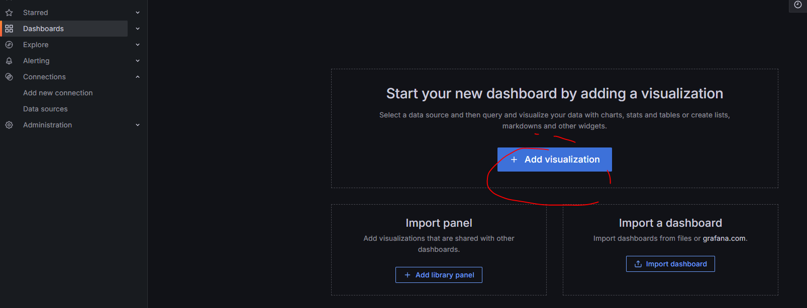

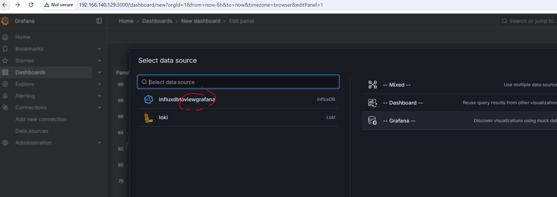

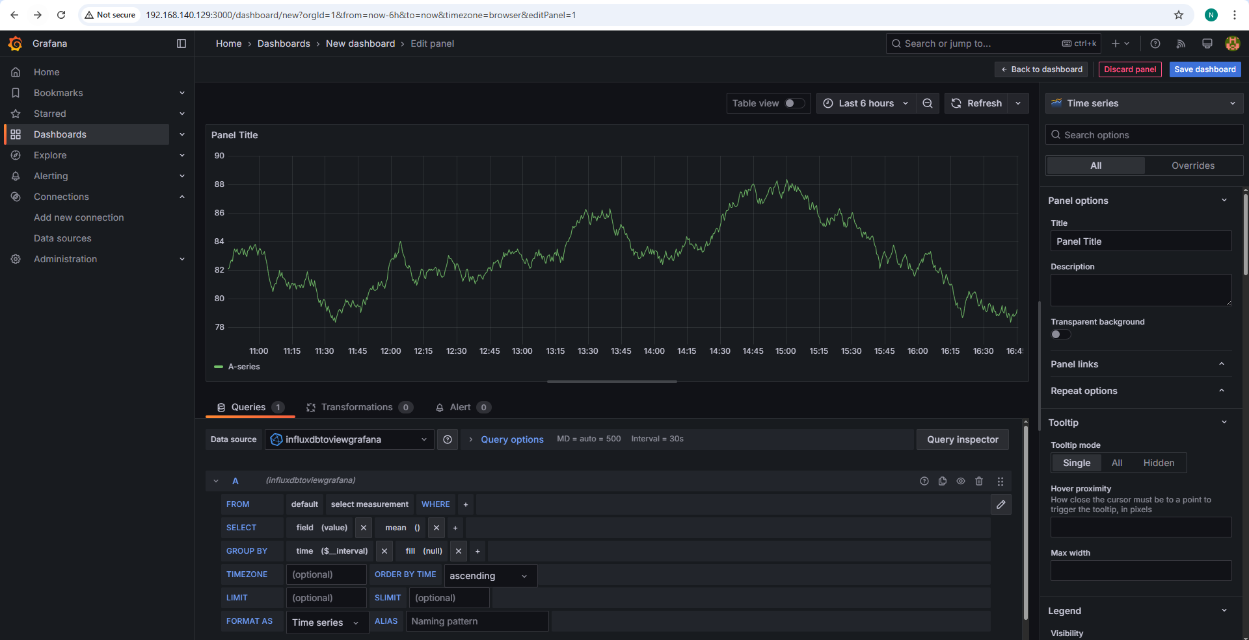

Edit to run the custom query

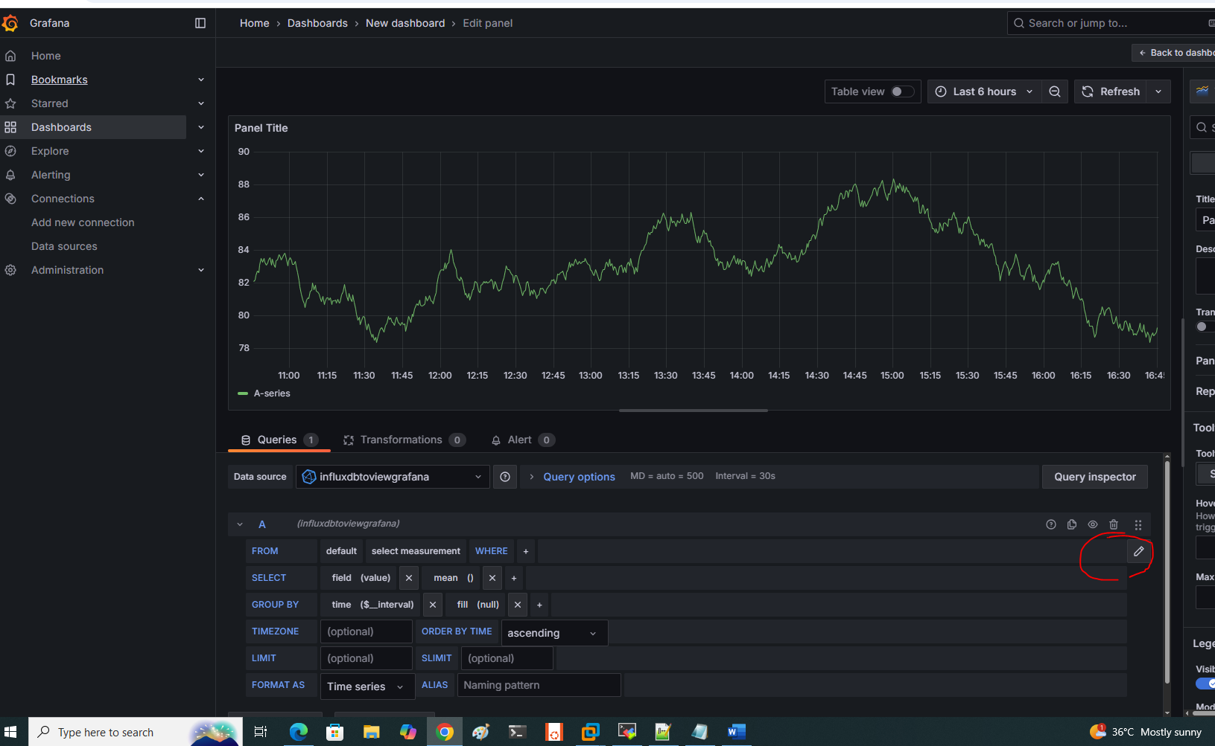

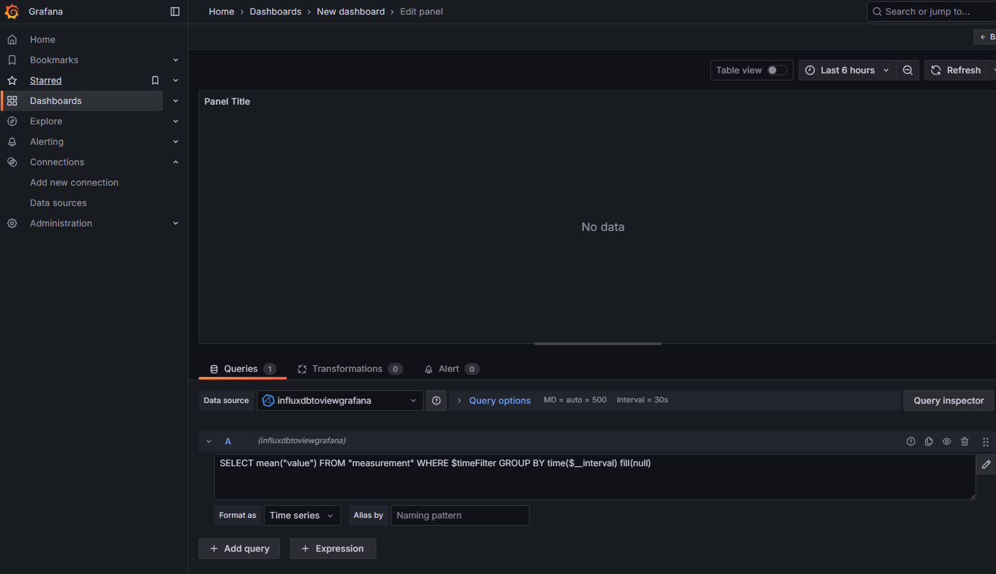

Here are the **ports required** for each service:

**Telegraf**

* **8125** (UDP) – StatsD input
* **8092** (UDP/TCP) – UDP listener
* **8086** (TCP) – InfluxDB output (if sending data to InfluxDB)
* **514** (UDP/TCP) – Syslog input

**Grafana**

* **3000** (TCP) – Web UI (default)
* **9094** (TCP) – gRPC for remote plugins (optional)

**InfluxDB**

* **8086** (TCP) – HTTP API (querying & writing data)
* **8088** (TCP) – Backup & restore service
* **2003** (TCP) – Graphite input (if enabled)

**Loki**

* **3100** (TCP) – Loki API & ingestion
* **9095** (TCP) – gRPC for remote writes (optional)

Adding new VM:

1,Install telegrapf

2.Start the service

3. update file /etc/telegraf/telegraf.conf with infuxdb info

4.Restart tele service

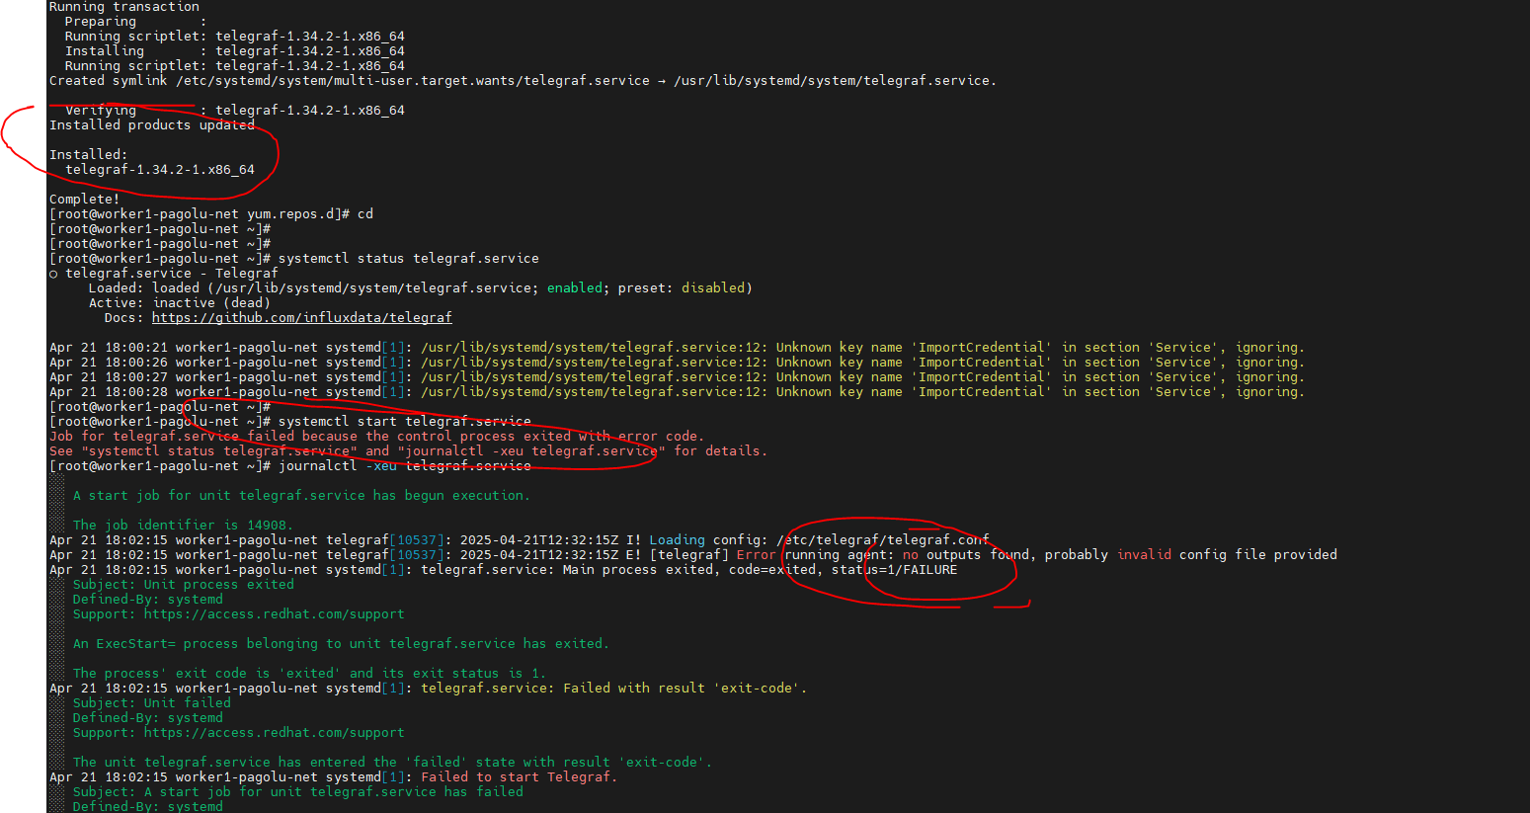

Update the /etc/telegraf/telegraf.conf

[[outputs.influxdb]]

urls = ["http://192.168.140.129:8086"]

database = "telegraf"

username = "admin"

password = "admin"

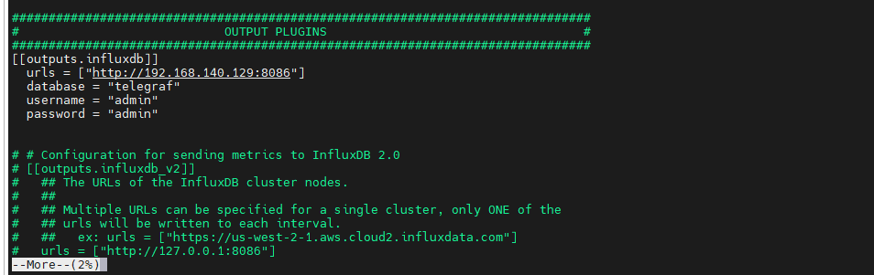

And restart the svc:

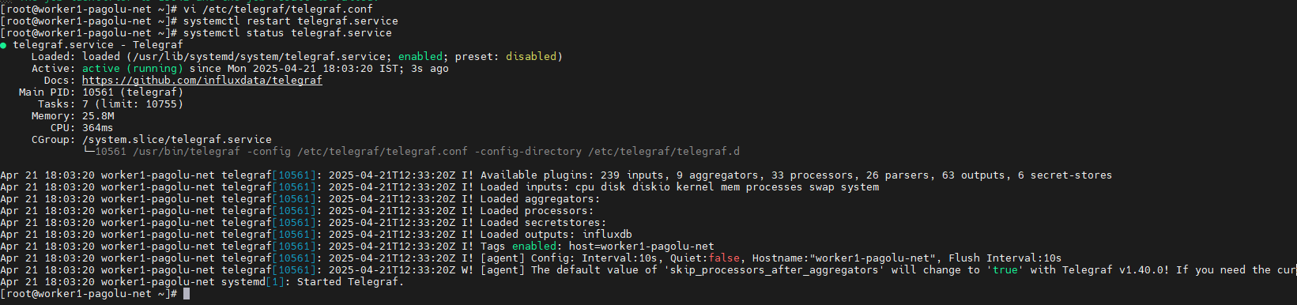

Check the data collection at:

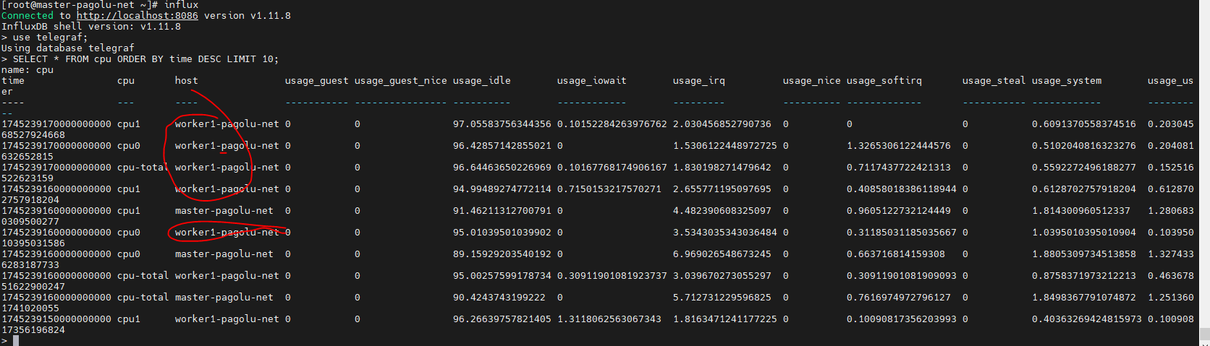

**Adding vm2**

