ASSIGNMENT 02 AWS

- Task 1

Create a vpc not by wizard this time but manually, having 2 public subnets and 2 private subnets and 2 protected subnets.
setup should be highly available
Create 1 IGW and 2 NGW in each availability zone and make the appropriate routes in route tables

vpc created, along with 6 subnets, 2 public , 2 private and 2 protetced
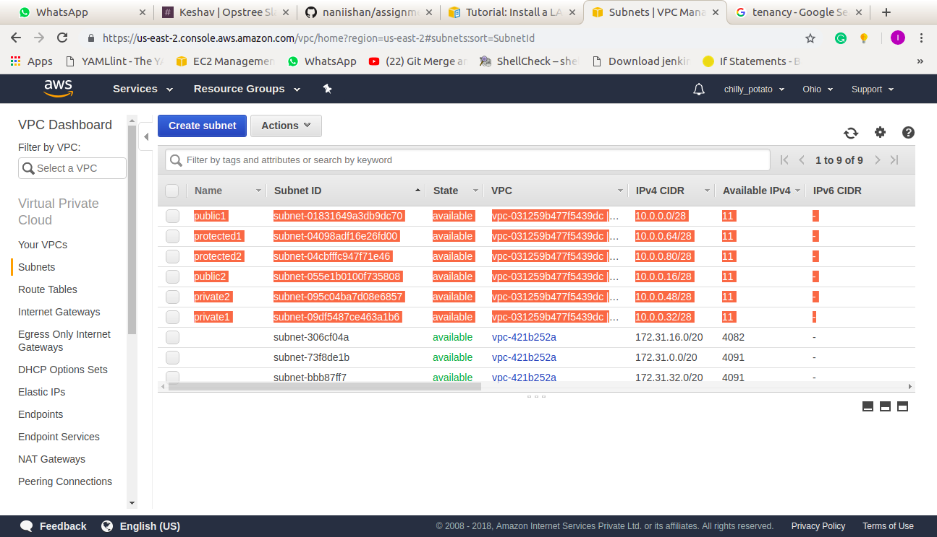

two route tables created, one for public and one for private, 2 NWG and 1 IGW also created.
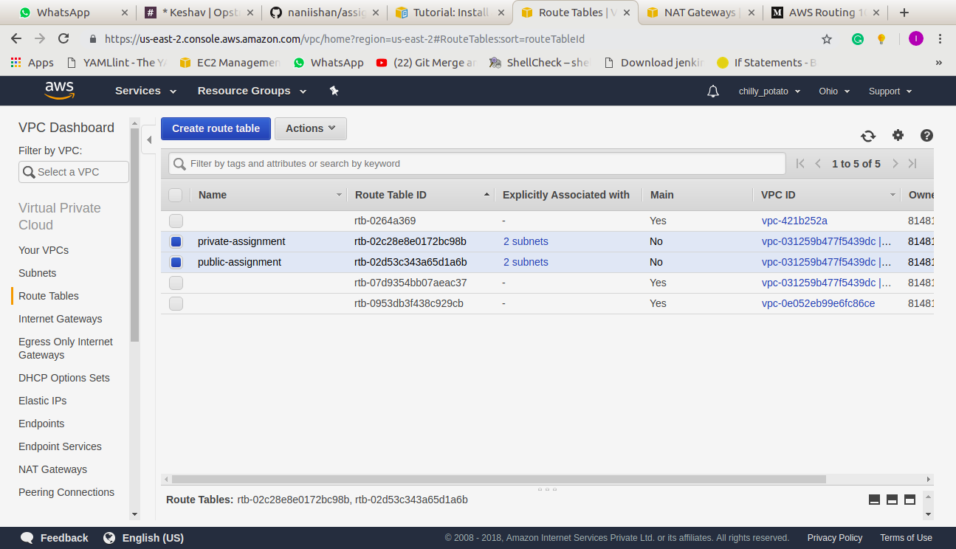

- Task 2

Make LAMP setup with 2 instances in each private subnets.
Server-1 should serve a webpage that would say "Hi! i am server 1"
Server-2 should serve a webpage that would say "Hi! i am server 2"

- created 2 instances in the private subnets,
- install apache2, mysql and php in both of them,
- created a .php file in /var/www/html/

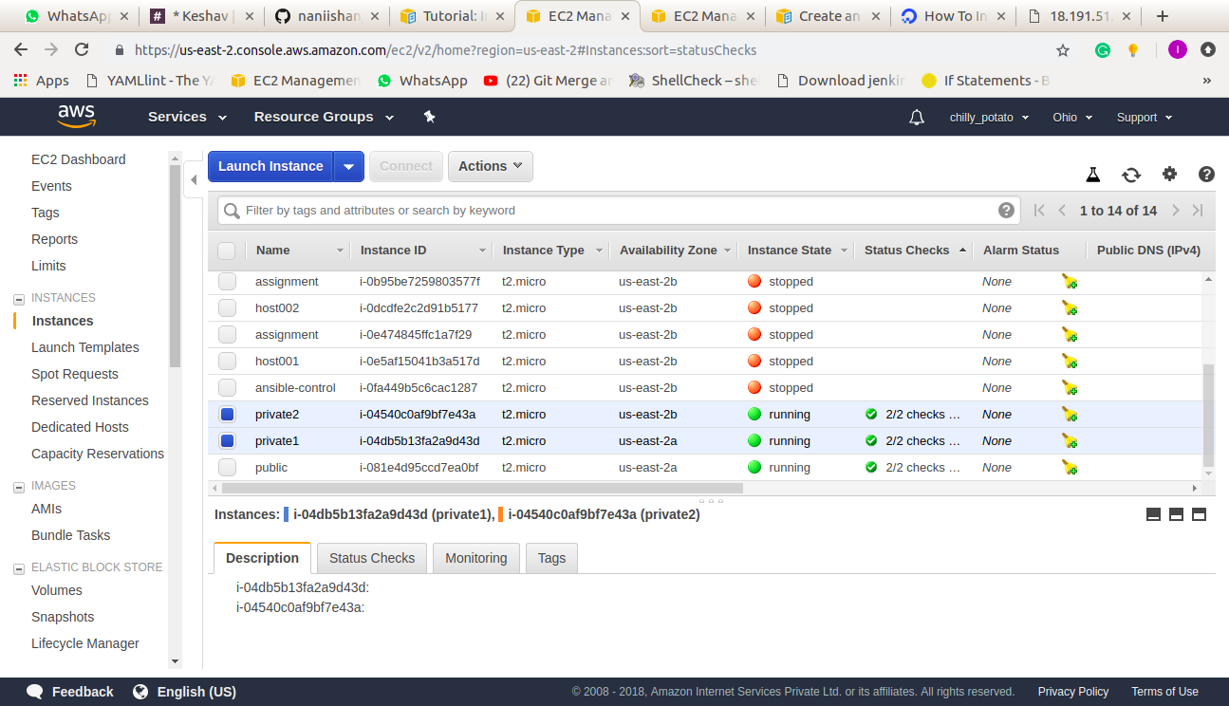

- Task 3

Launch a public load balancer that would forward the requests to these 2 LAMP instances
create the same setup using aws-cli except vpc

- created a public load balancer,
- having two public subnets in the AZ where we are having our private instances,
- attached private instances with the load balancer,
- configured the security group for the load balancer,
- waited for the status of the instances to be healthy,

this is the sample .php page in the private instances.
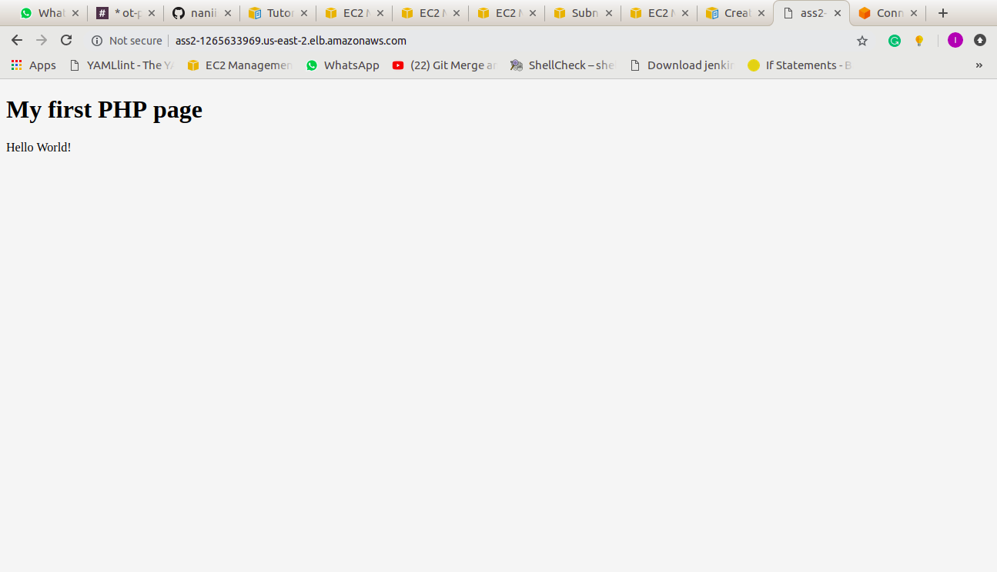

Instances in the private subnets are added to the load balancer and their status is showing as inservice.
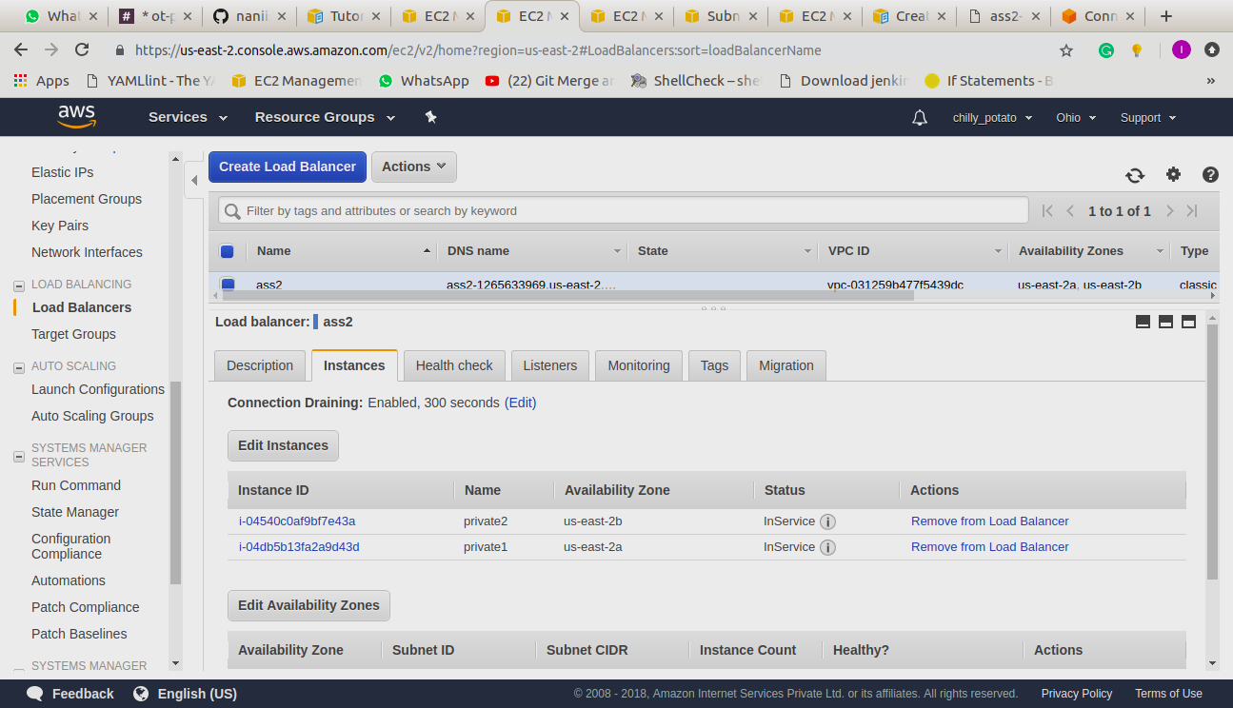

CLI

command to create a load balancer through CLI

aws elb create-load-balancer --load-balancer-name assignment2 –listenersprotocol=HTTP,LoadBalancerPort=80,InstanceProtocol=HTTP,InstancePort=80 --subnets subnet-01831649a3db9dc70 subnet-055e1b0100f735808 --scheme internal --security-groups sg-b9ffedd5

registering instances with the load balancer

aws elb register-instances-with-load-balancer --load-balancer-name assignment2 --instances i-4f8cf126 i-0bb7ca62 i-04540c0af9bf7e43a

