ASSIGNMENT 01 ANSIBLE

1. Install Ansible using pip

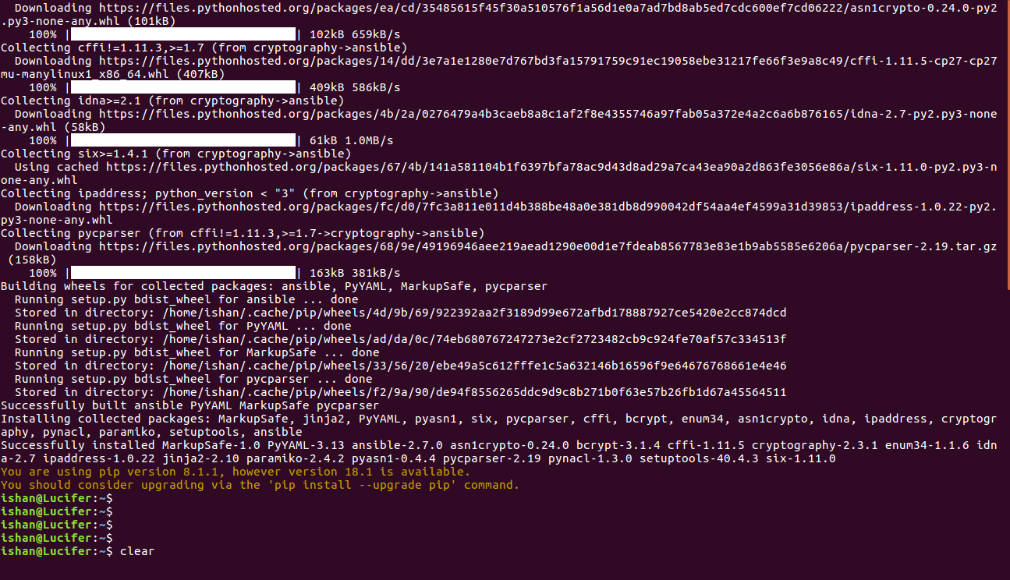
2. Display the ansible version.

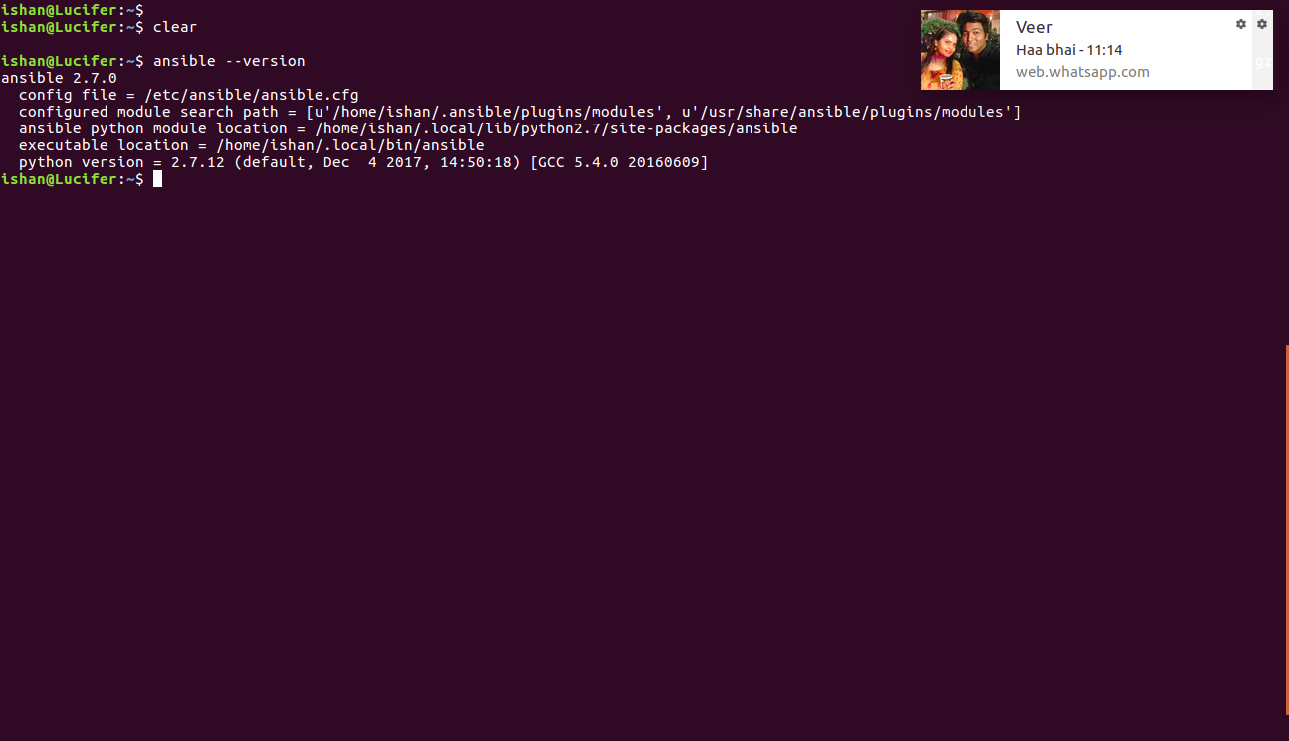

3. Check all the possible parameters you need to know in ansible.cfg file.

Inventory /etc/ansible/hosts
remote_port 22
roles_path /etc/ansible/roles
log_path /var/log/ansible.log
[privilege_escalation]
retries=3

4. Ansible Inventory: Check the default inventory file for ansible control master and use inventory, run ansible ping commands on various inventory groups. Try this on minimum of two virtual machines.(You can use any of these Docker/Vagrant

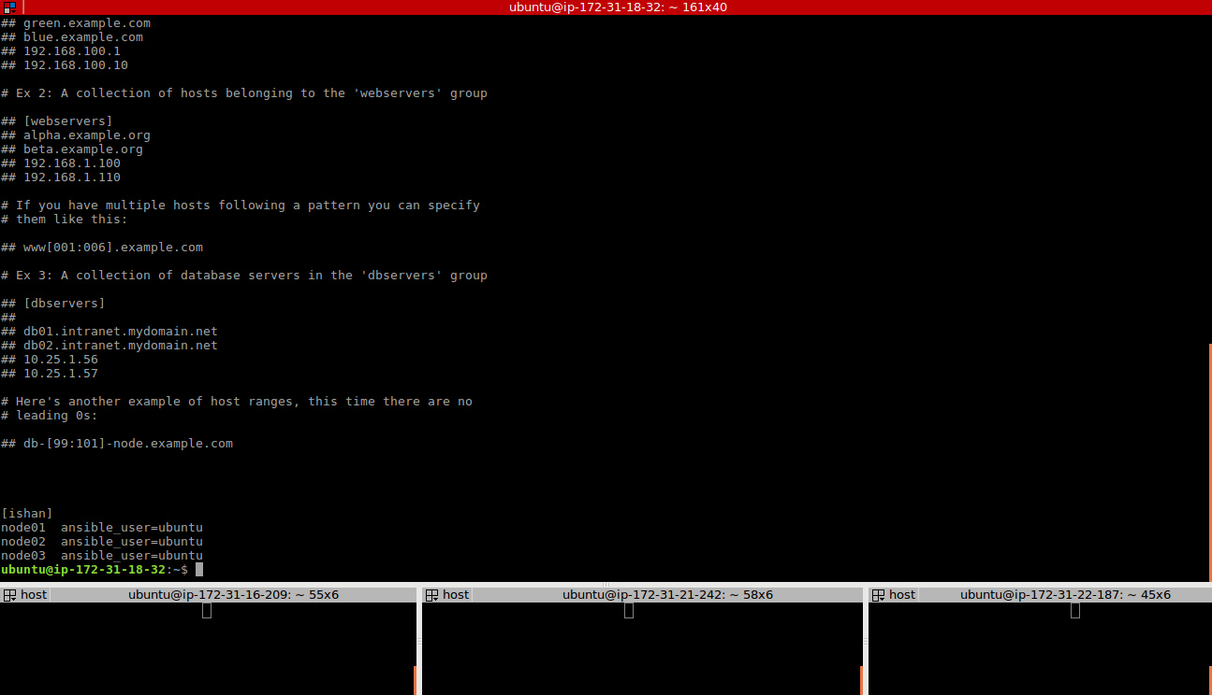
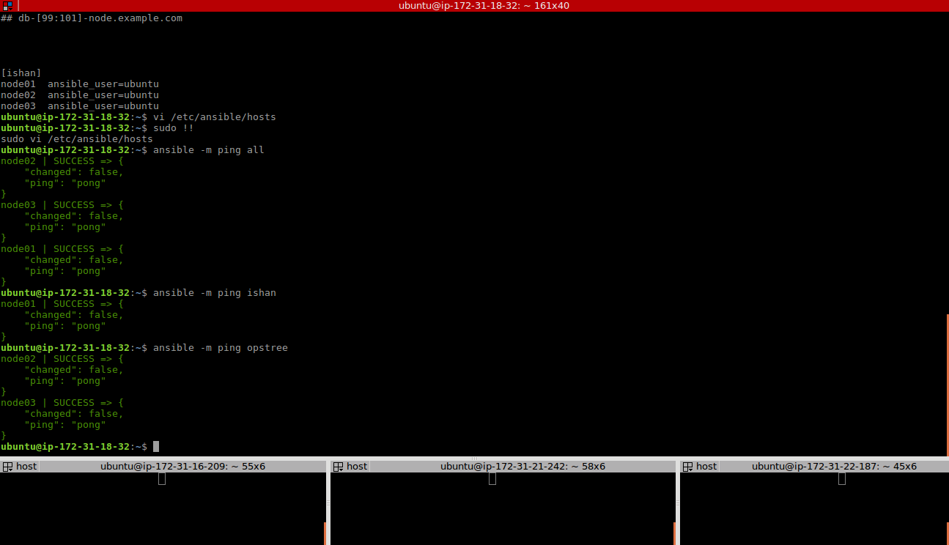
5. In ~/.ansible.cfg file (create the file if it doesn't exist already) do the following:
Create a new directory ~/.ansible/retry-files and set retry_files_save_path to it.
Set the Ansible system forks to 10
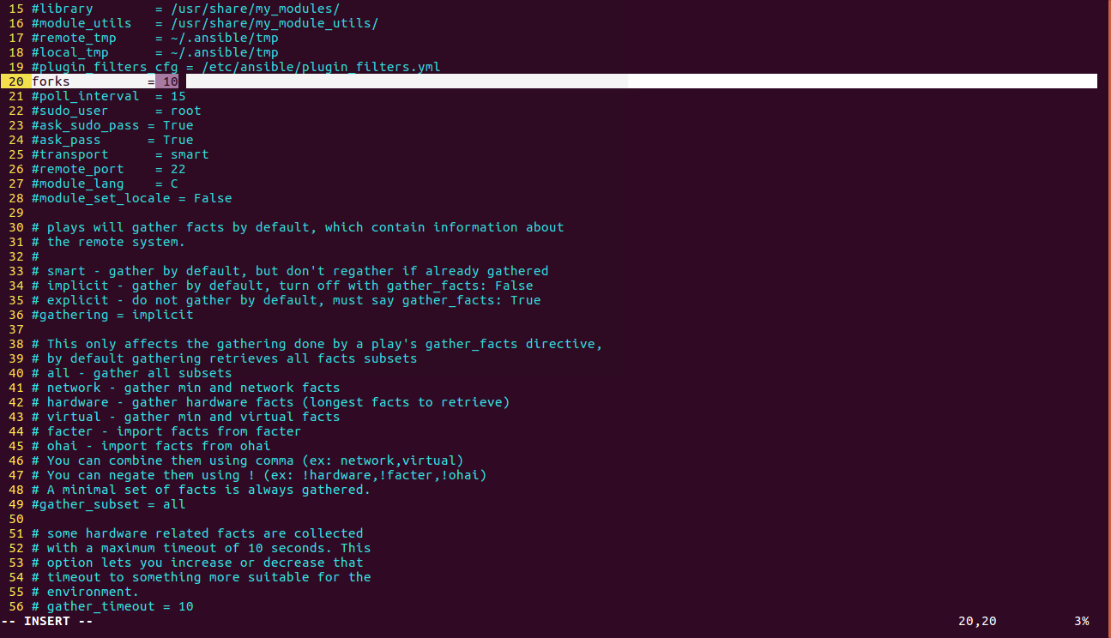
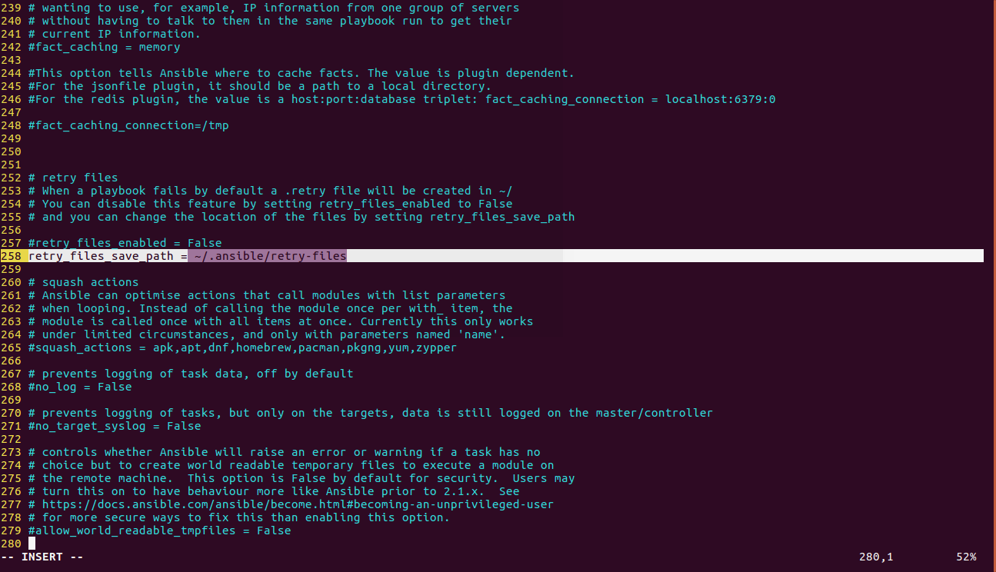
6. Host a static website on minimum three hosts using inventory, content of static website is "Index page of Ansible assignment"

ansible all -b -a "apt-get install nginx -y"
ansible -m copy -a “src=/etc/ansible/index.html dest=/var/www/html/” all

Now using ansible playbook, using jenkins......

