ASSIGNMENT02 ANSIBLE

1. Fetch and display to STDOUT Ansible facts using the setup module.

Ansible all -m setup –tree /tmp/facts
ansible all -m setup1 > facts

2. Fetch and display only the "virtual" subset of facts for each host.

Ansible -m setup -a ‘filter=virtual’ all

3. Fetch and display the value of fully qualified domain name (FQDN) of each host from their Ansible facts.

ansible -m setup all -a ‘filter=”ansible_fqdn”’

4. Display the Uptime of all the hosts using uptime command.

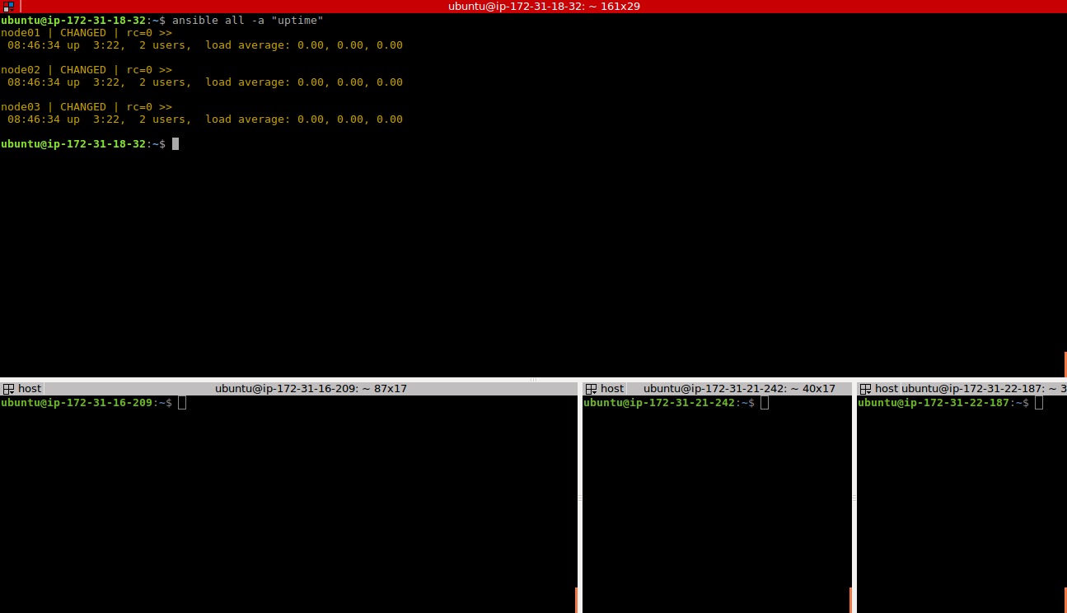

5. Ping all hosts except the 'control' host using the –limit option.

Ansible -m ping all –limit ‘!contol’
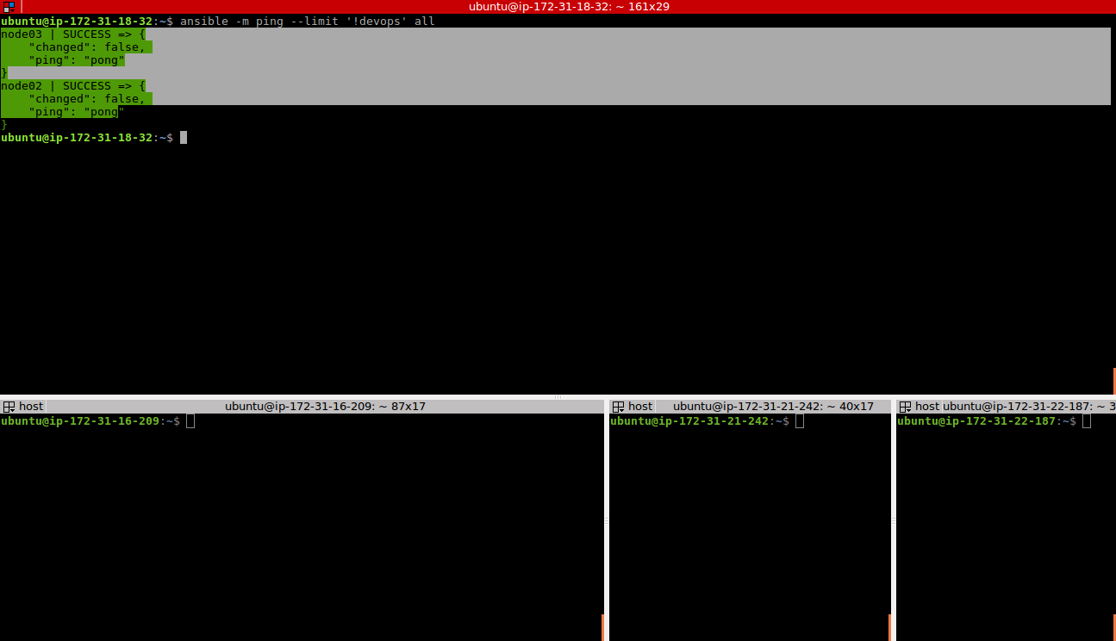

6. Download Java 8 using the apt module
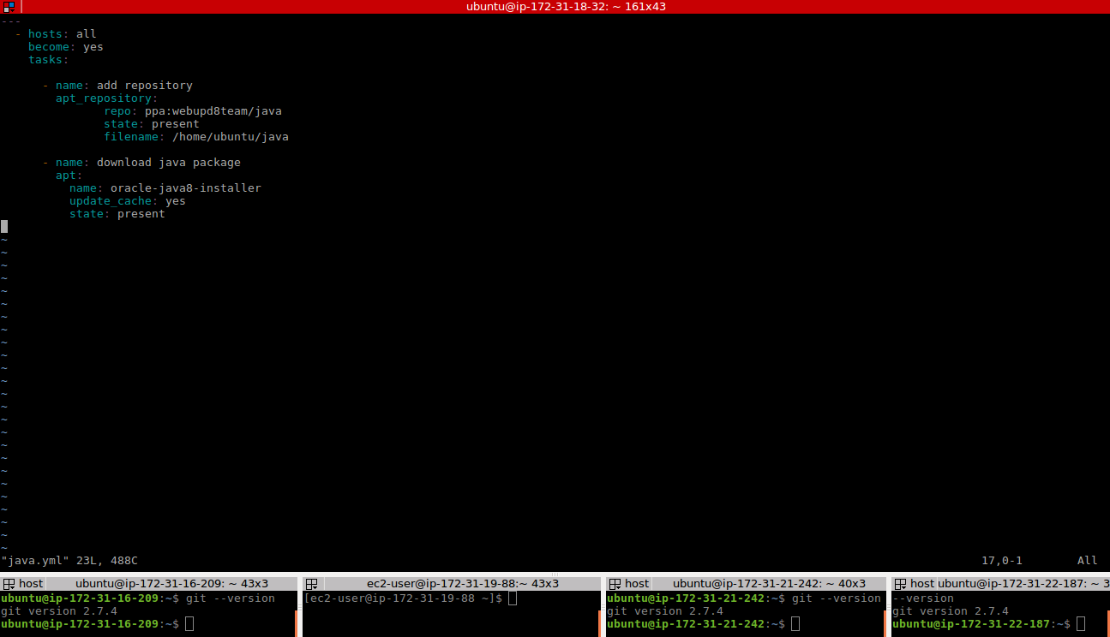

7. Setup and enable the EPEL package repository on the hosts in the "web" group using the yum module.

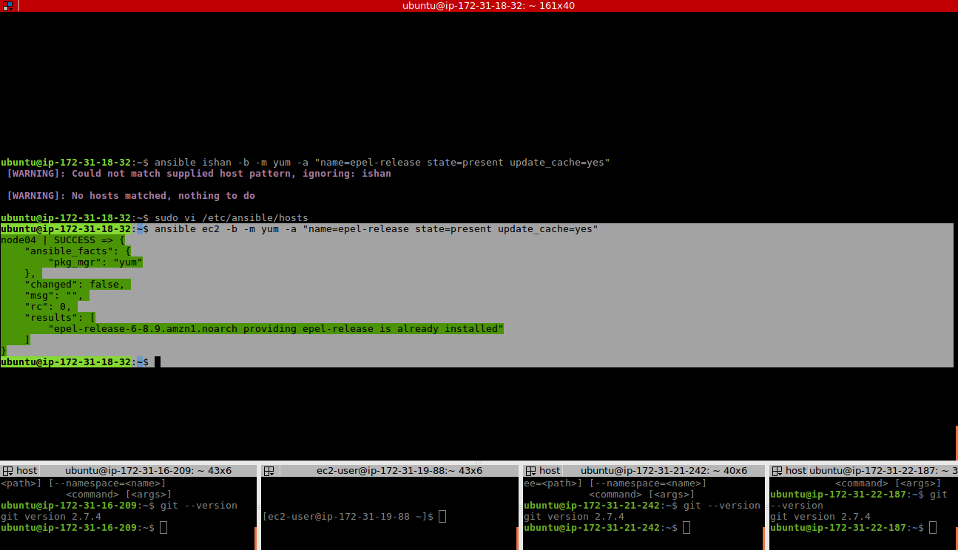
8. set a cron on ansible control machine that will run every 1 minute , and perform below tasks:-
execute ansible adhoc commands on client machines (cannot be control machine) , to create a file in /var/log/ninja_name on all the client nodes, append system_hostname [:space:] system_time in the file every 1 minute using ansible facts.

* ansible -b all -m shell -a "mkdir ninja_name && cd ninja_name && touch ishan.txt && echo ' Ubuntu ' >> ishan.txt chdir=/var/log/"

* ---

- hosts: all
become: yes
tasks:
- name: /var/log/ninja_name create a file
file:
dest: /var/log/ninja_name
state: directory
owner: ubuntu
mode: 0777

- name: create a fiel
file:
path: /var/log/ninja_name/ishan.txt
state: file
owner: ubuntu
mode: 0755

- name: append the data
shell: "echo {{ ansible_ssh_user }} >> ishan.txt"
args:
chdir: /var/log/ninja_name

