ASSIGNMENT03 ANSIBLE

1. Create and delete ninja directory on host machine

ansible -b all -m file -a "path=~/ninja state=directory owner=root mode=0755"

ansible -b all -m file -a "path=/home/ubuntu/ninja state=absent"

2. Set hostname on all nodes from remote machine.

ansible all -b -a "hostname nodes"

3. Fetch os of all nodes and store o/p into a file, use min two different machine of different flavour of os.

ansible all -a "cat /etc/os-release" --tree ~/os-release

4. Add three group into hosts file through ansible module.

ansible -b localhost -m lineinfile -a "path=/etc/ansible/hosts line='[ubuntu]\n172.31.21.242\n172.31.16.209\n\n[ec2-user]\n172.31.19.88\n\n [all]\n172.31.19.88\n172.31.21.242\n172.319.88' create=yes"

5. Install apache on Debian machine

ansible ubuntu -m apt -a "name=apache2 state=present update_cache=true" -b

6. Apache runn on 8082 port

ansible -b ubuntu -m lineinfile -a "path=/etc/apache2/ports.conf regexp='^Listen\ 80' line='Listen 8081'" && ansible ubuntu -m service -a "name=apache2 state=restarted" -b

7. Install nginx on centos machine, nginx run 8080 port

ansible ec2-user -m yum -a "name=nginx state=present update_cache=yes" -b && ansible ec2-user -m shell -a "sed -i 's/80/8080/g' /etc/nginx/nginx.conf" -b && ansible ec2-user -b -m service “name=nginx state=started”
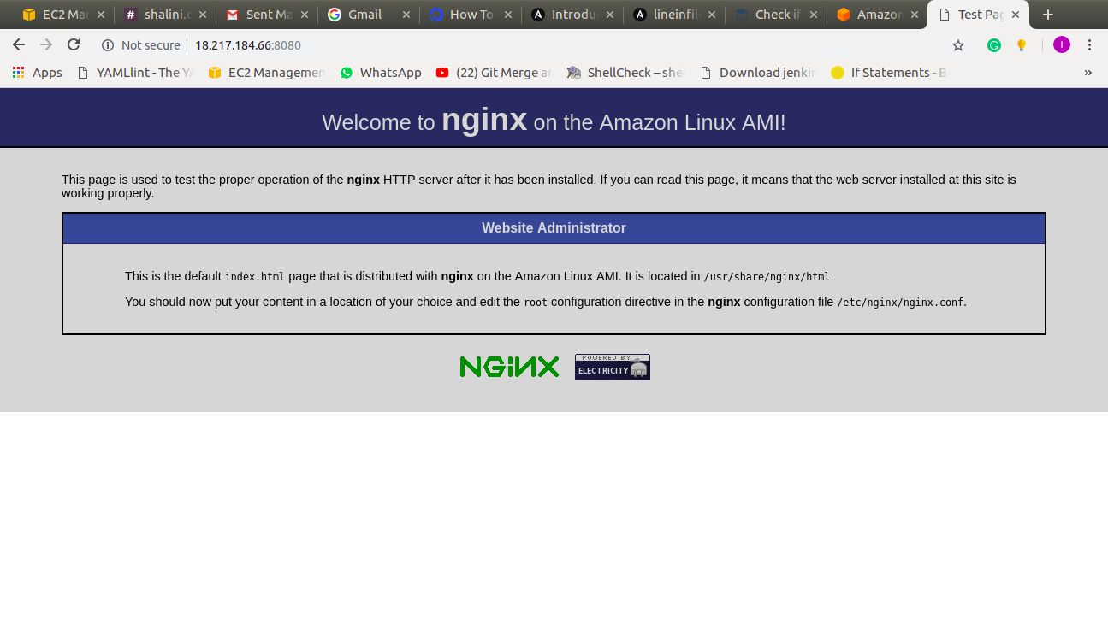
8. Configure Nginx - configure it to run as reverse proxy to apache

