ASSIGNMENT04 ANSIBLE

1. Create an Ansible playbook that targets members of the "app" group has the following state:

The tomcat7 is installed in all host
Has the war file in webapps folder specified in appwar.
Tomcat is started on each host.

Running playbook on the remote hosts.
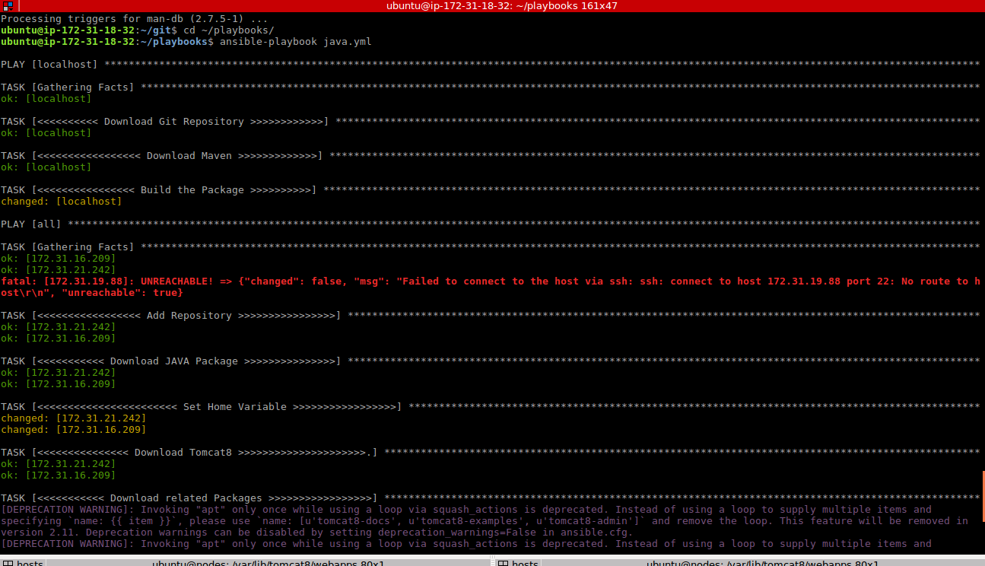
Running playbook with –check.
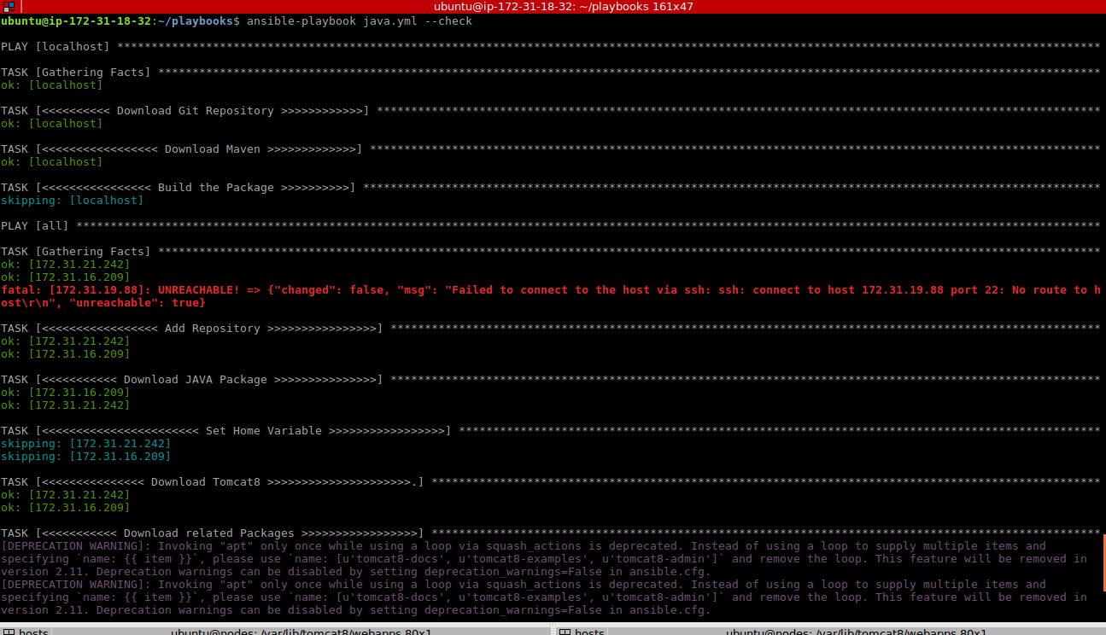
Runnig playbook with –syntax-check
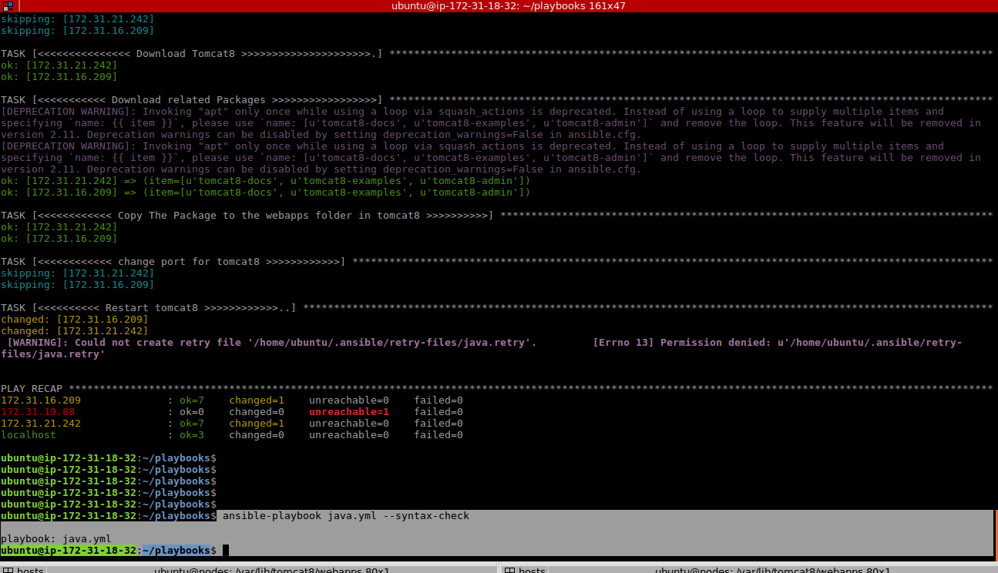

PLAYBOOK
---
- hosts: localhost
become: yes
tasks:
- name: <<<<<<<<<< Download Git Repository >>>>>>>>>>>>
git: repo=https://github.com/daticahealth/java-tomcat-maven-example.git dest=/home/ubuntu/git clone=yes

- name: <<<<<<<<<<<<<<<<< Download Maven >>>>>>>>>>>>>
apt: name=maven state=present update_cache=yes

- name: <<<<<<<<<<<<<<<< Build the Package >>>>>>>>>>
shell: mvn clean package
args:
chdir: /home/ubuntu/git/

- hosts: all
become: yes
tasks:

- name: <<<<<<<<<<<<<<<<< Add Repository >>>>>>>>>>>>>>>>
apt_repository:
repo: ppa:webupd8team/java
state: present
filename: /home/ubuntu/java

- name: <<<<<<<<<<< Download JAVA Package >>>>>>>>>>>>>>>
apt:
name: oracle-java8-installer
update_cache: yes
state: present

- name: <<<<<<<<<<<<<<<<<<<<<<< Set Home Variable >>>>>>>>>>>>>>>>>
shell: export JAVA_HOME="/usr/lib/jvm/java-8-oracle"

- name: <<<<<<<<<<<<<<< Download Tomcat8 >>>>>>>>>>>>>>>>>>>>>.
apt: name=tomcat8 update_cache=yes state=present

- name: <<<<<<<<<<< Download related Packages >>>>>>>>>>>>>>>>>
apt: name={{ item }} update_cache=yes state=present
with_items:
- tomcat8-docs
- tomcat8-examples
- tomcat8-admin

- name: <<<<<<<<<<<< Copy The Package to the webapps folder in tomcat8 >>>>>>>>>>
copy: src=/home/ubuntu/git/target/java-tomcat-maven-example.war dest=/var/lib/tomcat8/webapps

- name: <<<<<<<<<<<< change port for tomcat8 >>>>>>>>>>>>
shell: sed -i 's/9090/8181/g' /etc/tomcat8/server.xml

- name: <<<<<<<<<< Restart tomcat8 >>>>>>>>>>>>..
service: name=tomcat8 state=restarted

