ASSIGNMENT05 ANSIBLE

1. Run a playbook through jenkins to install java and tomcat on the hosts
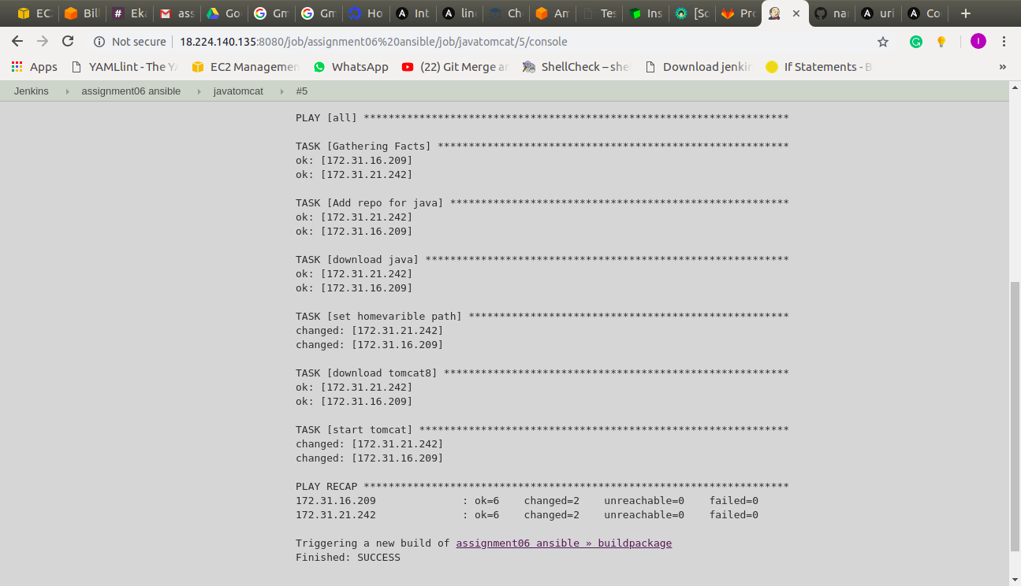
---
- hosts: all
become: yes
tasks:
- name: Add repo for java
apt_repository:
repo: ppa:webupd8team/java
state: present
filename: /home/ubuntu/java

- name: download java
apt: name=oracle-java8-installer update_cache=yes state=present

- name: set homevarible path
shell: export JAVA_HOME="/usr/lib/jvm/java-8-oracle"

# DOWNLOAD TOMCAT8

- name: download tomcat8
apt: name=tomcat8 state=present update_cache=yes

- name: start tomcat
service: name=tomcat8 state=restarted

2. Run a plabook through jenkins to build the package, through maven and get it through github.
---
- hosts: all
become: yes
tasks:
- name: download maven and git
apt: name={{ item }} state=present update_cache=yes
with_items:
- git
- maven

- name: create git folder
file: path=/home/ubuntu/git state=directory mode=0755

- name: download the repo
git: repo=https://github.com/daticahealth/java-tomcat-maven-example.git clone=yes dest=/home/ubuntu/git

- name: build the package
shell: mvn clean package
args:
chdir: /home/ubuntu/git/
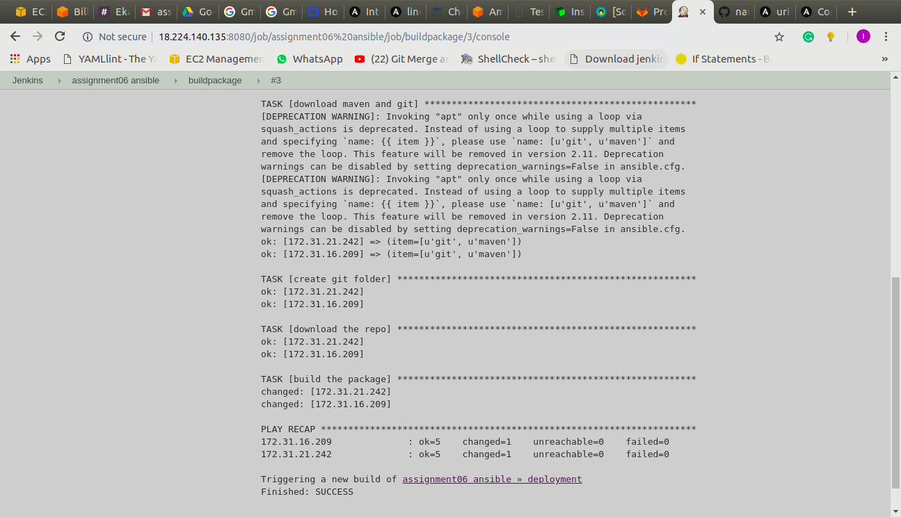

3. Run a playbook through ansible to deploy the package,
---
- name: deployment
hosts: all
become: yes
tasks:
- name: copy the artifact to the tomcat webapps
shell: cp *.war /var/lib/tomcat8/webapps/
args:
chdir: /home/ubuntu/git/target

- name: restart tomcat8
service: name=tomcat8 state=restarted

- name: health checks
uri:
url: http://52.15.230.9:8181/java-tomcat-maven-example/
register: result
until: result.status == 200
when: ansible_eth0.ipv4.address == "172.31.16.209"

- name: health checks
uri:
url: http://18.219.111.15:8181/java-tomcat-maven-example/
register: result
until: result.status == 200
when: ansible_eth0.ipv4.address == "172.31.21.242"

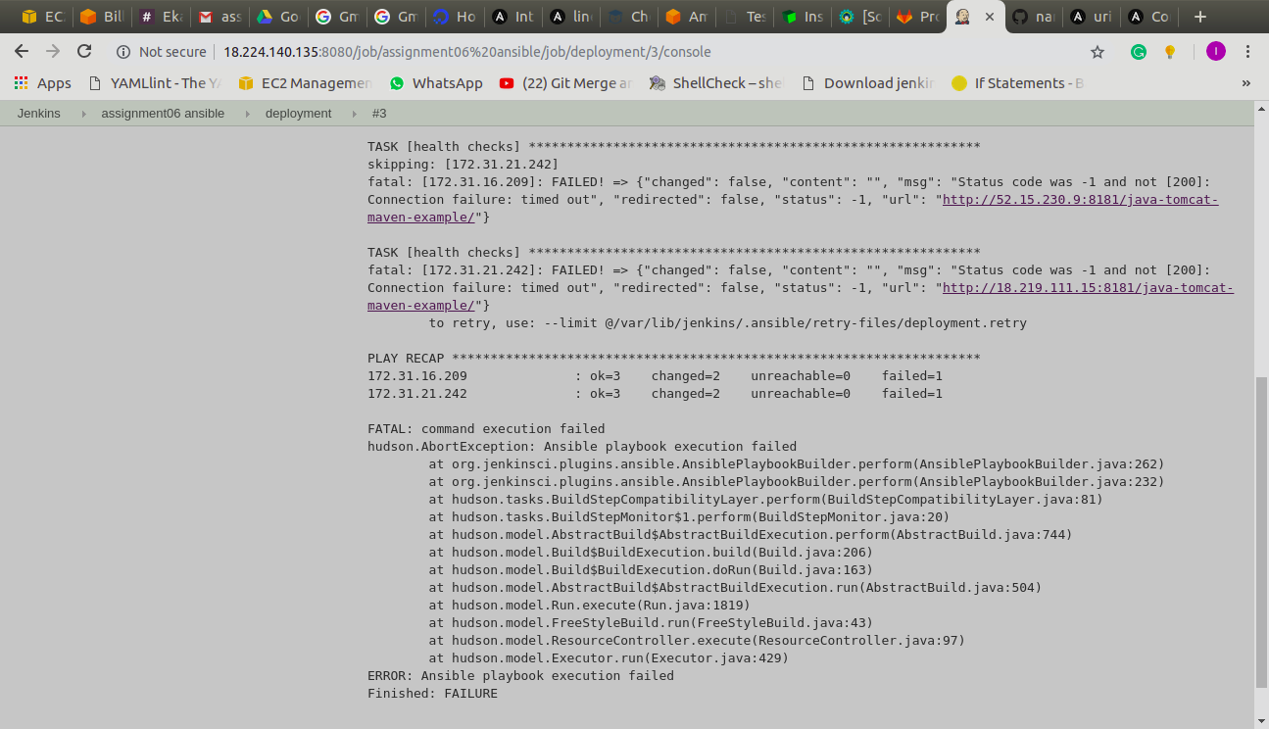
connected all 3 jobs, with the help of pipeline.

