ASSIGNMENT 06 ANSIBLE

The following playbook will create the new keys through ssh-keygen, and it will paste it to the authorized_keys file in host machines after that it will delete the previous keys and rename the new keys with the name of the previous keys i.e., id_rsa

modules used,
- command
- file
- authorized_keys

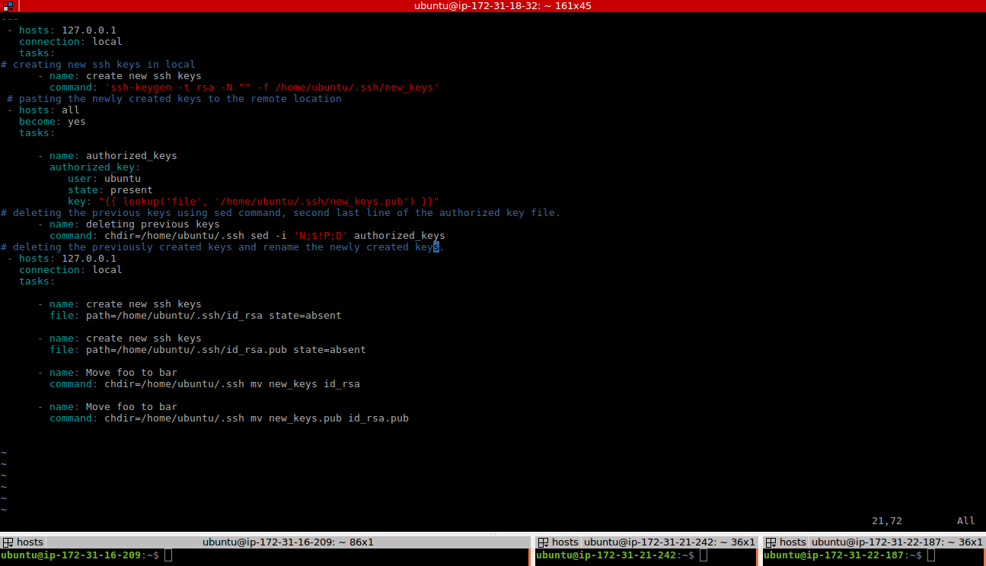
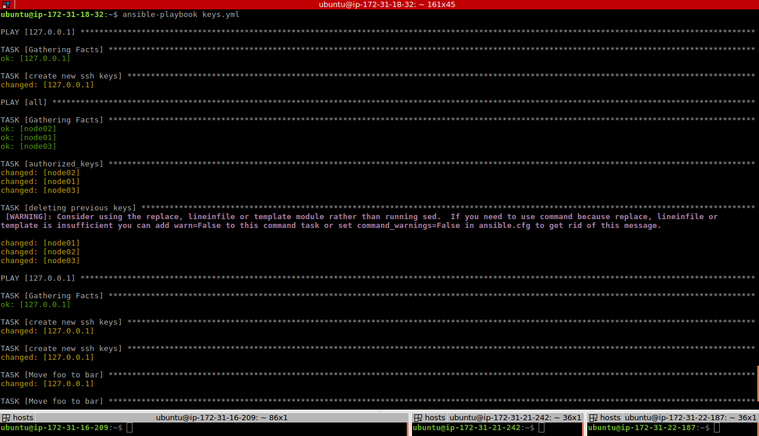

---
- hosts: 127.0.0.1
become: true
connection: local
tasks:

# creating new ssh keys in local
- name: create new ssh keys
command: 'ssh-keygen -t rsa -N "" -f /home/ubuntu/.ssh/new_keys'

# pasting the newly created keys to the remote location
- hosts: all
become: yes
tasks:

- name: authorized_keys
authorized_key:
user: ubuntu
state: present
key: "{{ lookup('file', '/home/ubuntu/.ssh/new_keys.pub') }}"

# deleting the previous keys using sed command, second last line of the authorized key file.
- name: deleting previous keys
command: chdir=/home/ubuntu/.ssh sed -i 'N;$!P;D' authorized_keys

# deleting the previously created keys and rename the newly created keys.
- hosts: 127.0.0.1
connection: local
tasks:

- name: create new ssh keys
file: path=/home/ubuntu/.ssh/id_rsa state=absent

- name: create new ssh keys
file: path=/home/ubuntu/.ssh/id_rsa.pub state=absent

- name: Move foo to bar
command: chdir=/home/ubuntu/.ssh mv new_keys id_rsa

- name: Move foo to bar
command: chdir=/home/u buntu/.ssh mv new_keys.pub id_rsa.pub

