ASSIGNMENT 01 AWS

1. Create a vpc through wizard, having one public subnet and one private subnet.

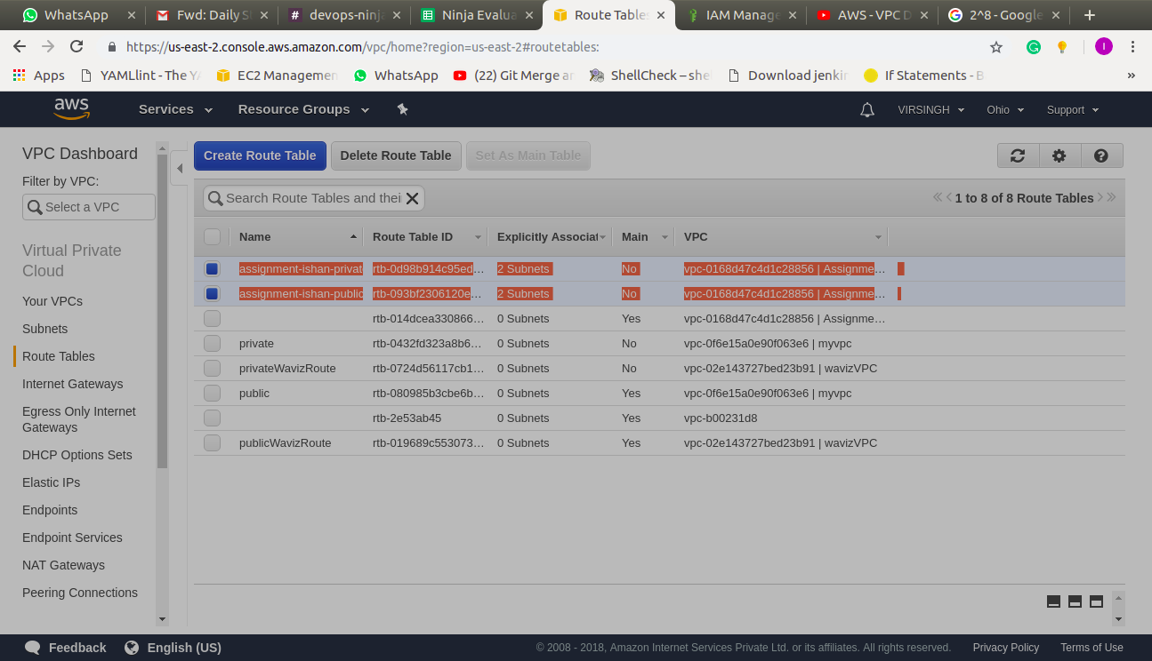
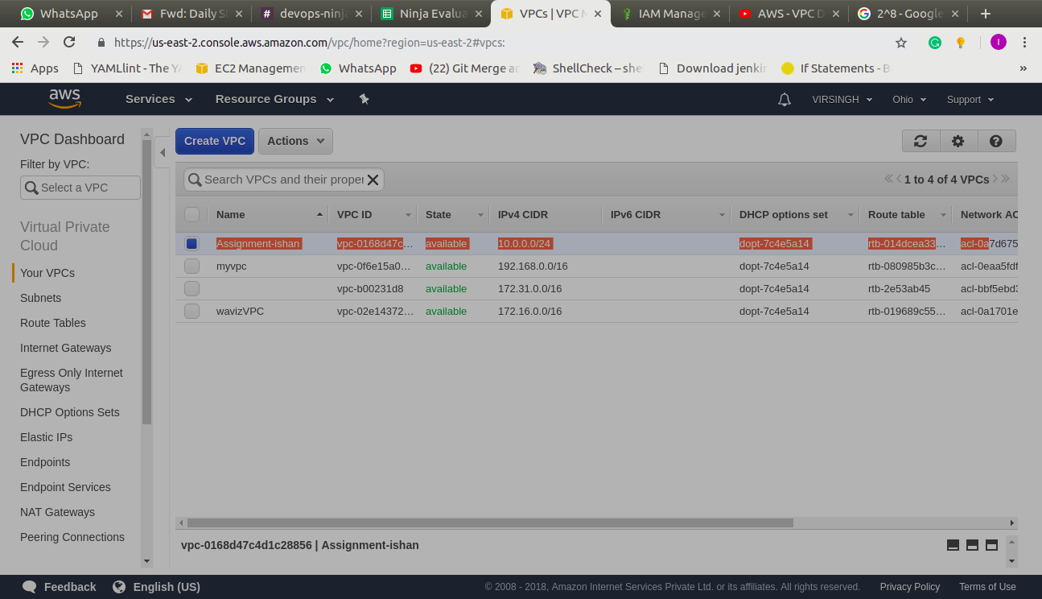

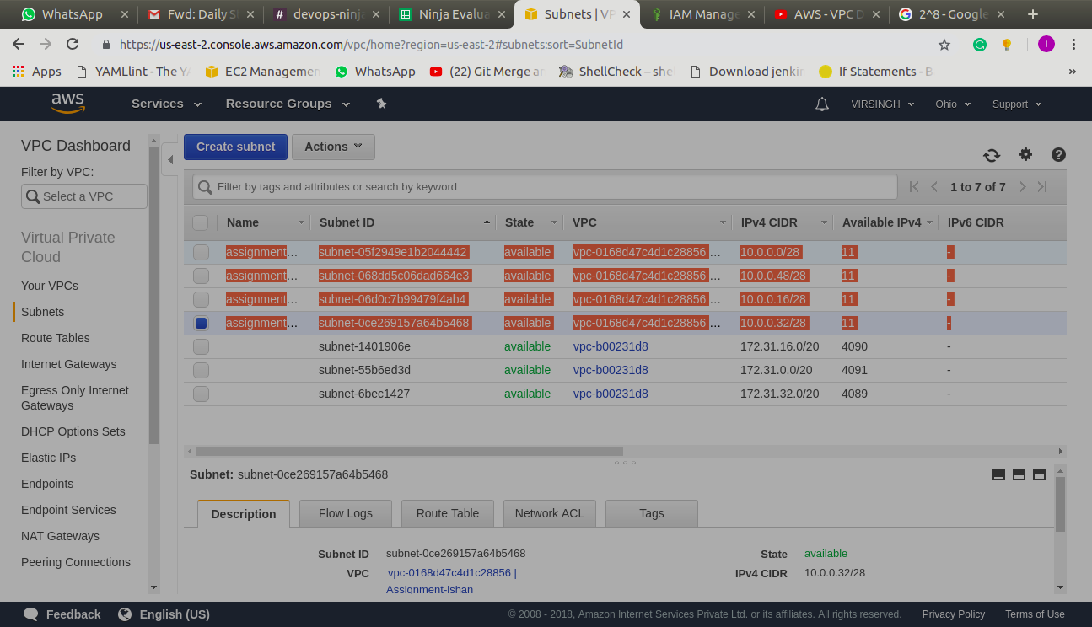
2. Create two instances within the vpc that you created in task 1, windows instance in public subnet and linux instance in private subnet. check if linux is pingable from windows and vice versa.

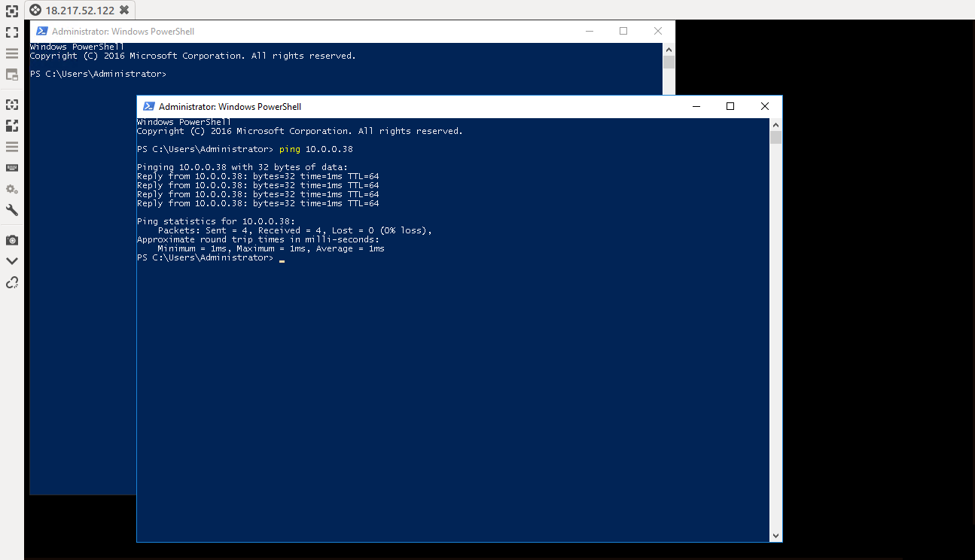

3. Deleted above 2 created instances and setup aws cli using following commands.

TERMINATING INSTANCES
aws ec2 terminate-instances --instance-id i-062fa45506cf68d4c
aws ec2 terminate-instances --instance-ids i-007bd77b9e38192d6
WINDOWS INSTANCE CREATED....IN PUBLIC SUBNET
aws ec2 run-instances --image-id ami-058b005523e354076 --count 1 --instance-type t2.micro --subnet-id subnet-06d0c7b99479f4ab4 --key-name assignment-ishan --region us-east-2

LINUX INSTANCE CREATED IN PRIVATE SUBNET
aws ec2 run-instances --image-id ami-0782e9ee97725263d --count 1 --instance-type t2.micro --subnet-id subnet-0ce269157a64b5468 --key-name assignment-ishan --region us-east-2

