ASSIGNMENT 05 doCKER

1. Signup on dockerhub.
Login on dockerhub and create a repository by providing repo name "mytestrepo" and a little description about the same.

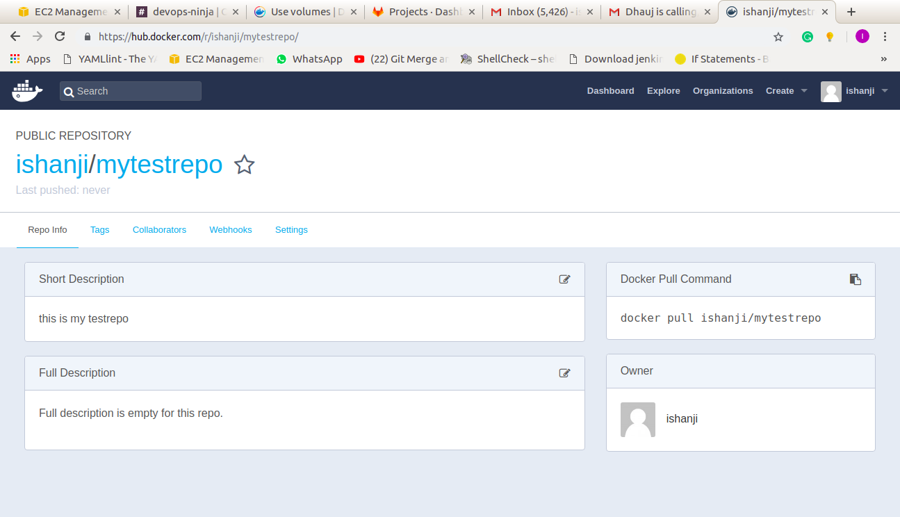
2. Search for "centos" image on docker using commandline.

docker search centos:7

3. Limit out search result to 10 entries only.

docker search centos:7 –limit=10

4. Apply a filter on search result to show entries for images having 3 stars.

docker search centos:7 --filter stars=3
docker search centos:7 –stars=3

5. Format the search result to get output containing only name,description and is_official values.

docker search centos:7 --format "{{.Name}}\t{{.Description}}\t{{.IsOfficial}}"

6 .Pull an image named "centos" from dockerhub.

Docker pull centos

7. Tag "centos" image with name "mycentos" in your repository with version 1.1

docker image tag centos:7 mycentos:version 1.1

8. Push that image to your repo "mytestrepo" on your dockerhub.

docker push mycentos:version1.1

10. Do commandline logout on dockerhub.

docker logout

