Git Assignment 1 (4th October)

1. Initializing the directory as a git directory.

2.create blank files a.txt and b.txt.

3. Write "Hi Team Ninja" into a.txt



4. Write "This is VCS:Git" into b.txt



5. Set git config variables.


6. Commit both files.
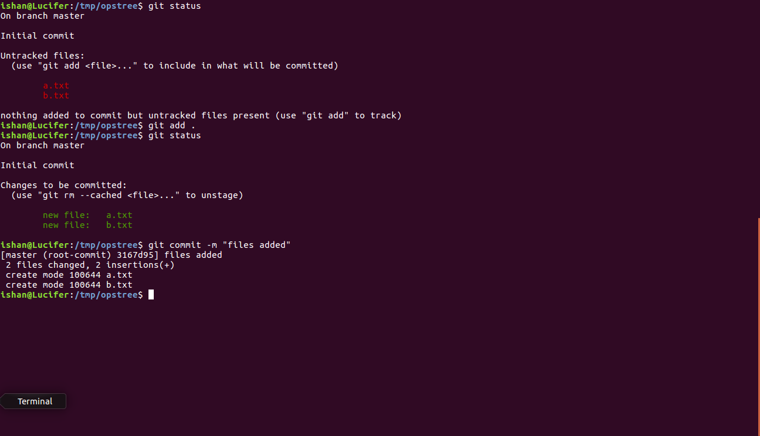

7.Create a branch ninja

8. Switch into branch ninja


9. Update file b.txt with ""This is VCS:Git. This is ninja branch"
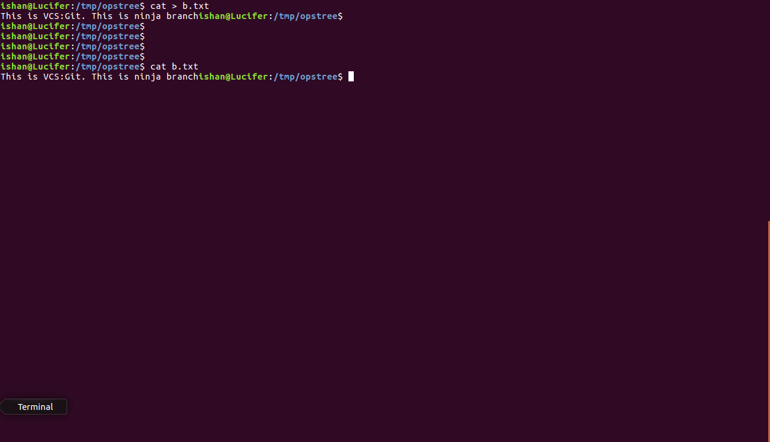
10. Check for the difference made in the file.

11.Commit your changes in ninja branch.
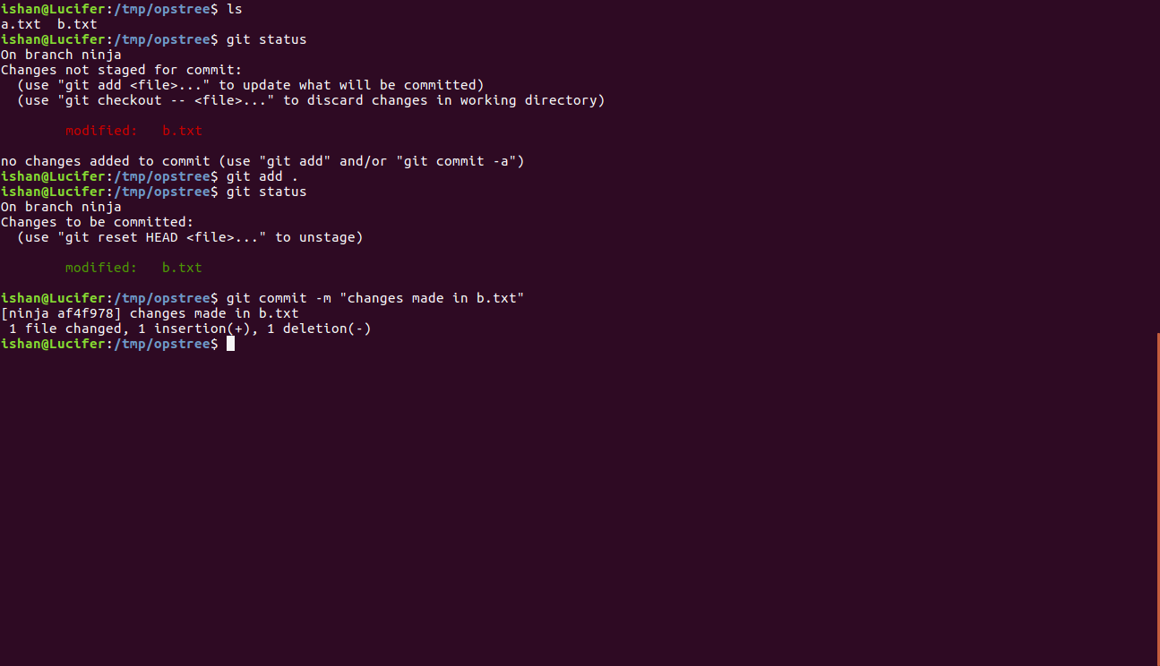
12. Check difference between last two commits.


13. Rename your file b.txt to c.txt
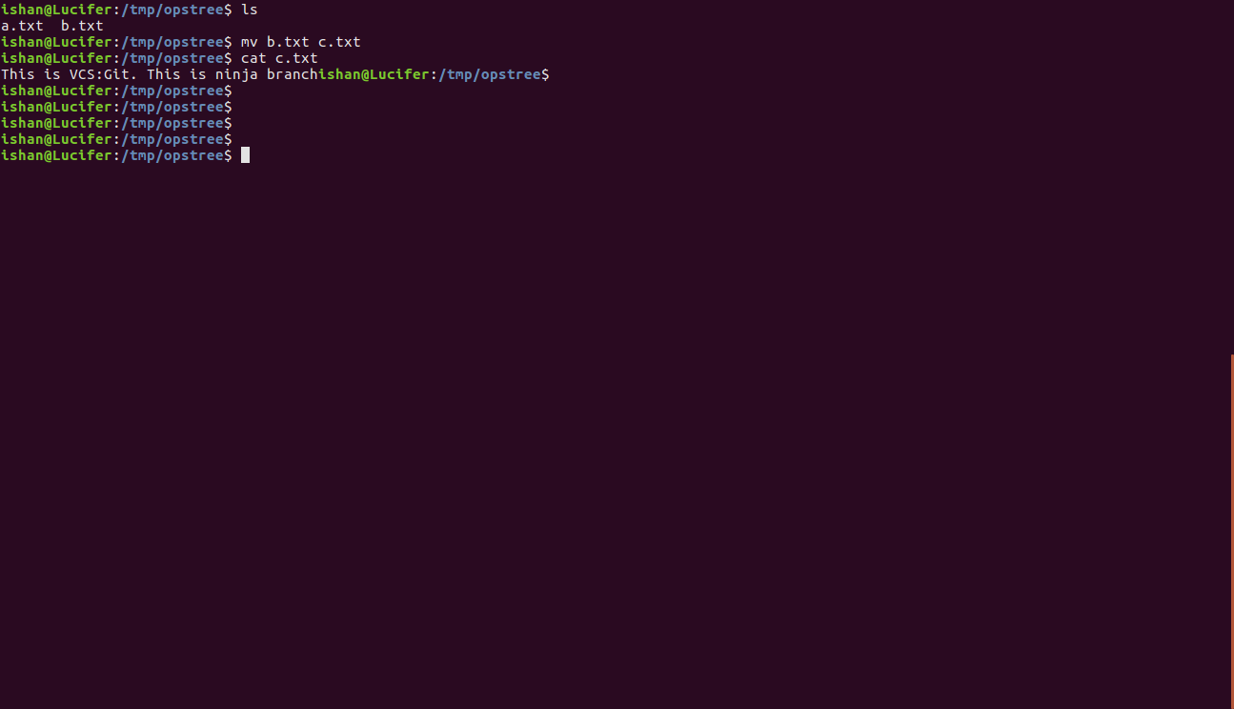
14. commit changes.
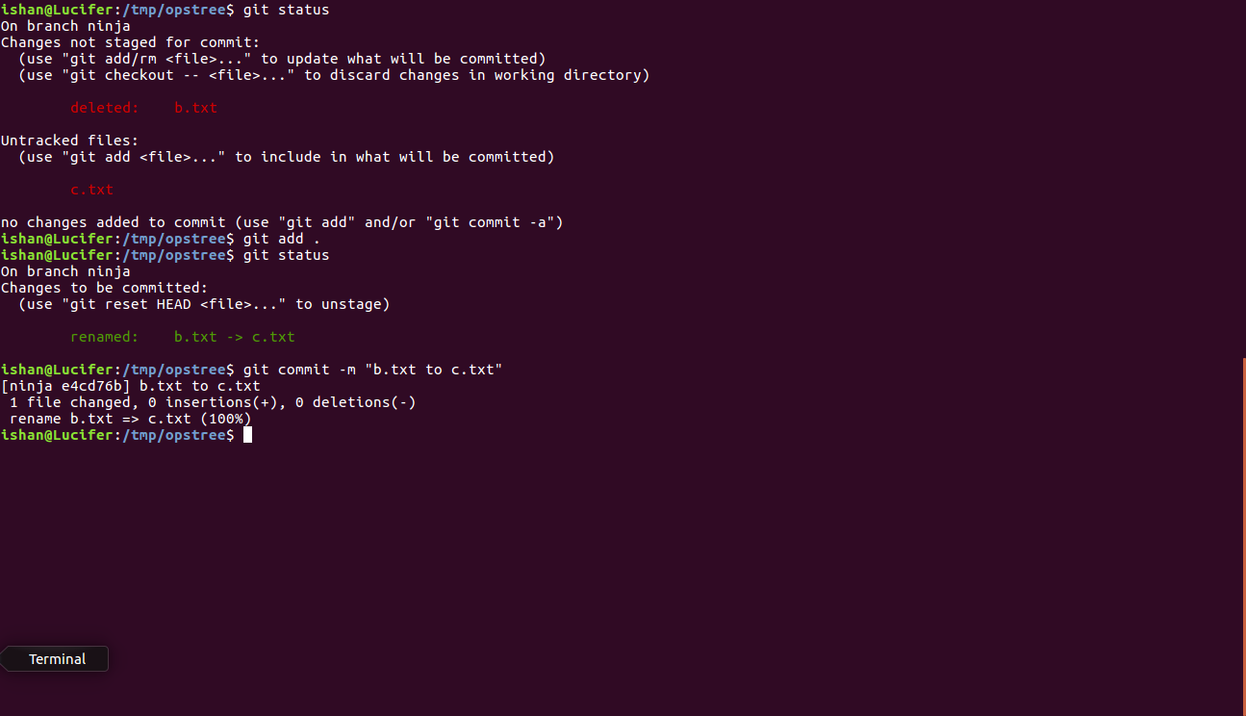

15. Remove file c.txt.

16. Commit your changes.
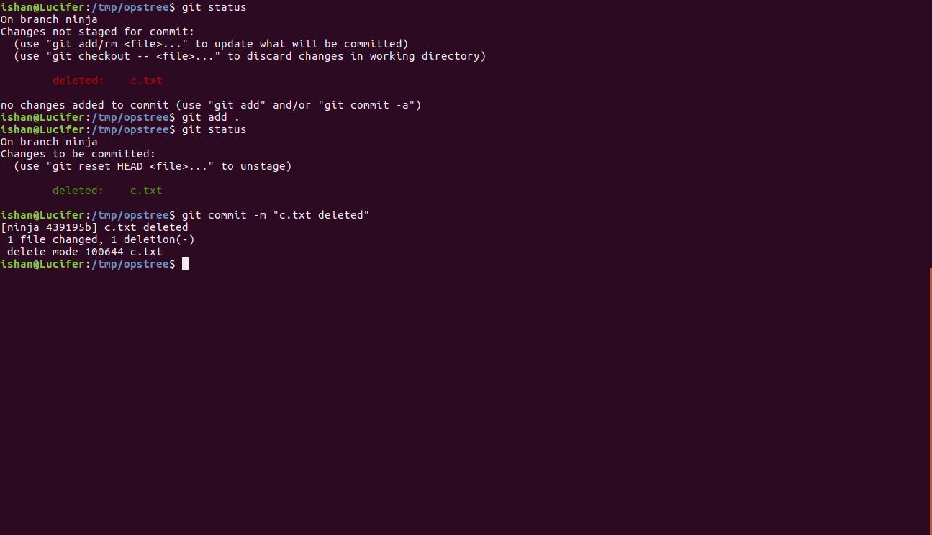

17. Create a file text.txt and add it.
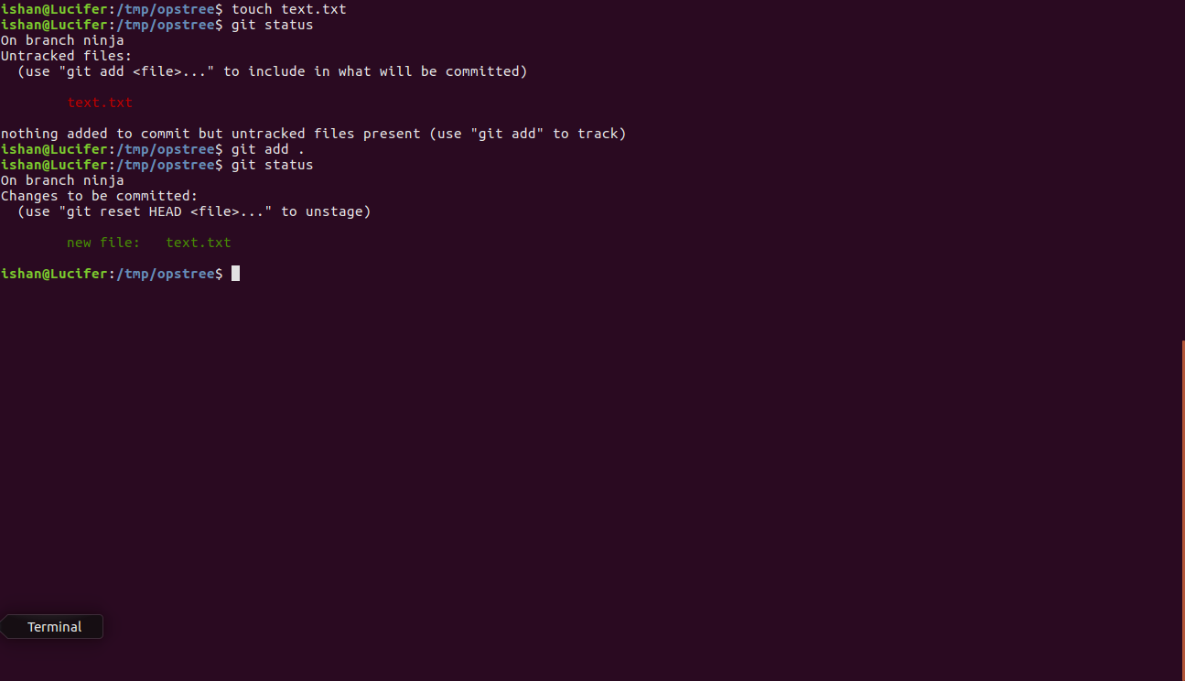
18. Remove it from the staging area.
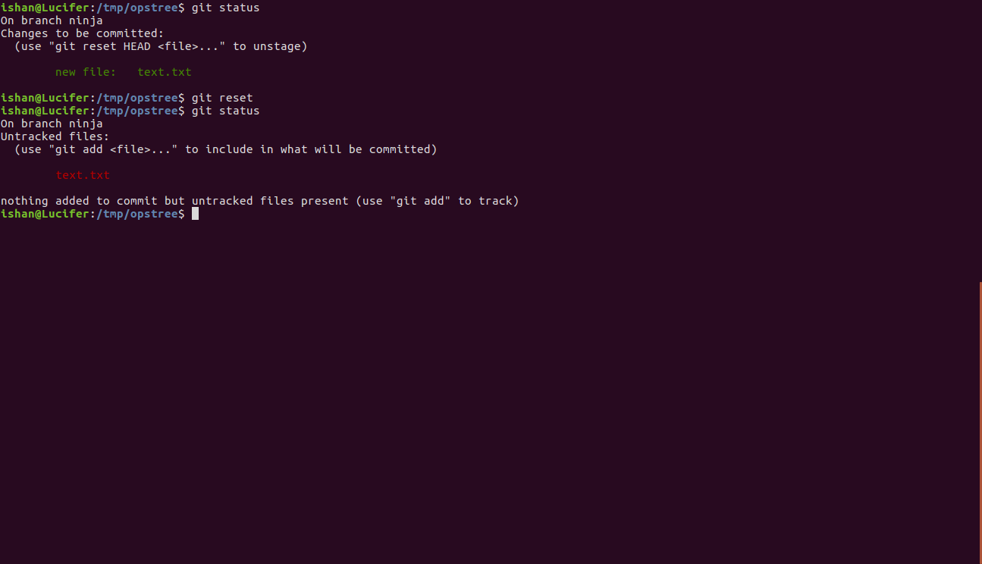
Assignment2:

1. Create a account on github.com.
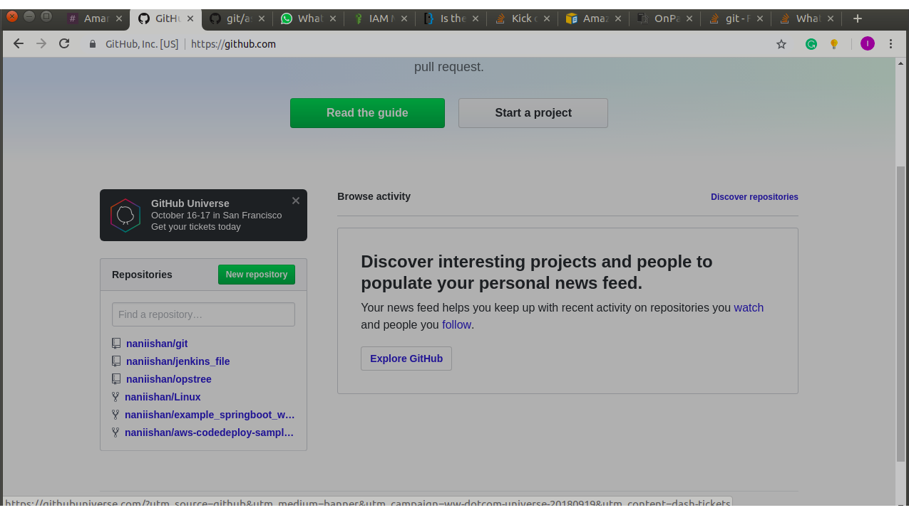

2. Fork ot-training/git repo into your account.
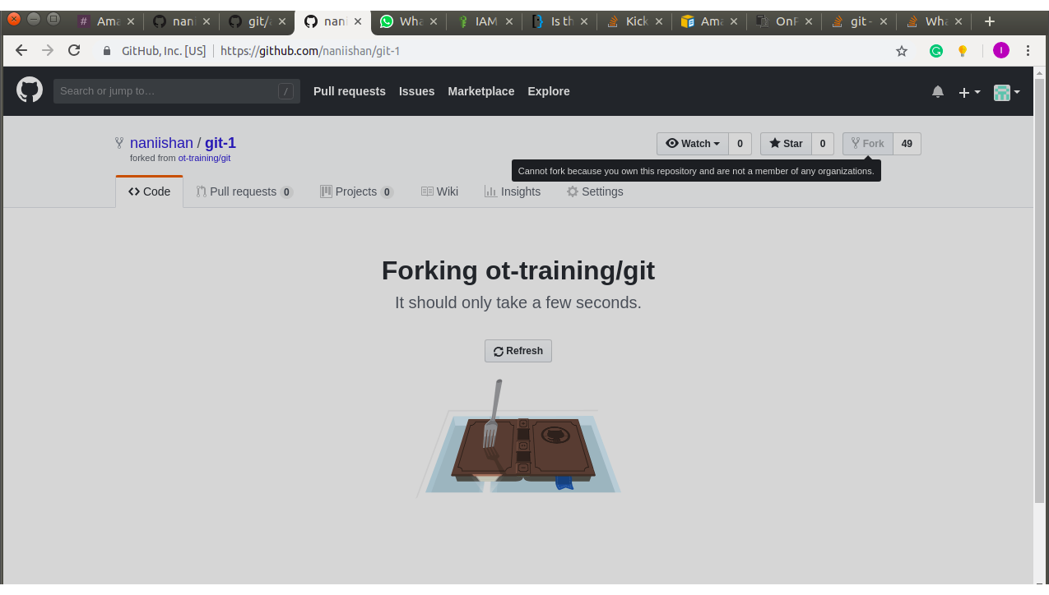
3. Clone your repo into your machine.

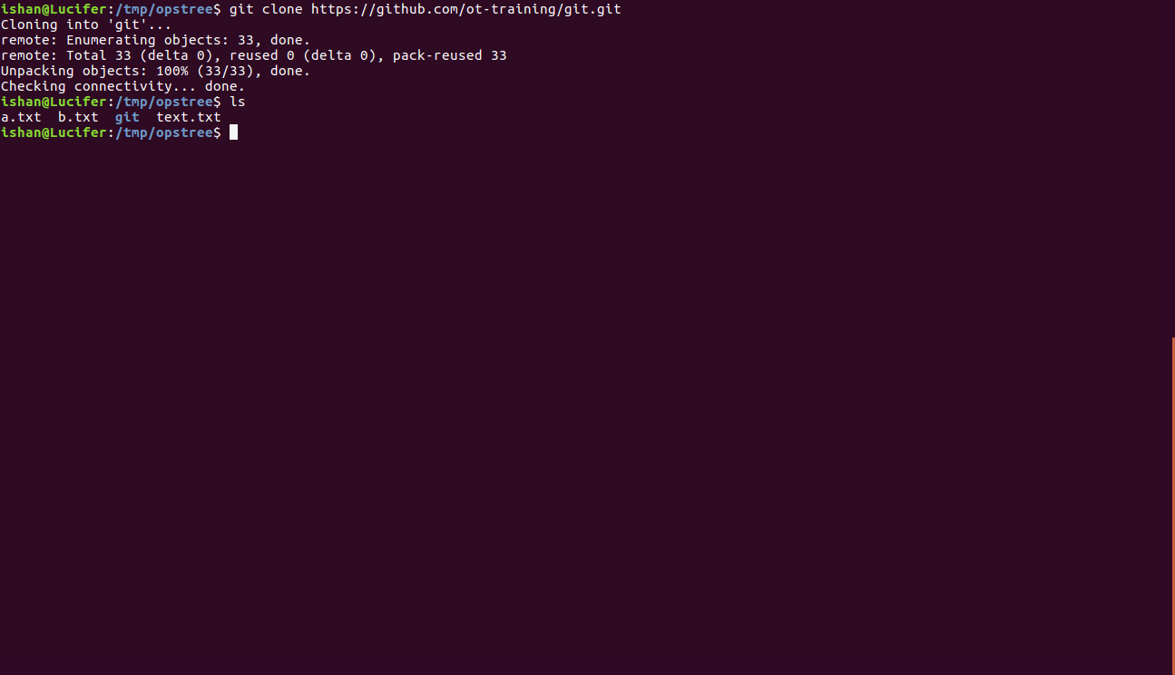

Assignment3:
1. Clone your repo into your machine.

2. Add a file to the attendees directory that describes you (ex. filename wouild be your name like saurabh.vajpayee.txt).
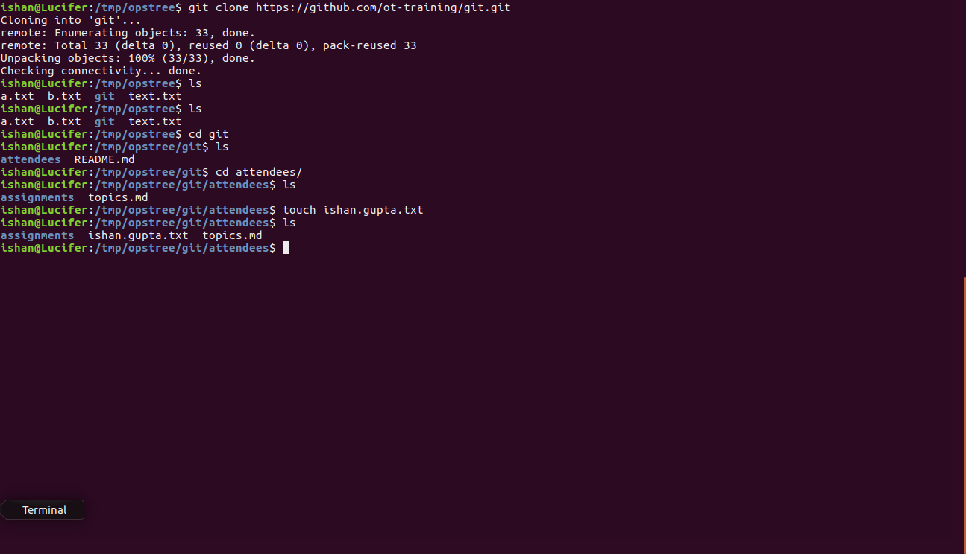
3. Commit your changes. Write a meaningful message like "Added information about YOUR NAME HERE."
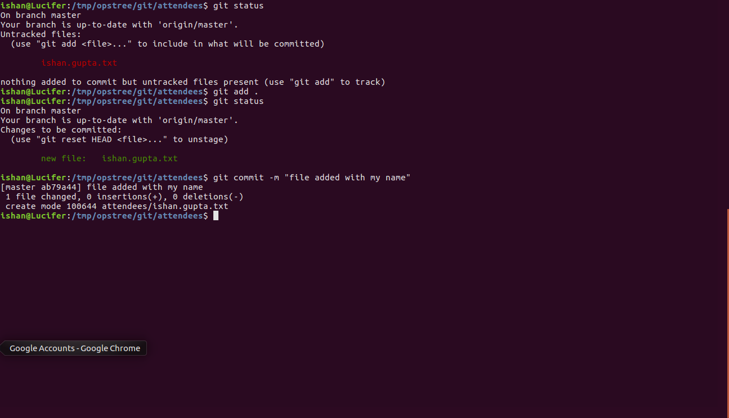
4. Save your changes into remote repo.
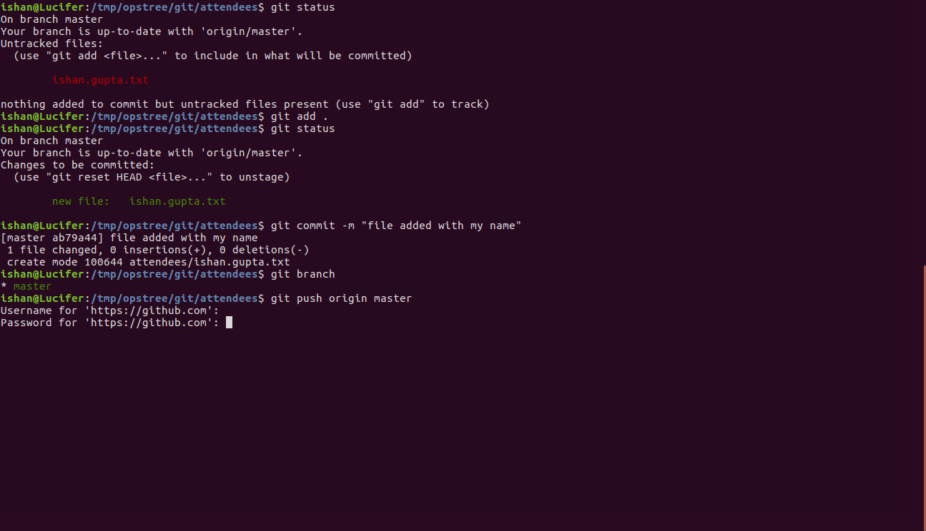

5. Check list of changes in your repo.
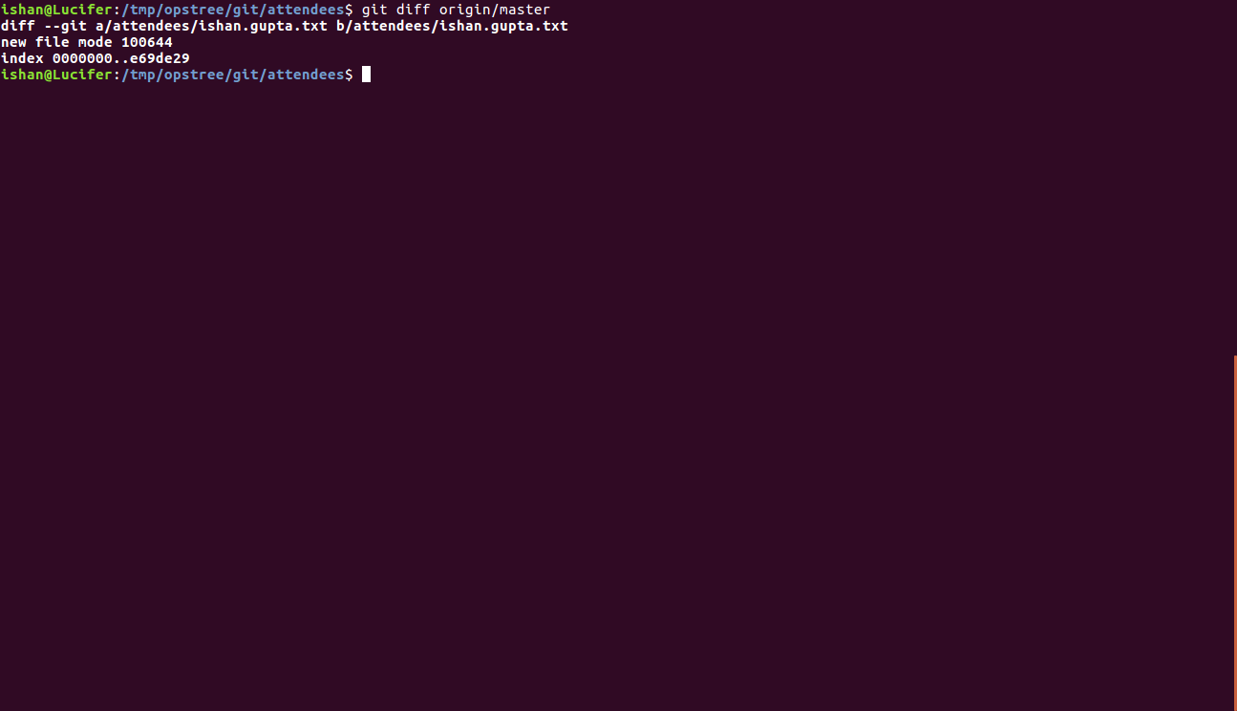
6. Add your name into attendees/assignments/day1/attendees.md
