ASSIGNMENT-1 JENKINS (4th October)

1. Install Jenkins using package.
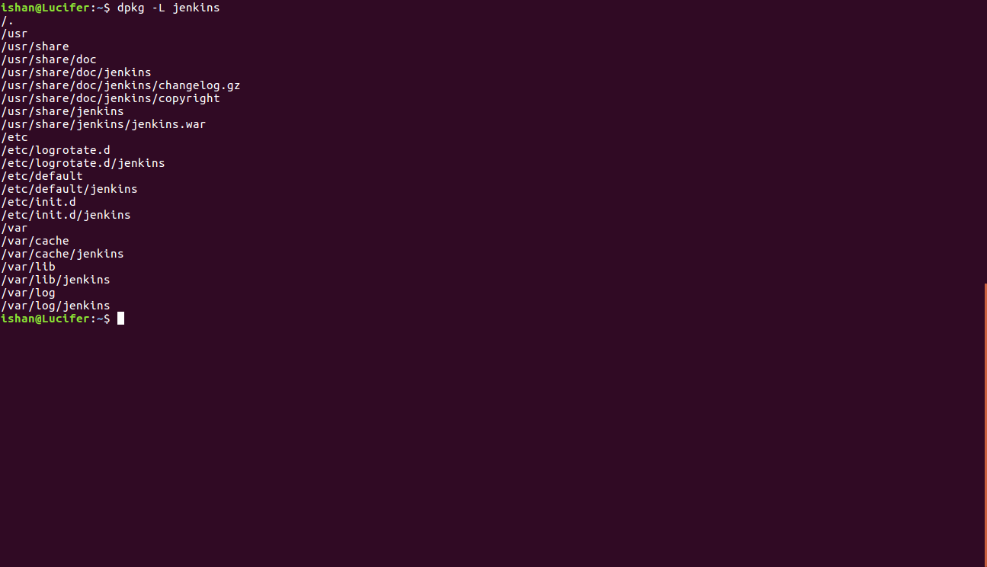
2. Run jenkins war on the top of a tomcat server.
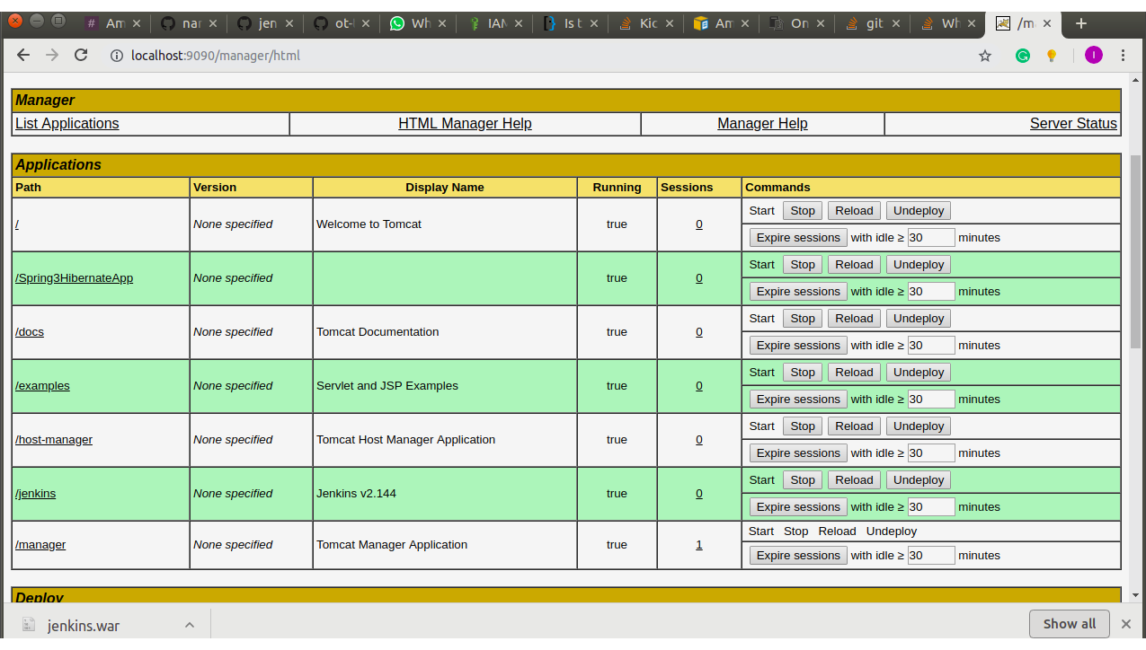

3. Install any five plugin and use them.
- Deploy to container
- Email Extension Template Plugin
- GitHub Integration Plugin
- Pipeline Plugin
- Publish Over SSH

4 . Install a plugin manually.
- We can download the .hpi file and upload it in the advanced section of the Plugins.
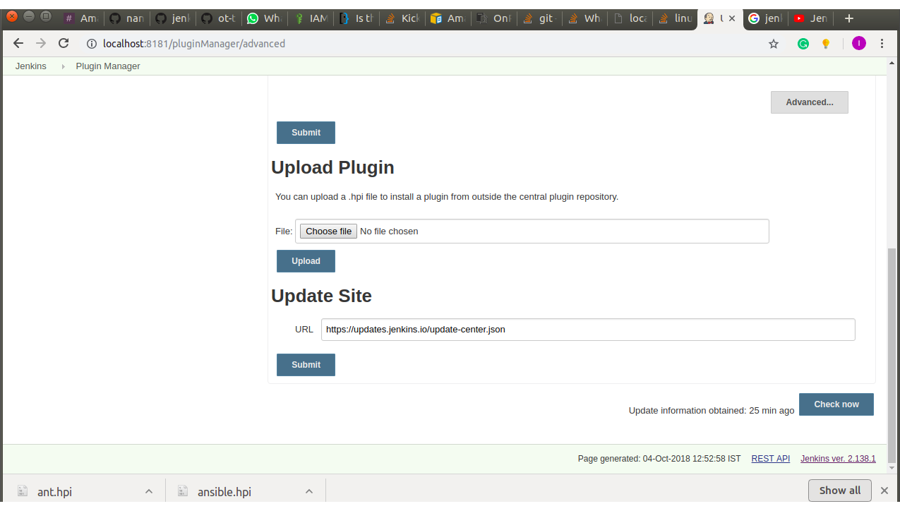

- We can download the .hpi file and place it in the plugins directory in jenkins home directory and then restart jenkins.
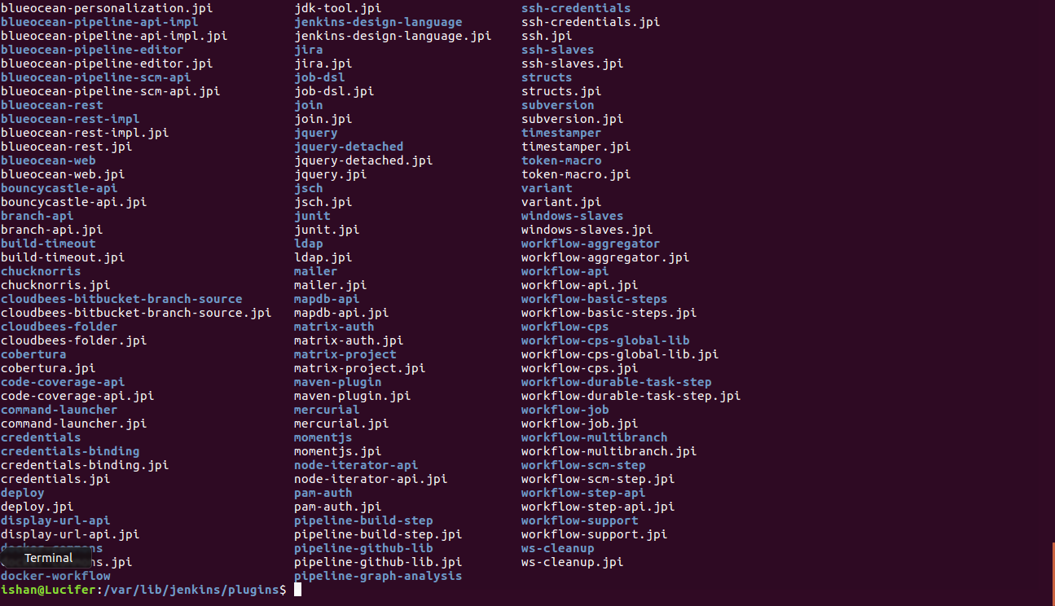
5. Create a freestyle job to print "Hello world".
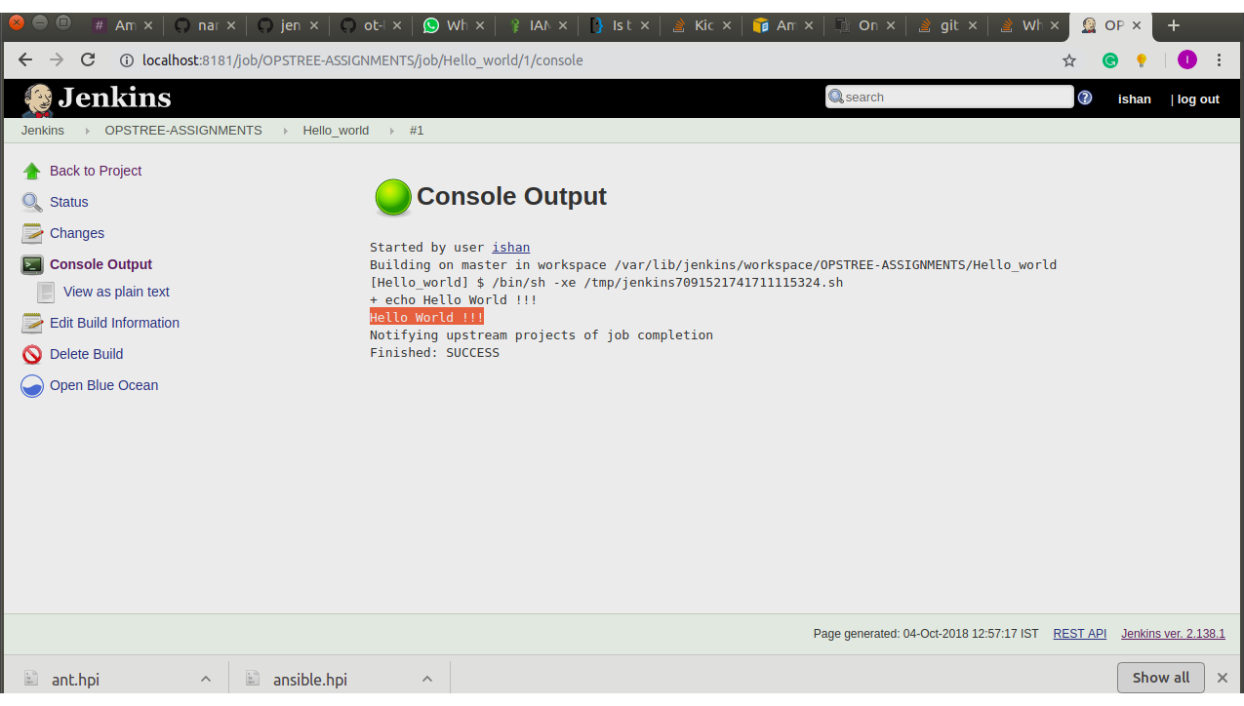

6. Create a freestyle job to which take absolute path of a directory then,
- List all files and directories inside that.
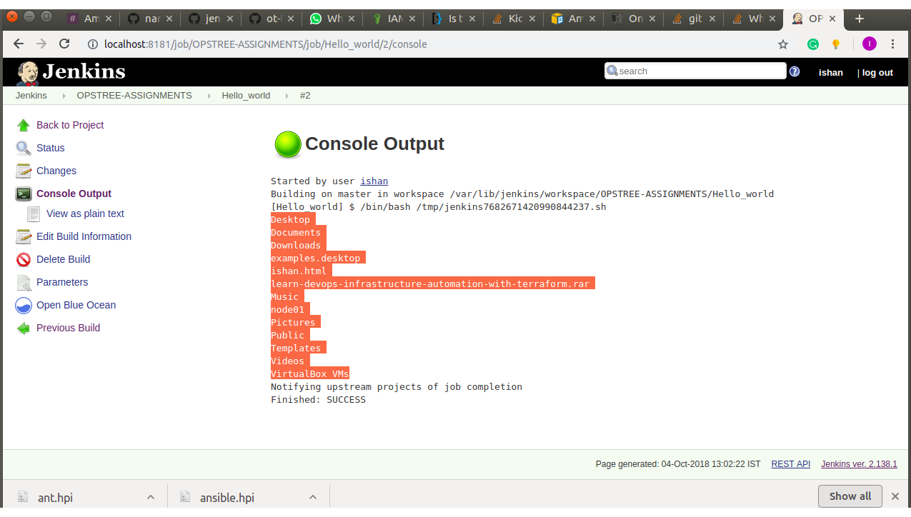
- Print a message "drectory not exist" if directory doesn't exist on file system
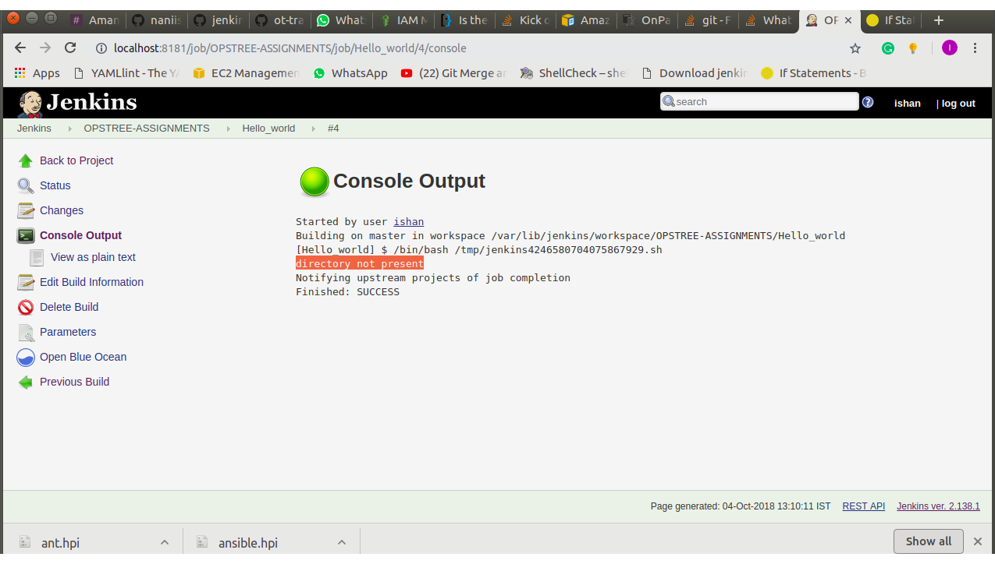

- Print "Inappropriate permissions" if you don't have permissions to list files.
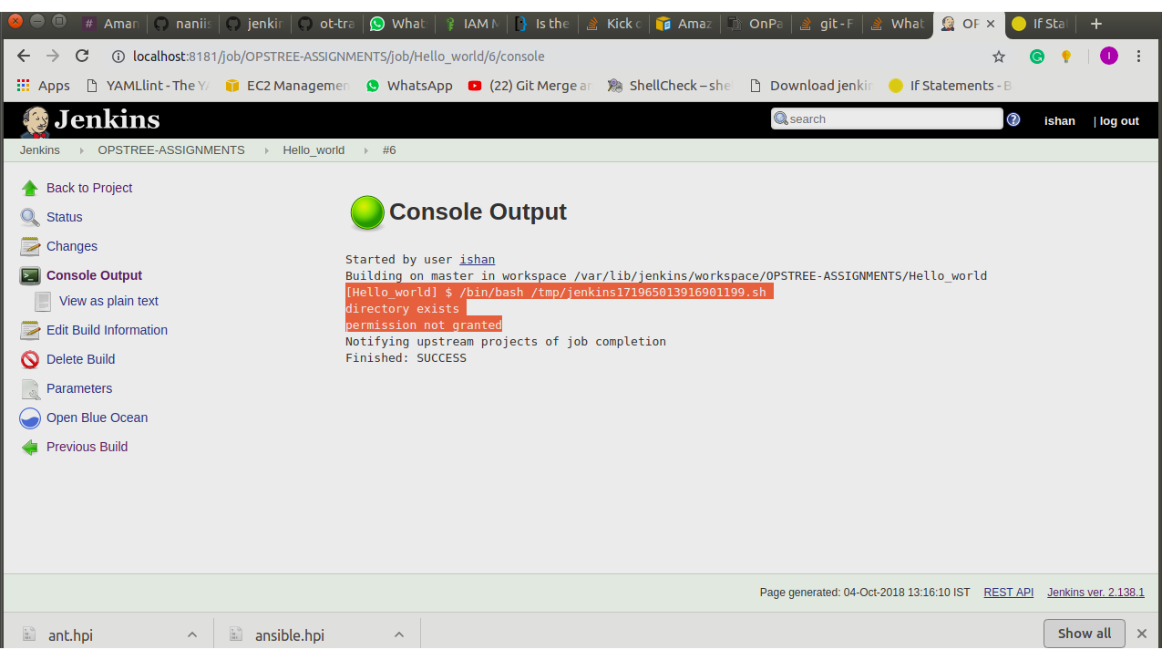
7. Create a job to clone your jenkins repo and cat a file from it.

