ASSIGNMENT 02 JENKINS (4th October)

ASSIGNMENT 1

1. Setup unix based authentication.

2. Configure Matrix based authorization.

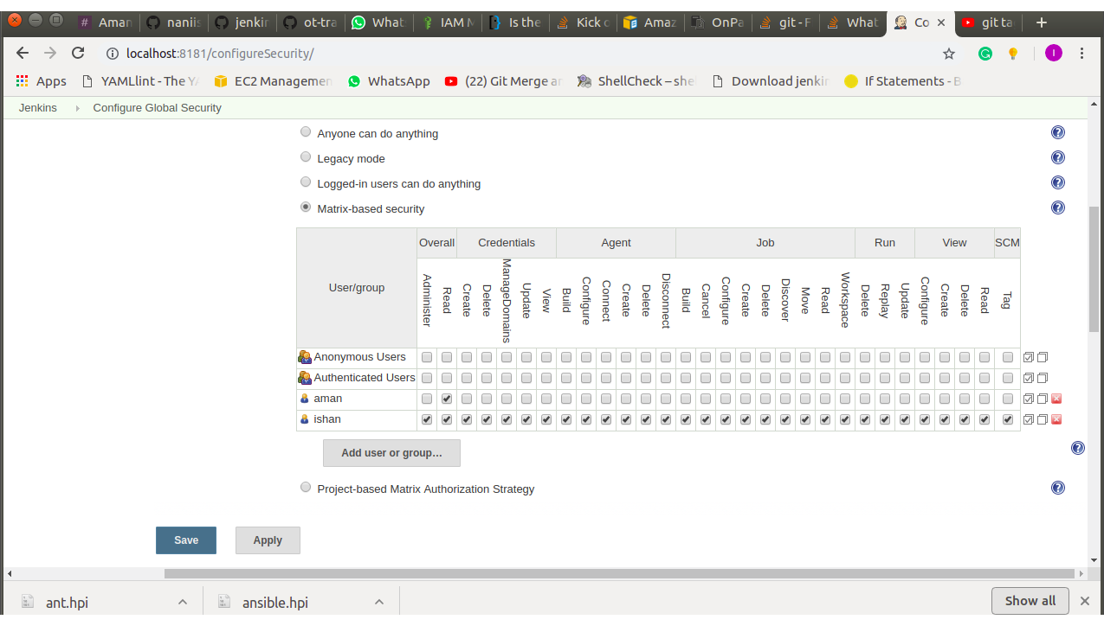
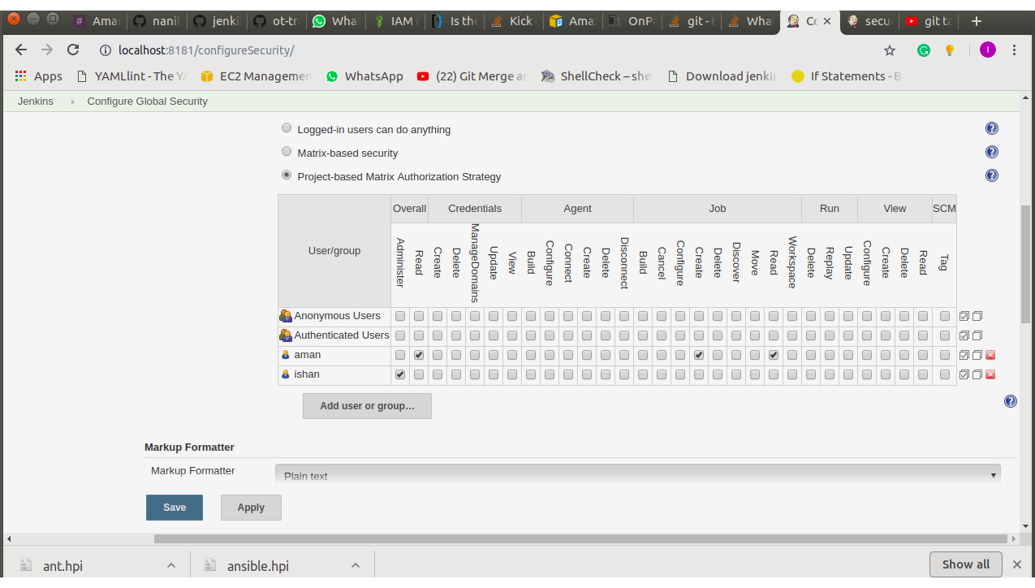
3. Implement project based matrix based authorization.

4. Configure SSO using gmail based login.

5. Setup a role based user authentication and autharization.
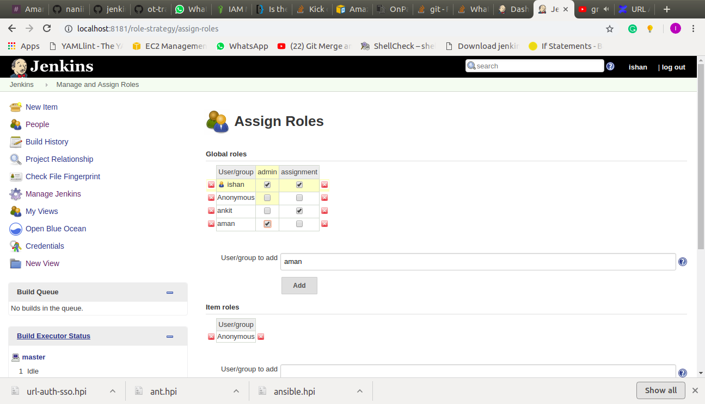
ASSIGNMENT 02
1. Setup email notification for each job failure only.
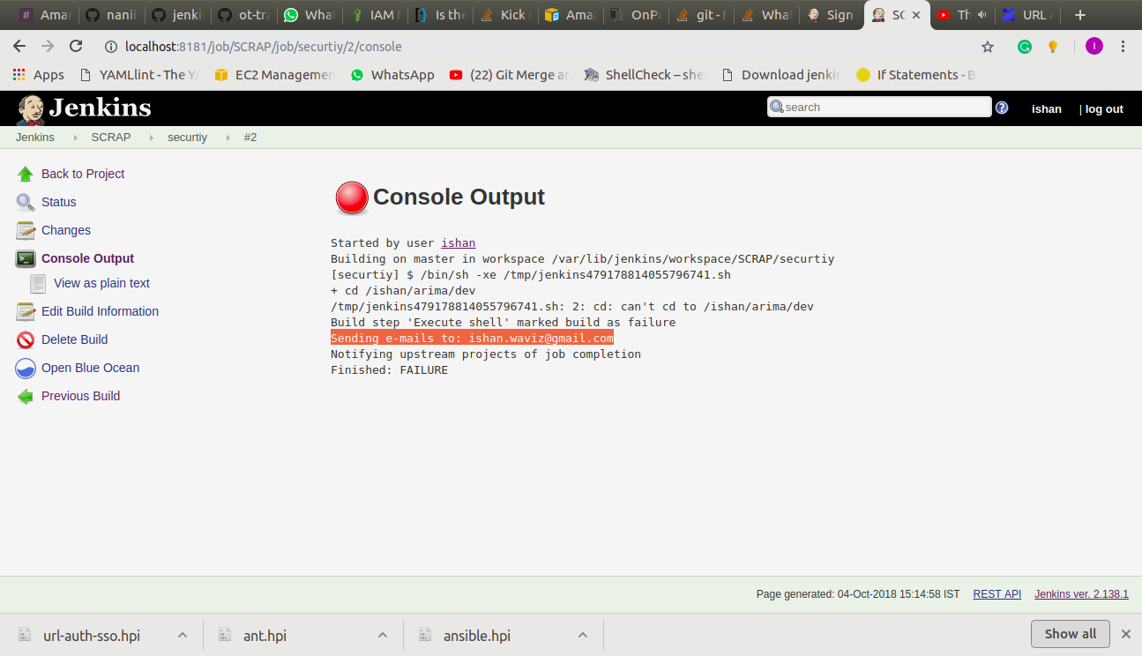

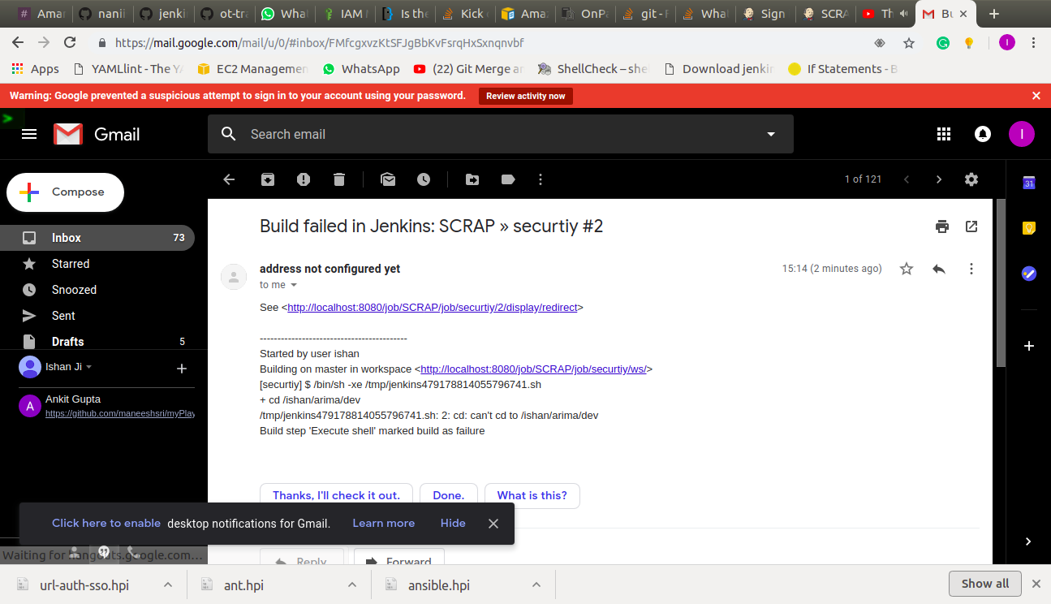

2. Send jenkins console logs in mail not as attachement but as plain text.
Write $BUILD_LOG in editable email, in settings.
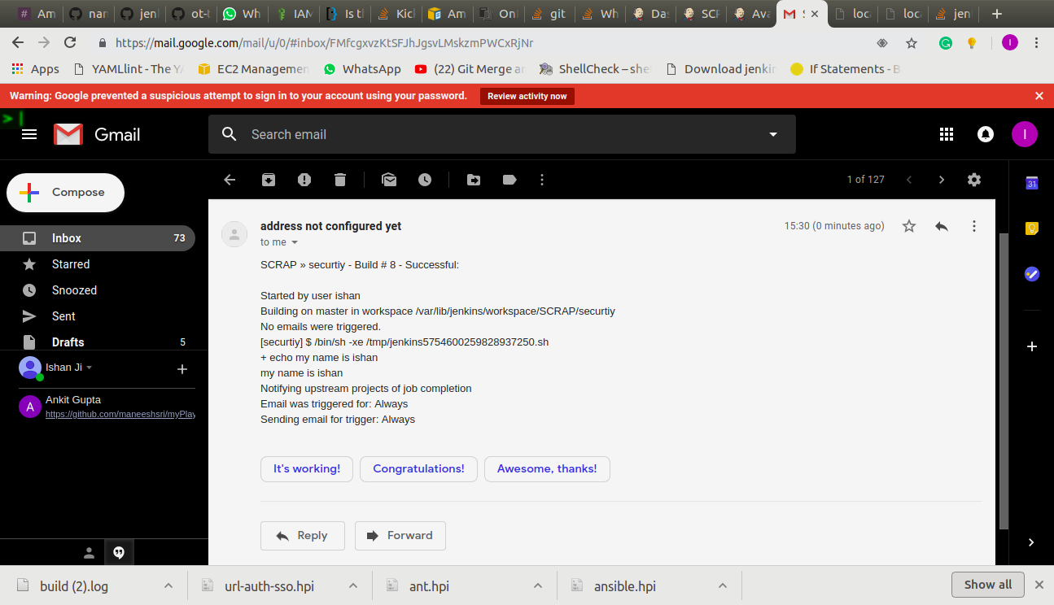

3. Enable slack integration for jenkins jobs build notifications.
Copy Base URL and API token from slack and paste it to the settings in JENKINS.
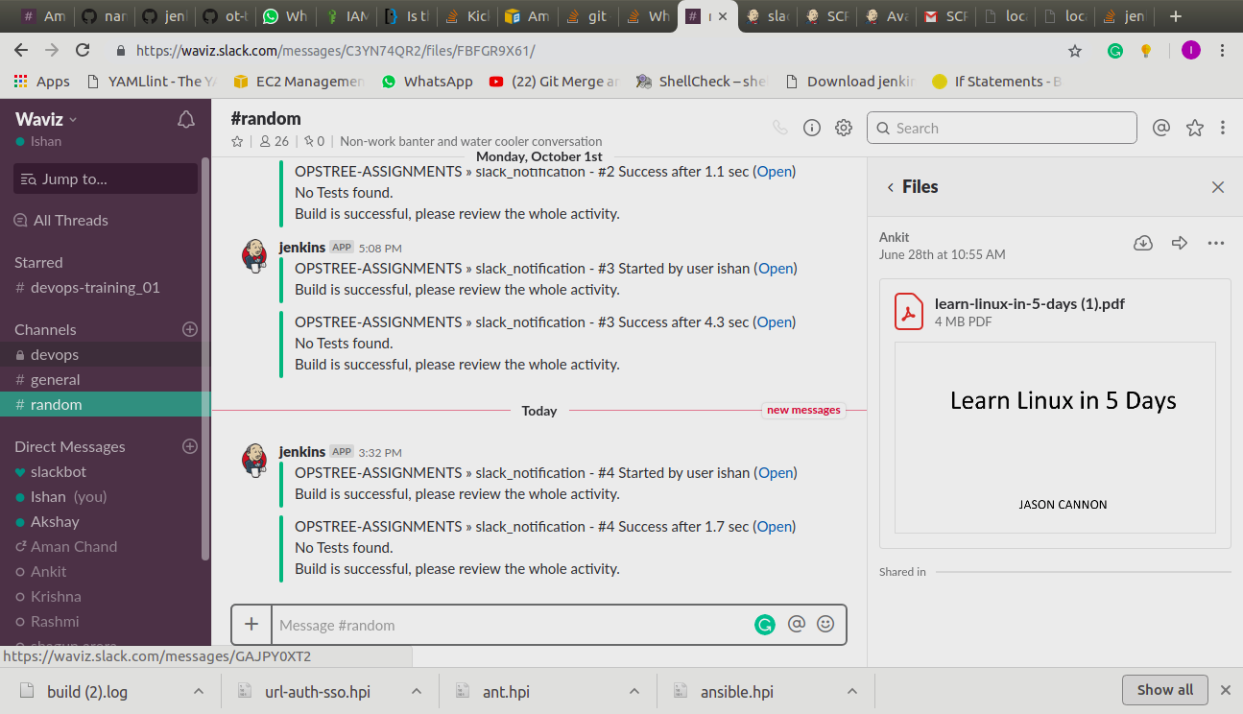

ASSIGNMENT 03
1.

