ASSIGNMENT 03 JENKINS (4th October)

ASSIGNMENT 1

1. Installed all the metioned plugins :
- Maven integration plugin
- Checkstyle Plug-in
- FindBugs Plug-in
- Static Analysis Collector Plug-in
- Cobertura Plugin

Configured Maven 3.5.2, JDK 8u162 in GLOBAL TOOL CONFIGURATION in JENKINS and installed GIT using command in LINUX.
1. Setup CodeStability Job,
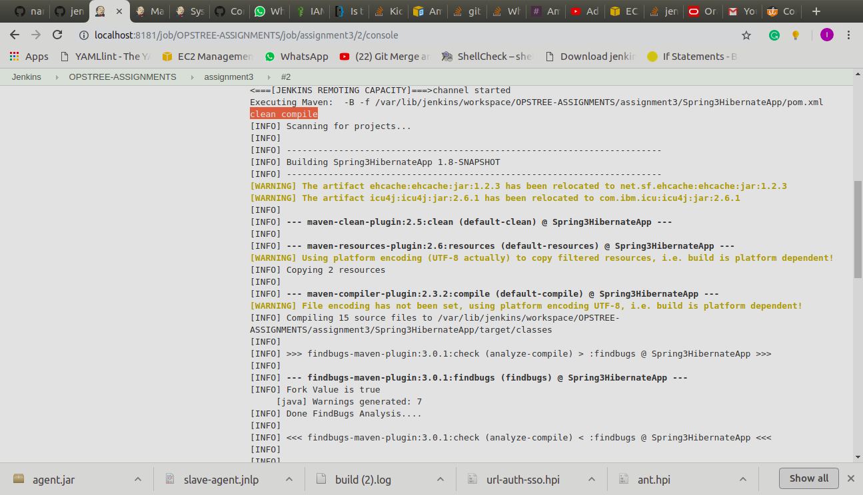
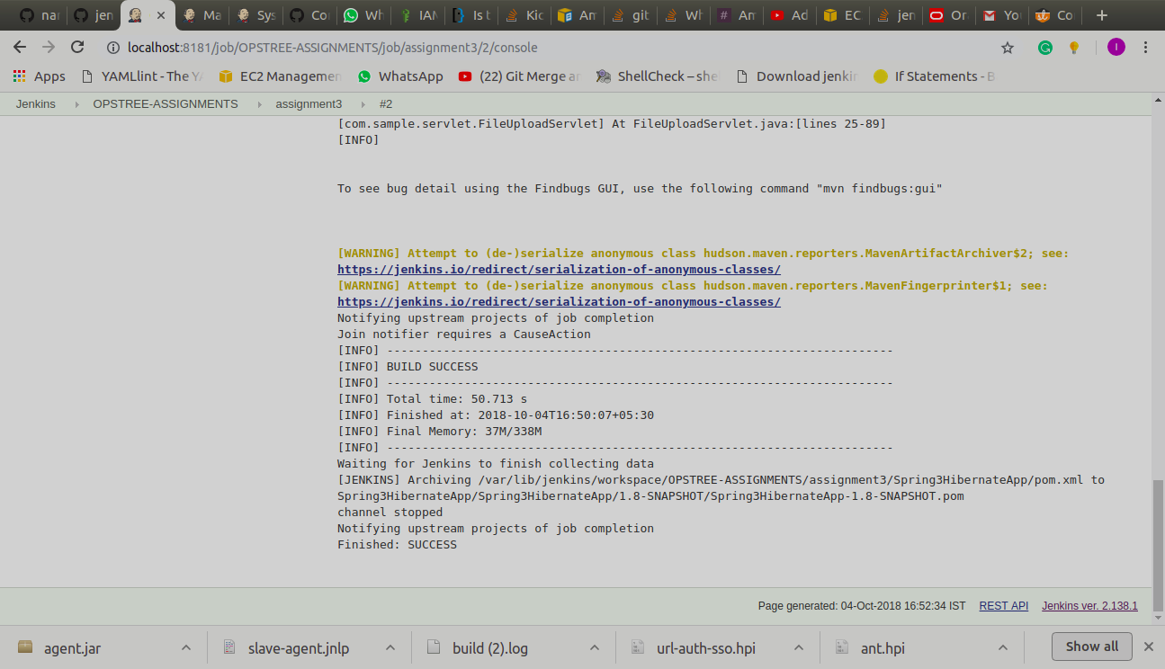
2. Setup static code analysis Job

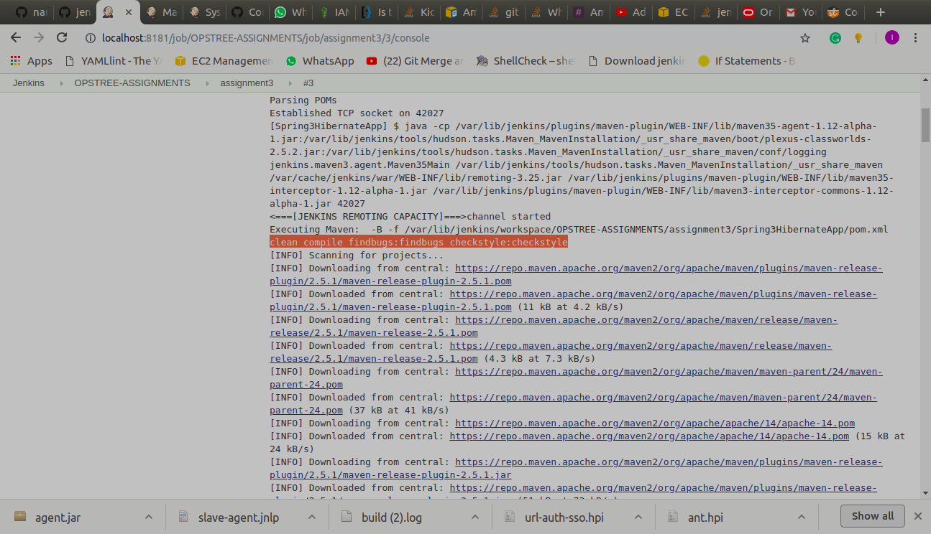
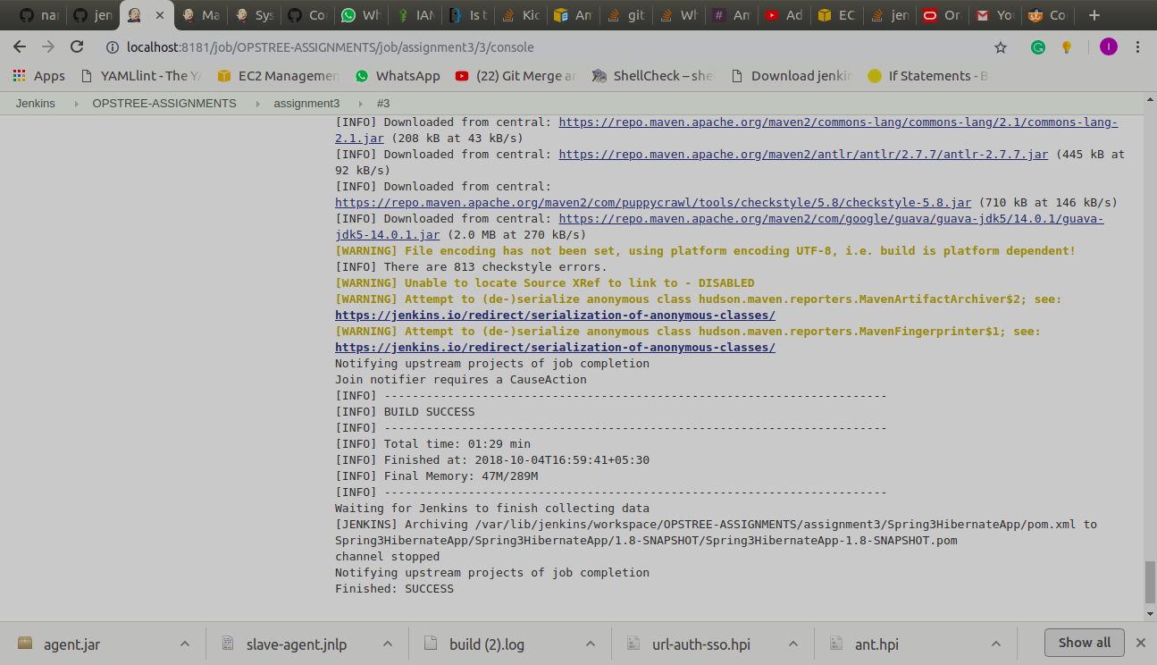

3. Setup code coverage Job
