ASSIGNMENT 4 JEKNINS (5th October)

1. Install Nginx
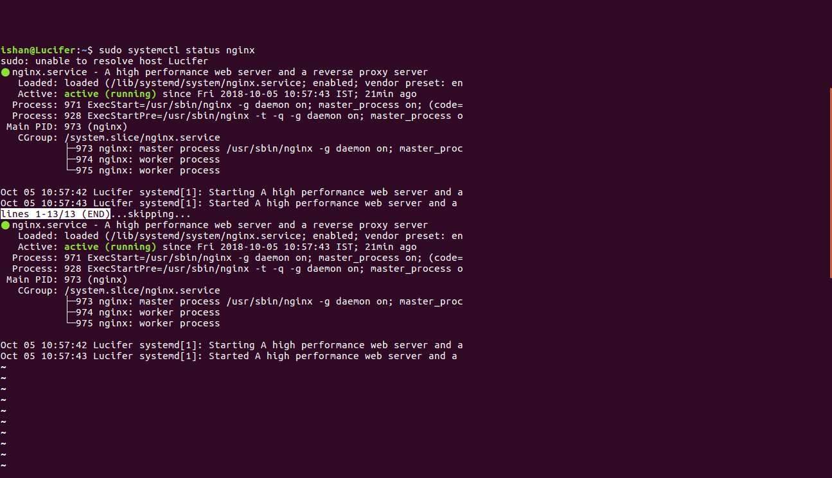
2. Installed GIT and SSH plugin in Jenkins.

3. Enable password less login between jenkins & root user

