ASSIGNMENT 5 (JENKINS) 4th October

1. helloworld Job.
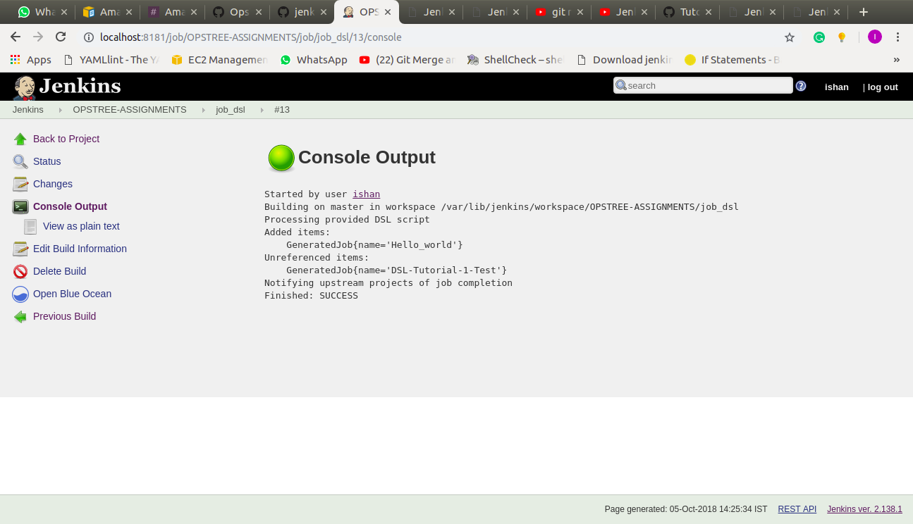
2. hellotoperson Job (Take SALUTATION as choice parameter & NAME as string parameter)

3. Gitclone and list content of cloned directory
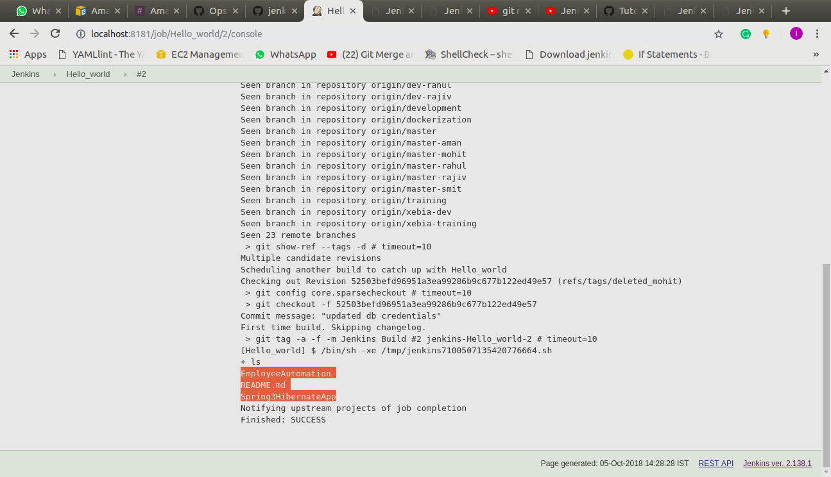
4. buildperiodically Job (This job will run by every 5 min)
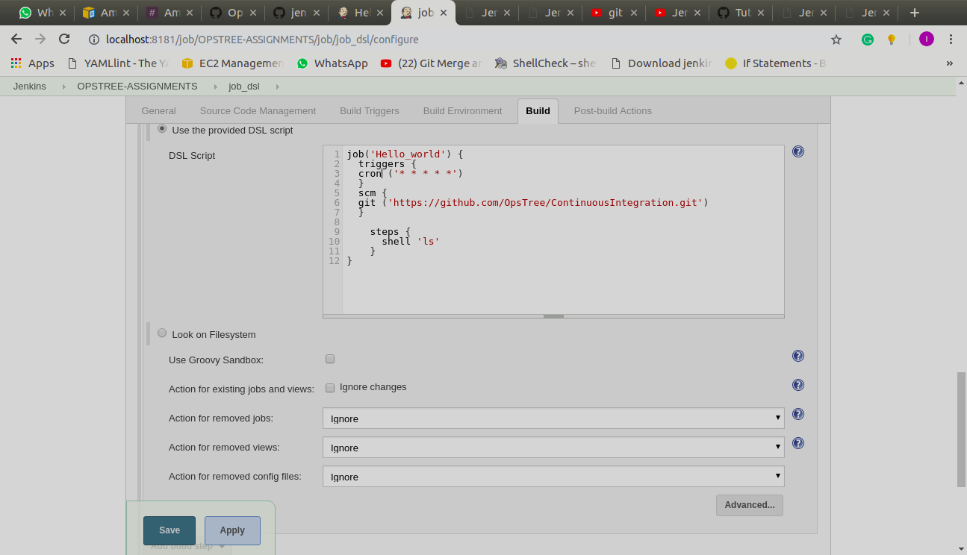
5. pollscm Job (This job will have a poll interval of 2 min)
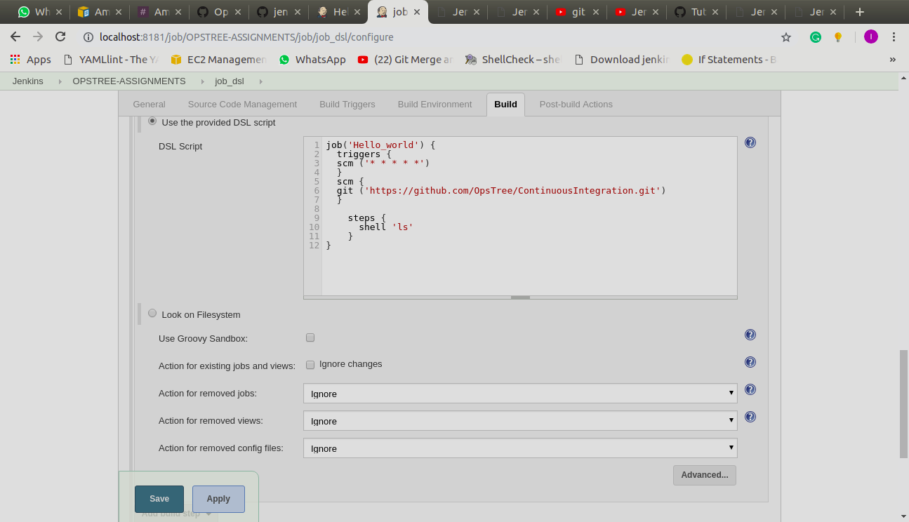

6. upstream Job (This job have helloworld job as upstream)
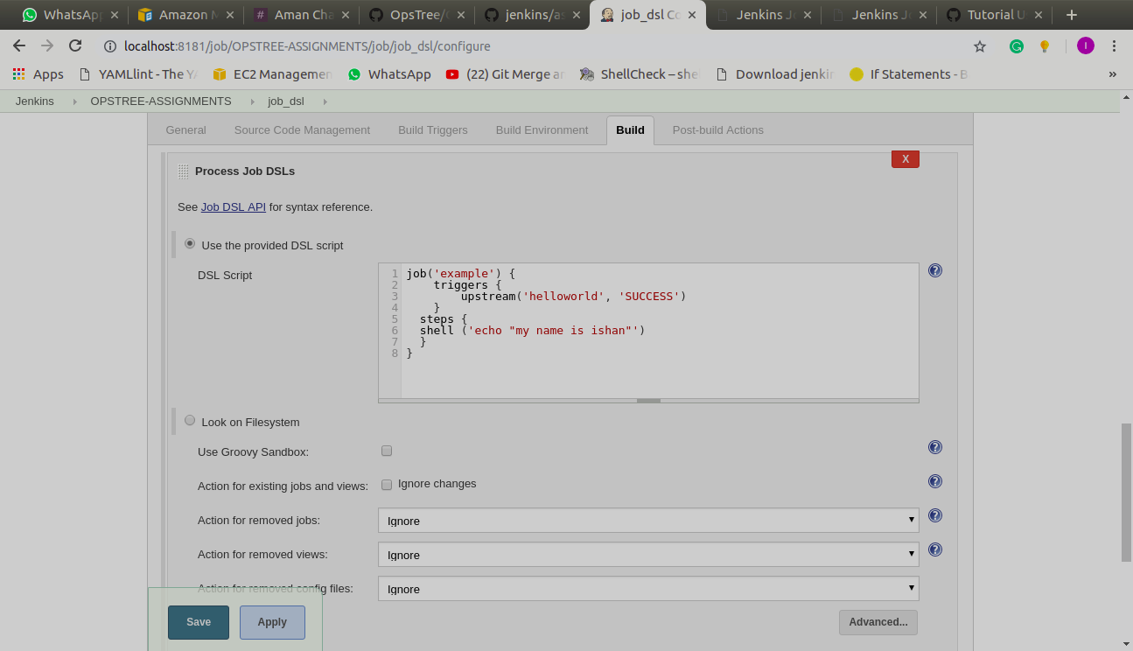
7. downstream Job ( This job have hellotoperson job as downstream. Note: Pass variable(SALUTATION & NAME) from this job to hellotoperson job.)
