ASSIGNMENT 6 JENKINS (5th October)

1. Create a scripted pipeline that will containe different stages of a CI/CD pipeline. Include all CI and CD jobs.
node {
stage('git'){
git 'https://github.com/daticahealth/java-tomcat-maven-example.git'
}
stage('mvn package'){
sh '''
mvn clean package'''
}
stage('deploy to tomcat'){
sh 'cp **/*.war /home/ishan/Downloads/apache-tomcat-8.5.34/webapps/'
}
}
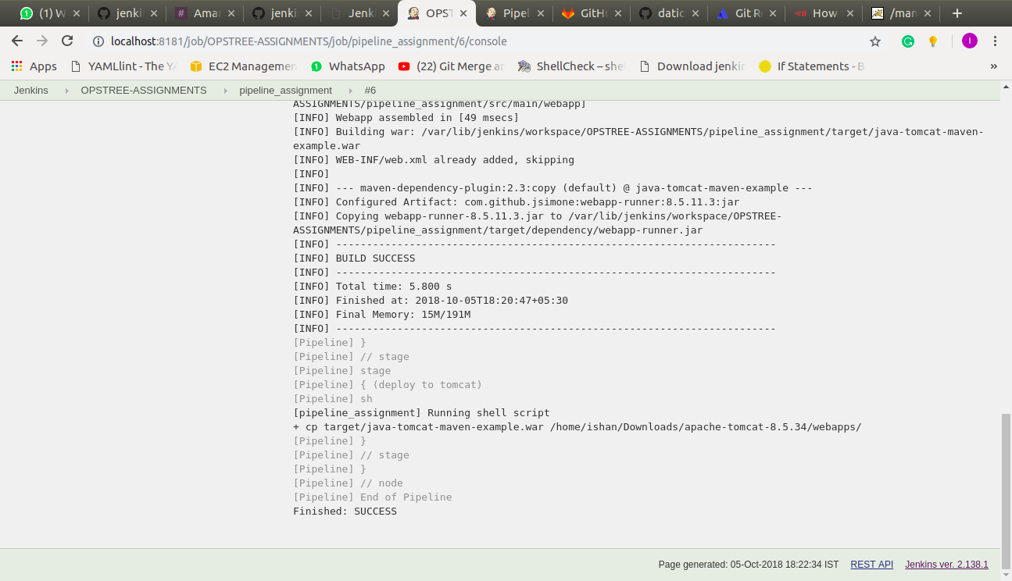

2. Insert manual approval before deployment job.

