ASSIGNMENT 03 LINUX

1. Make a script and pass one command line arguments(use loop)
print the table of command line argument if value is less 10
print 5 times "INDIA" if value is greater than or equal to 10

#!/bin/bash
echo "enter any number"
read -p "NUMBER:" number
if [ $number -lt 10 ]
then
for (( i=1;i<=10;i++))
do
t=$(($number*i))
echo $t
done
else
for(( i=1;i<=5;i++ ))
do
echo "INDIA"
done
fi
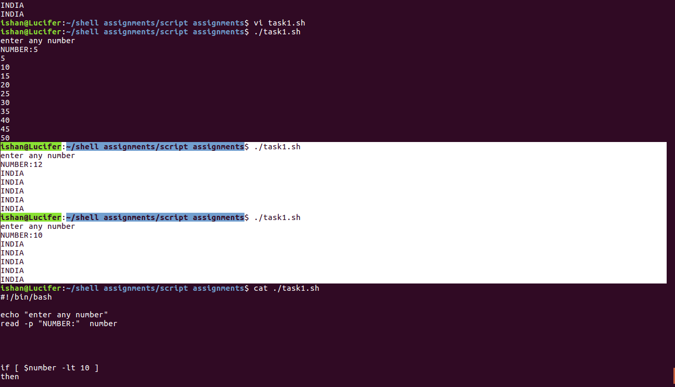

2. Make a script and pass 5 command line arguments (arguments value should be interger)
#!/bin/bash
echo $1,$5
if [ $2 -eq 10 ]
then
echo INDIA
else
echo india
fi
sum=$(($1+$2+$3+$4+$5))
echo $sum

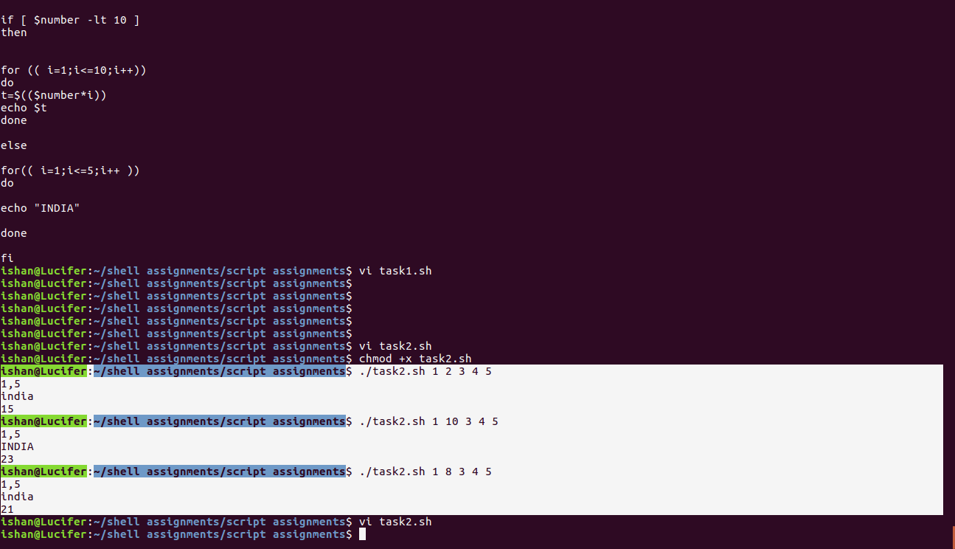
3. Make a script and print your name 10 times(use fuction to print your name

#!/bin/bash
echo "enter your name"
read ishan
name () {
echo $ishan
}

for (( i=0;i<=10;i++ ))
do
name
done

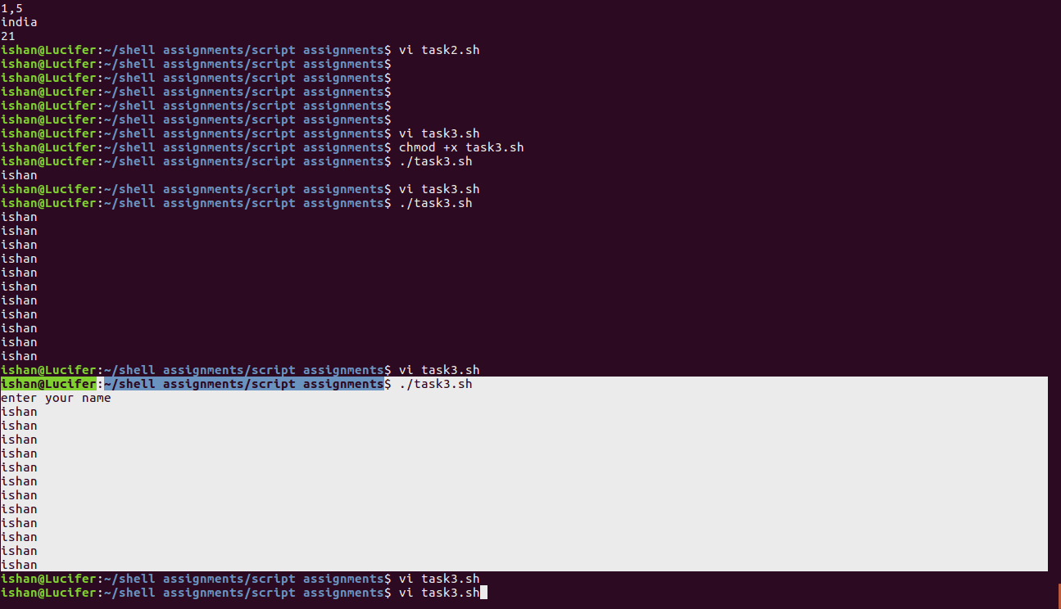
4. Make a excel sheet manually with 5 column, and print the 1st,3rd and 5th column

the file excel.csv was created manually, to get the desired output following is issued,

cat excel.csv | sed 's/,/ /g' | awk {'print $1" "$3" "$5'}

5. Install the zabbix-agent using shell script

sudo apt-get update
sudo apt-get install zabbix-agent -y
sudo systemctl start zabbix-agent
sudo sed -i 's/Server=127.0.0.1/Server=zabbix.opstree.com/' /etc/zabbix/zabbix_agentd.conf
sudo sed -i 's/Hostname=Zabbix/Hostname=192.168.0.20-zabbixagent/' /etc/zabbix/zabbix_agentd.conf
sudo service zabbix-agent restart

6. Make a script in which you will pass a git repo path and it will generate a html report of last 5 days commits.

7. Print "Enter any charcter you want to print”
Read input from the user (say mychar variable)
Print "Enter no of times you want to print {{Character }} " -----> value of character should be printed
Read input from the user (say n variable)
Print the mychar variable n no of times using for loop
#!/bin/bash

echo "enter any charater you want to print"
read mychar
echo "enter the no. of times you want to print the character"
read n
for (( i=1;i<=$n;i++ ))
do
echo $mychar
done

