ASSIGNMENT 01 LINUX (4th October)

1. Install and configure apache/httpd

installed apache2 through apt-get
changed the port from default 80 to 8081 in /etc/apache2/ports.conf
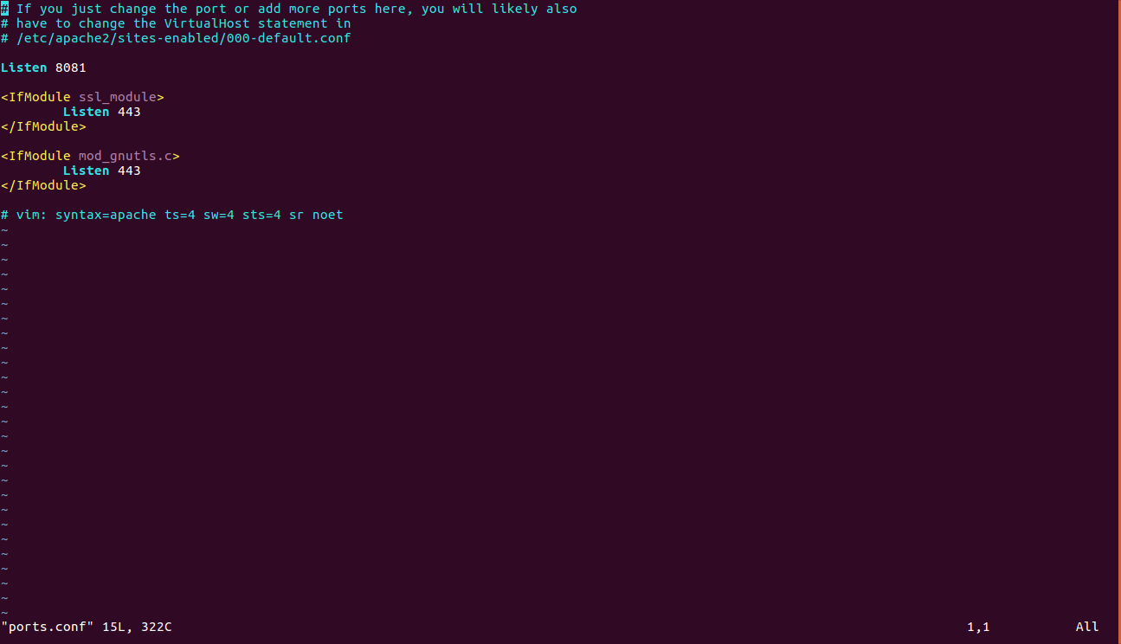
2. Install and configure nginx - configure it to run as reverse proxy to apache

3. Install and configure 'ntp' - with singapore time zone.
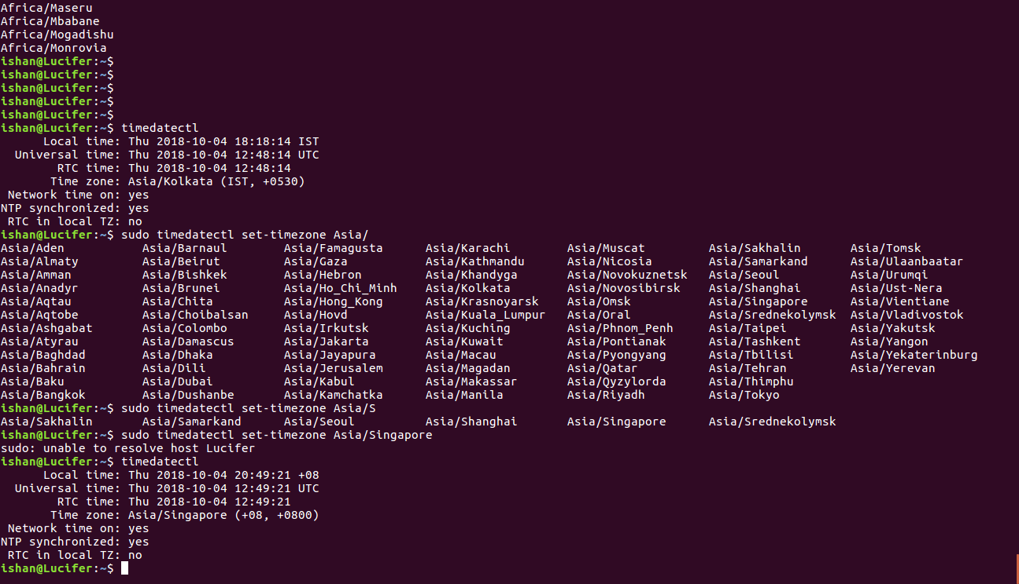
4. Install Tomcat version 8 (a brief explaination about the it's directories in doc)
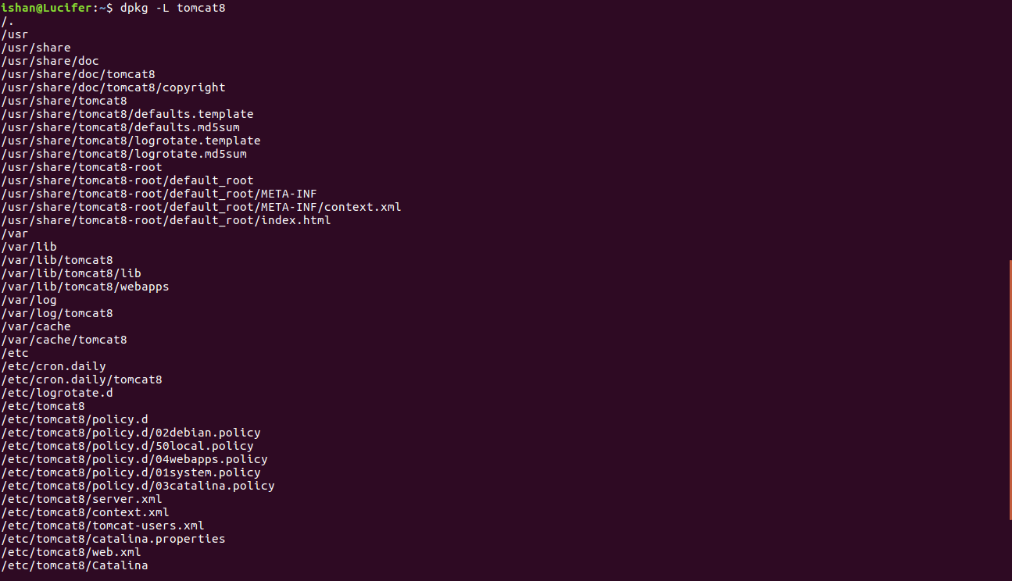
/bin- it contains executable files of tomcat, we can start, stop etc., tomcat from this file.
/conf-it contains configuration files, we can change the default port and can create users in this.
/webapps- the .war file are kept here, and automatically it gets deployed.
/logs- it contains various logs of tomcat,
5. Install java version 8 with home directory set as an environment variable
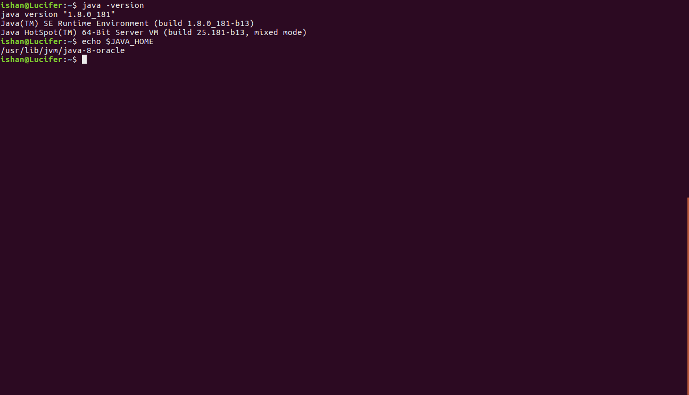
6. Install 'build essentials' (mention in doc that why do we need it )
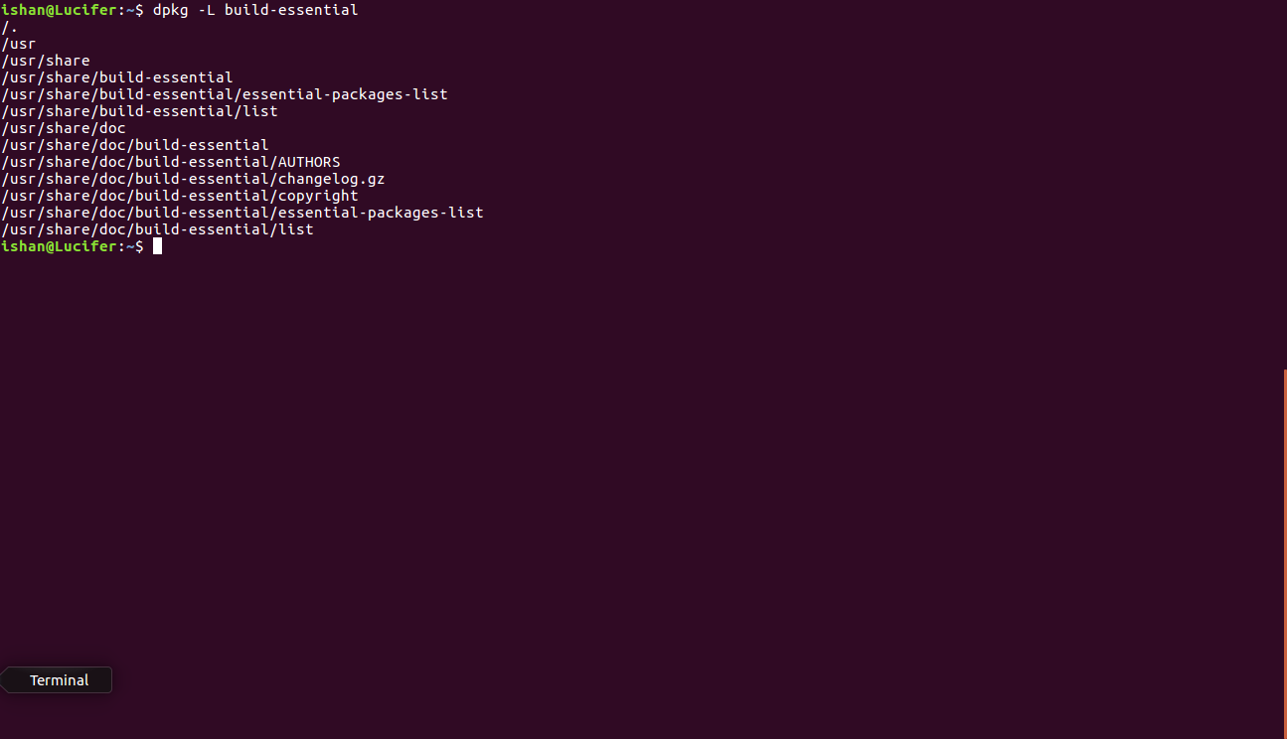
The build-essentials package is a reference for all the packages needed to compile a Debian package. It generally includes the GCC/g++ compilers and libraries and some other utilities.

7. Install logrotate and rotate tomcat's catalina.out log

