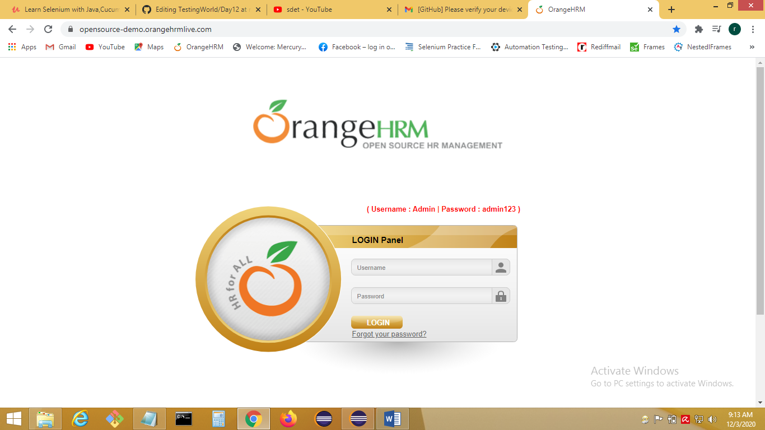

Source Code

**import** org.openqa.selenium.By;

**import** org.openqa.selenium.chrome.ChromeDriver;

**public** **class** Demo {

**public** **static** **void** main(String[] args) {

System.*setProperty*("webdriver.chrome.driver", "C://Drivers//chromedriver_win32/chromedriver.exe");

ChromeDriver driver = **new** ChromeDriver();

driver.get("https://opensource-demo.orangehrmlive.com/");

driver.manage().window().maximize();

driver.findElement(By.*id*("txtUsername")).sendKeys("Admin");

driver.findElement(By.*name*("txtPassword")).sendKeys("admin123");

driver.findElement(By.*name*("Submit")).click();

driver.close();

}

}

package day11;

import org.openqa.selenium.By;

import org.openqa.selenium.WebDriver;

import org.openqa.selenium.WebElement;

import org.openqa.selenium.chrome.ChromeDriver;

import org.openqa.selenium.firefox.FirefoxDriver;

import org.openqa.selenium.ie.InternetExplorerDriver;

/*1) Open Web Browser(Chrome/IE/firefox).

2) Open URL https://opensource-demo.orangehrmlive.com/

3) Enter username (Admin).

4) Enter password (admin123).

5) Click on Login.

6) Capture title of the home page.

7) Verify title of the page: OrangeHRM

8) Close browser

*/

public class LoginTest_OrangeHRM {

public static void main(String[] args) {

//1) Open Web Browser

//Chrome browser

System.setProperty("webdriver.chrome.driver", "C://Drivers//chromedriver_win32/chromedriver.exe");

WebDriver driver=new ChromeDriver(); //ChromeDriver driver=new ChromeDriver(); //Launch the chrome browser

//Firefox browser

//System.setProperty("webdriver.gecko.driver", "C://Drivers//geckodriver-v0.23.0-win64/geckodriver.exe");

//WebDriver driver=new FirefoxDriver(); //Launch the firefox browser

//IE

//System.setProperty("webdriver.ie.driver", "C://Drivers//IEDriverServer_Win32_3.14.0/IEDriverServer.exe");

//WebDriver driver=new InternetExplorerDriver();

//2) Open URL https://opensource-demo.orangehrmlive.com/

driver.get("https://opensource-demo.orangehrmlive.com/");

//3) Enter username (Admin).

//WebElement usernametxt=driver.findElement(By.id("txtUsername"));

//usernametxt.sendKeys("Admin");

driver.findElement(By.id("txtUsername")).sendKeys("Admin");

//4) Enter password (admin123).

driver.findElement(By.name("txtPassword")).sendKeys("admin123");

//5) Click on Login.

driver.findElement(By.name("Submit")).click();

//6) Capture title of the home page.

String act_title=driver.getTitle(); // capture the title of cuurent page

String exp_title="OrangeHRM";

//7) Verify title of the page: OrangeHRM

if(act_title.equals(exp_title))

{

System.out.println("Test Passed");

}

else

{

System.out.println("Test Failed");

}

//8) Close browser

driver.close(); //driver.quit();

}

}