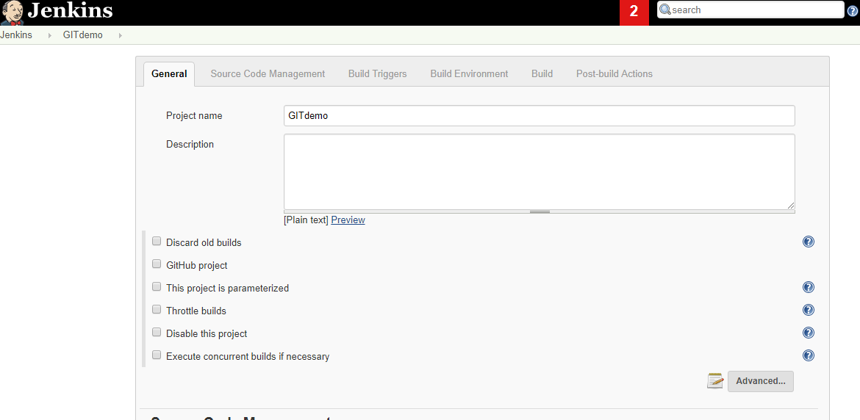

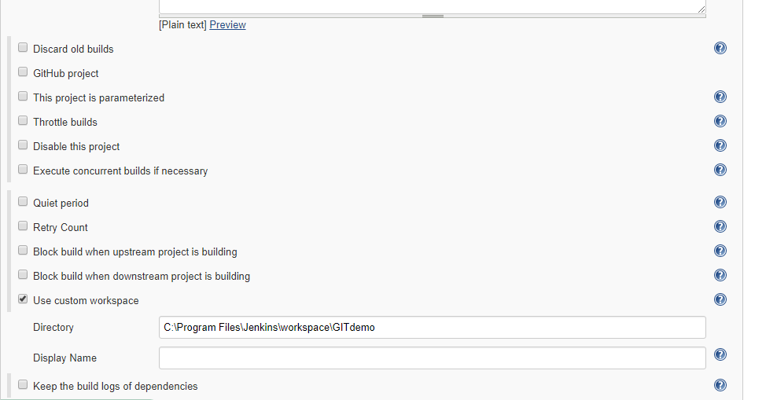

C:\Program Files\Jenkins\workspace\GITdemo

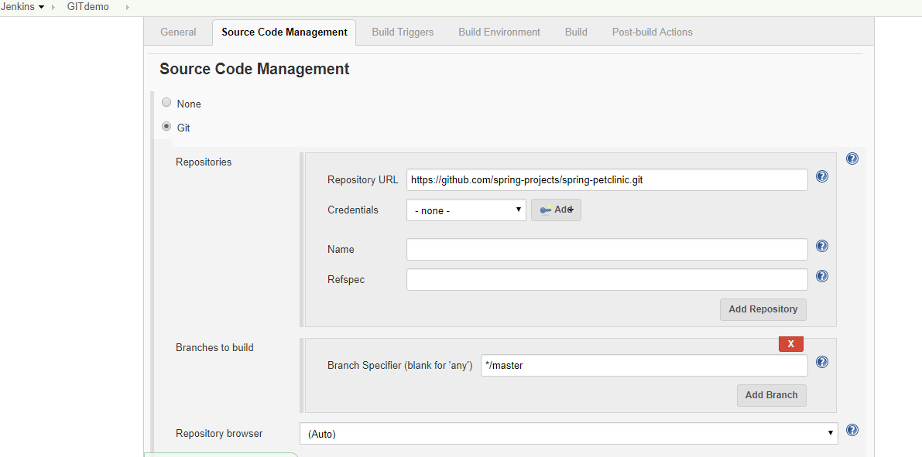

<https://github.com/spring-projects/spring-petclinic.git>

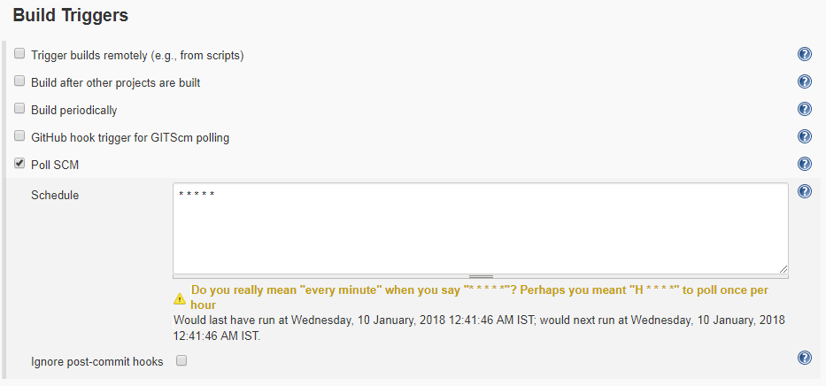

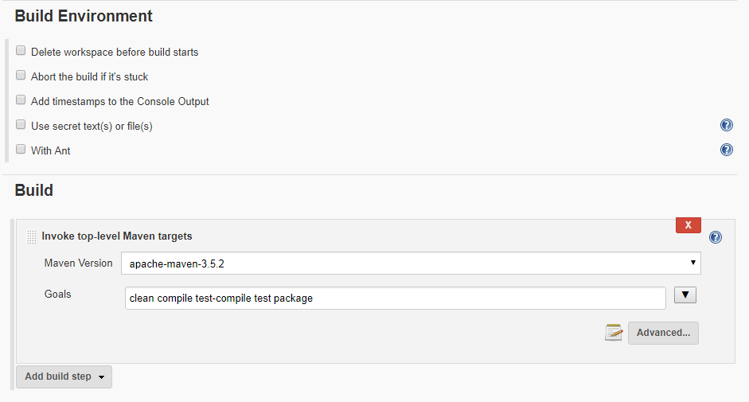

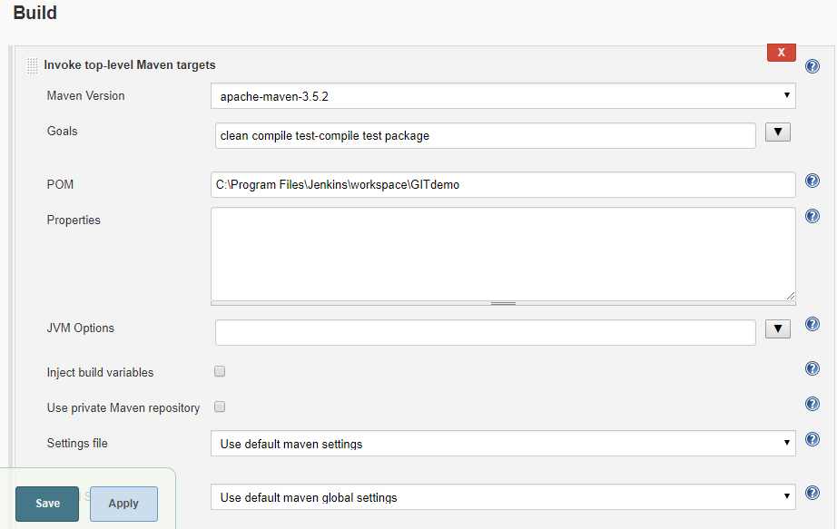

clean compile test-compile test package

C:\Program Files\Jenkins\workspace\GITdemo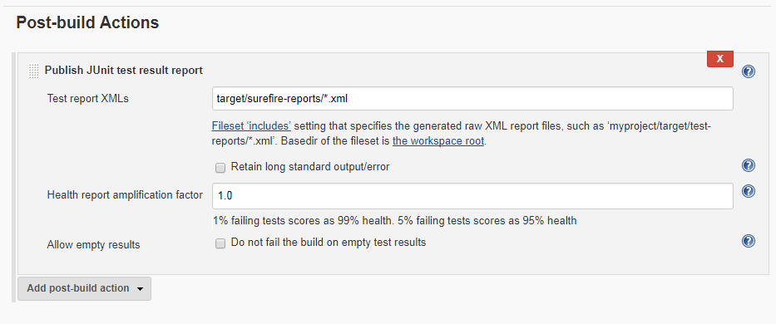

target/surefire-reports/*.xml

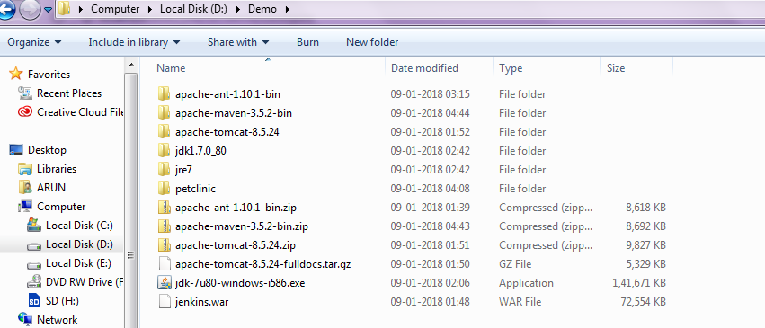

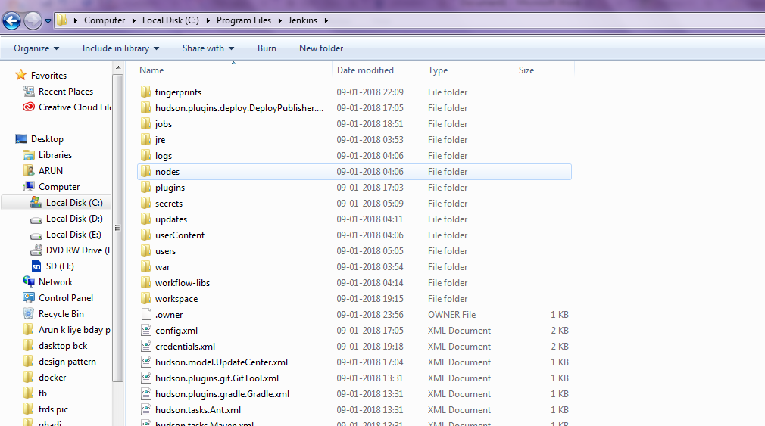

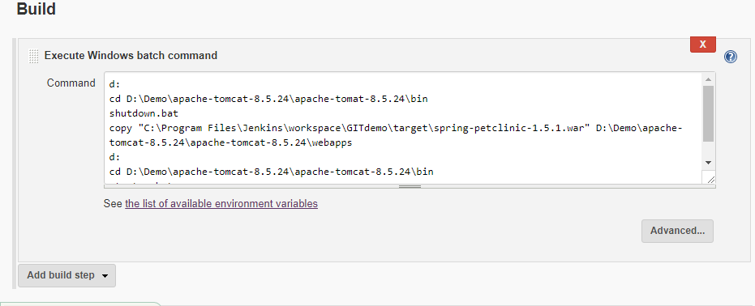

d:

cd D:\Demo\apache-tomcat-8.5.24\apache-tomat-8.5.24\bin

shutdown.bat

copy "C:\Program Files\Jenkins\workspace\GITdemo\target\spring-petclinic-1.5.1.war" D:\Demo\apache-tomcat-8.5.24\apache-tomcat-8.5.24\webapps

d:

cd D:\Demo\apache-tomcat-8.5.24\apache-tomcat-8.5.24\bin

startup.bat

Deploy plugin

Jenkins change port - jenkins.xml

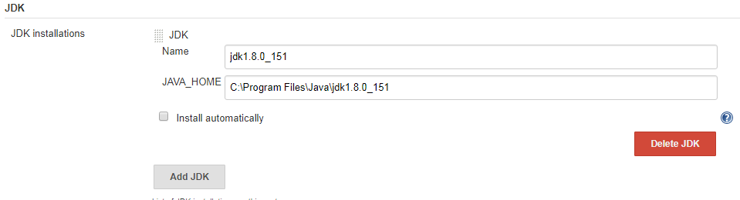

jdk1.8.0_151

C:\Program Files\Java\jdk1.8.0_151

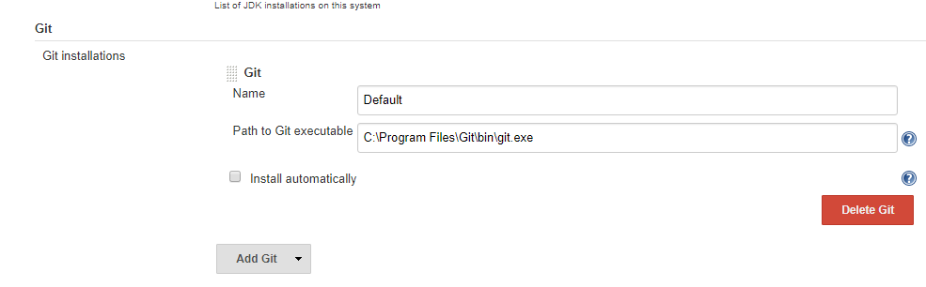

Default

C:\Program Files\Git\bin\git.exe

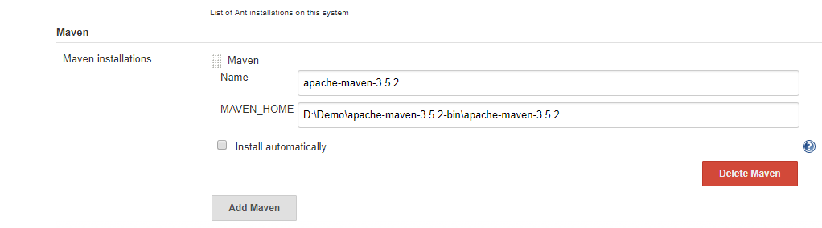

apache-maven-3.5.2

D:\Demo\apache-maven-3.5.2-bin\apache-maven-3.5.2



Configurations Jenkins:

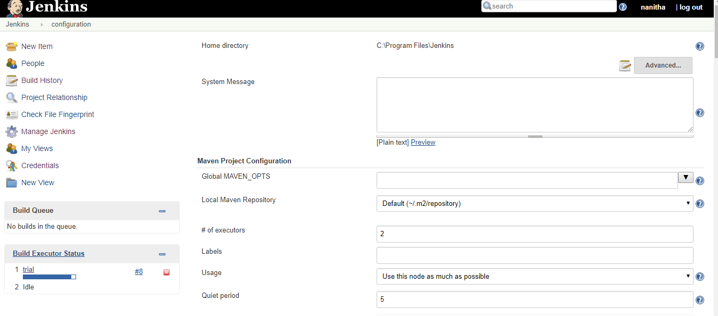

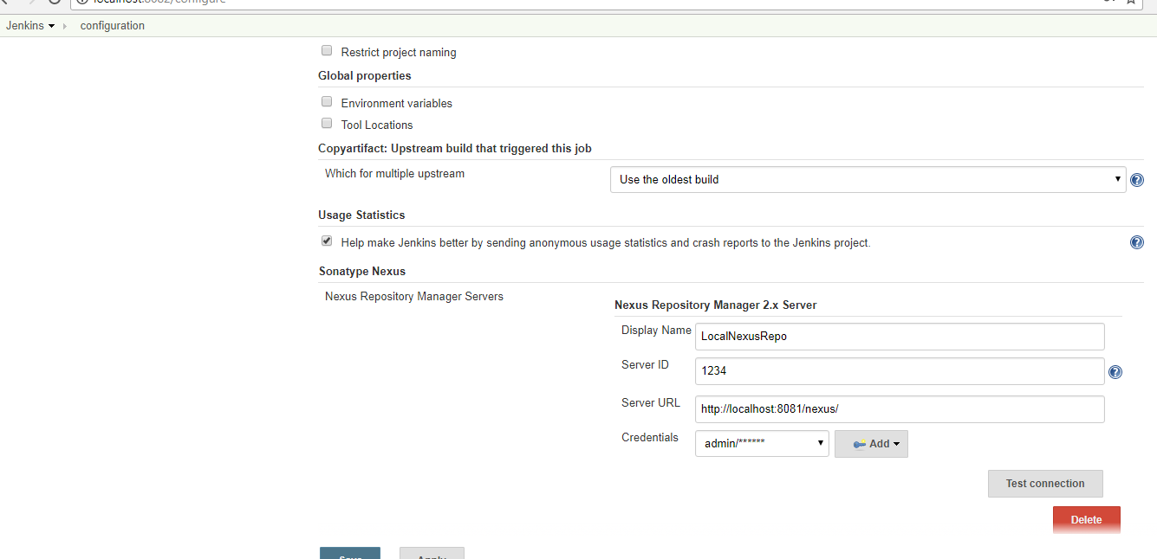

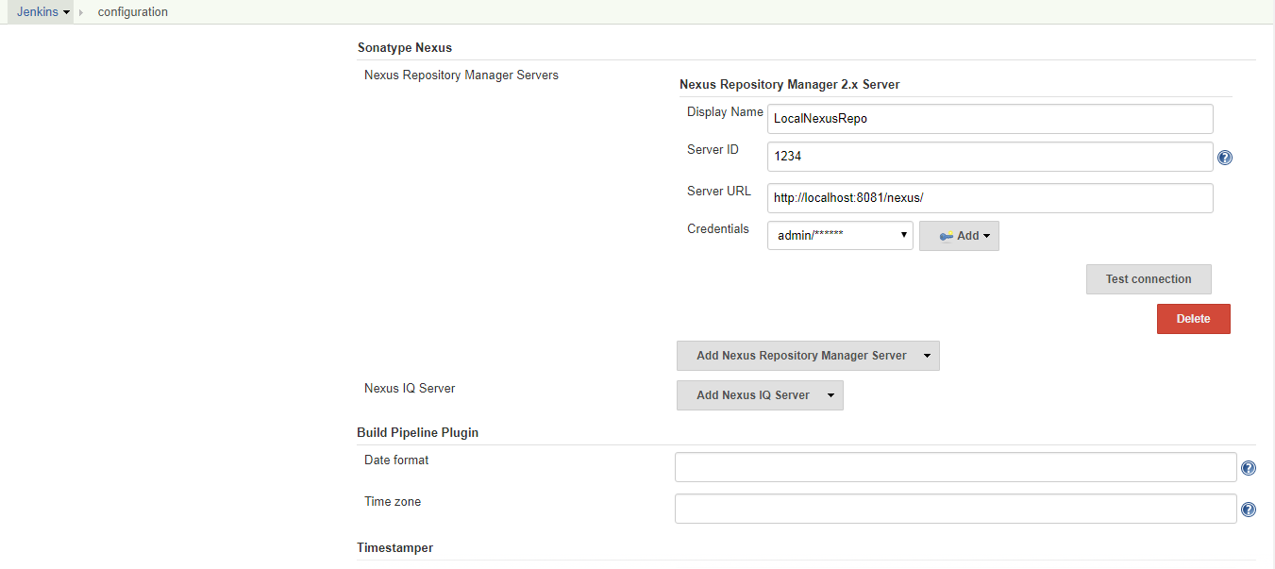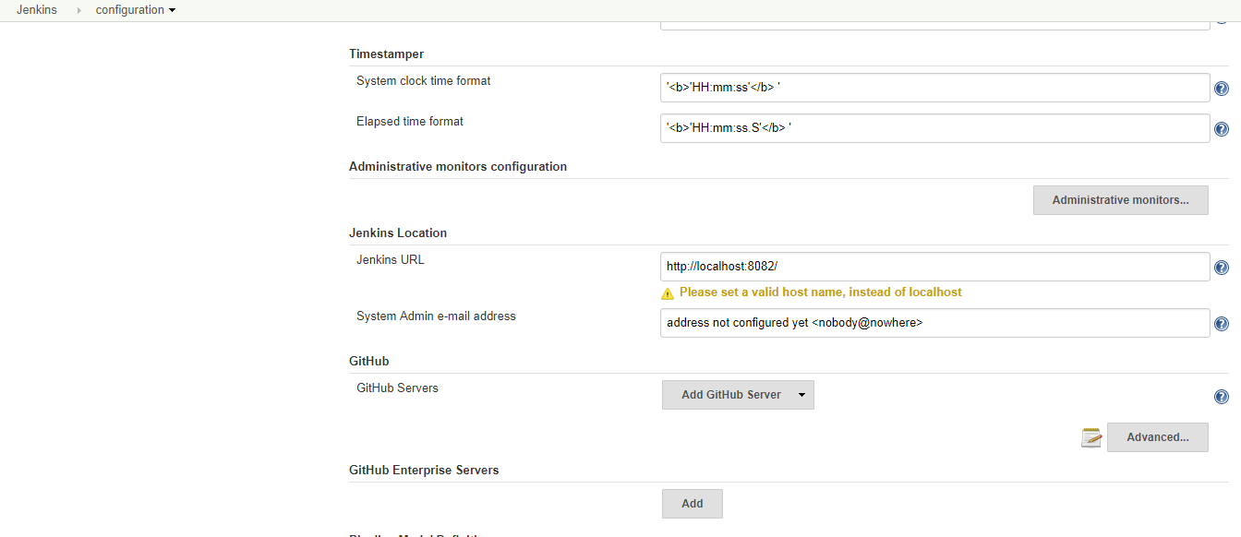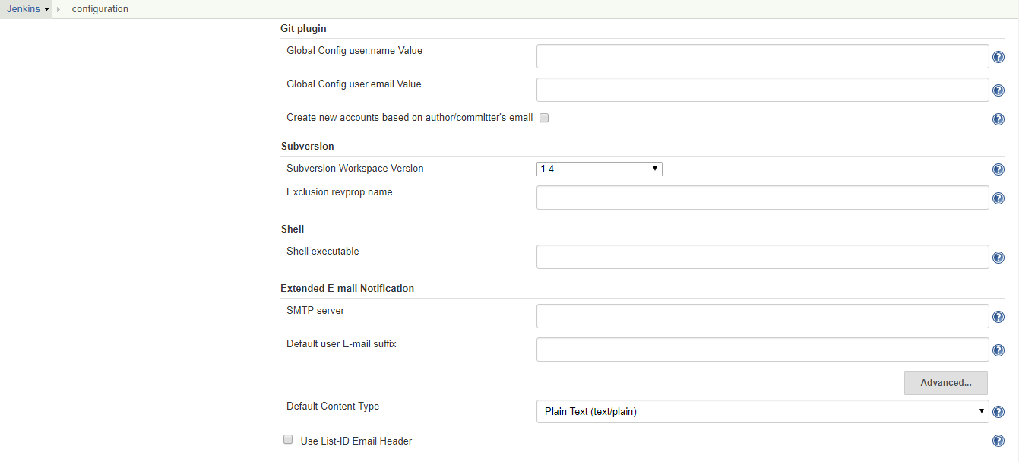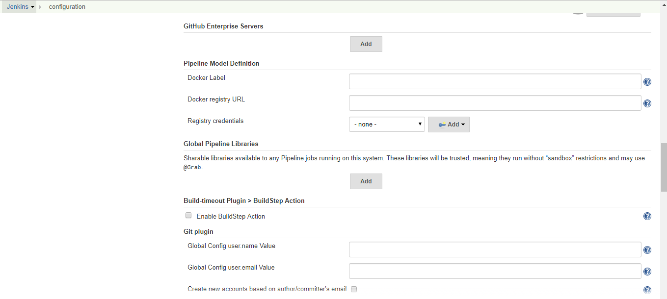



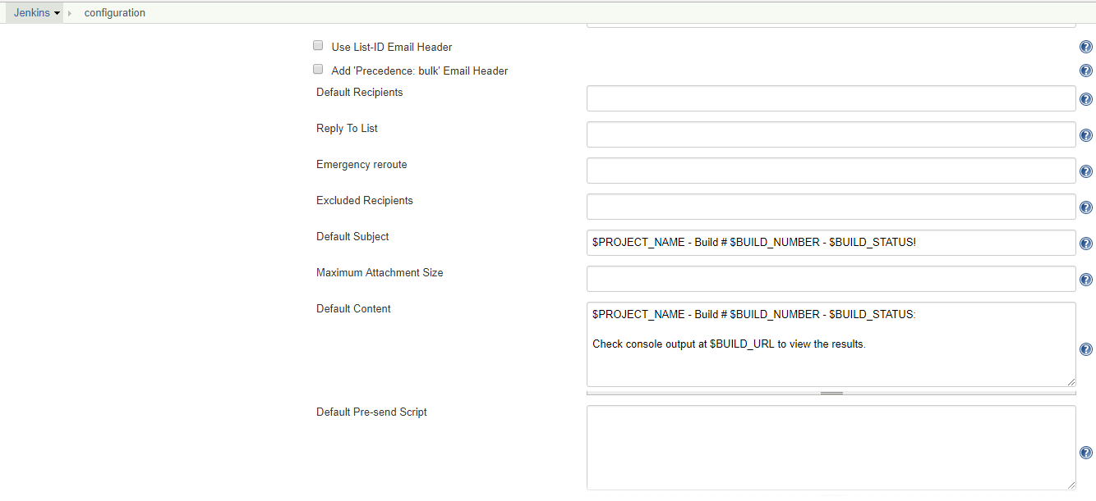

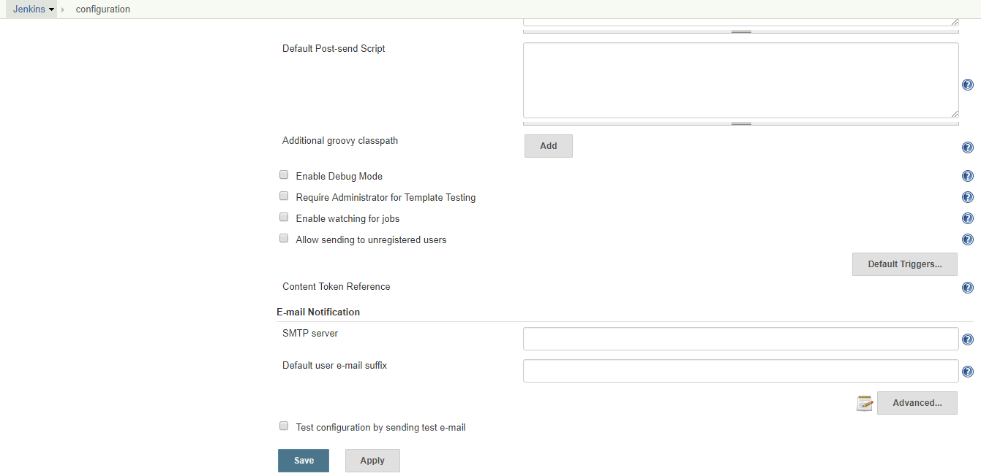

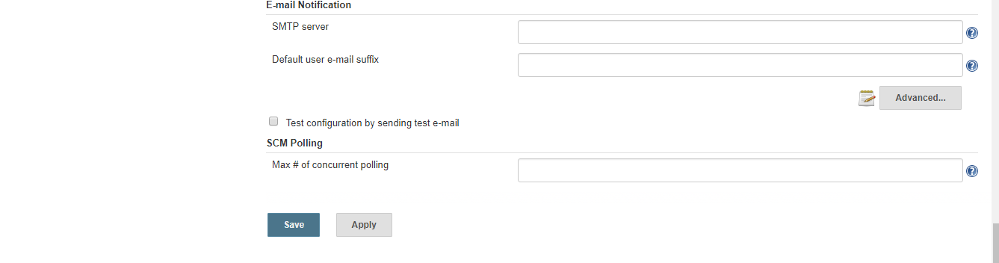

**Global Tool Configuration**

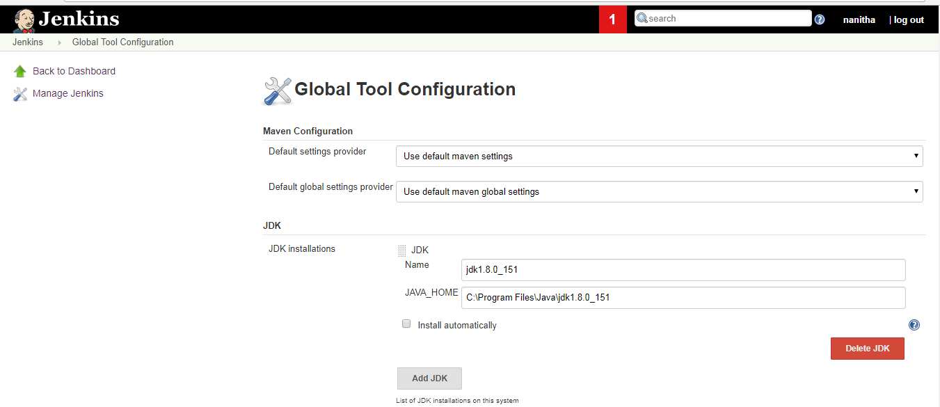

jdk1.8.0_151

C:\Program Files\Java\jdk1.8.0_151

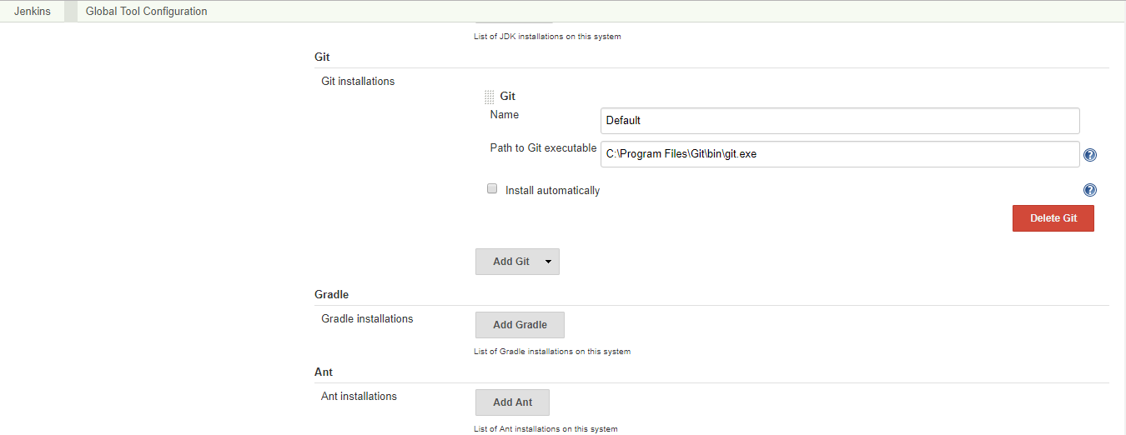

Default

C:\Program Files\Git\bin\git.exe

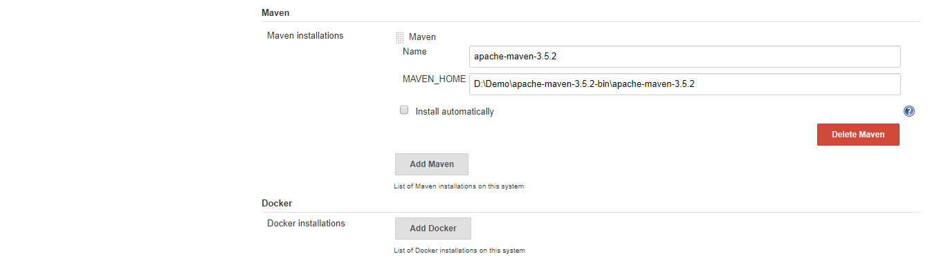

apache-maven-3.5.2

D:\Demo\apache-maven-3.5.2-bin\apache-maven-3.5.2

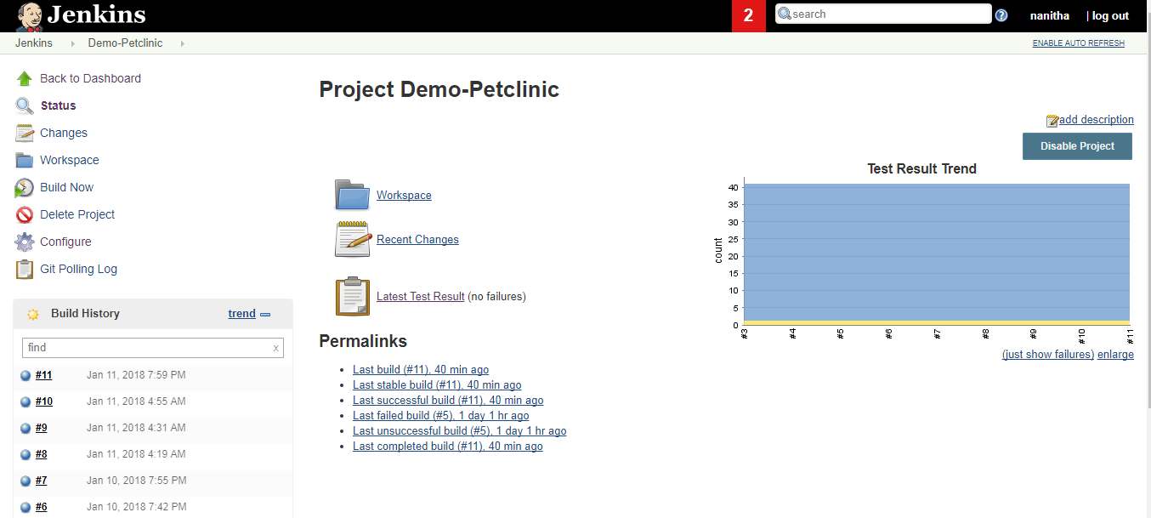

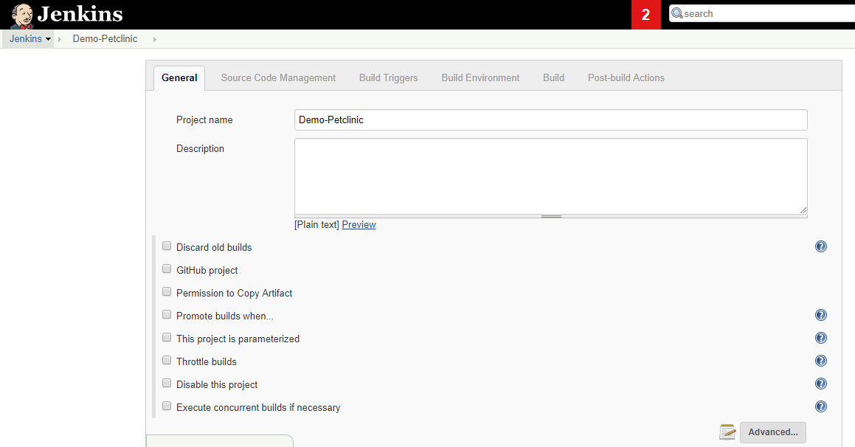

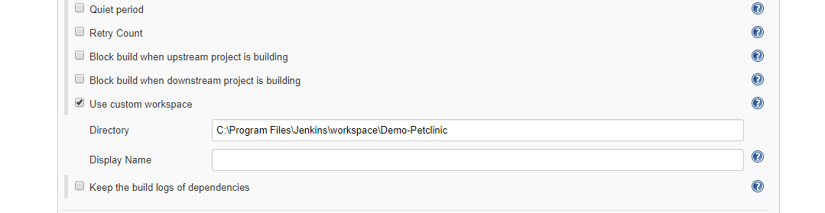

C:\Program Files\Jenkins\workspace\Demo-Petclinic

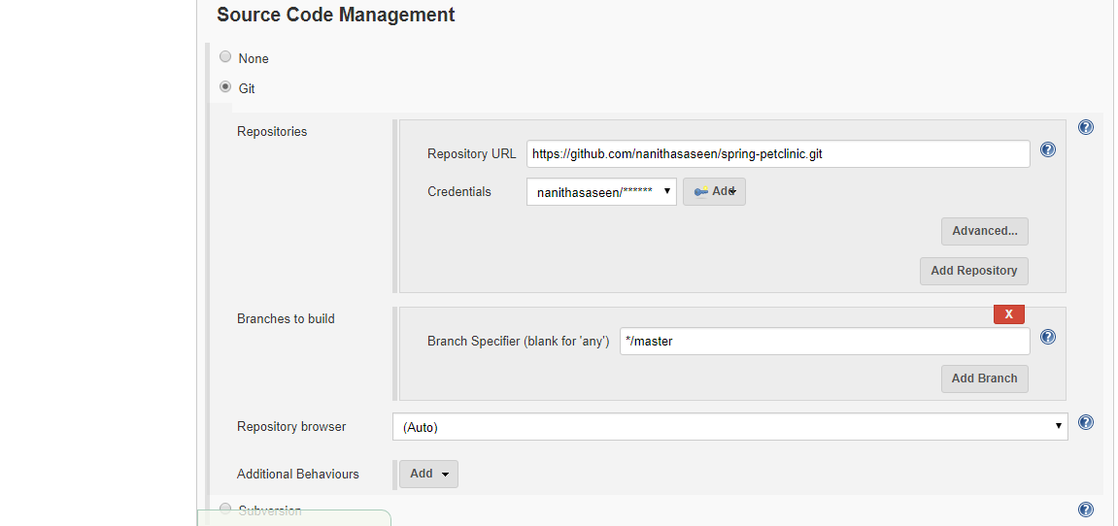

<https://github.com/nanithasaseen/spring-petclinic.git>

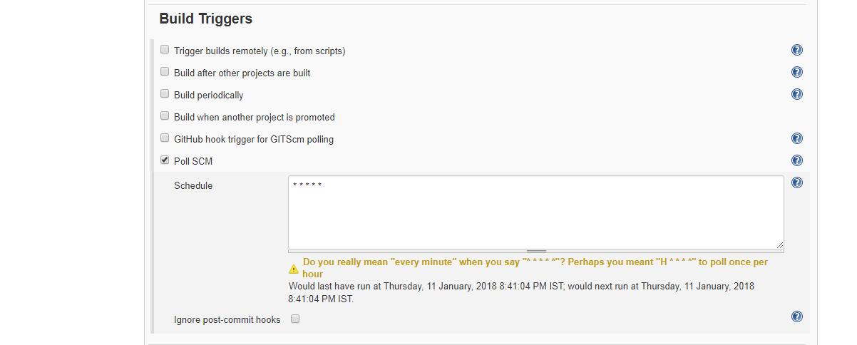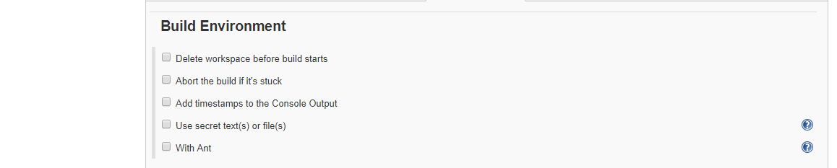

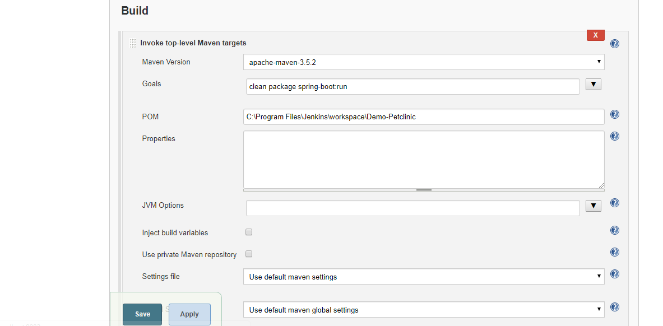

clean package spring-boot:run

C:\Program Files\Jenkins\workspace\Demo-Petclinic

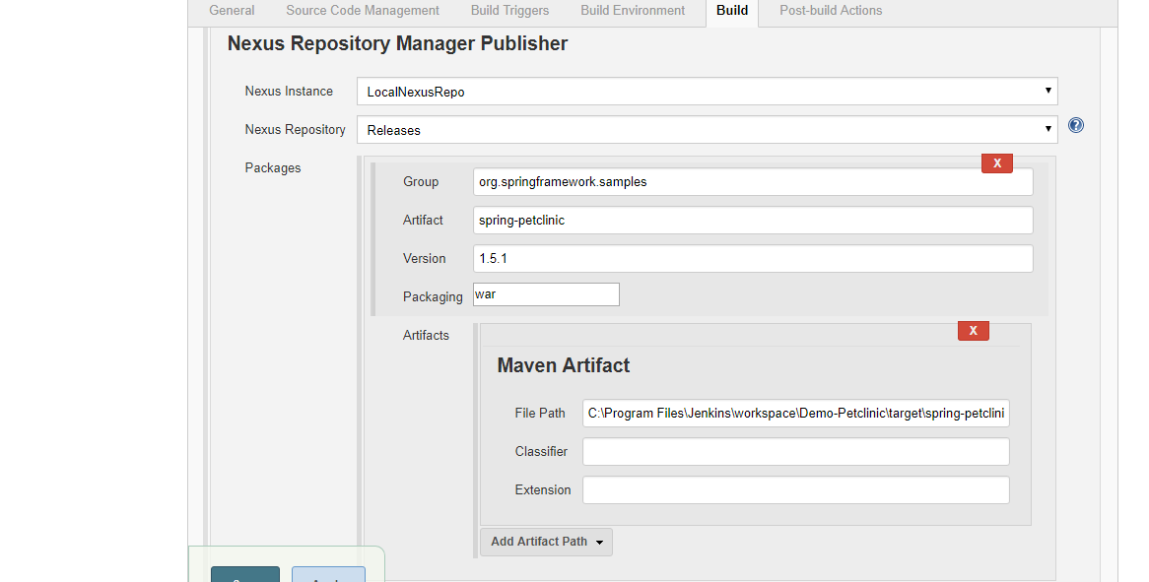

org.springframework.samples

spring-petclinic

1.5.1

War

C:\Program Files\Jenkins\workspace\Demo-Petclinic\target\spring-petclinic-1.5.1.war

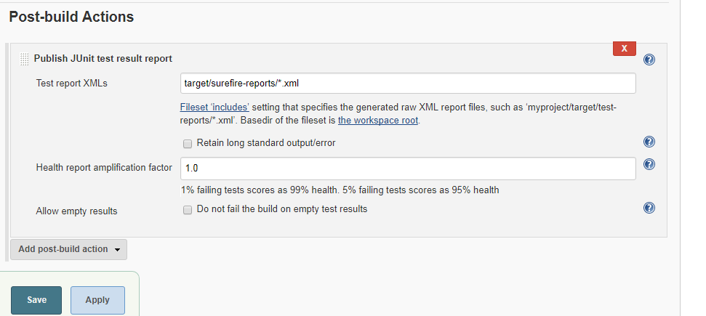

target/surefire-reports/*.xml