DOB Permit Issuance for the City of New York

* **Block wise Job Analysis:**

The above visualization shows the analysis of different type of jobs in a block. We can conclude that A2 is mostly pursued.

Using this type of analysis the City of New York can make decisions on the type of jobs pursued by the people in each block and try to concentrate on the per-capita income of each neighbourhood.

* **Cities Based on the number of Community Boards:**

The above visualization shows the tree-map representation of the Cities(Borough) based on the number of Community Boards they have in each of them.

Using this type of analysis will be very helpful in knowing the areas that are having Community Boards and focusing on the areas that need to have a community board so as to have a better neighbourhood.

* **Permits issued based on the Borough:**

The above visualization shows the analysis of the number of Permits issued in each Borough.

This can help the city of New York in analysing the number of permits issued for the construction and make better decisions in each Borough(city).

Using this the City of New York can also calculate the economic impacts based on the issuance of permits. And focus on areas where there are more number of permits and areas that have comparatively lesser number of permits issued.

* **Year-Wise permit Issuance:**

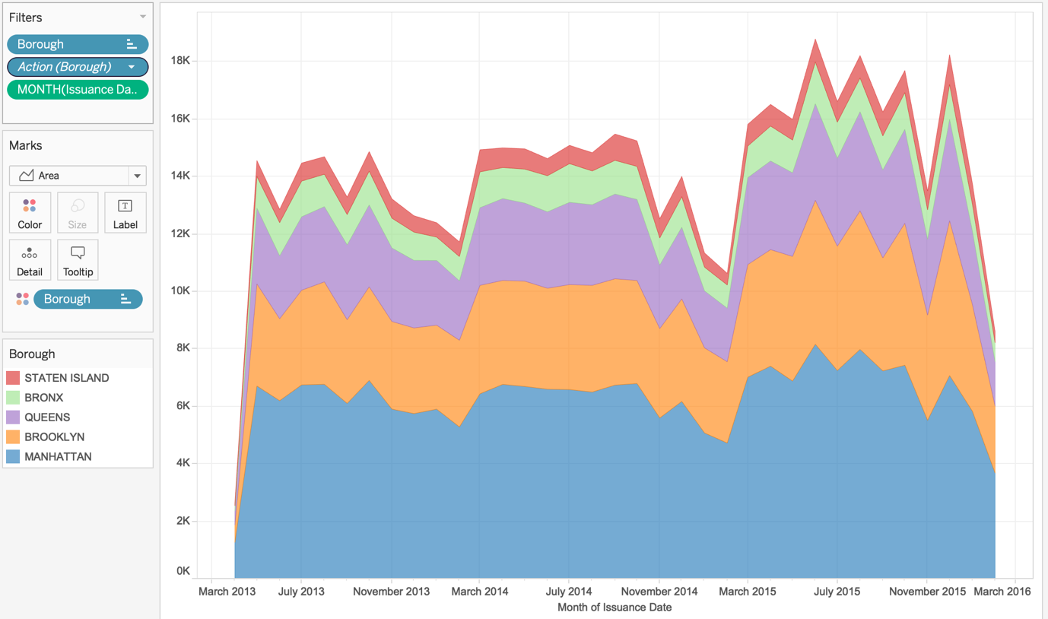

The above visualization indicates the area chart for the Year-Wise Issuance of permits for different Boroughs in the City of New York City.

With this analysis the City of New York can look into the factors which affect the decrease in the issuance of permits. If there is an increase, they can look for a pattern say, around which time of the year there is more number of permits issued.

* **Geographical Analysis of DOB Permits:**

The above visualization shows the heat map analysis of the Department of Buildings issuing the permits for construction and demolition.

The darker the colour means that there are more number of permits issued. The lighter the colour means that the area consists of less number of permits for construction and demolition.

This type of analysis makes it much easier to make decisions regarding the issuance of a permit to a particular area. Say, if an area consists of more number of permits, the City of New York can think of halting the further process of issuing of permits because there is already more number of ongoing permits.

* **Dashboard Analysis**

The above visualization shows the Dashboard which makes it very easy to look into each sheet of the workbook and collectively make a decision.