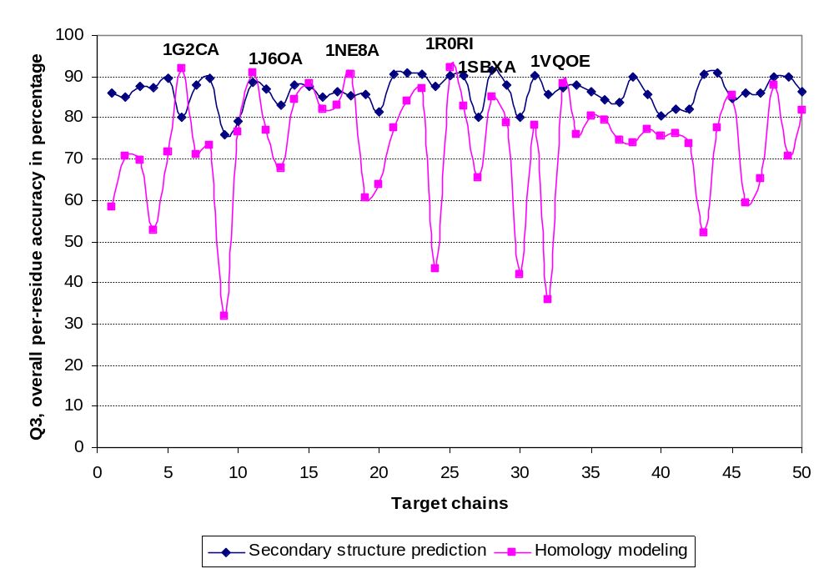
Supplemental Figure 1. Comparison of the secondary structure predicted by Frag1D and homology modelling for each of the 50 randomly selected chains. For most chains, Frag1D predicted much better then homology modelling in Q3. Only in 6 cases, 1G2CA, 1J6OA, 1NE8A, 1R0RI, 1SBXA and 1VQOE, homology modelling predicted better secondary structure than Frag1D. It seems 1SBXA should not be in this group, so there are 5, not 6 bad cases!?/sven How about sorting the chainson Q3 obtained by homology modelling – would make the diagram less bumpy!

