**Построена схема**

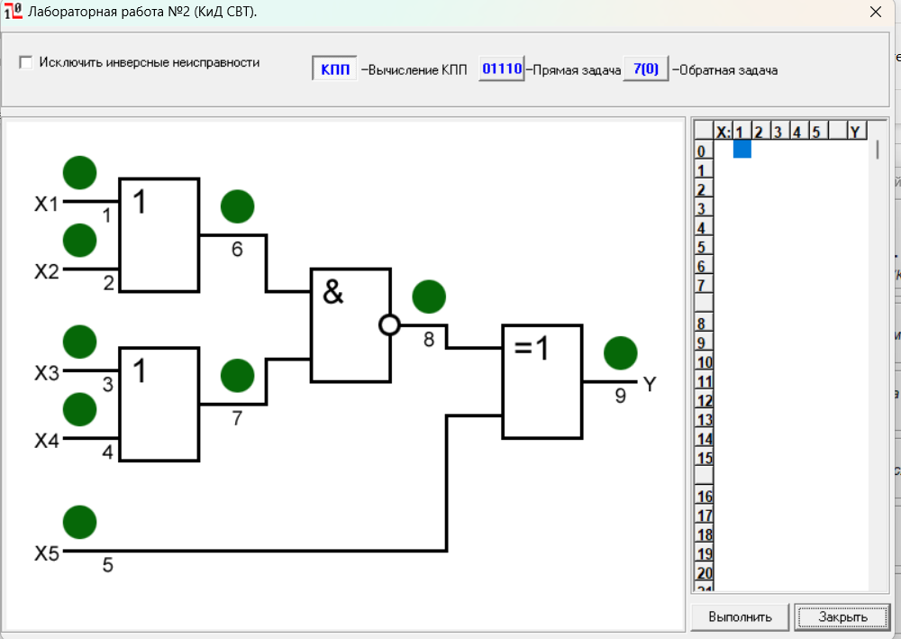

|  |  |  |  |  |  |  |  |  |  |  |  |  |  |  |  |  |  |  |  |  |  |  |  |  |  |  |  |
| --- | --- | --- | --- | --- | --- | --- | --- | --- | --- | --- | --- | --- | --- | --- | --- | --- | --- | --- | --- | --- | --- | --- | --- | --- | --- | --- | --- |
| **N** | **X1** | **X2** | **X3** | **X4** | **X5** |  | **Y** |  | **10** | **20** | **30** | **40** | **50** | **60** | **70** | **80** | **90** |  | **11** | **21** | **31** | **41** | **51** | **61** | **71** | **81** | **9/1** |
| **0** | 0 | 0 | 0 | 0 | 0 |  | 1 |  | 1 | 1 | 1 | 1 | 1 | 1 | 1 | 0 | 0 |  | 1 | 1 | 1 | 1 | 0 | 1 | 1 | 1 | 1 |
| **1** | 1 | 0 | 0 | 0 | 0 |  | 1 |  | 1 | 1 | 1 | 1 | 1 | 1 | 1 | 0 | 0 |  | 1 | 1 | 0 | 0 | 0 | 1 | 0 | 1 | 1 |
| **2** | 0 | 1 | 0 | 0 | 0 |  | 1 |  | 1 | 1 | 1 | 1 | 1 | 1 | 1 | 0 | 0 |  | 1 | 1 | 0 | 0 | 0 | 1 | 0 | 1 | 1 |
| **3** | 1 | 1 | 0 | 0 | 0 |  | 1 |  | 1 | 1 | 1 | 1 | 1 | 1 | 1 | 0 | 0 |  | 1 | 1 | 0 | 0 | 0 | 1 | 0 | 1 | 1 |
| **4** | 0 | 0 | 1 | 0 | 0 |  | 1 |  | 1 | 1 | 1 | 1 | 1 | 1 | 1 | 0 | 0 |  | 0 | 0 | 1 | 1 | 0 | 0 | 1 | 1 | 1 |
| **5** | 1 | 0 | 1 | 0 | 0 |  | 0 |  | 1 | 0 | 1 | 1 | 0 | 1 | 1 | 0 | 0 |  | 0 | 0 | 0 | 0 | 1 | 0 | 0 | 1 | 1 |
| **6** | 0 | 1 | 1 | 0 | 0 |  | 0 |  | 0 | 1 | 1 | 1 | 0 | 1 | 1 | 0 | 0 |  | 0 | 0 | 0 | 0 | 1 | 0 | 0 | 1 | 1 |
| **7** | 1 | 1 | 1 | 0 | 0 |  | 0 |  | 0 | 0 | 1 | 1 | 0 | 1 | 1 | 0 | 0 |  | 0 | 0 | 0 | 0 | 1 | 0 | 0 | 1 | 1 |
|  |  |  |  |  |  |  |  |  |  |  |  |  |  |  |  |  |  |  |  |  |  |  |  |  |  |  |  |
| **8** | 0 | 0 | 0 | 1 | 0 |  | 1 |  | 1 | 1 | 1 | 1 | 1 | 1 | 1 | 0 | 0 |  | 0 | 0 | 1 | 1 | 0 | 0 | 1 | 1 | 1 |
| **9** | 1 | 0 | 0 | 1 | 0 |  | 0 |  | 1 | 0 | 0 | 0 | 0 | 1 | 1 | 0 | 0 |  | 0 | 0 | 0 | 0 | 1 | 0 | 0 | 1 | 1 |
| **10** | 0 | 1 | 0 | 1 | 0 |  | 0 |  | 0 | 1 | 0 | 0 | 0 | 1 | 1 | 0 | 0 |  | 0 | 0 | 0 | 0 | 1 | 0 | 0 | 1 | 1 |
| **11** | 1 | 1 | 0 | 1 | 0 |  | 0 |  | 0 | 0 | 0 | 0 | 0 | 1 | 1 | 0 | 0 |  | 0 | 0 | 0 | 0 | 1 | 0 | 0 | 1 | 1 |
| **12** | 0 | 0 | 1 | 1 | 0 |  | 1 |  | 1 | 1 | 1 | 1 | 1 | 1 | 1 | 0 | 0 |  | 0 | 0 | 1 | 1 | 0 | 0 | 1 | 1 | 1 |
| **13** | 1 | 0 | 1 | 1 | 0 |  | 0 |  | 1 | 0 | 0 | 0 | 0 | 1 | 1 | 0 | 0 |  | 0 | 0 | 0 | 0 | 1 | 0 | 0 | 1 | 1 |
| **14** | 0 | 1 | 1 | 1 | 0 |  | 0 |  | 0 | 1 | 0 | 0 | 0 | 1 | 1 | 0 | 0 |  | 0 | 0 | 0 | 0 | 1 | 0 | 0 | 1 | 1 |
| **15** | 1 | 1 | 1 | 1 | 0 |  | 0 |  | 0 | 0 | 0 | 0 | 0 | 1 | 1 | 0 | 0 |  | 0 | 0 | 0 | 0 | 1 | 0 | 0 | 1 | 1 |
|  |  |  |  |  |  |  |  |  |  |  |  |  |  |  |  |  |  |  |  |  |  |  |  |  |  |  |  |
| **16** | 0 | 0 | 0 | 0 | 1 |  | 0 |  | 0 | 0 | 0 | 0 | 1 | 0 | 0 | 1 | 0 |  | 0 | 0 | 0 | 0 | 0 | 0 | 0 | 0 | 1 |
| **17** | 1 | 0 | 0 | 0 | 1 |  | 0 |  | 0 | 0 | 0 | 0 | 1 | 0 | 0 | 1 | 0 |  | 0 | 0 | 1 | 1 | 0 | 0 | 1 | 0 | 1 |
| **18** | 0 | 1 | 0 | 0 | 1 |  | 0 |  | 0 | 0 | 0 | 0 | 1 | 0 | 0 | 1 | 0 |  | 0 | 0 | 1 | 1 | 0 | 0 | 1 | 0 | 1 |
| **19** | 1 | 1 | 0 | 0 | 1 |  | 0 |  | 0 | 0 | 0 | 0 | 1 | 0 | 0 | 1 | 0 |  | 0 | 0 | 1 | 1 | 0 | 0 | 1 | 0 | 1 |
| **20** | 0 | 0 | 1 | 0 | 1 |  | 0 |  | 0 | 0 | 0 | 0 | 1 | 0 | 0 | 1 | 0 |  | 1 | 1 | 0 | 0 | 0 | 1 | 0 | 0 | 1 |
| **21** | 1 | 0 | 1 | 0 | 1 |  | 1 |  | 0 | 1 | 0 | 0 | 0 | 0 | 0 | 1 | 0 |  | 1 | 1 | 1 | 1 | 1 | 1 | 1 | 0 | 1 |
| **22** | 0 | 1 | 1 | 0 | 1 |  | 1 |  | 1 | 0 | 0 | 0 | 0 | 0 | 0 | 1 | 0 |  | 1 | 1 | 1 | 1 | 1 | 1 | 1 | 0 | 1 |
| **23** | 1 | 1 | 1 | 0 | 1 |  | 1 |  | 1 | 1 | 0 | 0 | 0 | 0 | 0 | 1 | 0 |  | 1 | 1 | 1 | 1 | 1 | 1 | 1 | 0 | 1 |
|  |  |  |  |  |  |  |  |  |  |  |  |  |  |  |  |  |  |  |  |  |  |  |  |  |  |  |  |
| **24** | 0 | 0 | 0 | 1 | 1 |  | 0 |  | 0 | 0 | 0 | 0 | 1 | 0 | 0 | 1 | 0 |  | 1 | 1 | 0 | 0 | 0 | 1 | 0 | 0 | 1 |
| **25** | 1 | 0 | 0 | 1 | 1 |  | 1 |  | 0 | 1 | 1 | 1 | 0 | 0 | 0 | 1 | 0 |  | 1 | 1 | 1 | 1 | 1 | 1 | 1 | 0 | 1 |
| **26** | 0 | 1 | 0 | 1 | 1 |  | 1 |  | 1 | 0 | 1 | 1 | 0 | 0 | 0 | 1 | 0 |  | 1 | 1 | 1 | 1 | 1 | 1 | 1 | 0 | 1 |
| **27** | 1 | 1 | 0 | 1 | 1 |  | 1 |  | 1 | 1 | 1 | 1 | 0 | 0 | 0 | 1 | 0 |  | 1 | 1 | 1 | 1 | 1 | 1 | 1 | 0 | 1 |
| **28** | 0 | 0 | 1 | 1 | 1 |  | 0 |  | 0 | 0 | 0 | 0 | 1 | 0 | 0 | 1 | 0 |  | 1 | 1 | 0 | 0 | 0 | 1 | 0 | 0 | 1 |
| **29** | 1 | 0 | 1 | 1 | 1 |  | 1 |  | 0 | 1 | 1 | 1 | 0 | 0 | 0 | 1 | 0 |  | 1 | 1 | 1 | 1 | 1 | 1 | 1 | 0 | 1 |
| **30** | 0 | 1 | 1 | 1 | 1 |  | 1 |  | 1 | 0 | 1 | 1 | 0 | 0 | 0 | 1 | 0 |  | 1 | 1 | 1 | 1 | 1 | 1 | 1 | 0 | 1 |
| **31** | 1 | 1 | 1 | 1 | 1 |  | 1 |  | 1 | 1 | 1 | 1 | 0 | 0 | 0 | 1 | 0 |  | 1 | 1 | 1 | 1 | 1 | 1 | 1 | 0 | 1 |

Таблица функций неисправностей

**Получение проверяющего теста с помощью таблицы.**

Создадим множество А = {}, в которое будем добавлять наборы, которые будут покрывать функции неисправностей.

Проанализировав таблицу 1, можно увидеть, что функции неисправностей 10 20 30 40 11 21 покрывает минимальное количество наборов – 6. Добавим в наше множество наборы, которые покрывают помимо этих наибольшее количество других, это наборы 5, 24 и 26 :

А = {10100, 00011, 01011}.

Остались непокрытыми функции неисправностей 31 41 и 41, покроем их набором 17. Добавим в множество А:

А = {10100, 10001, 00011, 01011}.

После проведенных действий наше множество А полностью покрывает функции неисправности, представленные в таблице 1.1.

Коэффициенты полноты проверки для каждого набора:

10100 – 7/18

10001 – 12/18

00011 – 15/18

01011 – 18/18

Эмпирическая зависимость коэффициента полноты проверки от длины теста:

**Получение проверяющего теста методом активизации путей.**

Таблица 2.1 – Результаты, полученные методом активизации путей

|  |  |  |  |  |  |
| --- | --- | --- | --- | --- | --- |
|  | **X1** | **X2** | **X3** | **X4** | **X5** |
| 1/0 | 1 | 0 | 1 | 1 | 1 |
| 1/1 | 0 | 0 | 1 | 1 | 1 |
| 2/0 | 0 | 1 | 1 | 1 | 1 |
| 2/1 | 0 | 0 | 1 | 1 | 1 |
| 3/0 | 1 | 1 | 1 | 0 | 1 |
| 3/1 | 1 | 1 | 0 | 0 | 1 |
| 4/0 | 1 | 1 | 0 | 1 | 1 |
| 4/1 | 1 | 1 | 0 | 0 | 1 |
| 5/0 | 1 | 1 | 1 | 1 | 0 |
| 5/1 | 1 | 1 | 1 | 1 | 1 |

Коэффициенты полноты проверки для каждого набора:

10111 - 6/18

00111 - 11/18

01111 - 12/18

11001 - 15/18

11101 - 16/18

11011 - 17/18

11110 - 18/18

11111 - 18/18

Эмпирическая зависимость коэффициента полноты проверки от длины теста:

**Реконвергентная схема**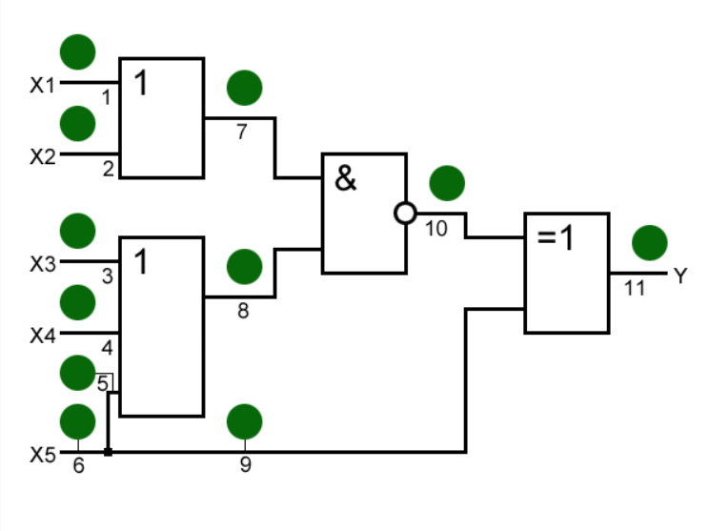

Все функции неисправностей являются выявленными.