**NANKYA SHADIA 22/U/6646**

**GitHub link**[: https://github.com/nankyashadia/UserInterface.git](:%20https:/github.com/nankyashadia/UserInterface.git)

**Design link**: <https://www.figma.com/design/Q3gmewpvaEwKQcr5G3dpe3/Food-app-design?node-id=1-667&t=zd91kXDzHLbagLOp-1>

**Prototype link** <https://www.figma.com/proto/Q3gmewpvaEwKQcr5G3dpe3/Food-app-design?page-id=0%3A1&node-id=1-667&node-type=canvas&viewport=-589%2C492%2C0.4&t=J1F2MkACdXeazjrf-1&scaling=scale-down&content-scaling=fixed&starting-point-node-id=1%3A667&show-proto-sidebar=1>

This report outlines the design process for *Shadia Eats*, a food ordering app focused on delivering a seamless, enjoyable experience. The app enables users to browse menu items, view details, customize selections, and make payments efficiently across eleven well-structured pages. With a clean, straightforward interface, the app reduces steps in the ordering process, making it ideal for users who prioritize convenience and quality.

The design includes both low-fidelity and high-fidelity elements:

Page 1: Splash Screen

Low-Fidelity Design: Introduces the app with branding elements; simple layout featuring logo, app name, and loading animation.

High-Fidelity Design: Soft green background (#E0ECD6) with a bold, sans-serif logo for "Shadia Eats" at the centre. A high-quality image of food (e.g., burgers) near the bottom reinforces the app's focus.

Page 2: Home Screen (Menu List)

Low-Fidelity Design: Shows a list of food items for browsing, with placeholders for search and filtering options, organized in a simple, grid-like structure.

High-Fidelity Design: Maintains soft green background, with each food item on light gray cards (#F5F5F5) featuring high-resolution images and clear, sans-serif font for names and prices to keep the focus on images.

Page 3: Food Item Detail Pages (Cheeseburger, Hamburger, Fried Chicken)

Content: Each page showcases an individual food item (e.g., Cheeseburger, Hamburger, Fried Chicken), with the item's details, description, and price prominently displayed.

Design Focus: Emphasizes imagery and clear typography, ensuring users can easily understand and select food items.

Page 4: Payment Page

Low-Fidelity Design: Provides an order summary, total cost, payment method selection, and confirmation button, with a clear layout from review to payment.

High-Fidelity Design: Soft green background, item thumbnails in light gray, total cost and payment details in dark green accents. A dark green "Confirm Payment" button completes the transaction visually and functionally.

Page 5: Pop-Up Message Page

Low-Fidelity Design: Confirmation icon, success message, and dismiss button to reassure users of successful actions (e.g., payment).

High-Fidelity Design: Light green overlay, solid white background for the pop-up, green checkmark icon, and a success message in dark green. Button in complementary green to maintain visual continuity.

Page 6: User Profile Page

Low-Fidelity Design: Displays user's account information with options to edit name, email, password, and a logout button.

High-Fidelity Design: Light green background, profile picture with dark green border, and fields with green buttons for "Edit" and "Save." A prominent red "Logout" button for secure exit.

Page 7: Customer Support Page

Low-Fidelity Design: Chat-like interface for users to interact with support, with message bubbles for support and user messages.

High-Fidelity Design: Light green background, user messages in light green bubbles on the right, support messages in darker green on the left, and a white input field with a green send button.

My prototype works on dragging and on tap.

LOW FIDELITY

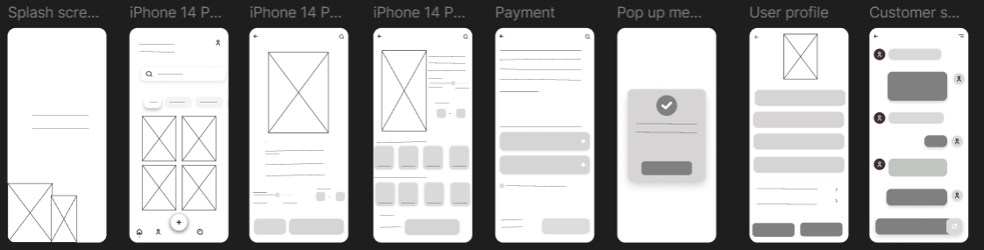

HIGH FIDERITY

