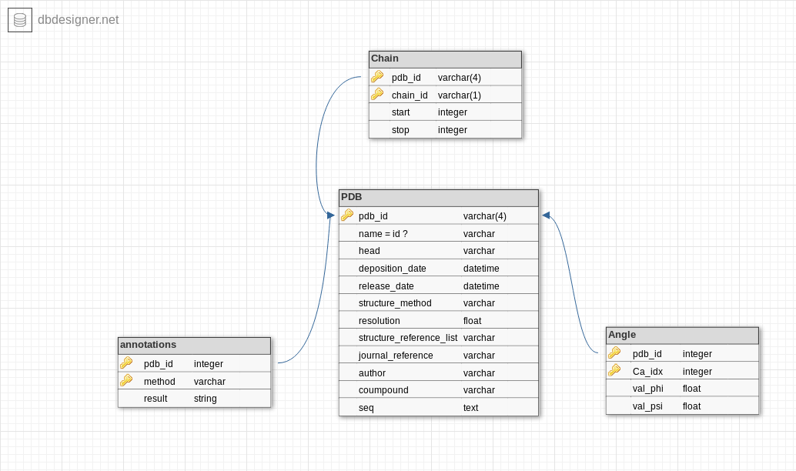
Report project BDD
﻿Authors : BOURASSIN Nicolas - CARVAILLO Jean-Charles - PERIN Charlotte - VAGINAY Athénaïs (2017)

Introduction

Context
Secondary structures have a major impact on the protein structures and their assembly process. The alpha-helix and the beta-sheet, are the most described of these secondary structures, although the turn (less common) was also identified. The other segments of the polypeptide are associated to coil.

A less known repetitive structure, the PolyProline II (PPII) helix, was also identified but firstly considered as having too low frequency to deserve a close interest.

Nevertheless, PPII helix frequency was shown to be higher than initially described ; and PPII could be involved in protein - protein interactions.Secondary structures have a major impact on the protein structures and their assembly process.
The alpha-helix and the beta-sheet, are the most described of these secondary structures, although the turn (less common) was also identified. The other segments of the polypeptide are associated to coil.

Note : These PolyProline II helices could also commonly occur in polypeptids with other residues apart from proline.

Polyproline helices assignation server
As a consequence of limited number of studies on PPII helices, the assignment tools are lacking to study further these secundary structures. This database and website are dedicated to assign and analyse PPII helices in addition of more known secundary structure. A PPII is formed by several consecutive residues adopting (φ,ψ) backbone dihedral angles respectively near -75° and 150°, and have trans isomers of their peptide bond.

Features

Input
Our database support PDB and ENT files.﻿

Adjustable parameters
The phi or psi angle values are computed in radians and can be converted in degree for the ramachandran map.

Representation of the results

Search or update one PDB

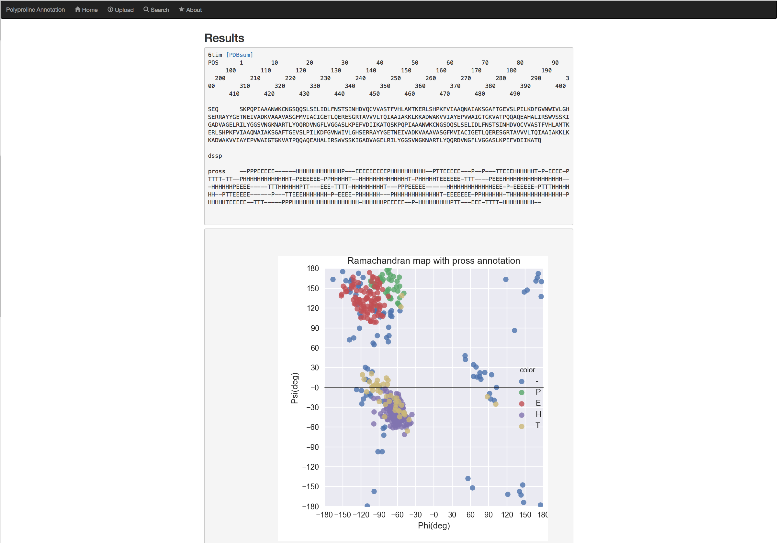

Search by keyword or resolution
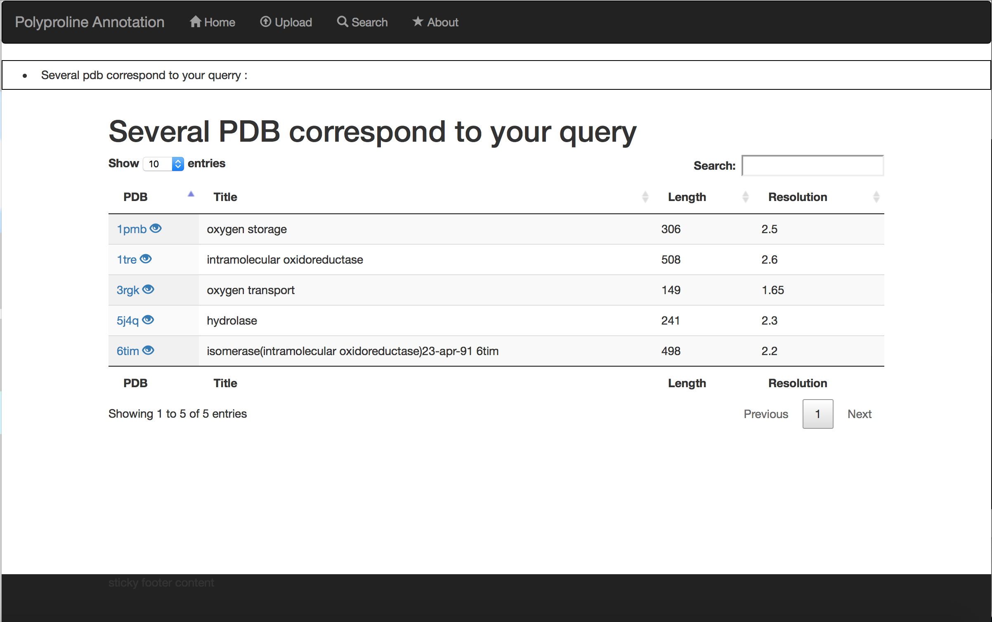

Non-redundant database
The database do not accept input files with the same ID, but it is possible to give in input two files of the same protein (structures obtained from different protocols for example) referenced on the Protein Data Bank under different ID.

Implemented assignation methods :
We implemented the DSSP and PROSS annotation methods. DSSP need to be preinstalled on your laptop or computer.

Database implementation :

Figure *** : database implementation schema

Our database is implemented in sqlAlchemy. We use four tables to stock informations : PDB table stocks every informations contained in the input file, apart from the start and stop coordinates of the chain stocked in Chain table. The computed informations are the phi and psi angles (stocked in Angle table) and the annotations by a method (the name of the annotation method and its result are stocked in Annotation table).

Required environment & packages :
Python3.x is needed with multiple python packages. Flask, SQLAlchemy and dependencies are the most important module in this project. With this modules and this architecture, we can improve easily the website and the database. The database can be convert in a lot of database langages.
We use biopython to parse the pdb file and compute phi and psi angles. Matplotilib, seaborn and numpy are used to performed the ramachandran map.
To use this database and website, you need all packages specified in the requirements text.

Perspectives

Features we would like to implement
TODO (optional)

Known bugs
None.

References
- Venkatachalam CM (1968) Stereochemical criteria for polypeptides and proteins. V. Conformation of a system of three linked peptide units. Biopolymers 6: 1425-1436.
- Richardson JS (1981) The anatomy and taxonomy of protein structure. Adv Protein Chem 34: 167-339.
- Rose GD (1978) Prediction of chain turns in globular proteins on a hydrophobic basis. Nature 272: 586-590.
- Makowska J, Rodziewicz-Motowidlo S, Baginska K, Vila JA, Liwo A, et al. (2006) Polyproline II conformation is one of many local conformational states and is not an overall conformation of unfolded peptides and proteins. Proc Natl Acad Sci U S A 103: 1744-1749.
- Pauling L, Corey RB (1951) The structure of fibrous proteins of the collagen-gelatin group. Proc Natl Acad Sci U S A 37: 272-281.
- Cowan PM, McGavin S, North AC (1955) The polypeptide chain configuration of collagen. Nature 176: 1062-1064.

