Hyperliquid Strategy Research and Allocation Due Diligence
  - Funding carry, protocol vaults and cross asset relative value
Historical cutoff 31 August 2026 UTC · Research edition 16 September 2026

1 Key Takeaways and Allocation View
Hyperliquid offers observable funding transfers and protocol-vault performance, but the available evidence supports selective further diligence rather than allocation approval. This report assesses return quality, execution capacity and control requirements using official data, with Messari providing research context.
Carry depends on implementation. At 100,000 USDC, the baseline passive strategy returns +1.93% after modeled costs, versus −1.83% for the specified entry-and-exit rule. Costs consume 22.4% and 224.6% of positive gross PnL. Low turnover merits further testing; the present rule does not.
HLP requires attribution. Cash-flow-adjusted performance is approximately +18.44% across 48 irregular valuations, but two intervals account for 94.9% of cumulative log return. This warrants protocol diligence, without establishing recurring or transferable market-making alpha.
Capacity remains unestablished. Additional size-dependent impact reduces passive return to 1.83% at 100,000 USDC and 0.98% at 10 million. No central scenario clears the illustrative 2% annual hurdle. The 100,000-USDC stress exit proxy has a 44-hour P95, exceeding the proposed 24-hour requirement.
Cross-asset hedging is session-dependent. The selected weekend calendar leaves a regular-session-only TSLA hedge unavailable for 65.5 hours and MGC for 49 hours. Price discovery during closure cannot alone establish executable arbitrage.
Passive carry and HLP receive priority for further verification. The current trading rule stays on hold; ordinary vaults lack comparable verified performance, and HIP-3 remains a mechanism-and-risk study. These categories are research decisions, not investment recommendations or directly comparable return rankings.

2 Research Universe and Methodology
The principal window is 1 September 2025–31 August 2026 UTC. Historical observations stop at that cutoff; retrieval and documentation checks occurred during 9–16 September. Later retrieval does not establish that current rules applied historically. [1]
Table 2.1 Sample selection and coverage
Research object | Why selected | Verified coverage and boundary
BTC perpetual and UBTC/USDC | Matched underlying; carry benchmark | 365 daily bars per instrument; 8,760 funding hours. Wrapper and redemption risks remain.
ETH perpetual and UETH/USDC | Second underlying; implementation comparison | Same daily and hourly coverage; historical executable quotes unverified.
HLP | Public protocol-vault case | 48 combined, deduplicated valuations; 115,522 ledger events. Returns remain approximate.
Ordinary public vaults | Manager-screening universe | Current records are not a historical eligibility register; no comparable performance ranking.
TradeXYZ TSLA and GOLD | Equity and commodity hedge cases | Session/specification review only; synchronized external quotes unavailable.

The initial HLP allTime series contained 27 observations; combining month and allTime histories produces the final 48. Missing observations are never assigned zero returns. Historical books, dollar OI, dated fees and full position histories remain incomplete.
Table 2.2 Inclusion and exclusion rules
Criterion | Required treatment
Instrument and history | Verify mapping; seek at least six months of common usable observations. Shorter coverage remains descriptive.
Data integrity | Align UTC timestamps, deduplicate and investigate gaps; use information available at the decision time.
Vault selection | Assess mandate, history, completeness and size; do not select by recent APR.
Missing or closed cases | Retain closed, weak and unverifiable cases in the screening log; no backdated membership assumptions.

Evidence is separated into verified observations, research inferences, model estimates and open diligence items. Without complete historical membership, vault findings remain case studies. Public records cannot independently establish audited returns, complete manager AUM or organizational capability.

3 Market Structure and Strategy Opportunity
BTC and ETH funding was positive in 81.5% and 83.0% of hours. Median rates were 0.125 bps per hour for both; means were 0.069/0.070 bps. Direct sign switches numbered 736/764. Negative episodes had a two-hour median but lasted up to 45/64 hours. Both monthly means turned negative in April. Persistent positive observations therefore coexist with meaningful reversal risk.
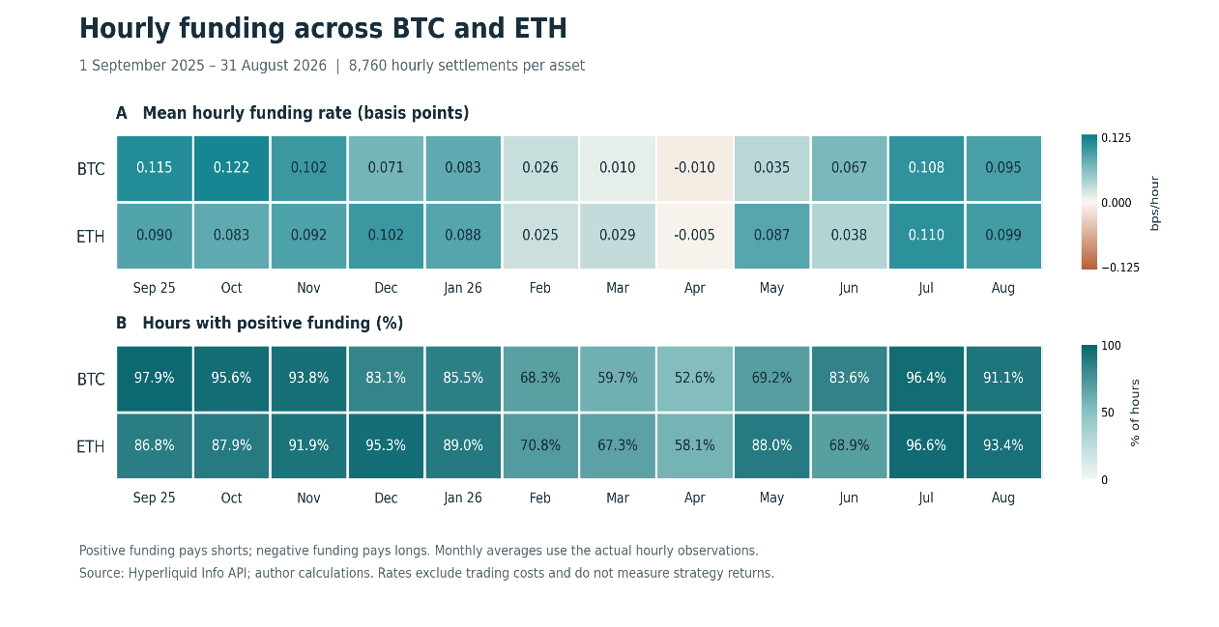
Figure 3.1 Monthly funding distribution summary. Each asset contributes 8,760 hours. Source: Hyperliquid Info API, retrieved 9 September 2026; author calculations. Funding rates are not strategy returns.
UBTC/UETH spot turnover represented 1.90%/1.48% of corresponding perpetual turnover in mapped base units. Spot liquidity deserves separate capacity analysis; turnover does not measure executable depth.
Measure | Research use
Executable spot–perpetual basis | Synchronized, size-specific sell-perpetual/buy-spot VWAP spread, before fees.
Mark–oracle deviation | Valuation/reference divergence and collateral risk.
Funding rate | Hourly cash transfer applied to the relevant position and oracle price.

Historical liquidity regimes use BTC daily log(high/low): the top decile defines stress, with 37 days; the 40th–60th percentiles define normal, with 73. These are retrospective descriptors, not entry signals. Historical spread/depth distributions, OI and concentration remain unverified; Section 6 provides explicitly modeled diagnostics instead. Margin tiers, cross/isolated treatment and applicable historical rules also require reconstruction. Messari's HYPE funding charts concern the token across markets, not all Hyperliquid contracts. [2, 6]

4 Funding Carry Construction and Net Performance
The conditional replay starts with 100,000 USDC, assuming USDC equals USD. Each asset receives up to 20% of equity in spot against an equal-unit perpetual short, sized using the higher reference price. Another 40% funds perpetual collateral; at least 20% remains cash. Returns include all capital; spot is not counted again as collateral. Idle capital earns zero.
Table 4.1 Fixed strategy specification
Component | Rule
Passive benchmark | Maintain both hedges; rebalance daily at 04:00 UTC; accept either funding sign.
Signal and timing | Decide at 00:00 from 72 completed funding hours; execute after 04:00 settlement.
Entry | Project the mean over 30 days; require funding above 1.5 times round-trip costs.
Liquidity and basis | Entire target quantity ≤0.1% of prior-day base volume on each leg; previous-close price gap <100 bps in absolute value.
Exit | Close if the mean becomes nonpositive or either filter fails; re-entry must satisfy the entry test.
Shared stop | Close permanently if four-hour collateral/notional proxy falls below 50%; charge terminal exits.

For unchanged position intervals, net PnL combines both price legs and funding, less fees, additional execution and financing costs:
Here S/P denote spot/perpetual prices, q the positive matched quantity, O the settlement oracle, and F/X/B fees, additional execution and financing/other costs. Funding settles hourly on the position held at settlement and oracle value. The replay substitutes the latest completed four-hour spot close for unavailable historical settlement oracle prices. Settlement precedes trades; new positions cannot receive an already-settled payment. Candle opens and terminal closes are price references, not verified fills. [2]
Fees are constant scenarios: 7 bps spot and 4.5 bps perpetual taker rates, observed on 10 September, plus 2 bps execution cost per leg per trade. Historical rates and discounts are not reconstructed. Baseline weighted 14-day turnover stays below 0.60 million. The approximate round-trip budget is 31 bps of one-leg notional, implying a 46.5-bps entry hurdle. Financing, bridge/service fees and cash yield are zero assumptions. Slippage embedded in actual fills must not be deducted twice. [3]
Table 4.2 Conditional performance on all capital
Metric | Passive | Rule
Net return | +1.93% | −1.83%
Annualized daily volatility | 0.37% | 0.36%
Sharpe / Sortino | 5.19 / 8.73 | −5.14 / −5.74
Maximum daily-close drawdown | −0.10% | −2.19%
Worst day / rolling seven days | −0.08% / −0.07% | −0.08% / −0.19%
Recovery from trough | 19 days | Unrecovered
Two-leg turnover / average equity | 7.09× | 42.74×
Costs / positive gross PnL | 22.4% | 224.6%
May–August net return | +0.75% | −0.84%

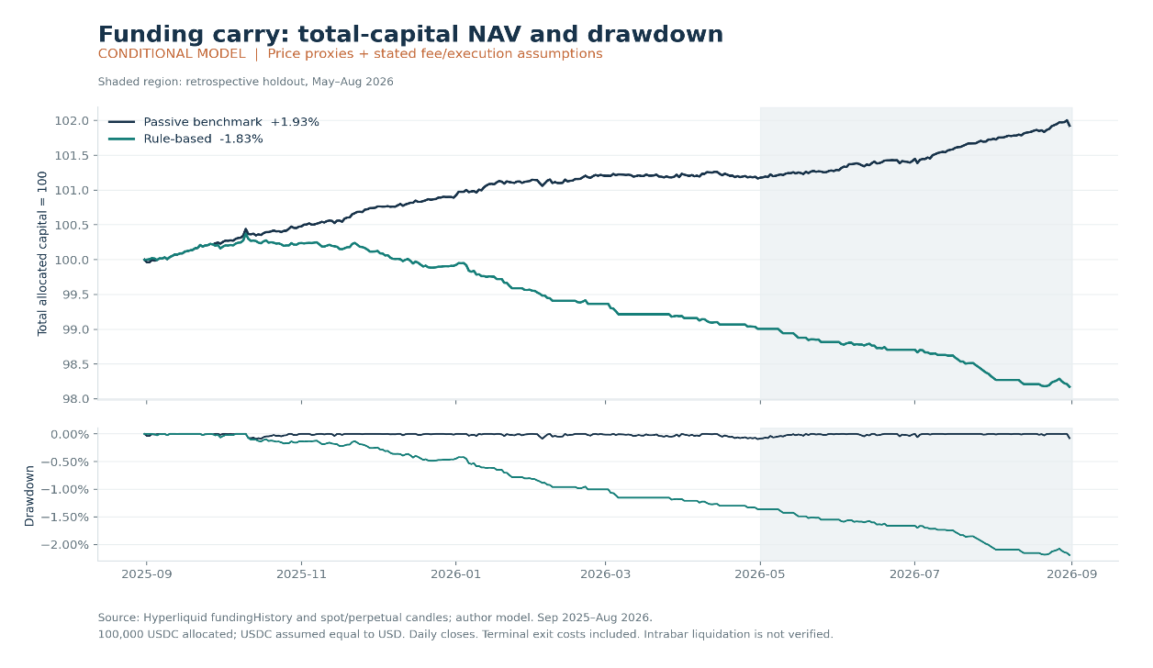
Figure 4.1 Total-capital NAV and daily-close drawdown. The shaded interval is a retrospective holdout. Source: official API observations and author model.
Daily returns annualize using 365 days. Sharpe's cash hurdle and Sortino's target are zero; downside deviation includes all days. These ratios do not validate intraday margin survival or operational reliability.
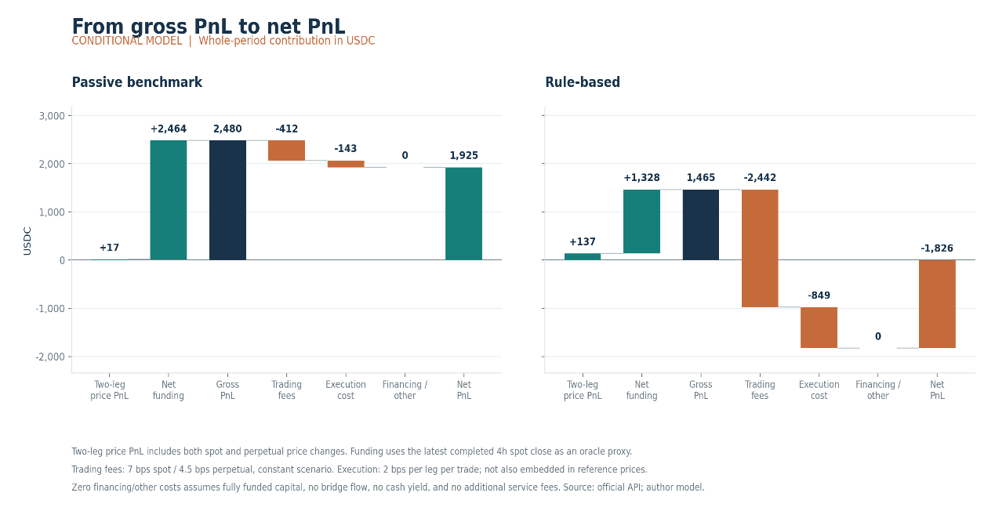
Figure 4.2 Price PnL and funding reconciled to net PnL. Costs are model estimates in USDC, not verified transaction expenses.
Passive gross PnL of 2,480 USDC becomes 1,925 after costs. The rule earns 1,465 gross but incurs 3,292 in costs. Liquidity failures cause 41 of 50 nonterminal exits; median BTC/ETH holding spells of four/two days undermine the 30-day payback premise. Removing the filter produces +0.81% diagnostically, without proving executability.
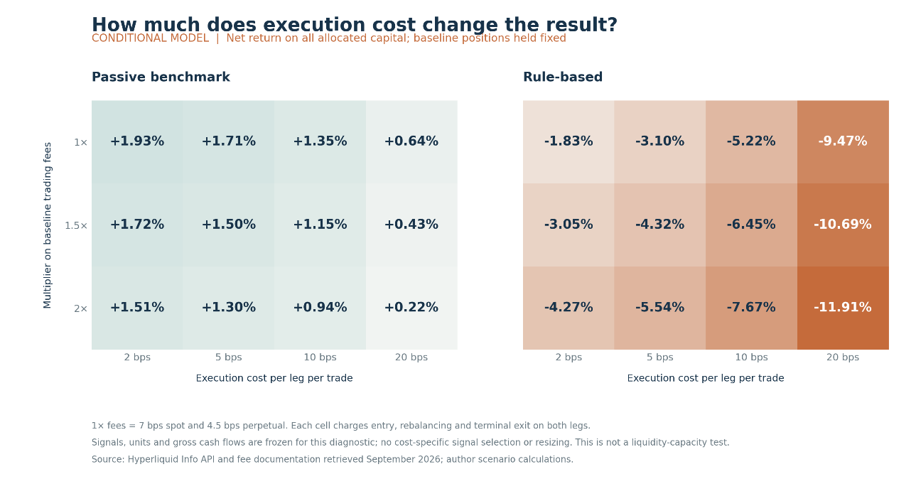
Figure 4.3 Cost sensitivity with baseline positions fixed. The matrix changes expenses without rerunning entry decisions.
May–August is retrospective: full-period funding was already inspected. All nine combinations of 24/72/168-hour windows and 1/1.5/2 cost buffers lose money, ranging from −2.73% to −0.97%. With positions fixed, doubled fees and 10-bps execution costs yield +0.94%/−7.67%. Genuine forward validation remains outstanding.

5 HLP and Public Vaults
HLP's current documented activities comprise market making, liquidations, USDC supply to Earn and trading-fee receipts. Historical activation dates and transaction attribution remain necessary; aggregate profit does not establish transferable manager alpha. [4]
Performance verification. The official ledger contains 55,171 deposits, 60,128 withdrawals, 221 owned-vault reallocations and two other inward transfers totaling 6.96 USDC. Internal reallocations are excluded from external flows. Parent account value includes owned-vault balances; adding children again would double-count assets. Observed external withdrawals report zero commission and closing cost. [1, 5]
Exact time-weighted return requires valuations immediately around external flows:

Here V−/V+ are pre-/post-flow values and CF is external cash flow. Those valuations are unavailable. Instead, 48 irregular observations from 3 September 2025 to 31 August 2026 define 47 intervals. Actual flow timing determines Modified Dietz weights, and interval returns are geometrically linked. This approximation can be distorted by large flows during volatile intervals. [15]
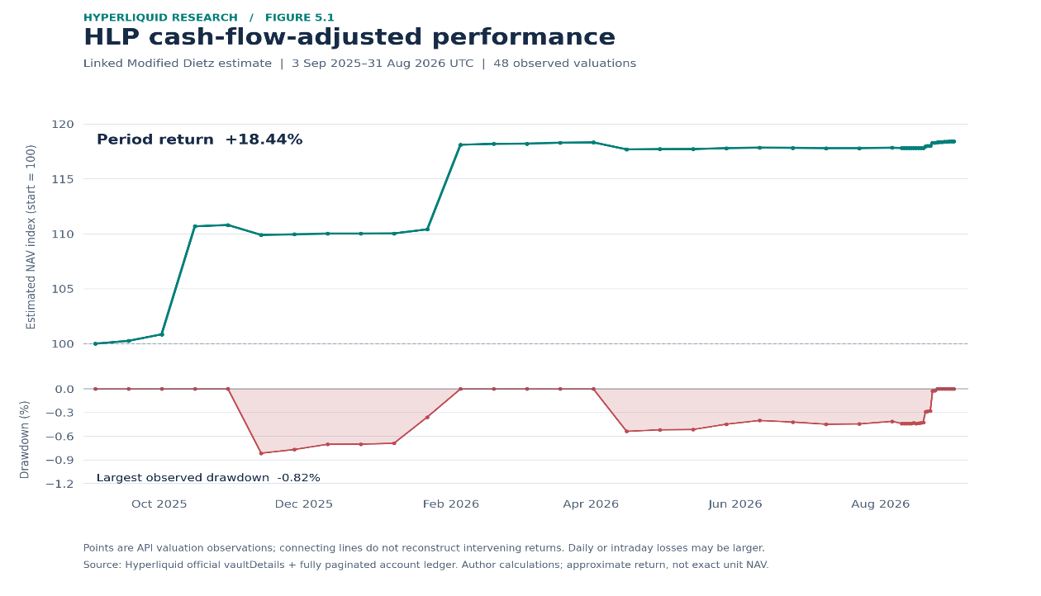
Figure 5.1 Approximate cash-flow-adjusted NAV and observed-interval drawdown. Source: official account histories and ledger; author Modified Dietz reconstruction. Sparse valuations do not measure intraday or daily maximum drawdown.
Estimated return is +18.44%, with −0.82% maximum drawdown across observed valuations. The largest interval profit-reconciliation residual is 13.71 USDC; the cumulative 139.95-USDC difference remains unexplained rather than assigned to a strategy.
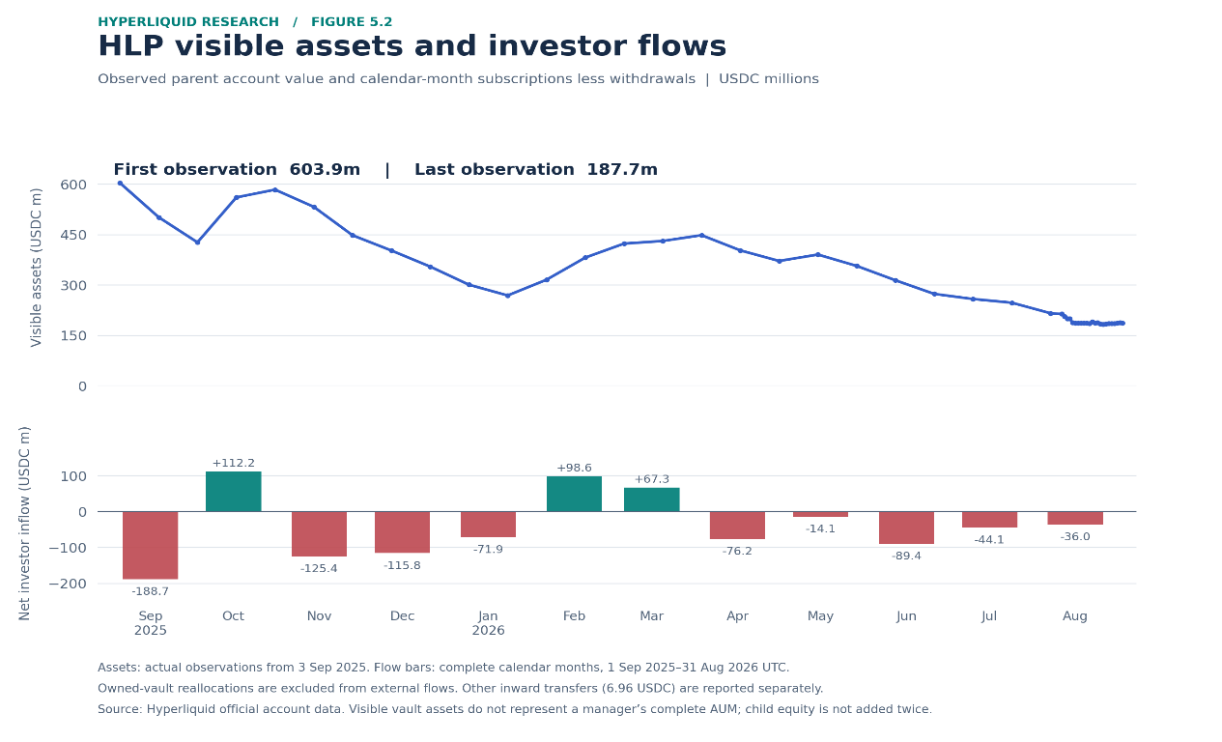
Figure 5.2 Visible assets and external flows. Endpoint and calendar-month windows differ; calendar bars include 1–3 September flows preceding the first valuation.
Visible assets fall from 603.9 million to 187.7 million USDC. Endpoint net outflows of approximately 477.8 million offset 61.6 million of profit. Calendar-month net investor withdrawals total 483.5 million. Redemptions explain most asset contraction; their motives are unverified.
The strongest two intervals, 1–15 October 2025 and 21 January–4 February 2026, contribute 94.9% of cumulative log return. This does not identify individual profitable days or their mechanisms. Unattributed funding, trading, inventory, fees and interest remain open items.
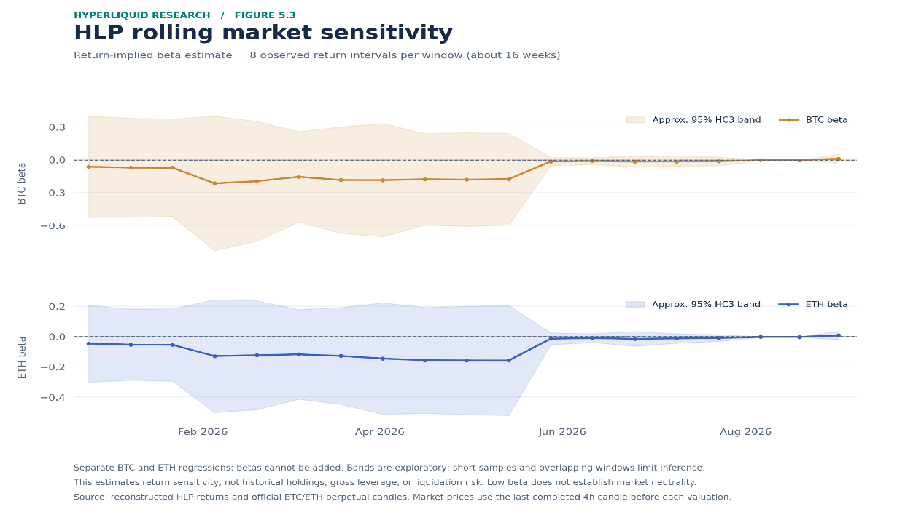
Figure 5.3 Separate BTC and ETH rolling betas over eight approximately fortnightly intervals, with approximate HC3 uncertainty bands. These are return regressions, not reconstructed holdings.
Market returns use the last completed four-hour perpetual candle before each valuation. Latest BTC/ETH betas of approximately 0.011/0.008 have bands including zero; the coefficients are not additive exposure weights. Low beta cannot exclude nonlinear liquidation losses. Historical gross/net exposure, leverage, concentration and turnover require position records. Ordinary vaults await equivalent reconciliation. Visible vault assets are not complete manager AUM; unconfirmed off-chain hedges remain outside scope.

6 Execution Costs and Capacity
Capacity must satisfy return, exit-time and collateral constraints simultaneously. Allocations from 25,000 to 10 million USDC retain Section 4's capital structure. The additional impact fraction equals a coefficient times the preceding day's log(high/low), multiplied by the square root of trade quantity divided by that day's base-unit volume, separately for each leg. Coefficients are 0.5 centrally and 0.25/1.0 in sensitivities. This uncalibrated model supplements fees and the 2-bps floor; its envelope is not a confidence interval.
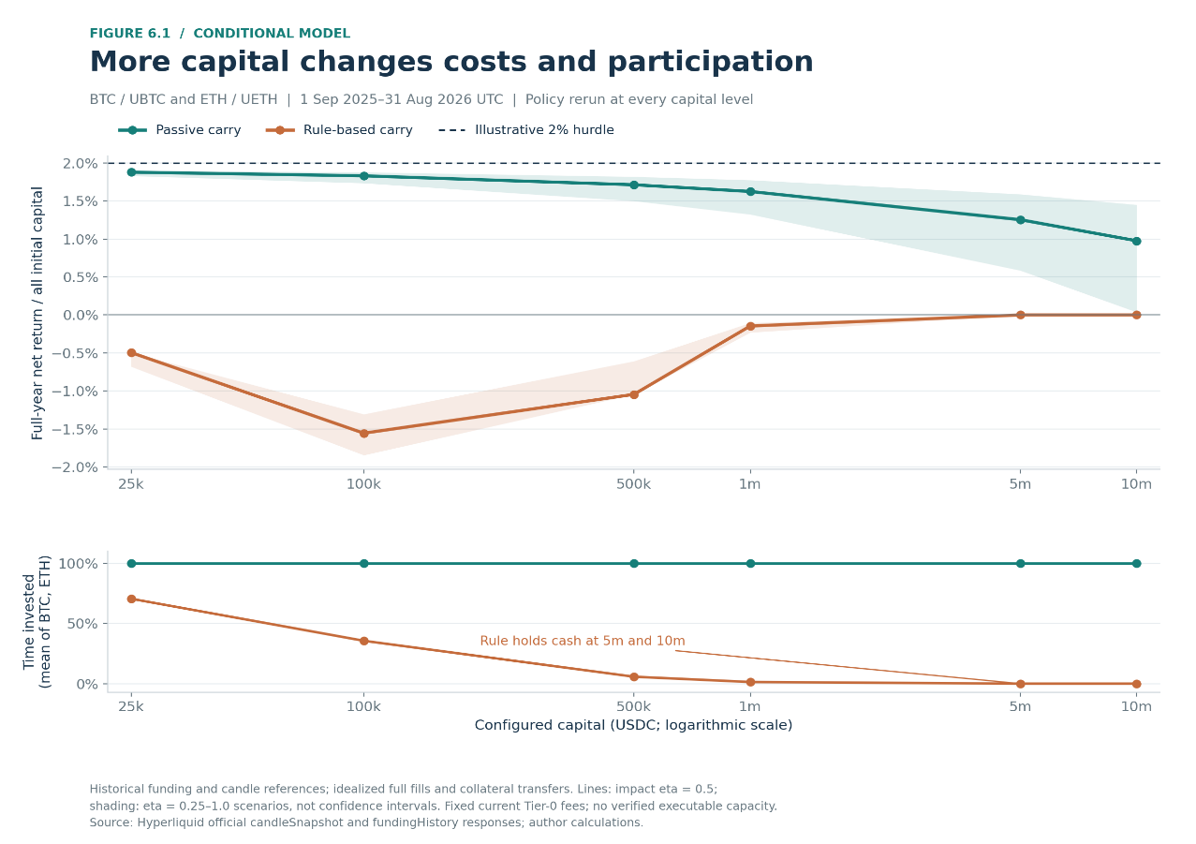
Figure 6.1 Allocation versus net return and participation. Each size/coefficient reruns the policy, including projected impact in the rule's entry budget. Source: official candles/funding and author scenarios.
Central passive returns decline from 1.88% at 25,000 USDC to 1.83% at 100,000 and 0.98% at 10 million. Rule returns are −0.49%, −1.56% and 0.00%; it opens no positions at 5 million or 10 million. Zero means idle cash, not improved trading. Different participation also explains why the 100,000-USDC rule differs from Section 4. Complete fills and frictionless collateral transfers remain idealizations.
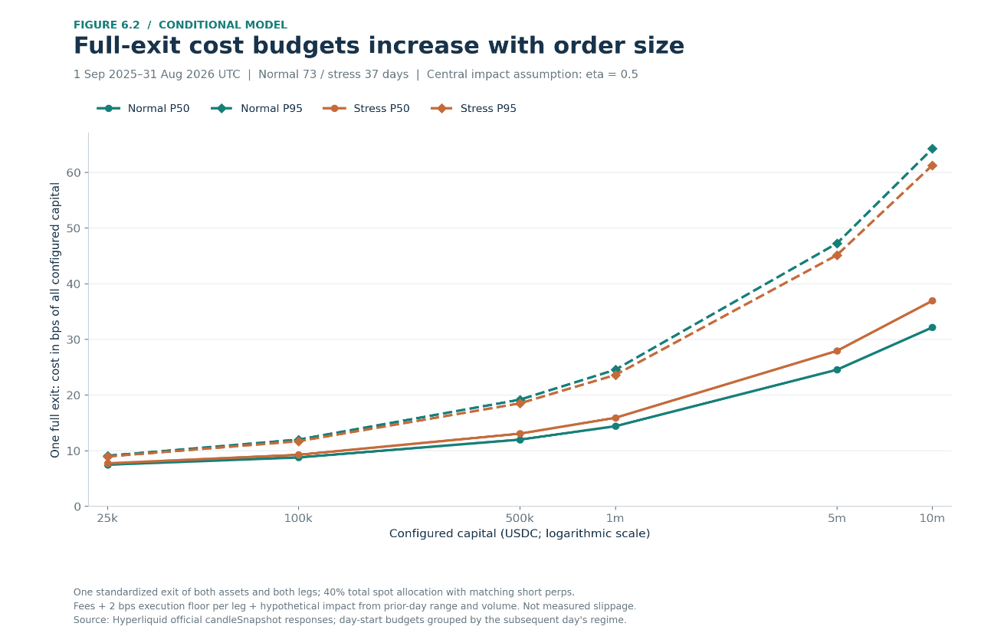
Figure 6.2 Modeled full-exit cost budgets relative to all capital. Prior-day inputs are grouped by the subsequent observed regime: 73 normal and 37 stress days.
At 100,000 USDC, normal P50/P95 exit budgets are 8.79/12.01 bps of capital, versus 9.27/11.71 under stress. These are modeled budgets; lower stress P95 does not prove cheaper stressed execution.
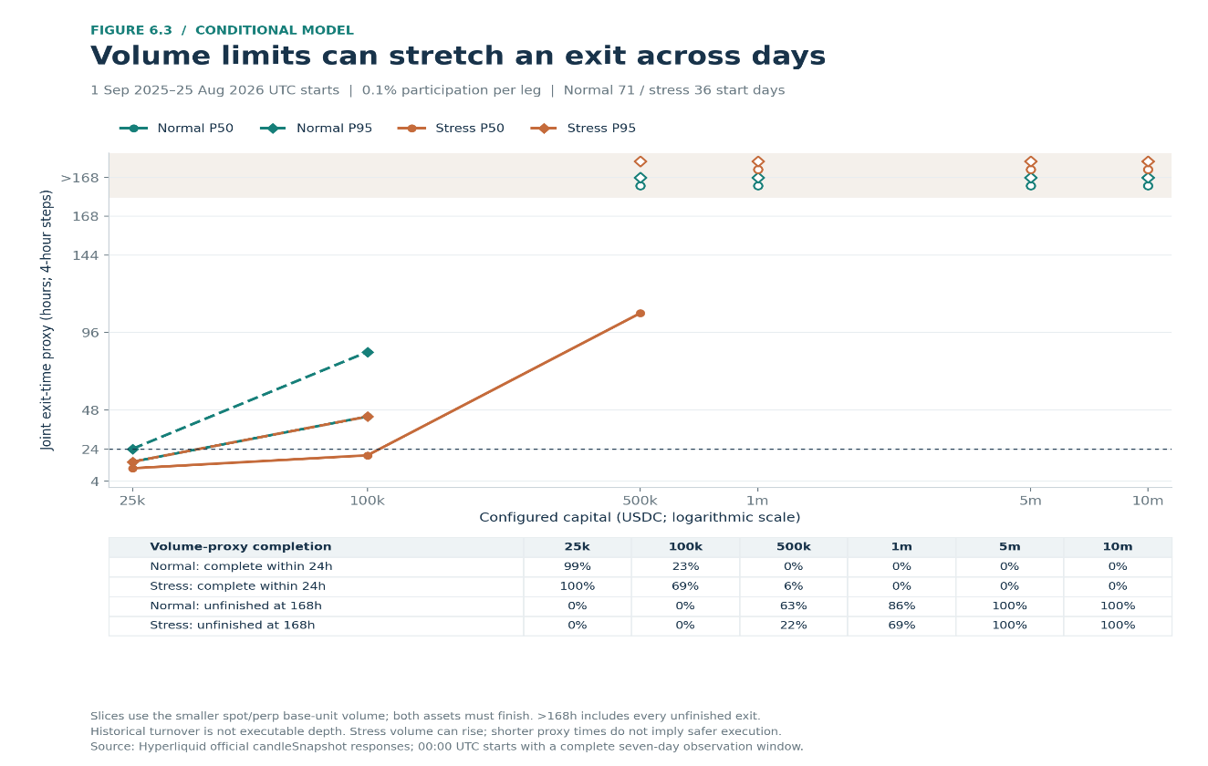
Figure 6.3 Joint exit-time proxy and unfinished cases. Slices use at most 0.1% of each leg's four-hour base volume; both assets must finish. Complete seven-day windows yield 71 normal and 36 stress starts.
Normal P50/P95 exit times at 100,000 USDC are 44/84 hours, versus 20/44 under stress. At 500,000, 63.4% of normal and 22.2% of stress starts remain unfinished after 168 hours. Higher stress turnover can shorten this proxy without improving depth. These diagnostics are neither extra charges against Figure 6.1 nor a jointly verified execution simulation.
An illustrative gate requires at least 2% annual net return, 95% of stress exits within 24 hours and no collateral-buffer breach. No central return scenario clears it; actual capacity is unestablished, not measured at zero. Priority bidding adds costs if used: IOC charges follow filled notional; ALO placement can cost money without a fill. Queue competition, inventory and adverse selection require order-level evidence; L2 snapshots alone cannot reproduce market-making performance. [7]

7 Tail Risk and Operational Risk
Tail losses emerge when hedges, collateral and liquidity fail together. A rally can deplete short-perpetual collateral while offsetting spot gains remain unavailable for margin. Cash reserves are useful only if eligible and transferable within the relevant account mode. Mark-based liquidation differs from executable prices. Auto-deleveraging can remove a profitable short, leaving residual long spot exposure. [6, 8]
Funding reversal, adverse basis, UBTC/UETH redemption impairment and USDC depegging are distinct channels. Unit custody, signing and redemption continuity require review. Carry and HLP share venue, validator and software dependencies; strategy variety does not eliminate common failure modes. [9]
Current HLP terms impose a four-day lock from the latest deposit; other vault terms require individual verification. Withdrawal eligibility, position liquidation and externally usable cash are separate milestones. Undated current mechanisms inform prospective diligence, not historical attribution. [4]
Joint stress scenarios should combine price gaps, negative funding, reduced depth and transfer delays. Outputs must cover total-capital loss, minimum maintenance headroom, residual delta and cash available within 24/72 hours. Reverse stress tests should locate mandate or collateral breaches; sparse observations cannot establish tail-event probabilities.
Operational review must test key permissions, reconciliation, feed freshness, failover, cancellation timers and incident ownership. Canceling orders does not close positions. Neither Section 4's collateral proxy nor HLP's sparse drawdown verifies these protections.

8 HIP3 Cross Asset Relative Value
Messari reports a 53% median reduction in reopening-reference forecast error across 614 market-weekends relative to stale closing prices. Its target is an external-oracle benchmark, not executable profit. [10]
The cases pair TradeXYZ TSLA with Tesla shares and GOLD with CME Micro Gold, representing 10 troy ounces per MGC contract. Exact historical HIP-3 multipliers and reference definitions remain unverified. TSLA requires corporate-action and stock-borrow reconciliation; GOLD requires distinguishing spot references from rolled futures, choosing expiry and accounting for basis, roll and delivery. Both require currency conversion, financing and separate collateral. [11, 12]
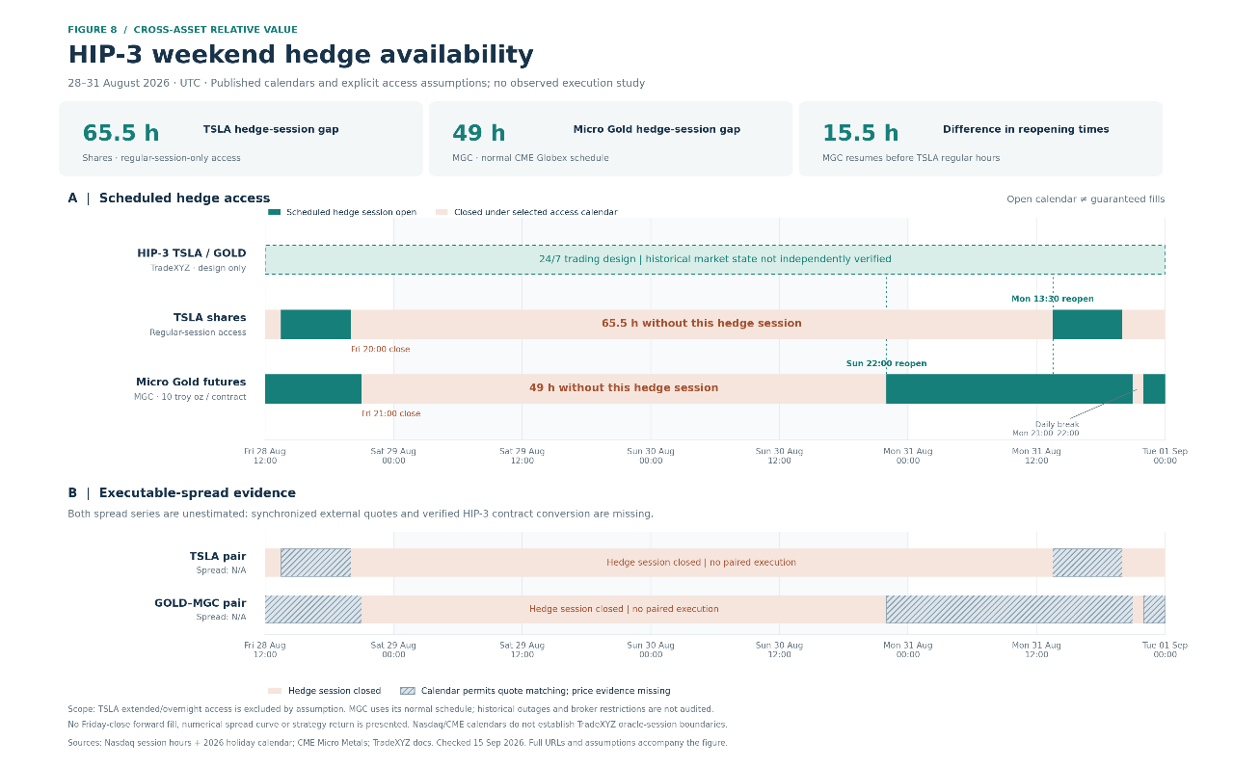
Figure 8 Session and evidence map for 28–31 August 2026 UTC. The TSLA hedge assumes regular-session-only access; MGC follows the standard CME calendar. Missing synchronized prices remain N/A. Calendar reconstruction is not an uptime audit.
When external markets open, compare simultaneous, correctly sided quotes after unit normalization and all costs. During closure, Friday prices cannot support new two-leg trades; existing hedges may be impossible to resize. The illustrated TSLA/MGC closures last 65.5/49 hours, respectively. Actual broker access, holidays and daylight-saving rules determine tradability. [11, 13]
At reopening, gaps, halts and partial fills can leave residual risk. Oracle convergence or an indicative auction price does not guarantee a hedge fill. Pre-fund both venues and test stressed margin, cash transfer and joint exit requirements. Without dated specifications, synchronized quotes, confirmed access and actual costs, this remains a mechanism-and-risk case study; no cross-market strategy return is estimated.

9 Manager Due Diligence and Evidence Gaps
Public behavior is one component of manager assessment. HLP merits protocol diligence; ordinary vaults remain screening cases pending reconciled performance and a complete account perimeter.
Dimension | Required evidence
Strategy and research | Economic rationale, data lineage, out-of-sample tests, overfitting controls.
Performance integrity | All accounts, off-chain hedges, flows, fees, independent reconciliation.
Risk controls | Hard limits, joint stresses, overrides and incident records.
Infrastructure | Latency, rejections, stale feeds, failover and emergency cancellation tests.
Team | Responsibilities, departures, succession and independent risk oversight.
Operations | Key governance, permissions, custody, providers and redemption terms.

Each research card records supporting evidence, counterevidence, unresolved questions and conditions for further diligence. Unknown controls are unverified, not automatically failed. Progress requires reconciled performance, scoped limits and demonstrated permissions; material contradictions or declined verification suspend progression.
HLP is a protocol vault, while an ordinary vault is not automatically a separately managed account. Ownership, delegated authority, mandate restrictions and withdrawal rights require confirmation. Visible assets do not establish full manager AUM.
No manager interviews or private control tests have been conducted. Record each source, effective period, retrieval date, reviewer and open condition; material strategy, personnel, access or risk changes trigger reassessment.

10 Monitoring and Breach Response
This proposed framework demonstrates monitoring design, not completed SMA management. Public HLP observations support research escalation only. Limits combine mandates, historical distributions, stress tests and false-alarm review; statistical alerts differ from confirmed hard breaches.
Category | Monitor and investigate
Hedge and direction | Asset-level net/gross exposure and beta; failed hedge or unintended direction?
Margin | Maintenance headroom and eligible collateral; shortfall or blocked transfer?
Execution | Slippage, rejections and unhedged duration; market impact or system failure?
Performance | Drawdown, PnL residual and concentration; expected loss or style drift?
Operations | Data age, reconciliation and personnel/access changes; restrict risk or reopen diligence?

Simulated incident. Assume 1 million USDC and a 2% asset-level exposure limit, allowing temporary exceedance for 60 seconds. A 40,000-USDC unmatched ETH spot fill persists for 90 seconds after hedge rejections. Fresh positions and deduplicated fills confirm 4% exposure; hypothetical logs suggest nonce conflicts. Ask the operator to verify shared signers, affected accounts and failed safeguards. [14]
Suspend new entries, reconcile outstanding orders, then hedge through an authorized route or reduce spot within execution limits. The analyst documents findings; material or unresolved risk escalates to the risk owner and Head of Research. Closure requires reconciled positions, restored limits, tested remediation and independent restart approval. All thresholds are illustrative.
Daily reconciliation covers balances, flows, fees, funding and PnL. Weekly reviews examine deviations, limits and incidents. Monthly universe reviews update closures, visible assets, independently verified AUM, personnel and mandates. Critical events receive immediate escalation. Every action has an owner, deadline and closure evidence; missing data remain unknown.

11 Investment Thesis and Decision Conditions
Passive carry advances to execution validation. Frequent positive funding and lower turnover support the mechanism. Allocation requires synchronized quotes and fills, dated fees, verified funding valuation, token-redemption review and joint margin/exit tests. Persistent negative funding, adverse basis or all-in costs that eliminate the required return would weaken the thesis. The illustrative capacity gate remains unmet.
The present rule stays on hold. Its cost burden, short holding periods and losses across tested parameters contradict the intended 30-day payback logic. Reconsideration requires a precommitted revision and genuinely new validation data. Removing a costly filter retrospectively is insufficient.
HLP advances to protocol diligence. Reconciled positive profit supports further work, while concentration in two intervals and sparse valuations prevent persistence claims. Obtain higher-frequency valuations, historical positions, mechanism activation dates, transaction attribution and redemption/control evidence. Repeated attributable gains within acceptable stressed loss and liquidity limits would strengthen the thesis; dependence on exceptional receipts, hidden inventory risk or impaired withdrawals would weaken it.
Ordinary vaults remain evidence-insufficient. Comparable cash-flow-adjusted records, full accounts, off-chain hedges and manager-control evidence are prerequisites to selection. A closure label alone establishes neither poor performance nor misconduct.
HIP-3 remains conditional research. Verified contract matching, broker permissions, borrow, synchronized executable prices and prefunded stressed collateral must precede return estimation. Reference mismatch or inability to maintain the hedge invalidates an apparent arbitrage.
Joint normal/stress correlations are not established on aligned observations. Shared Hyperliquid settlement, collateral and liquidity dependencies therefore remain portfolio constraints. No research object yet meets a fully evidenced allocation standard.

Sources
Figures combine official observations with labeled models and calendar reconstructions; source links describe mechanisms and research context. Rules lacking verified effective dates are not backdated. Documentation cross-check completed 16 September 2026.
[1] Hyperliquid Info API
[2] Hyperliquid funding
[3] Hyperliquid fees
[4] Hyperliquid protocol vaults
[5] Hyperliquid portfolio graphs
[6] Hyperliquid margining
[7] Hyperliquid priority fees
[8] Hyperliquid auto-deleveraging
[9] Unit documentation
[10] Messari Price Discovery in Hyperliquid's Weekend Markets
[11] CME Micro Gold contract specifications
[12] Hyperliquid HIP-3 framework
[13] Nasdaq trading calendar and hours
[14] Hyperliquid nonces and API wallets
[15] GIPS calculation methodology guidance

