POLYTECHNIC UNIVERSITY (PANGLONG)
FACULTY OF COMPUTING



2025-2026 ACADEMIC YEAR
ADVANCED DATABASE SYSTEM (CS-4225)
A PROJECT REPORT ON
PROJECT PARTNER MATCHER SYSTEM

SUBMITTED BY
GROUP II
FOURTH YEAR (CS)
SEPTEMBER, 2026
NO | NAME | ROLL NUMBER
1 | Nann Hsu Myat Phyo | 4CS-2
2 | Nang Phway Phway Laung | 4CS-3
3 | Nang Awam Hein | 4CS-4
4 | Ma Myo Thidar Po | 4CS-38
5 | Ma Pann Ei Zin Zin Thaw | 4CS-52

Supervised by
Daw Zin Mar Oo
Associate Professor
Department of Information Science
CONTENTS
ABSTRACT 1
CHAPTER 1 INTRODUCTION 2
1.1 Introduction 2
1.2 Background of the Project 2
1.3 Problem Statement 2
1.4 Objectives 3
  - Significance of the Project 3
CHAPTER 2 SYSTEM STUDY 4
2.1 Existing System 4
2.2 Proposed Project Partner Matcher System 4
2.3 Technologies Used 5
2.4 Development Tools 5
CHAPTER 3 SYSTEM ANALYSIS AND DATABASE DESIGN 6
3.1 System Requirements 6
3.1.1 Functional Requirements 6
3.1.2 Non-Functional Requirements 6
3.2 User Roles and Responsibilities 7
3.3 CRUD Operations 8
3.4 Database Design 8
3.4.1 Entity Relationship Diagram 9
3.4.2 Relational Schema 9
3.4.3 Data Dictionary 11
CHAPTER 4 SYSTEM IMPLEMENTATION 17
4.1 Database Implementation 17
4.2 User Interface Implementation 21
4.2.1 User Registration 21
4.2.2 User Authentication and Password Recovery 21
4.2.3 Specialization and Skills Selection 22
4.2.4 AI Assessment and Profile Completion 23
4.2.5 User Profile Page 23
4.2.6 Create Project Post 24
4.2.7 Project Requests Management and Notifications 25
CHAPTER 5 CONCLUSION 26

Tables and Figures
Tables
Table 1 – CRUD Matrix for Project Partner Matcher System 8

Figures
Figure 1 – Entity Relationship Diagram for Project Partner Matcher
System 9
Figure 2 – Create Account and Academic Profile Page 21
Figure 3 – Login and Password Reset Page 22
Figure 4 – Specializations and Technical Skills Selection Page 22
Figure 5 – AI Skill Assessment and Profile Completion Page 23
Figure 6 – User Profile Page 24
Figure 7 – Create Project Post 24
Figure 8 – Project Requests Management and Notification Page 25

ABSTRACT

This project presents a Project Partner Matcher system developed to help students easily find suitable team members for academic projects based on their skills. Traditionally, students find project partners manually through personal contacts or group chats, which often leads to unbalanced teams and members with the required skills. The proposed web-based system supports the team formation process by allowing students to register their technical skills, project post ideas with required skills, and send join requests. Project creators can review applicant skills and manage their project team members efficiently. By using a centralized database, the system ensures data accuracy, reduces time spent on team formation, and supports effective collaboration among students.

CHAPTER 1
INTRODUCTION

1.1 Introduction
The Project Partner Matcher is a web-based database system designed to help students form project teams based on their skills and project requirements. It provides features for managing student profiles, skill portfolios, project postings, skill tags, join requests, and team member roles through a centralized database.

  - Background of the Project
In many universities, group projects are a key part of learning. Traditionally, students choose project partners based on personal friendship rather than skill compatibility. As project complexity increases, finding partners with specific skills (such as UI/UX design, backend development, or database management) becomes difficult. Therefore, a centralized system is needed to connect students based on complementary skills.

  - Problem Statement
Manual project partner matching presents several challenges for both students and project leaders. First, students may find it difficult to identify partners with specific technical skills, which can result in unbalanced teams with overlapping skills rather than complementary ones. Furthermore, project leaders may face difficulties tracking and managing incoming join requests efficiently. The process further complicated by the lack of a centralized platform for showcasing student’s skills, making it difficult for students to present their capabilities and find suitable project opportunities.
  - Objectives
The objectives of the system are
- To develop a web-based system for matching students with project opportunities based on their skills
- To bridge the skill gap in academic group projects by matching student abilities with project requirements
- To simplify project management by allowing creators to post ideas, set member limits, and tag required skills
- To provide a profile showcase for students to display their technical skills and search for relevant project opportunities
- To streamline team formation through a real-time request and acceptance mechanism
- To ensure data accuracy and prevent duplicate membership using database constraints

  - Significance of the Project
The proposed system helps students quickly build well-rounded project teams with all necessary skills. It saves time during group formation and encourages collaboration across different majors. The project also demonstrates the application of relational database management, data normalization, and constraint handling in a real-world scenario.

CHAPTER 2
SYSTEM STUDY

2.1 Existing System
In the existing manual process, students search for project partners through personal contacts, word-of-mouth, or unstructured social media group chats. This manual approach creates several major operational drawbacks. Finding partners with specific technical skills is often difficult and time-consuming because students rely heavily on their immediate social circles. As a result, teams are typically formed based on personal friendship rather than skill compatibility, leading to significant skill shortages in critical project areas. Furthermore, project leaders struggle to track join requests as application messages easily get buried in crowded group chats. Without an automated system, there is also a lack of data control, making it impossible to automatically enforce member limits or monitor team status updates.

2.2 Proposed Project Partner Matcher System
The proposed Project Partner Matcher system directly solves the weaknesses of the existing manual process by providing an automated, database-driven web platform. The system enables students to quickly search, and filter project opportunities based on required skills and proficiency levels, significantly saving time. Project creators can clearly specify required skills when creating a post, ensuring that teams are well-rounded with all necessary technical capabilities. Project leaders can also review applicant profiles and systematically manage incoming join requests through a centralized dashboard. In addition, database constraints such as maximum members limits and UNIQUE key rules automatically prevent duplicate team entries and restrict teams from exceeding their allowed member capacity.

2.3 Technologies Used
The proposed system is constructed using a modern web development technology stack. The frontend interface is built with standard HTML, CSS, and JavaScript to ensure a responsive and interactive user experience. On the backend, Python and the Flask web framework are used to process application logic and manage URL routes. Database interactions are handled using Flask-SQLAlchemy, an Object-Relational Mapping (ORM) library that allows the application to securely communicate with a centralized MySQL database while enforcing database constraints. In addition, Flask-SocketIO is integrated to enable real-time bi-directional communication, allowing instant updates and notifications for project join requests and member approvals without requiring page refreshes.

2.4 Development Tools
The primary development tools include Visual Studio for developing Python, Flask, and frontend code, and MySQL Workbench for MySQL database management and relational schema design. The application is hosted locally using Flask's built-in development server and tested on modern web browsers such as Google Chrome or Microsoft Edge.

CHAPTER 3
SYSTEM ANALYSIS AND DATABASE DESIGN

3.1 System Requirements
The system requirements define the functions and qualities that the Web-based Project Partner Matcher System should provide. They are divided into functional and non-functional requirements.

3.1.1 Functional Requirements
The system provides the following functions:
- Student Authentication and Account Setup
- Specialization Selection
- Skill-Based Proficiency Registration
- Profile and Session Management
- Project Browsing and Search Feed
- Project Creation and Skill Tagging
- Project Discovery and Application
- Notifications and Request Handling
- Team Membership Tracking

3.1.2 Non-Functional Requirement
The system should satisfy the following requirements:
- Security: Student login credentials and passwords are securely validated and protected.
- Performance: The system quickly processes join requests, feeds, and profile views with minimal response latency.
- Usability: Provides an intuitive mobile-friendly user interface with responsive controls and feedback modal dialogs.
- Reliability: Centralized storage in MySQL guarantees consistent updates during applicant requests and status changes.
- Maintainability: The system should be easy to maintain and update.
- Data Integrity: Keeping student information correct, complete, and reliable across the entire system.

3.2 User Roles and Responsibilities
The system caters to two primary functional roles among students.

Project Creator / Leader (Student)
- Registers an account and specifies academic major and sets up skill portfolio.
- Creates, edits, or updates project posts.
- Tags required project skills and sets maximum team member capacity.
- Reviews applicant profiles, skills, and proficiency levels.
- Accepts or rejects pending project join requests.
- Manages team members and updates project post status (e.g., Open/Closed).

Project Applicant / Team Member (Student)
- Registers an account and specifies academic major and sets up skill portfolio.
- Browses project postings on the main feed and views project details.
- Submits join requests (Apply) to suitable project postings.
- Views application status and joined project details.
3.3 CRUD Operations
CRUD stands for Create, Read, Update, and Delete. The matrix below shows the data access permissions for each user role in the system.

Table 1 - CRUD Matrix for Project Partner Matcher System
Entity | Project Applicant  (Member) | Project Creator (Leader)
Majors | C, R, U | R
Students | C, R, U | R
Skills | C, R, U | R
Student_Skills | C, R | R
Project_Posts | R | C, R, U
Project_Skills | R | C, R, D
Project_Requests | C, R, D | R, U
Project_Members | R | C, R
Notifications | R | R

3.4 Database Design
The database design organizes student details, project posts, skill tags, join requests, and team memberships systematically through relational tables linked by primary and foreign keys.

3.4.1 Entity Relationship Diagram
The Entity-Relationship (ER) Diagram represents the entities, their attributes, and the relationships between them.

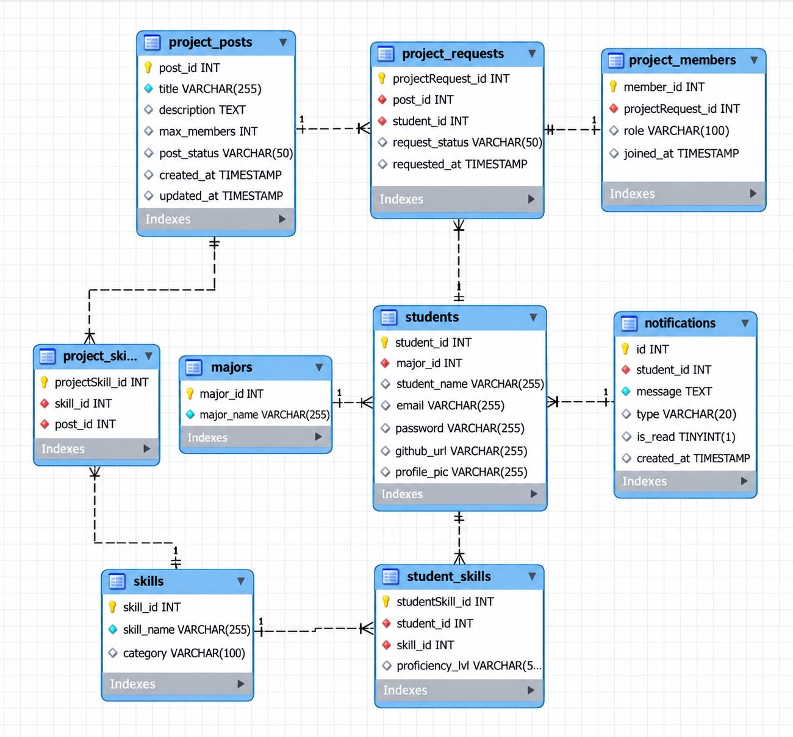
Figure 1- Entity Relationship Diagram for Project Partner Matcher System

3.4.2 Relational Schema

Majors | (Major_Id Primary Key,
 | Major_Name)

Students | (Student_Id Primary Key,
 | Major_Id Foreign Key,
 | Student_Name,
 | Email,
 | Password,
 | Github_url,
 | Profile_pic)

Skills | (Skill_Id Primary Key,
 | Skill_Name,
 | Category)

Student_Skills | (StudentSkill_Id Primary Key,
 | Student_Id Foreign Key,
 | Skill_Id Foreign Key,
 | Proficiency_Lvl)

Project_Posts | (Post_Id Primary Key,
 | Title,
 | Description,
 | Max_Members,
 | Post_Status,
 | Created_At,
 | Updated_At)

Project_Skills | (ProjectSkill_Id Primary Key,
 | Skill_Id Foreign Key,
 | Post_Id Foreign Key)

Project_Requests | (ProjectRequest_Id Primary Key,
 | Post_Id Foreign Key,
 | Student_Id Foreign Key,
 | Request_Status,
 | Requested_At)

Project_Members | (Member_Id Primary Key,
 | ProjectRequest_Id Foreign Key,
 | Role,
 | Joined_At)

Notifications | (Id Primary Key,
 | Student_Id Foreign Key,
 | Message,
 | Type,
 | Is_read,
 | Created_At)

3.4.3 Data Dictionary
A data dictionary is a central list of all the data in a database. It defines each piece of data, telling you its name, what kind of data it is (like text or numbers), and what it's used for. Think of it as a detailed catalog that helps everyone understand what information is stored and how to use it correctly.

Majors Table
Attribute Name | Data Type | Key | Description
Major_Id | INT | PK | Unique identifier for each academic major
Major_Name | VARCHAR (255) |  | Name of the major (e.g., CS, CT)

Students Table
Attribute Name | Data Type | Key | Description
Student_Id | INT | PK | Unique identifier for student
Major_Id | INT | FK | Foreign key referencing the Majors table
Student_Name | VARCHAR (255) |  | Full name of the student
Email | VARCHAR (255) |  | Unique email address
Password | VARCHAR (255) |  | Password for the student account
Github_Url | VARCHAR (255) |  | URL link to the student's GitHub profile
Profile_Pic | VARCHAR (255) |  | File path or URL link of the student's profile picture

Skills Table
Attribute Name | Data Type | Key | Description
Skill_Id | INT | PK | Unique identifier for the skill
Skill_Name | VARCHAR (255) |  | Name of the technical skill
Category | VARCHAR (100) |  | Skill category or domain of the skill

Student_Skills Table
Attribute Name | Data Type | Key | Description
StudentSkill_Id | INT | PK | Unique identifier for the student skill record
Student_Id | INT | FK | Foreign key referencing the Students table
Skill_Id | INT | FK | Foreign key referencing the Skills table
Proficiency_Lvl | VARCHAR (50) |  | Proficiency level (e.g., Beginner, Intermediate)

Project_Posts Table
Attribute Name | Data Type | Key | Description
Post_Id | INT | PK | Unique identifier for the project post
Title | VARCHAR (255) |  | Title of the project
Description | TEXT |  | Detailed description of the project
Max_Members | INT |  | Maximum number of allowed team members
Post_Status | VARCHAR (50) |  | Status of post (Default: 'Open')
Created_At | TIMESTAMP |  | Timestamp of record creation
Updated_At | TIMESTAMP |  | Timestamp of record update

Project_Skills Table
Attribute Name | Data Type | Key | Description
ProjectSkill_Id | INT | PK | Unique identifier for the project skill record
Skill_Id | INT | FK | Foreign key referencing the Skills table
Post_Id | INT | FK | Foreign key referencing the Project_Posts table
Project_Requests Table
Attribute Name | Data Type | Key | Description
ProjectRequest_Id | INT | PK | Unique identifier for the project request
Post_Id | INT | FK | Foreign key referencing the Project_Posts table
Student_Id | INT | FK | Foreign key referencing the Students (Applicant/ Member) table
Request_Status | VARCHAR (50) |  | Status of the request (Default: 'Pending')
Requested_At | TIMESTAMP |  | Request submission timestamp

Project_Members Table
Attribute Name | Data Type | Key | Description
Member_Id | INT | PK | Unique identifier for the team member record
ProjectRequest_Id | INT | FK | Foreign key referencing the Project_Requests table
Role | VARCHAR (100) |  | Role in the team (Default: 'Member')
Joined_At | TIMESTAMP |  | Timestamp when the member joined the team
Notifications Table
Attribute Name | Data Type | Key | Description
Id | INT | PK | Unique identifier for the notification record
Student_Id | INT | FK | Foreign key referencing the Students table
Message | TEXT |  | The text content of the notification message to be sent
Type | VARCHAR(20) |  | Category or type of the notification (e.g., Apply, Accepted, Rejected).
Is_Read | TINYINT(1) |  | Indicates whether the notification has been read (0 = Unread, 1 = Read)
Created_At | TIMESTAMP |  | The timestamp when the notification was created.

CHAPTER 4
SYSTEM IMPLEMENTATION

4.1 Database Implementation
The database is implemented using MySQL database management system to store and manage student and project details.

Database Creation
A database is created to store all information required by the Project Partner Matcher.
Table Implementation
The required tables are created based on database design.

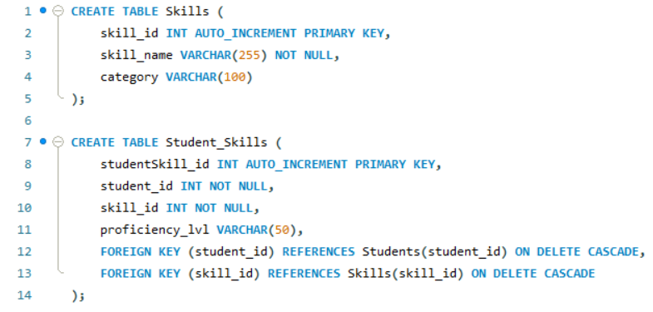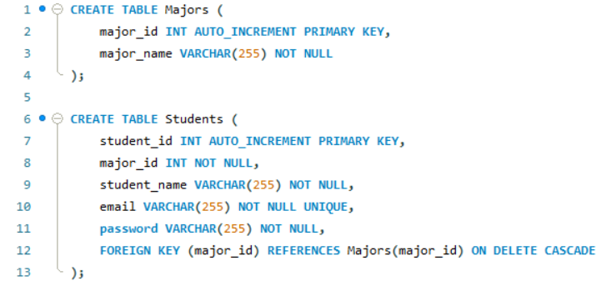
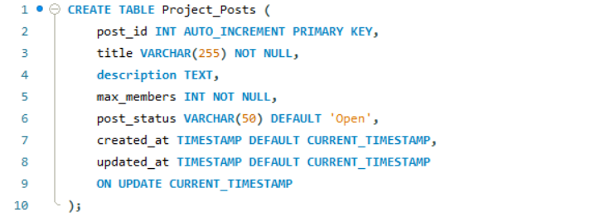
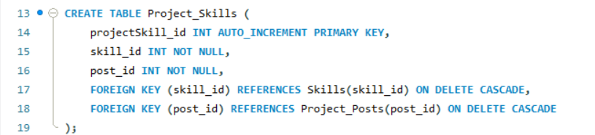
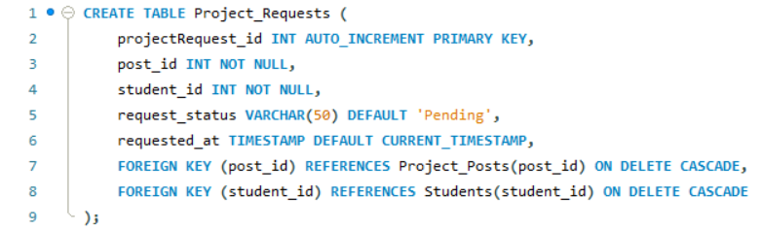
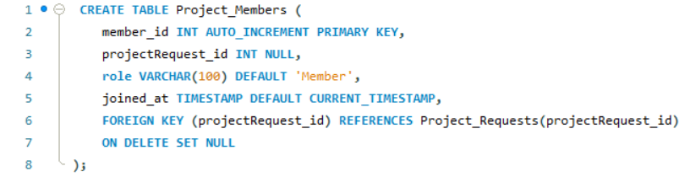
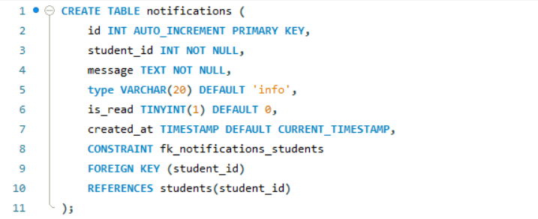
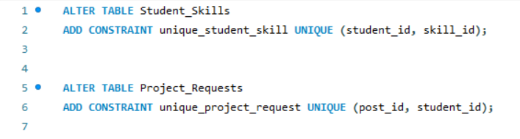

Constraints
Database constraints are used to maintain data accuracy and integrity. The following constraints:
- Primary Key
- Foreign Key
- NOT NULL
- UNIQUE
- DEFAULT
- AUTO_INCREMENT
- ON DELETE CASCADE
- ON DELETE SET NULL

Relationships
- Major_Id in the Students table references Major_Id in the Majors table.
- Student_Id in the Student_Skills table references Student_Id in the Students table.
- Skill_Id in the Student_Skills table references Skill_Id in the Skills table.
- Skill_Id in the Project_Skills table references Skill_Id in the Skills table.
- Post_Id in the Project_Skills table references Post_Id in the Project_Posts table.
- Post_Id in the Project_Requests table references Post_Id in the Project_Posts table.
- Student_Id in the Project_Requests table references Student_Id in the Students table.
- ProjectRequest_Id in the Project_Members table references ProjectRequest_Id in the Project_Requests table.
- Student_Id in the Notifications table references Student_Id in the Students table.

4.2 User Interface Implementation
The user interface is developed using HTML, CSS, JavaScript, and Flask (Python). It provides a responsive and user-friendly interface for students to find project partners, manage posts, and receive real-time notifications.

4.2.1 User Registration
These pages help new users sign up by collecting their personal and study details to create a student account.

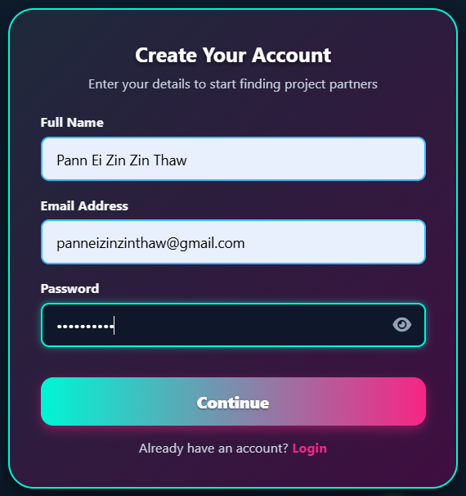 | 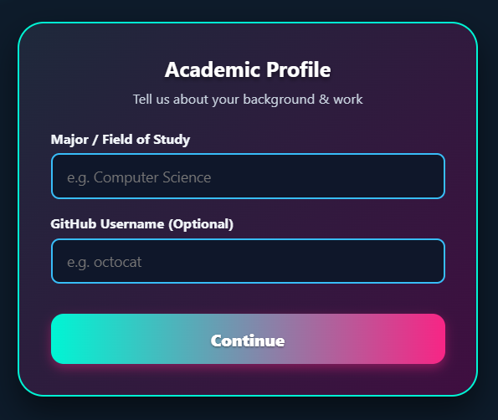
Figure 2 - Create Account and Academic Profile Page

4.2.2 User Authentication and Password Recovery
These pages allow registered users to securely login to their accounts using their credentials and reset their password to recover account access when needed.
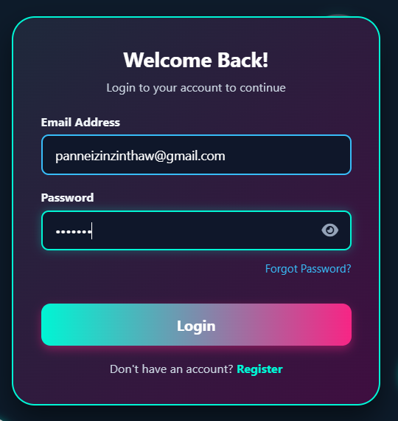 | 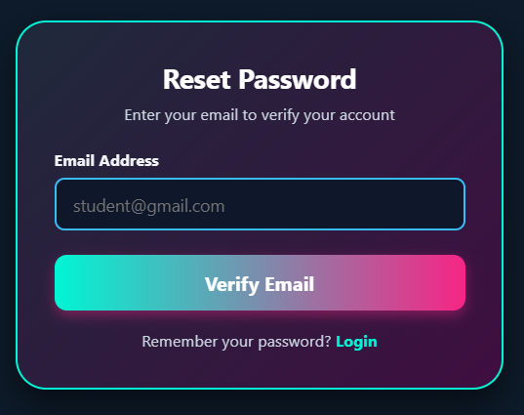
Figure 3 - Login and Password Reset Page

4.2.3 Specialization and Skills Selection
These pages allow users to choose their main field of study and select specific technical skills based on their chosen category.
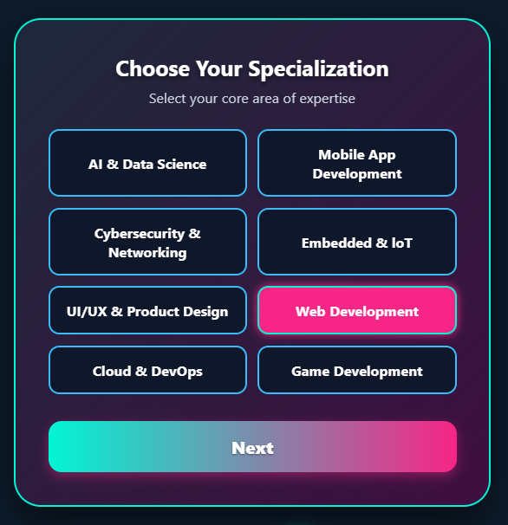 | 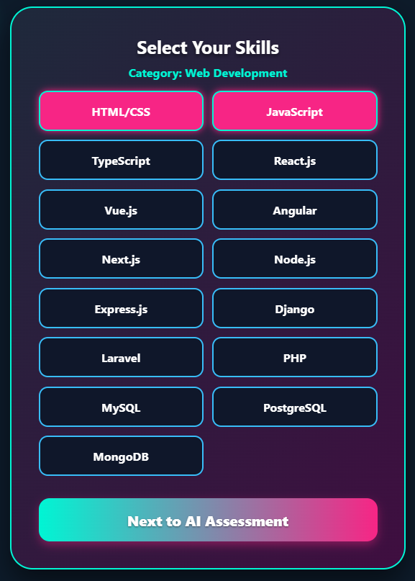
Figure 4 - Specialization and Technical Skills Selection Page

4.2.4 AI Assessment and Profile Completion
These pages let the system test user skills with AI and allow users to upload a photo to finish setting up their account.
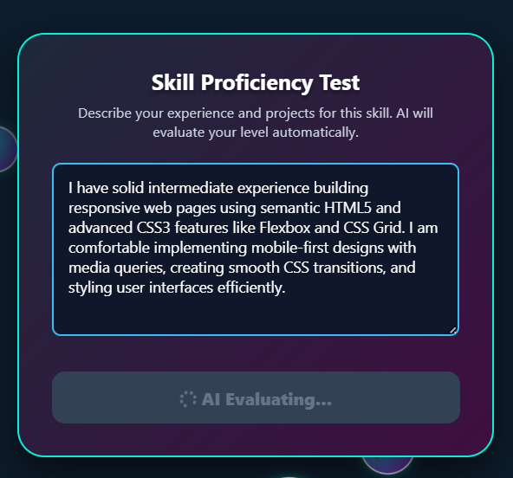 | 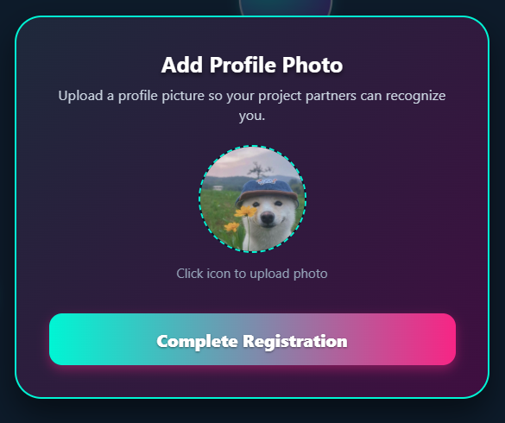
Figure 5 - AI Skill Assessment and Profile Completion Page

4.2.5 User Profile Page
This page allows users to view their account details and manage their project activities through three tabs: My Posts, which displays the projects they have created; Applied, which shows their project applications and statuses; and Accepted, which displays projects where their join requests have been accepted and allows them to manage their team participation.
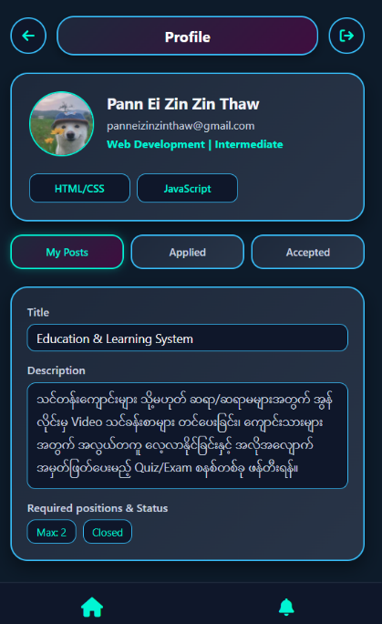 | 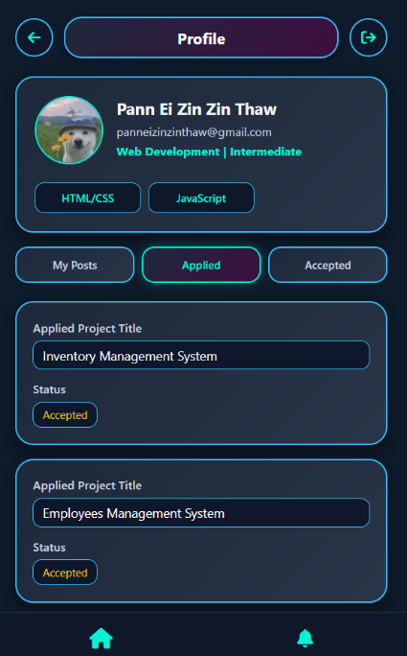 | 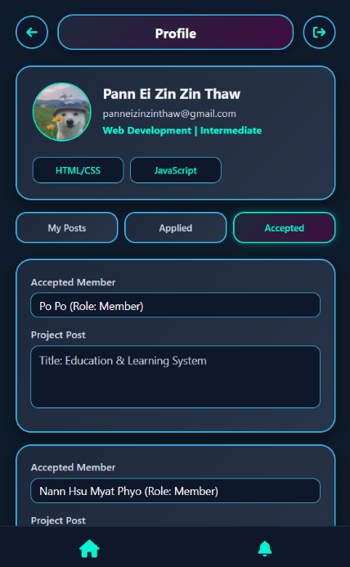
Figure 6 - User Profile Page

4.2.6 Create Project Post
This page allows users to create and publish new project listings by providing project details, required technical skills, and member capacity.
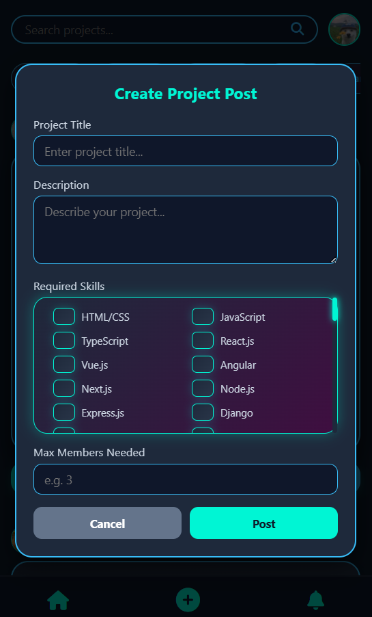 | 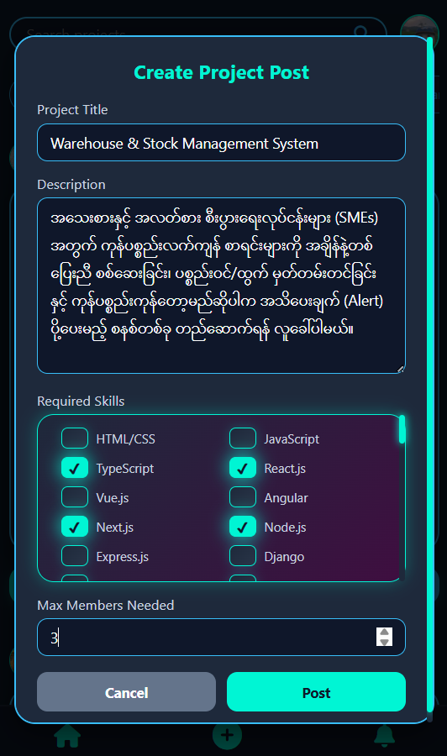
Figure 7 - Create Project Post Page
4.2.7 Project Requests Management and Notifications
This page allows project owners to review and manage incoming project applications by accepting or rejecting requests, while keeping users updated on their application statuses through real-time notifications.
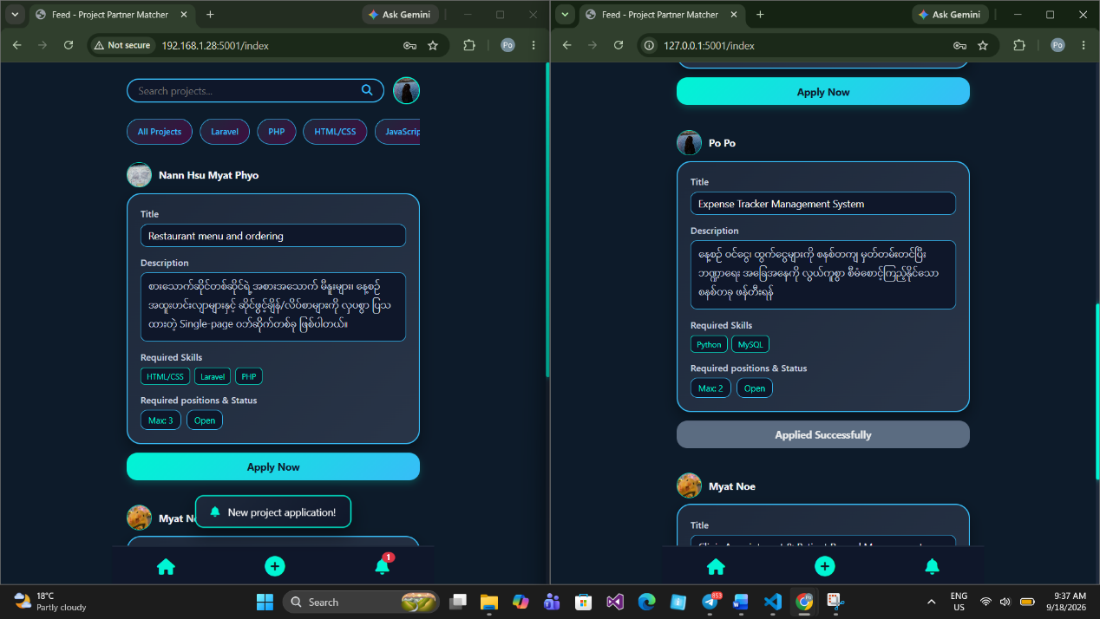
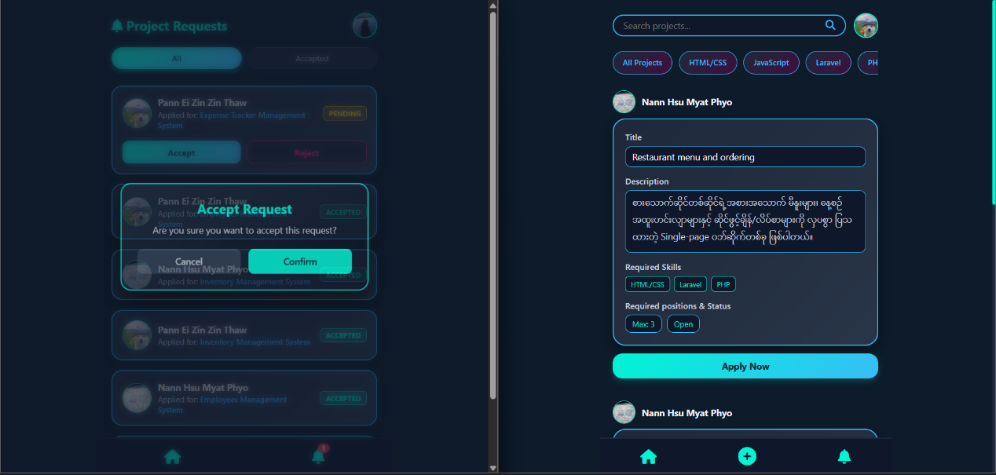
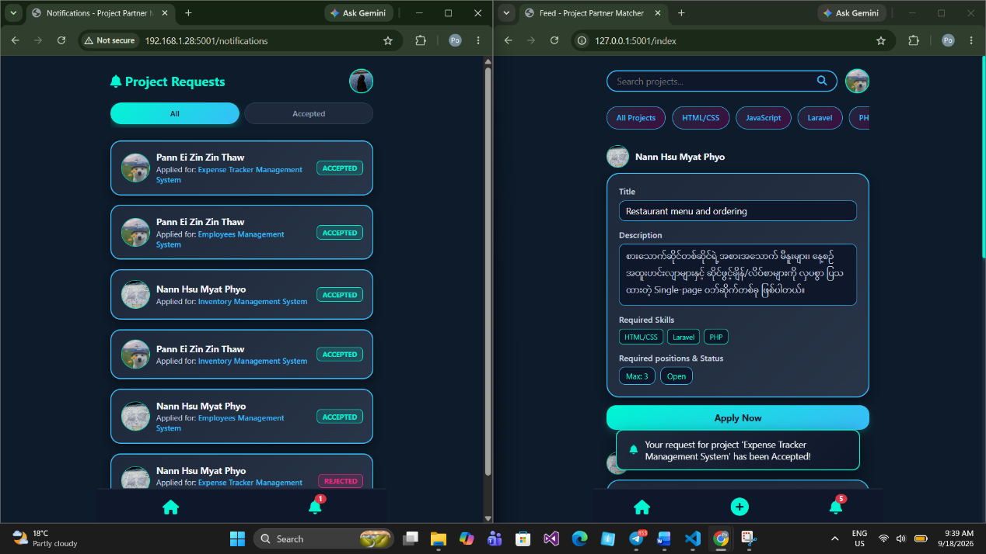
Figure 8 - Project Requests Management and Notification Page
CHAPTER 5
CONCLUSION

The Project Partner Matcher system was successfully developed to support team formation for student academic projects. By replacing manual partner selection with a centralized web platform, the system allows students to showcase their technical skills and connects students based on technical capabilities. Database enforcement using MySQL maintains data integrity through primary keys, foreign keys, UNIQUE constraints, and other database constraints. The Flask backend manages application logic and database operations, while the system prevents duplicate project requests, enforces team member limits, and provides notifications for project request status updates. Overall, the system provides a structured approach to project team formation and supports collaboration among students from different academic majors.

