POLYTECHNIC UNIVERSITY (PANGLONG)
FACULTY OF COMPUTING



CST-3257: Applied Database and Application (C#, ADO.Net)
“Storage Rental Booking System”
Report Book

Supervisor
Daw Theint Theint Moe

Presented by
3CS-11: Nann Hsu Myat Phyo
Section – A
2024-2025 Academic Year

CONTENT Page

Acknowledgement i
Abstract ii
Introduction 1
Objectives 2 Implementation 3
  - Sign-Up Page
  - Login Page
  - Customer Page
  - Booking Page
  - Add Product Page
  - Admin Page
Conclusion 11
ACKNOWLEDGEMENT
I wish to express my profound gratitude to Dr. Myint Myint Khaing, Pro-Rector of the Polytechnic University (Panglong), Faculty of Computing, for her generous support and the resources extended to us throughout our academic journey at the university. Her dedication and guidance have significantly contributed to the advancement of our studies.
In particular, I would really like to acknowledge with deep appreciation my supervisor, Daw Theint Theint Moe, Associate Professor (Department of Information Technology Supporting and Maintenance) at the Faculty of Computing, Polytechnic University (Panglong), for her insightful suggestions and invaluable assistance in refining and editing my project.
ABSTRACT
The Storage Rental Booking System is a software application designed to simplify and streamline the process of managing storage unit rentals. It enables customers to easily search, book, and manage available storage units while providing administrators with tools for efficient inventory management and booking records. The system enhances transparency, reduces manual errors, and saves time by offering a user-friendly interface for both customers and administrators. By automating the rental process, it ensures improved accuracy, better customer service, and effective utilization of storage spaces.

INTRODUCTION
The Storage Rental Booking System is developed to provide a modern and efficient solution for managing storage facilities and customer bookings. In traditional methods, customers face difficulties in checking availability and booking storage units, while administrators struggle with maintaining accurate records and managing multiple requests. This system addresses those issues by offering a digital platform that allows users to conveniently search and reserve storage units online, while administrators can easily monitor unit availability and manage customer details. With its user-friendly design and automated processes, the system improves service quality, minimizes errors, and ensures better resource utilization.

OBJECTIVES
- To provide an efficient way to manage storage unit availability and reservations.
- To allow customers to easily search, select, and book storage units online.
- To design a user-friendly interface for both customers and administrators.
- To maintain accurate records of bookings and customer details.
- To reduce manual errors and save time through automation.
- To improve customer service by offering quick access to storage availability information.
- To ensure security and transparency in handling customer information and transactions.
- To maximize the utilization of storage resources effectively.

IMPLEMENTATIONS
- Sign-Up Page
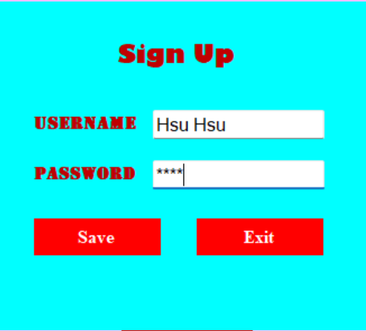
Figure 1: Sign Up Page

This Page is Sign-up Form. Customer will fill username and password and then click save button. Customer should remember their fill information.

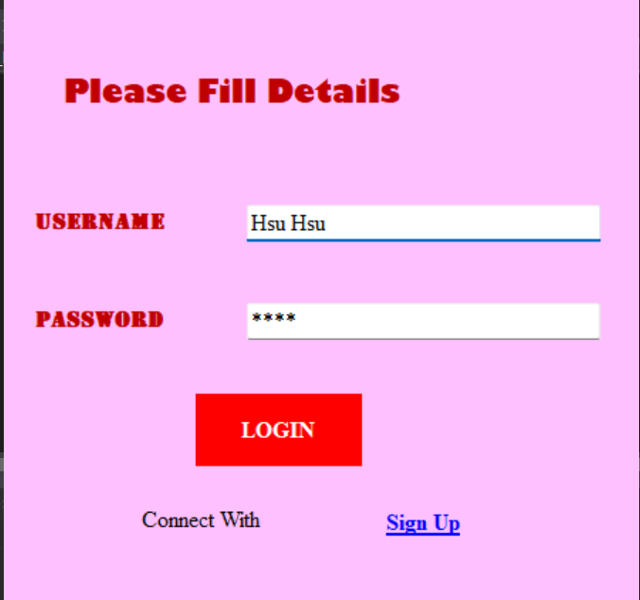
- Login Page
Figure 2: Login Page

The image shows a Login Page. At the top, the heading “Please Fill Details” is displayed, asking the user to provide their information before logging in. The form contains two text boxes for Username and Password. After entering the information, the user can press the LOGIN button to access the system. Additionally, there is a “Connect With” text and a Sign Up link for new users to create an account.
This Login Page is designed to allow users to enter the system by authenticating with their Username and Password.

- Customer Page
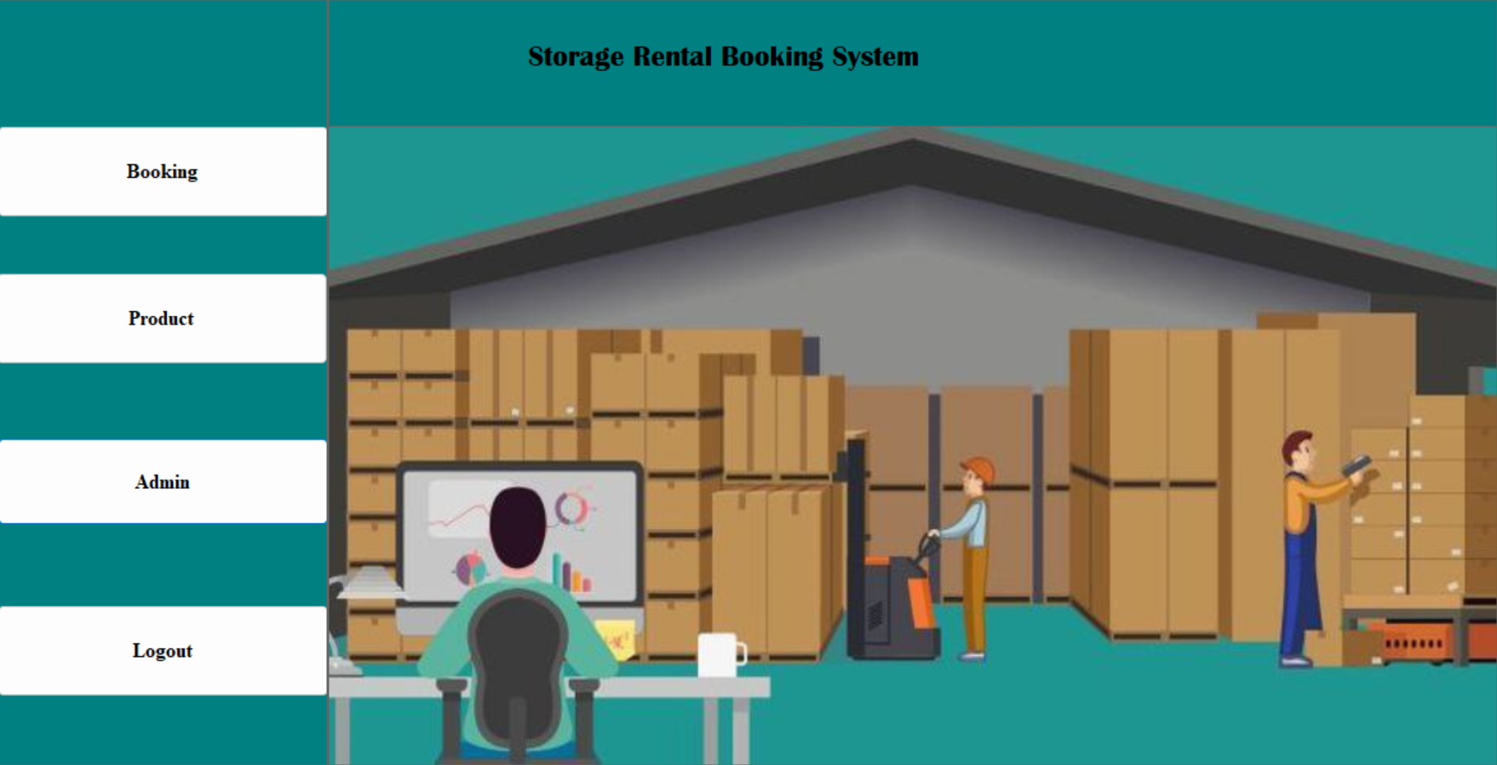
Figure 3: Customer Page

The illustrated Customer Page is part of the Storage Rental Booking System designed for customer use. It includes menu options such as Booking, Product, Admin, and Logout, allowing customers to book storage units, view product categories, and manage their accounts. The central section is decorated with graphics of workers handling stored goods, making the system more user-friendly and visually understandable.

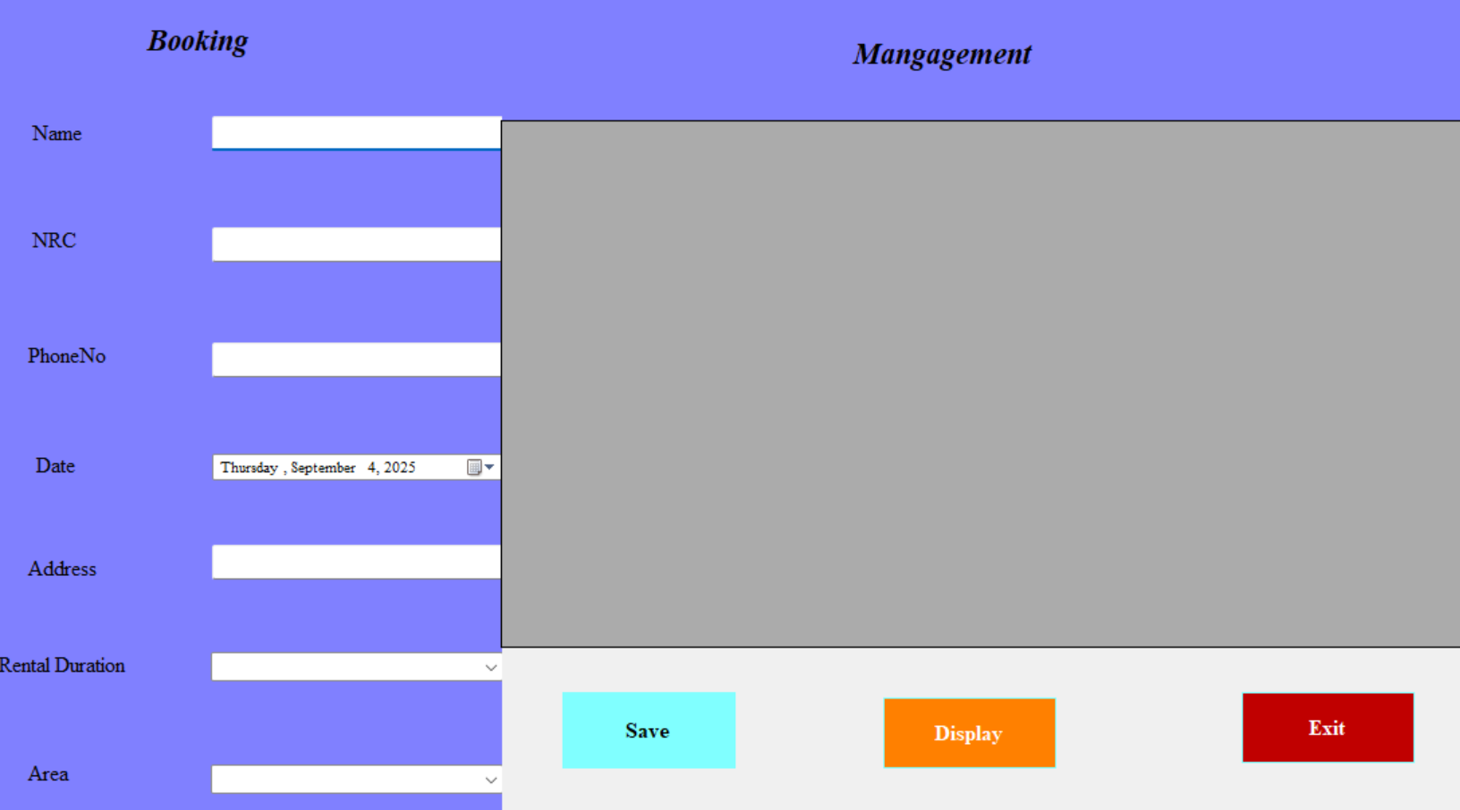
4. Booking Page
Figure 4: Booking Page

Shows the Booking Page of the Storage Rental Booking System, which is designed for customers to enter their details and make storage rental bookings. It includes form fields such as name, address, phone number, and NRC, allowing users to provide the required information. The page also contains Save, Display, and Exit buttons that enable customers to save their data, review submitted information, and exit the page. Therefore, the Booking Page serves as an essential component that helps customers easily complete the data entry and booking process.

5. Add Product Page
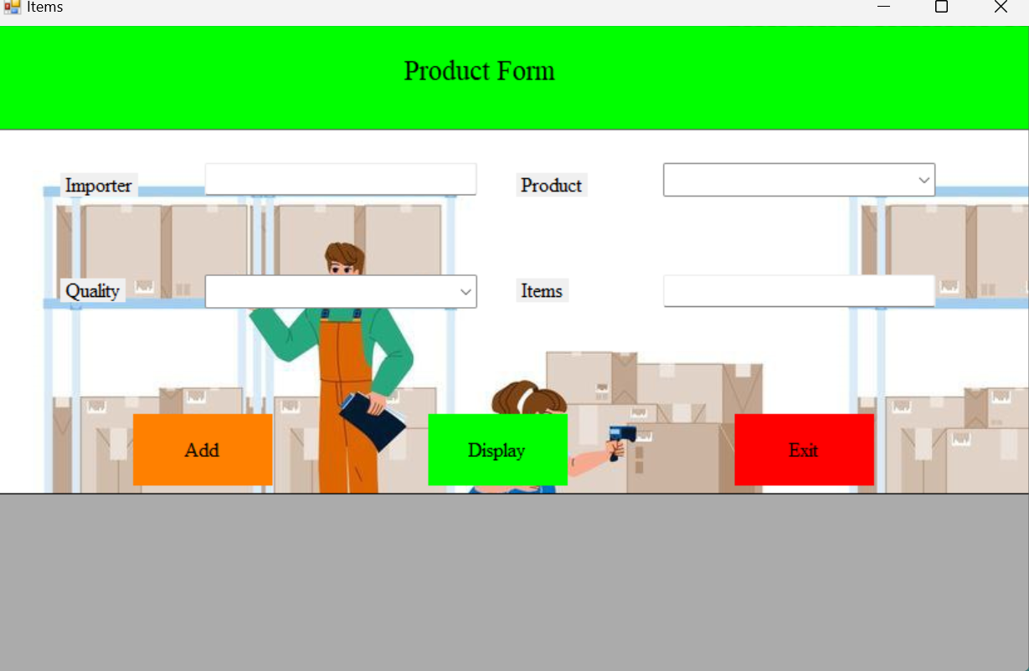
Figure 5: Add Product Page

This page is designed for adding new product details into the system. It contains input fields such as product name, item, quality, and inspector information, allowing accurate product data entry. The page also provides three main buttons: Add (to insert new product data), Display (to view the existing product records), and Exit (to leave the page). Therefore, the Add Product Page plays an important role in managing product information within the system by enabling users to add and review product details efficiently.

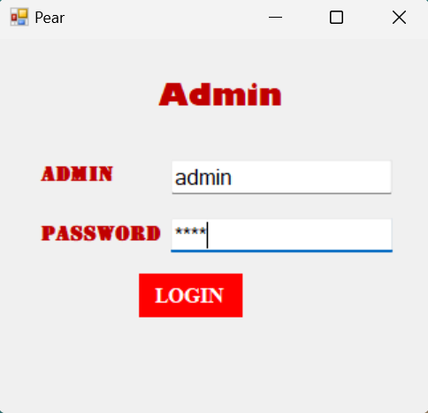
6. Admin Page
Figure 6: Admin Login

This figure shows the Admin Login Form, where the administrator can enter a username and password, then click the login button to access the system.

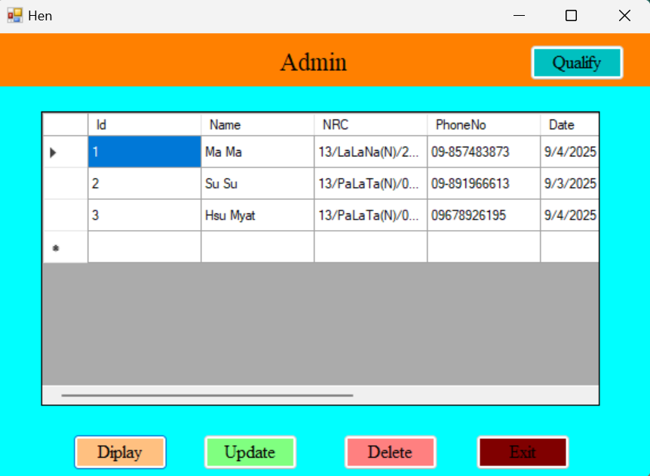
Figure 7: Admin can Update and Delete

This figure shows the Admin Login Form, where the administrator can enter a username and password, then click the login button to access the system.
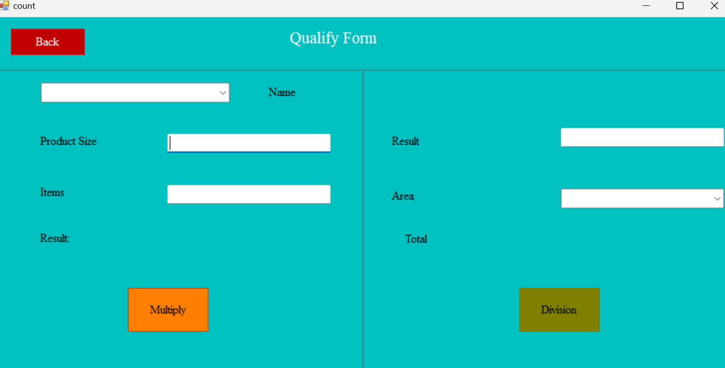
Figure 8: Qualify

Qualify Form, which is used for entering and managing qualification details. The form contains input fields such as Name, Email, Product Size, Area, and Total. It also includes control buttons like Modify, Delete, and Exit, allowing the administrator to update, remove, or close the form. This interface helps in systematically qualifying and managing user or product information in the system.

Conclusion
The Storage Rental Booking System provides an effective and reliable solution for managing storage facilities by automating the booking process and record keeping. It helps customers conveniently search and reserve storage units while enabling administrators to monitor availability, manage transactions, and maintain accurate records. By reducing manual work, improving efficiency, and ensuring transparency, the system enhances customer satisfaction and promotes better utilization of resources. Overall, it offers a modern and user-friendly approach to storage management that saves both time and cost.

