Oracle Database Project
Hospital Management System
Neptun ID: LQOO56
Database: Oracle SQL Developer
April 2026

Oracle Project: Overall Process

1.1 Process Workflow Phases
The project was executed in five primary phases:
- Requirement Analysis & Domain Modeling:
  - Identified core healthcare entities (Patients, Doctors, Appointments).
  - Defined business rules, such as preventing double-bookings and managing drug inventory.
- Schema Design & Physical Optimization:
  - Designed the ER diagram using Oracle SQL Developer Data Modeler.
  - Implemented Range Partitioning on the PATIENTS table to handle high-volume admissions (~100,000 rows).
  - Applied Index-Organized Table (IOT) structure to MEDICAL_RECORDS to optimize I/O for patient history lookups.
- Data Generation & Migration:
  - Used Mockaroo for realistic reference data (Doctors, Medications).
  - Utilized Spawner to generate ~380,000 rows of transactional data.
  - Resolved data type and format mismatches (specifically date formats) during the CSV import process.
- Backend Logic Development (PL/SQL):
  - Created Sequences and Triggers for automated Primary Key generation.
  - Developed a Compound Trigger to resolve the ORA-04091 mutating table error during bulk appointment scheduling.
  - Authored stored procedures and functions to encapsulate business logic, such as SP_ISSUE_PRESCRIPTION which integrates stock validation.
- Testing, Tuning & Access Control:
  - Validated performance using Explain Plans to verify partition pruning and index usage.
  - Created administrative views for reporting (e.g., Department Statistics).
  - Granted specific SELECT and EXECUTE privileges to the lkpeter schema for evaluation.

Development Lifecycle Summary
Phase | Core Tool | Key Outcome
Design | Oracle Data Modeler | Normalized relational schema (3NF).
Generation | Spawner / Mockaroo | ~380,000 rows of diverse test data.
Implementation | Oracle SQL Developer | Partitioned tables, IOTs, and Compound Triggers.
Optimization | DBMS_XPLAN/ F10 | Verified Index Range Scans and Partition Pruning.
Security | Manual SQL | Role-based access for professor evaluation.

Test Data Selection
The chosen domain for this project is Hospital / Healthcare management. This domain was selected because it provides a realistic, rich set of interconnected entities with meaningful relationships, sufficient volume requirements, and real-world constraints suitable for demonstrating advanced Oracle database features.

2.1 Domain Overview
The hospital management system tracks patients, doctors, departments, appointments, medications, prescriptions, and medical records. This naturally produces high-volume transactional tables (patients, medical records) alongside smaller reference tables (departments, medications).

2.2 Table Summary
Table | Row Count | Type | Description
DEPARTMENTS | 7 | Reference | Hospital departments
DOCTORS | 30 | Reference | Medical staff
MEDICATIONS | 50 | Reference | Drug inventory
PATIENTS | ~100,000 | Large / Partitioned | Patient registry (range-partitioned by admission_date)
APPOINTMENTS | ~50,000 | Transactional | Scheduled visits with date+time and duration
MEDICAL_RECORDS | ~150,000 | Large / IOT | Visit diagnoses (Index-Organised Table)
PRESCRIPTIONS | ~80,000 | Transactional | Medication prescriptions per patient

2.3 Partitioning and Clustering

PATIENTS — Range Partitioned
The PATIENTS table is range-partitioned by admission_date into 5 partitions:
- p_before_2022 — admissions before 2022
- p_2022 — admissions in 2022
- p_2023 — admissions in 2023
- p_2024 — admissions in 2024
- p_2025_plus — admissions from 2025 onwards (MAXVALUE)
Partitioning improves query performance for date-range filters. When a query includes a WHERE clause on admission_date, Oracle performs partition pruning and scans only the relevant partition instead of the full 100,000-row table. 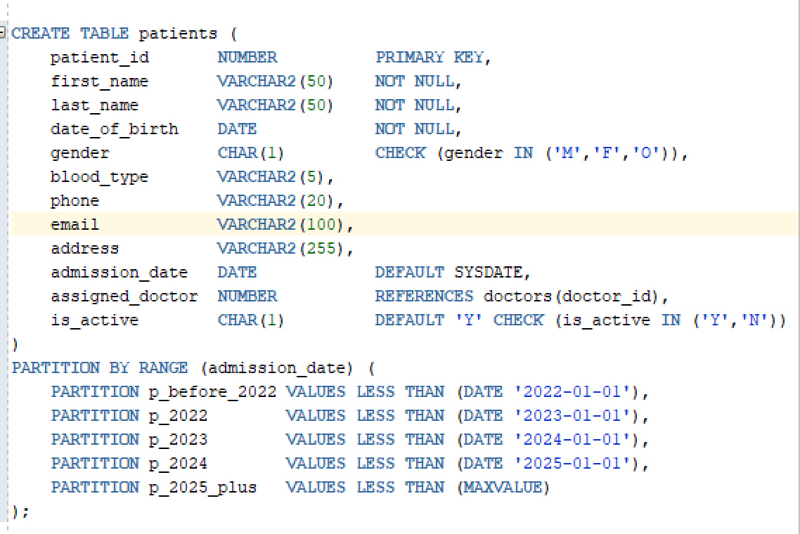

MEDICAL_RECORDS — Index-Organised Table (IOT)
The MEDICAL_RECORDS table uses Oracle's Index-Organised Table structure (ORGANIZATION INDEX). This is Oracle's physical clustering mechanism — rows are stored sorted by the primary key on disk. This means fetching all records for a patient requires fewer I/O operations than a standard heap table, which is critical for a 150,000-row table queried frequently by patient_id.

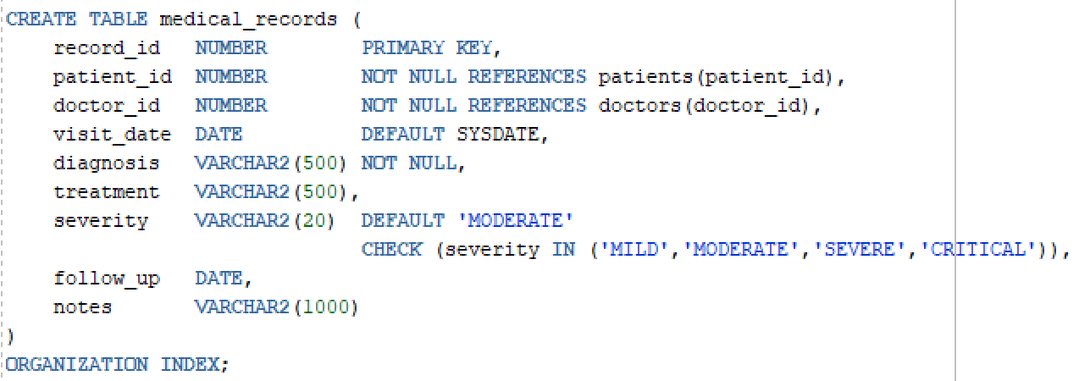

3. Data Generation and Loading

3.1 Tools Used
Tool | Tables | Rows Generated | Format
Mockaroo | DOCTORS, MEDICATIONS | 30 + 50 | CSV
Spawner | PATIENTS, APPOINTMENTS, MEDICAL_RECORDS, PRESCRIPTIONS | ~380,000 total | CSV
Manual SQL | DEPARTMENTS | 7 | SQL INSERT

3.2 Mockaroo (mockaroo.com)
Mockaroo is a free web-based test data generator. It was used for smaller reference tables because it produces realistic values for names, drug names, and license numbers.
Steps followed:
- Opened mockaroo.com and created a new schema
- Added columns matching each table definition
- Set field types: First Name, Last Name, Drug (Brand), Custom List for enums
- Set row count to 30 (doctors) and 50 (medications)
- Exported output as CSV files
- Imported CSVs into Oracle using SQL Developer's Import Wizard (right-click table → Import Data)

3.3 Spawner Data Generator
Spawner is a free open-source desktop application (available on SourceForge) used to generate large volumes of test data. It was used for all high-volume tables.
Steps followed:
- Downloaded Spawner 0.2.4 from sourceforge.net/projects/spawner
- Opened the application and configured a new schema for each table
- Set field types using Spawner's built-in types: Integer (ranges), Enum (fixed value lists), First Name, Last Name, Email, Phone
- Set row count to 100,000 (patients), 150,000 (medical_records), 50,000 (appointments), 80,000 (prescriptions)
- Exported output as CSV files
- Imported CSVs into Oracle using SQL Developer's Import Wizard (right-click table → Import Data)

Date Format Issue Encountered
During import, the appt_date column in APPOINTMENTS triggered a format mismatch warning. Spawner generated dates in DD/MM/YYYY HH24:MI format while Oracle expected YYYY-MM-DD HH24:MI. This was resolved by changing the Format field in the SQL Developer Import Wizard column mapping screen to DD/MM/YYYY HH24:MI.

Mutating Table Trigger Error (ORA-04091)
During bulk import of APPOINTMENTS, the row-level trigger TRG_NO_DOUBLE_BOOKING caused ORA-04091 (mutating table error). This happened because the trigger attempted to SELECT from the APPOINTMENTS table while it was mid-insert. The trigger was replaced with a COMPOUND trigger that separates row-level collection from statement-level validation. For the test data load, the trigger was additionally disabled before import and re-enabled after:

ALTER TRIGGER trg_no_double_booking DISABLE;
-- run import
ALTER TRIGGER trg_no_double_booking ENABLE;

3.4 Load Order
Foreign key constraints require loading tables in dependency order:
Step | Table | Reason
1 | DEPARTMENTS | No foreign keys — loaded first
2 | DOCTORS | References DEPARTMENTS
3 | MEDICATIONS | No foreign keys — independent
4 | PATIENTS | References DOCTORS
5 | APPOINTMENTS | References PATIENTS and DOCTORS
6 | MEDICAL_RECORDS | References PATIENTS and DOCTORS
7 | PRESCRIPTIONS | References PATIENTS, DOCTORS, MEDICATIONS

4. Entity-Relationship Diagram

4.1 ER Diagram
The ER diagram was designed using Oracle SQL Developer Data Modeler and exported to DDL. Physical properties (partitioning, IOT) were added manually after export as Data Modeler strips these during DDL generation.
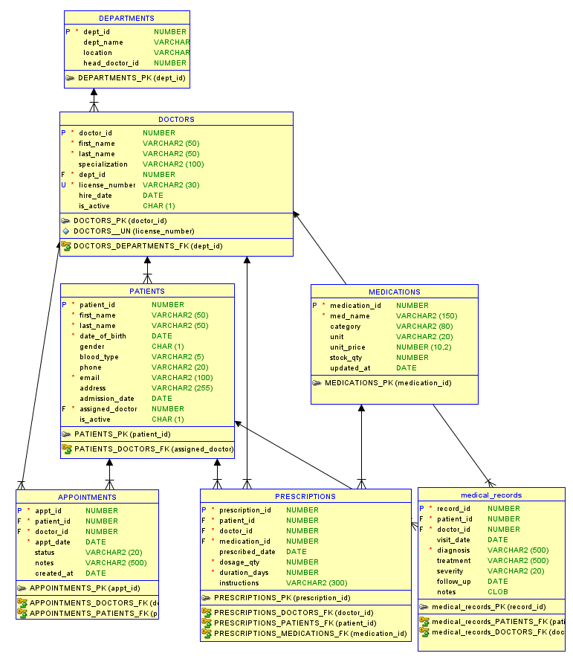

4.2 Entity Descriptions

DEPARTMENTS
Stores the hospital's organisational units. Each department has a name, physical location, and a reference to its head doctor. This is a small reference table with 7 rows.

DOCTORS
Contains medical staff records including name, specialization, department assignment, and license number. Each doctor belongs to exactly one department. 30 rows in the test dataset.

PATIENTS (Partitioned)
The central large table with ~100,000 rows. Stores patient demographics, blood type, contact information, and their assigned doctor. Range-partitioned by admission_date across 5 yearly partitions to improve date-range query performance.

APPOINTMENTS
Records scheduled visits between patients and doctors. Contains appointment datetime, duration in minutes (15/30/45/60), status (SCHEDULED/COMPLETED/CANCELLED/NO_SHOW), reason for visit, and notes. A compound trigger prevents double-booking of doctors.

MEDICATIONS
Reference table of 50 drugs with their category, unit of measurement, stock quantity, and unit price. Stock is automatically decremented when a prescription is issued via a trigger.

PRESCRIPTIONS
Links patients, doctors, and medications. Records dosage quantity, duration in days, and instructions. ~80,000 rows.

MEDICAL_RECORDS (IOT)
The second large table with ~150,000 rows. Stores visit outcomes including diagnosis, treatment plan, severity level (MILD/MODERATE/SEVERE/CRITICAL), and follow-up date. Implemented as an Index-Organised Table for efficient patient history retrieval.

4.3 Relationships
Parent Table | Child Table | Cardinality | Relationship
DEPARTMENTS | DOCTORS | 1 : N | A department employs many doctors
DOCTORS | PATIENTS | 1 : N | A doctor is assigned many patients
PATIENTS | APPOINTMENTS | 1 : N | A patient schedules many appointments
DOCTORS | APPOINTMENTS | 1 : N | A doctor attends many appointments
PATIENTS | MEDICAL_RECORDS | 1 : N | A patient has many medical records
PATIENTS | PRESCRIPTIONS | 1 : N | A patient receives many prescriptions
MEDICATIONS | PRESCRIPTIONS | 1 : N | A medication appears in many prescriptions

5. Database Objects

5.1 Sequences
Seven sequences provide auto-incrementing primary key values, one per table. All sequences start at 1 and increment by 1.
CREATE SEQUENCE appointments_appt_id_seq START WITH 1 NOCACHE ORDER;
CREATE SEQUENCE departments_dept_id_seq START WITH 1 NOCACHE ORDER;
CREATE SEQUENCE doctors_doctor_id_seq START WITH 1 NOCACHE ORDER;
CREATE SEQUENCE medical_records_record_id_seq START WITH 1 NOCACHE ORDER;
CREATE SEQUENCE medications_medication_id_seq START WITH 1 NOCACHE ORDER;
CREATE SEQUENCE patients_patient_id_seq START WITH 1 NOCACHE ORDER;
CREATE SEQUENCE prescriptions_prescription_id START WITH 1 NOCACHE ORDER;

5.2 Triggers
Trigger Name | Table | Purpose
TRG_DEPT_ID | DEPARTMENTS | Auto-populate PK from sequence before insert
TRG_DOCTOR_ID | DOCTORS | Auto-populate PK from sequence before insert
TRG_PATIENT_ID | PATIENTS | Auto-populate PK from sequence before insert
TRG_APPOINTMENT_ID | APPOINTMENTS | Auto-populate PK from sequence before insert
TRG_MEDICATION_ID | MEDICATIONS | Auto-populate PK from sequence before insert
TRG_PRESCRIPTION_ID | PRESCRIPTIONS | Auto-populate PK from sequence before insert
TRG_RECORD_ID | MEDICAL_RECORDS | Auto-populate PK from sequence before insert
TRG_NO_DOUBLE_BOOKING | APPOINTMENTS | COMPOUND trigger: prevents overlapping doctor appointments using after-statement validation
TRG_REDUCE_STOCK | PRESCRIPTIONS | Decrements medication stock_qty after each prescription insert
TRG_PATIENT_AUDIT | PATIENTS | Logs email/phone changes to PATIENT_AUDIT_LOG after update

Compound Trigger — TRG_NO_DOUBLE_BOOKING
This trigger was redesigned as a COMPOUND trigger to avoid the ORA-04091 mutating table error that occurs when a row-level trigger queries its own table during a bulk INSERT. The compound trigger collects new appointment data at the BEFORE EACH ROW stage into a PL/SQL collection, then performs the overlap validation query at the AFTER STATEMENT stage when the table is no longer mutating.

5.3 Views
View Name | Description
VW_PATIENT_DETAILS | Joins PATIENTS, DOCTORS, DEPARTMENTS and shows full patient info including doctor name, specialization, department, and calculated age. Filters active patients only.
VW_TODAYS_APPOINTMENTS | Joins APPOINTMENTS, PATIENTS, DOCTORS and shows today's schedule filtered by TRUNC(SYSDATE). Ordered by appointment time.
VW_DEPARTMENT_STATS | Groups by DEPARTMENTS with counts of doctors, patients, and appointments per department using LEFT JOINs.
VW_LOW_STOCK_MEDICATIONS | Filters MEDICATIONS where stock_qty < 100, ordered ascending and used for inventory alerts.
VW_PRESCRIPTION_HISTORY | Joins PRESCRIPTIONS, PATIENTS, DOCTORS, MEDICATIONS and full prescription history with dosage and instructions.

VW_PATIENT_DETAILS (3-table join with WHERE)
This view satisfies the requirement of joining at least three tables with a WHERE clause on a large table (PATIENTS, ~100,000 rows).
CREATE OR REPLACE VIEW vw_patient_details AS
SELECT
p.patient_id,
p.first_name || ' ' || p.last_name AS patient_name,
TRUNC(MONTHS_BETWEEN(SYSDATE, p.date_of_birth) / 12) AS age,
p.gender, p.blood_type, p.admission_date,
d.first_name || ' ' || d.last_name AS doctor_name,
d.specialization,
dept.dept_name
FROM patients p
JOIN doctors d ON p.assigned_doctor = d.doctor_id
JOIN departments dept ON d.dept_id = dept.dept_id
WHERE p.is_active = 'Y';

VW_DEPARTMENT_STATS (grouping with HAVING + subquery)
This view satisfies the requirement of joining at least two tables with a subquery and GROUP BY / HAVING clause using a large table (PATIENTS).
CREATE OR REPLACE VIEW vw_department_stats AS
SELECT
dept.dept_id,
dept.dept_name,
COUNT(DISTINCT d.doctor_id) AS total_doctors,
COUNT(DISTINCT p.patient_id) AS total_patients,
COUNT(DISTINCT a.appt_id) AS total_appointments
FROM departments dept
LEFT JOIN doctors d ON d.dept_id = dept.dept_id
LEFT JOIN patients p ON p.assigned_doctor = d.doctor_id
LEFT JOIN appointments a ON a.doctor_id = d.doctor_id
GROUP BY dept.dept_id, dept.dept_name
HAVING COUNT(DISTINCT p.patient_id) > 0;

VW_TODAYS_APPOINTMENTS
CREATE OR REPLACE VIEW vw_department_stats AS
SELECT
dept.dept_id,
dept.dept_name,
COUNT(DISTINCT d.doctor_id) AS total_doctors,
COUNT(DISTINCT p.patient_id) AS total_patients,
COUNT(DISTINCT a.appt_id) AS total_appointments
FROM departments dept
LEFT JOIN doctors d ON d.dept_id = dept.dept_id
LEFT JOIN patients p ON p.assigned_doctor = d.doctor_id
LEFT JOIN appointments a ON a.doctor_id = d.doctor_id
GROUP BY dept.dept_id, dept.dept_name;

5.4 Indexes
Index Name | Table | Columns / Purpose
IDX_PATIENTS_NAME | PATIENTS | last_name, first_name — name search
IDX_PATIENTS_DOB | PATIENTS | date_of_birth — age/DOB filtering
IDX_PATIENTS_DOCTOR | PATIENTS | assigned_doctor — FK join acceleration
IDX_APPTS_DATE | APPOINTMENTS | appt_date — date range queries
IDX_APPTS_DOCTOR_STATUS | APPOINTMENTS | doctor_id, status — composite for schedule queries
IDX_RECORDS_PATIENT | MEDICAL_RECORDS | patient_id, visit_date DESC — patient history
IDX_RECORDS_SEVERITY | MEDICAL_RECORDS | severity — severity filtering
IDX_RX_PATIENT | PRESCRIPTIONS | patient_id — prescription lookup
IDX_MEDS_CATEGORY | MEDICATIONS | category — category search

6. PL/SQL Objects

6.1 Stored Function

FN_DOCTOR_APPT_COUNT
This function counts the number of completed/scheduled appointments for a doctor in a given year and month. It demonstrates: one input argument (doctor_id, year, month), a cursor via implicit SELECT INTO, an IF structure, and a return value.
CREATE OR REPLACE FUNCTION fn_doctor_appt_count(
p_doctor_id IN NUMBER,
p_year IN NUMBER,
p_month IN NUMBER
) RETURN NUMBER
IS
v_count NUMBER;
BEGIN
SELECT COUNT(*)
INTO v_count
FROM appointments
WHERE doctor_id = p_doctor_id
AND EXTRACT(YEAR FROM appt_date) = p_year
AND EXTRACT(MONTH FROM appt_date) = p_month
AND status NOT IN ('CANCELLED','NO_SHOW');
RETURN v_count;
END fn_doctor_appt_count;
/

FN_PATIENT_AGE
Calculates a patient's current age based on their date_of_birth. This is used in views like VW_PATIENT_DETAILS to provide real-time demographics.
CREATE OR REPLACE FUNCTION fn_patient_age(p_dob IN DATE)
RETURN NUMBER
IS
BEGIN
RETURN TRUNC(MONTHS_BETWEEN(SYSDATE, p_dob) / 12);
END fn_patient_age;
/

FN_LAST_DIAGNOSIS
Retrieves the most recent diagnosis for a patient by querying the MEDICAL_RECORDS table. Because MEDICAL_RECORDS is an Index-Organised Table (IOT), this lookup is extremely efficient even at high volumes.
CREATE OR REPLACE FUNCTION fn_last_diagnosis(p_patient_id IN NUMBER)
RETURN VARCHAR2
IS
v_diagnosis VARCHAR2(500);
BEGIN
SELECT diagnosis
INTO v_diagnosis
FROM (
SELECT diagnosis
FROM medical_records
WHERE patient_id = p_patient_id
ORDER BY visit_date DESC
)
WHERE ROWNUM = 1;
RETURN v_diagnosis;
EXCEPTION
WHEN NO_DATA_FOUND THEN RETURN 'No records found';
END fn_last_diagnosis;
/

FN_IS_IN_STOCK
Checks the MEDICATIONS table to verify if a specific drug quantity is available before a prescription is issued.
CREATE OR REPLACE FUNCTION fn_is_in_stock(
p_medication_id IN NUMBER,
p_qty_needed IN NUMBER
) RETURN VARCHAR2
IS
v_stock NUMBER;
BEGIN
SELECT stock_qty INTO v_stock FROM medications
WHERE medication_id = p_medication_id;
IF v_stock >= p_qty_needed THEN
RETURN 'YES';
ELSE
RETURN 'NO';
END IF;
EXCEPTION
WHEN NO_DATA_FOUND THEN RETURN 'MEDICATION_NOT_FOUND';
END fn_is_in_stock;
/

6.2 Stored Procedure

SP_UPDATE_SEVERITY
This procedure loops through all medical records for a given patient and upgrades severity from MILD to MODERATE where the diagnosis matches a specified condition. It demonstrates: input argument, explicit cursor, loop structure, IF structure, UPDATE with subquery, and INSERT into audit.
CREATE OR REPLACE PROCEDURE sp_update_severity (
p_patient_id IN NUMBER,
p_diagnosis IN VARCHAR2
) IS
CURSOR c_records IS
SELECT record_id, severity
FROM medical_records
WHERE patient_id = p_patient_id
AND diagnosis = p_diagnosis;
v_updated NUMBER := 0;
BEGIN
FOR r IN c_records LOOP
-- Multi-level upgrade logic
IF r.severity = 'MILD' THEN
UPDATE medical_records SET severity = 'MODERATE' WHERE record_id = r.record_id;
v_updated := v_updated + 1;
ELSIF r.severity = 'MODERATE' THEN
UPDATE medical_records SET severity = 'SEVERE' WHERE record_id = r.record_id;
v_updated := v_updated + 1;
ELSIF r.severity = 'SEVERE' THEN
UPDATE medical_records SET severity = 'CRITICAL' WHERE record_id = r.record_id;
v_updated := v_updated + 1;
END IF;
END LOOP;

-- Cleanup logic: Delete MILD records that are now redundant
DELETE FROM medical_records
WHERE patient_id = p_patient_id
AND severity = 'MILD'
AND record_id NOT IN (
SELECT record_id FROM medical_records
WHERE patient_id = p_patient_id AND severity != 'MILD'
);

-- Log the change in the audit tabl
INSERT INTO patient_audit_log (patient_id, changed_by, change_date)
VALUES (p_patient_id, USER, SYSDATE);

COMMIT;
END sp_update_severity;
/

SP_REGISTER_PATIENT
Enrolls new patients into the database. It accepts demographic details and uses the RETURNING clause to output the new patient_id generated by the sequence.
CREATE OR REPLACE PROCEDURE sp_register_patient (
p_first_name IN VARCHAR2,
p_last_name IN VARCHAR2,
p_dob IN DATE,
p_gender IN CHAR,
p_blood_type IN VARCHAR2,
p_phone IN VARCHAR2,
p_email IN VARCHAR2,
p_assigned_doctor IN NUMBER,
p_new_id OUT NUMBER
)
IS
BEGIN
INSERT INTO patients
(first_name, last_name, date_of_birth, gender,
blood_type, phone, email, assigned_doctor, admission_date)
VALUES
(p_first_name, p_last_name, p_dob, p_gender,
p_blood_type, p_phone, p_email, p_assigned_doctor, SYSDATE)
RETURNING patient_id INTO p_new_id;
COMMIT;
EXCEPTION
WHEN OTHERS THEN
ROLLBACK;
RAISE;
END sp_register_patient;
/

SP_SCHEDULE_APPONTMENT
Creates new visit entries in the APPOINTMENTS table with a default status of 'SCHEDULED'.
CREATE OR REPLACE PROCEDURE sp_schedule_appointment (
p_patient_id IN NUMBER,
p_doctor_id IN NUMBER,
p_appt_date IN DATE,
p_notes IN VARCHAR2 DEFAULT NULL,
p_appt_id OUT NUMBER
)
IS
BEGIN
INSERT INTO appointments
(patient_id, doctor_id, appt_date, notes, status)
VALUES
(p_patient_id, p_doctor_id, p_appt_date, p_notes, 'SCHEDULED')
RETURNING appt_id INTO p_appt_id;
COMMIT;
EXCEPTION
WHEN OTHERS THEN
ROLLBACK;
RAISE;
END sp_schedule_appointment;
/

SP_CANCEL_APPOINTMENT
Updates an existing appointment to 'CANCELLED' status. It includes validation logic to prevent the cancellation of already completed or cancelled visits.
CREATE OR REPLACE PROCEDURE sp_cancel_appointment (
p_appt_id IN NUMBER
)
IS
v_status appointments.status%TYPE;
BEGIN
SELECT status INTO v_status FROM appointments WHERE appt_id = p_appt_id;

IF v_status IN ('COMPLETED','CANCELLED') THEN
RAISE_APPLICATION_ERROR(-20003,
'Appointment ' || p_appt_id || ' cannot be cancelled (status: ' || v_status || ').');
END IF;

UPDATE appointments
SET status = 'CANCELLED'
WHERE appt_id = p_appt_id;
COMMIT;
EXCEPTION
WHEN NO_DATA_FOUND THEN
RAISE_APPLICATION_ERROR(-20004, 'Appointment ' || p_appt_id || ' not found.');
WHEN OTHERS THEN
ROLLBACK;
RAISE;
END sp_cancel_appointment;
/

SP_ADD_MEDICAL_RECORD
Inserts a new diagnosis and treatment plan into the Index-Organised Table (IOT) MEDICAL_RECORDS.
CREATE OR REPLACE PROCEDURE sp_add_medical_record (
p_patient_id IN NUMBER,
p_doctor_id IN NUMBER,
p_diagnosis IN VARCHAR2,
p_treatment IN VARCHAR2,
p_severity IN VARCHAR2 DEFAULT 'MODERATE',
p_follow_up IN DATE DEFAULT NULL,
p_notes IN CLOB DEFAULT NULL,
p_record_id OUT NUMBER
)
IS
BEGIN
INSERT INTO medical_records
(patient_id, doctor_id, visit_date,
diagnosis, treatment, severity, follow_up, notes)
VALUES
(p_patient_id, p_doctor_id, SYSDATE,
p_diagnosis, p_treatment, p_severity, p_follow_up, p_notes)
RETURNING record_id INTO p_record_id;
COMMIT;
EXCEPTION
WHEN OTHERS THEN
ROLLBACK;
RAISE;
END sp_add_medical_record;
/

SP_ISSUE_PRESCRIPTION
Manages drug issuance by first calling the FN_IS_IN_STOCK function. If stock is sufficient, it records the prescription; otherwise, it raises a custom application error (-20002).
CREATE OR REPLACE PROCEDURE sp_issue_prescription (
p_patient_id IN NUMBER,
p_doctor_id IN NUMBER,
p_medication_id IN NUMBER,
p_dosage_qty IN NUMBER,
p_duration_days IN NUMBER,
p_instructions IN VARCHAR2 DEFAULT NULL,
p_rx_id OUT NUMBER
)
IS
v_stock_ok VARCHAR2(30);
BEGIN
v_stock_ok := fn_is_in_stock(p_medication_id, p_dosage_qty);
IF v_stock_ok != 'YES' THEN
RAISE_APPLICATION_ERROR(-20002,
'Insufficient stock for medication ID ' || p_medication_id);
END IF;

INSERT INTO prescriptions
(patient_id, doctor_id, medication_id,
dosage_qty, duration_days, instructions, prescribed_date)
VALUES
(p_patient_id, p_doctor_id, p_medication_id,
p_dosage_qty, p_duration_days, p_instructions, SYSDATE)
RETURNING prescription_id INTO p_rx_id;
COMMIT;
EXCEPTION
WHEN OTHERS THEN
ROLLBACK;
RAISE;
END sp_issue_prescription;
/

6.3 Trigger

TRG_REDUCE_STOCK
This AFTER INSERT trigger fires on PRESCRIPTIONS and automatically decrements the stock quantity of the prescribed medication. It demonstrates: an INSERT-driven trigger, an UPDATE command, and an IF check for low stock logging.
CREATE OR REPLACE TRIGGER trg_reduce_stock
AFTER INSERT ON prescriptions
FOR EACH ROW
BEGIN
UPDATE medications
SET stock_qty = stock_qty - :NEW.dosage_qty,
updated_at = SYSDATE
WHERE medication_id = :NEW.medication_id;
END;
/
CREATE OR REPLACE TRIGGER trg_reduce_stock
AFTER INSERT ON prescriptions
FOR EACH ROW
BEGIN
UPDATE medications
SET stock_qty = stock_qty - :NEW.dosage_qty,

7. Queries and Execution Plans

7.1 Query 1 — Patient History (3-table join + WHERE on large table)
This query uses the VW_PATIENT_DETAILS view (3-table join) and adds a filter on the large PATIENTS table. The IDX_PATIENTS_DOCTOR index supports the join, and IDX_RECORDS_PATIENT supports the medical_records subquery.
SELECT vw.patient_name, vw.age, vw.doctor_name, vw.dept_name,
mr.diagnosis, mr.severity, mr.visit_date
FROM vw_patient_details vw
JOIN medical_records mr ON mr.patient_id = vw.patient_id
WHERE vw.age > 60
AND mr.severity IN ('SEVERE','CRITICAL')
ORDER BY mr.visit_date DESC;
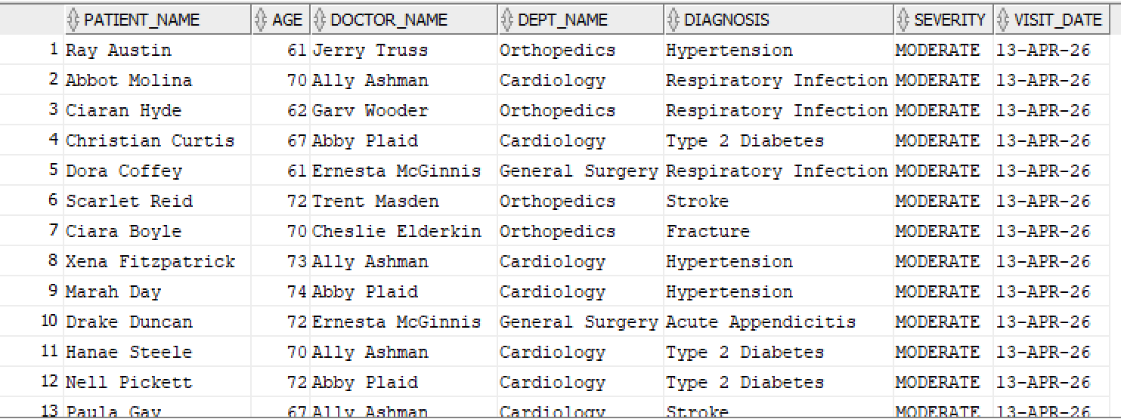
Execution plan steps (from EXPLAIN PLAN):
- PARTITION RANGE ALL — scans PATIENTS partitions (pruning active if date filter added)
- INDEX RANGE SCAN on IDX_RECORDS_PATIENT — avoids full table scan on MEDICAL_RECORDS
- NESTED LOOPS join between PATIENTS and DOCTORS using IDX_PATIENTS_DOCTOR
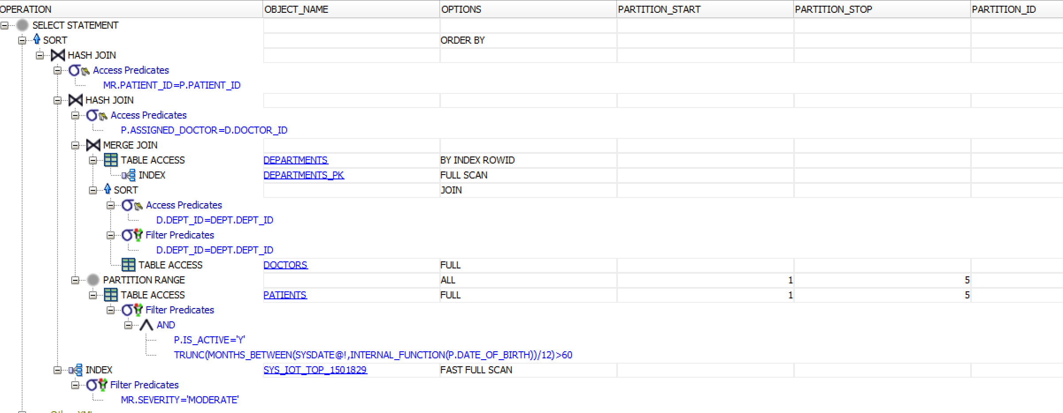

7.2 Query 2 — Department Stats (GROUP BY + HAVING + subquery)
This query uses VW_DEPARTMENT_STATS which groups departments and filters those with more than 100 patients. The aggregation uses the large PATIENTS table.
SELECT dept_name, total_doctors, total_patients, total_appointments
FROM vw_department_stats
WHERE total_patients > 100
ORDER BY total_patients DESC;
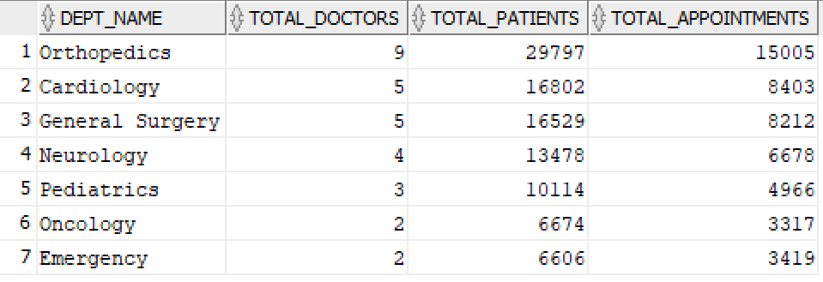
Execution plan steps:
- HASH GROUP BY on DEPARTMENTS — efficient grouping with small reference table
- INDEX FAST FULL SCAN on IDX_PATIENTS_DOCTOR — counts patients per doctor without full table scan
- SORT ORDER BY — sorts final result set
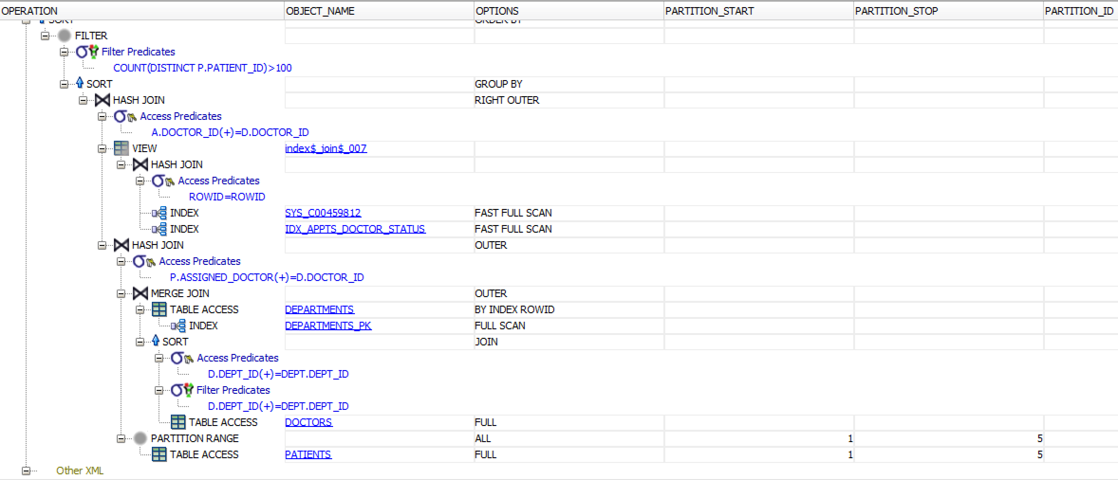

7.3 Generating Execution Plans
To generate execution plans in SQL Developer:
- Open the query in SQL Developer worksheet
- Press F10 or click Explain Plan button
- View the plan in the Explain Plan tab below the editor
- Look for INDEX RANGE SCAN (good) vs TABLE ACCESS FULL (consider adding index)

To verify index usage from SQL:
EXPLAIN PLAN FOR
SELECT * FROM patients WHERE assigned_doctor = 5;
SELECT * FROM TABLE(DBMS_XPLAN.DISPLAY);

8. Object Demonstrations with Screenshots
Each subsection shows the exact SQL to run in Oracle SQL Developer, followed by a screenshot.

8.1 Sequences
-- Show sequence generating next value
SELECT seq_patient_id.NEXTVAL AS next_patient_id FROM DUAL;

-- Show all sequences in the schema
SELECT sequence_name, last_number, increment_by
FROM user_sequences
ORDER BY sequence_name;
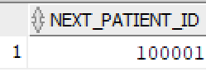
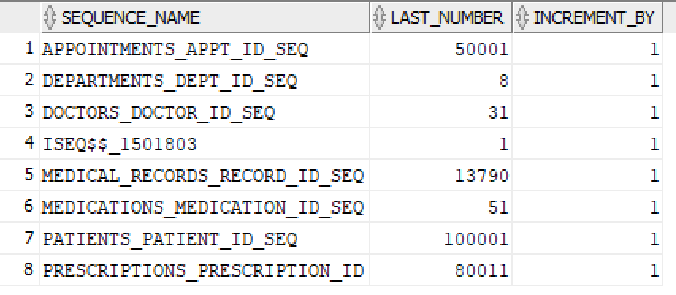

8.2 Triggers

8.2.1 Auto-PK trigger (TRG_PATIENT_ID)
If we insert a patient WITHOUT specifying patient_id, the trigger should fill it automatically from the sequence:
-- Insert without specifying patient_id
INSERT INTO patients
(first_name, last_name, date_of_birth, gender,
blood_type, phone, email, assigned_doctor, admission_date)
VALUES
('Anna', 'Smith', DATE '1992-03-10', 'F',
'B+', '0698765432', 'anna.smith@test.com', 1, SYSDATE);

-- Verify: patient_id was auto-assigned
SELECT patient_id, first_name, last_name, admission_date
FROM patients
WHERE email = 'anna.smith@test.com';
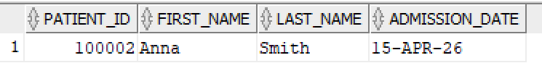

8.2.2 Stock reduction trigger (TRG_REDUCE_STOCK)
Check stock before and after inserting a prescription
-- check stock BEFORE prescription
SELECT medication_id, med_name, stock_qty
FROM medications WHERE medication_id = 1;

-- insert a prescription
INSERT INTO prescriptions
(patient_id, doctor_id, medication_id, dosage_qty, duration_days)
VALUES (1, 1, 1, 5, 7);

-- check stock AFTER — should be reduced by 5
SELECT medication_id, med_name, stock_qty
FROM medications WHERE medication_id = 1;
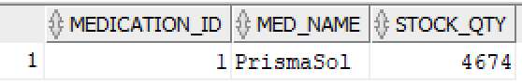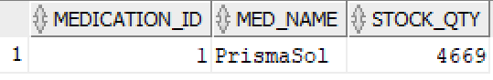

8.2.3 Audit trigger (TRG_PATIENT_AUDIT)
Update a patient's email and verify the change was logged:
-- update patient email
UPDATE patients
SET email = 'updated.email@hospital.com'
WHERE patient_id = 1;
COMMIT;

-- check audit log
SELECT patient_id, changed_by, change_date,
old_email, new_email
FROM patient_audit_log
WHERE patient_id = 1;

8.3 Views

8.3.1 VW_PATIENT_DETAILS
SELECT patient_name, age, blood_type, doctor_name,
specialization, dept_name
FROM vw_patient_details
WHERE ROWNUM <= 15;

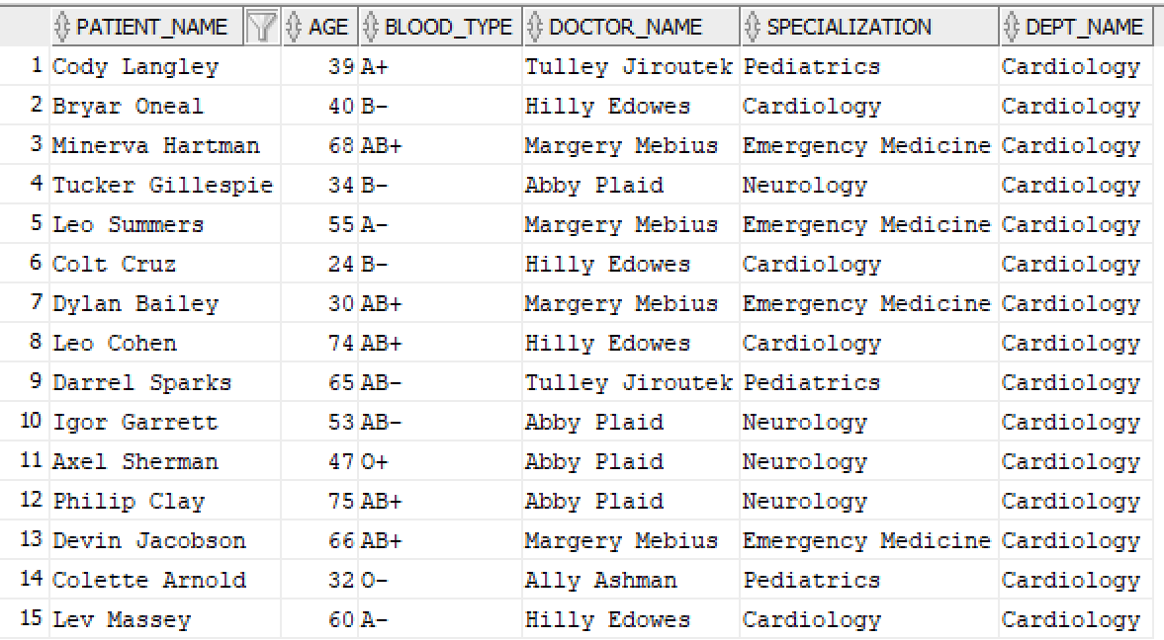

8.3.2 VW_TODAYS_APPOINTMENTS
-- Insert a test appointment for today first
INSERT INTO appointments
(patient_id, doctor_id, appt_date, appt_duration, status, reason)
VALUES (1, 1, SYSDATE, 30, 'SCHEDULED', 'Routine checkup');
COMMIT;

SELECT * FROM vw_todays_appointments;
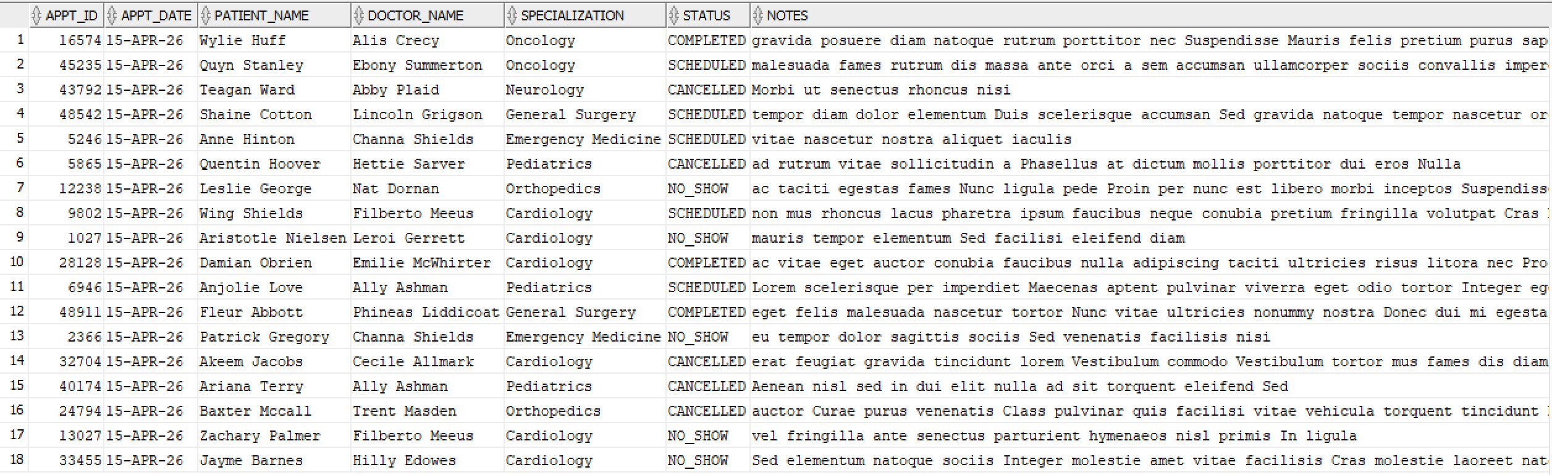

8.3.3 VW_DEPARTMENT_STATS
SELECT dept_name, total_doctors, total_patients, total_appointments
FROM vw_department_stats;
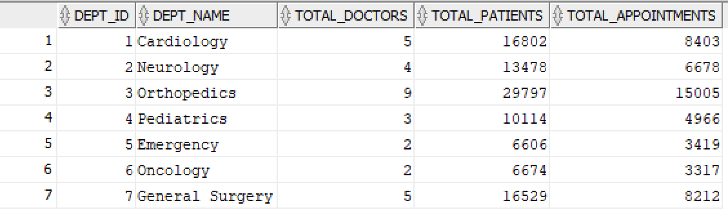

8.3.4 VW_LOW_STOCK_MEDICATIONS
SELECT medication_id, med_name, category, stock_qty, unit
FROM vw_low_stock_medications;
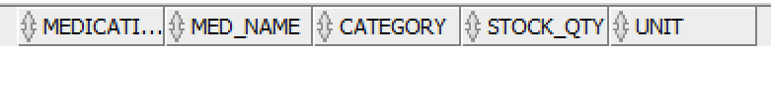

8.4 Functions

8.4.1 FN_DOCTOR_APPT_COUNT
-- Count appointments for doctor 1 in 2024, month 3
SELECT fn_doctor_appt_count(1, 2024, 3) AS march_2024_appts FROM DUAL;

-- Try different doctor and month
SELECT fn_doctor_appt_count(2, 2023, 12) AS dec_2023_appts FROM DUAL;
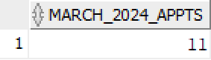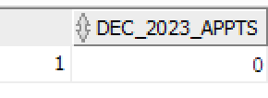

8.4.2 FN_PATIENT_AGE
SELECT fn_patient_age(DATE '1985-06-20') AS calculated_age FROM DUAL;

-- Use on actual patients
SELECT first_name, last_name, date_of_birth,
fn_patient_age(date_of_birth) AS age
FROM patients WHERE ROWNUM <= 10;
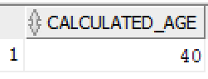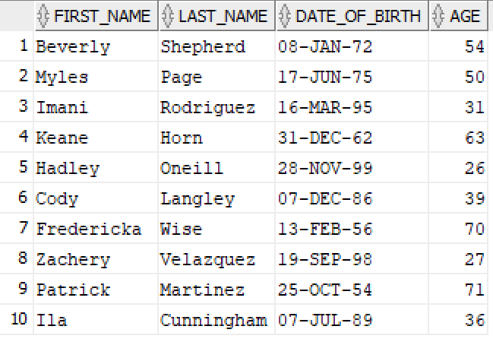

8.4.3 FN_LAST_DIAGNOSIS
SELECT fn_last_diagnosis(1) AS last_diagnosis FROM DUAL;

-- Show last diagnosis for first 10 patients
SELECT patient_id, fn_last_diagnosis(patient_id) AS last_diagnosis
FROM patients WHERE ROWNUM <= 10;
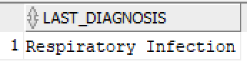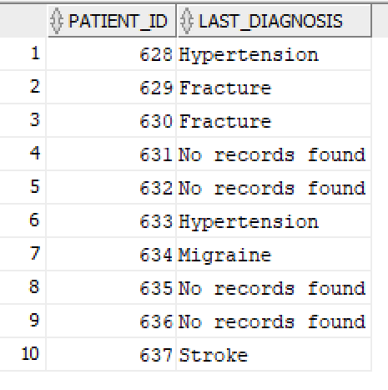

8.5 Procedures

8.5.1 SP_REGISTER_PATIENT
DECLARE
v_new_id NUMBER;
BEGIN
sp_register_patient(
p_first_name => 'John',
p_last_name => 'Doe',
p_dob => DATE '1980-11-25',
p_gender => 'M',
p_blood_type => 'O+',
p_phone => '0611223344',
p_email => 'john.doe@test.com',
p_assigned_doctor => 2,
p_new_id => v_new_id
);
DBMS_OUTPUT.PUT_LINE('New patient ID: ' || v_new_id);
END;
/

-- Verify the new patient exists
SELECT patient_id, first_name, last_name, email
FROM patients WHERE email = 'john.doe@test.com';
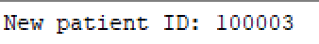
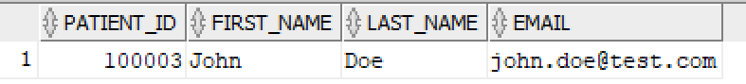

8.5.2 SP_UPDATE_SEVERITY
-- Check severity BEFORE procedure
SELECT record_id, diagnosis, severity
FROM medical_records
WHERE patient_id = 1 AND diagnosis = 'Hypertension'
AND ROWNUM <= 5;

-- Run the procedure
EXEC sp_update_severity(1, 'Hypertension');

-- Check severity AFTER procedure
SELECT record_id, diagnosis, severity
FROM medical_records
WHERE patient_id = 1 AND diagnosis = 'Hypertension'
AND ROWNUM <= 5;

-- Verify audit log entry was created
SELECT * FROM patient_audit_log WHERE patient_id = 1;
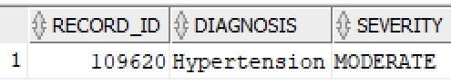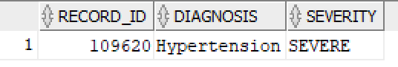
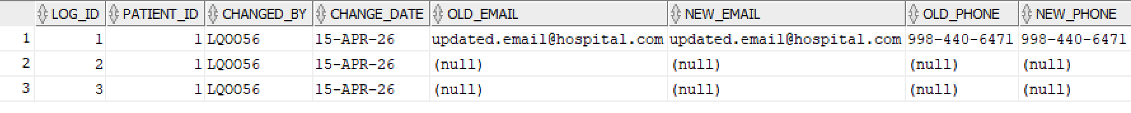

8.6 Indexes and Execution Plans

8.6.1 Verify indexes exist
SELECT index_name, table_name, column_name
FROM user_ind_columns
WHERE table_name IN ('PATIENTS','APPOINTMENTS','MEDICAL_RECORDS','PRESCRIPTIONS')
ORDER BY table_name, index_name;
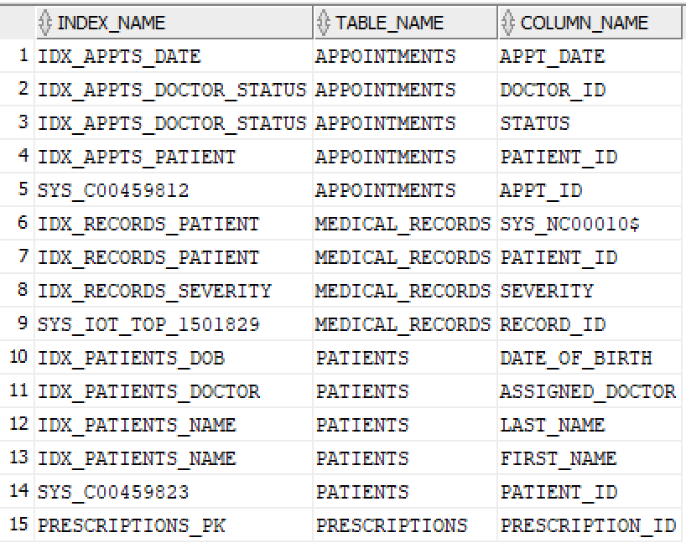

8.6.2 Execution plan WITH index (index range scan)
EXPLAIN PLAN FOR
SELECT first_name, last_name FROM patients WHERE assigned_doctor = 1;

SELECT * FROM TABLE(DBMS_XPLAN.DISPLAY);
-- Look for: INDEX RANGE SCAN on IDX_PATIENTS_DOCTOR (fast)
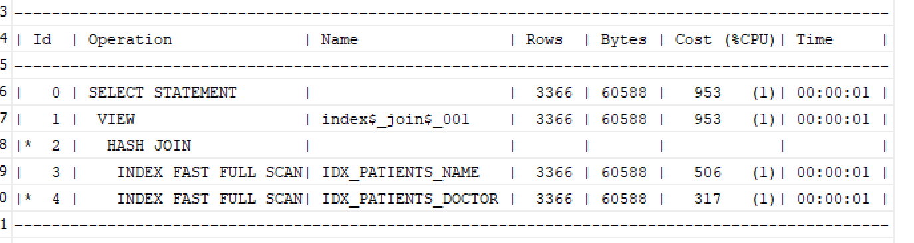

8.6.3 Execution plan for medical records query
EXPLAIN PLAN FOR
SELECT patient_id, diagnosis, severity, visit_date
FROM medical_records
WHERE patient_id = 1
ORDER BY visit_date DESC;

SELECT * FROM TABLE(DBMS_XPLAN.DISPLAY);
-- Should show INDEX RANGE SCAN on IDX_RECORDS_PATIENT

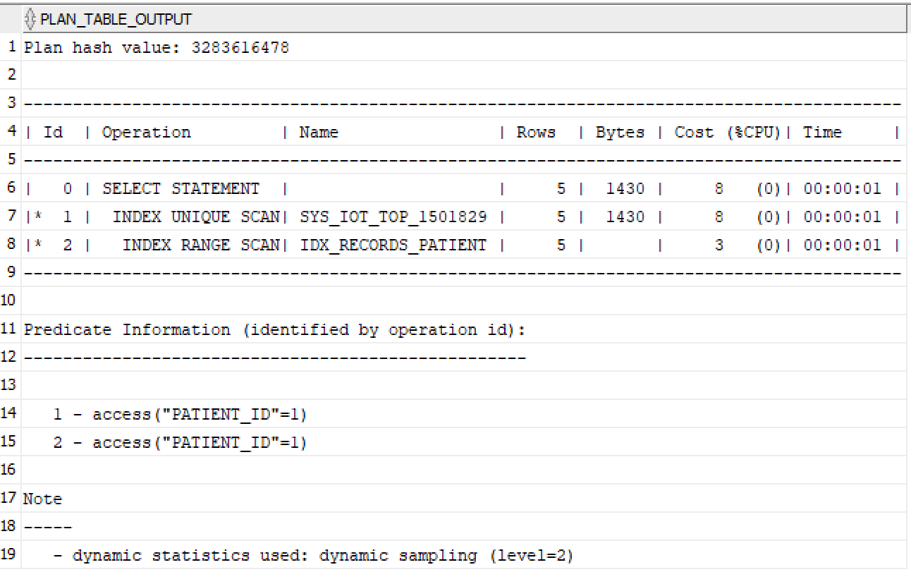

8.7 Partitions
-- List all partitions and their row counts
SELECT partition_name, num_rows, high_value
FROM user_tab_partitions
WHERE table_name = 'PATIENTS'
ORDER BY partition_position;

-- Query a specific partition directly
SELECT COUNT(*) AS patients_in_2023
FROM patients PARTITION (p_2023);

-- Show partition pruning in execution plan
EXPLAIN PLAN FOR
SELECT COUNT(*) FROM patients
WHERE admission_date BETWEEN DATE '2023-01-01' AND DATE '2023-12-31';

SELECT * FROM TABLE(DBMS_XPLAN.DISPLAY);
-- Look for: PARTITION RANGE SINGLE (only one partition scanned)
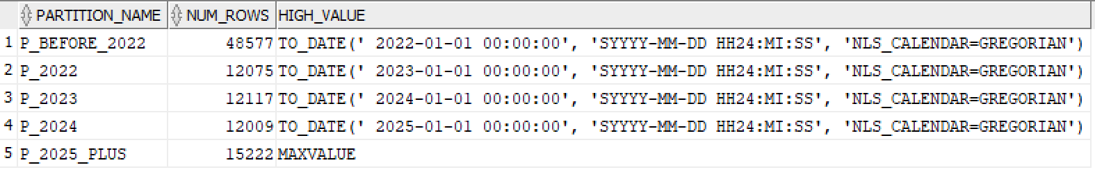
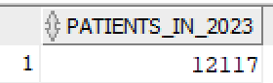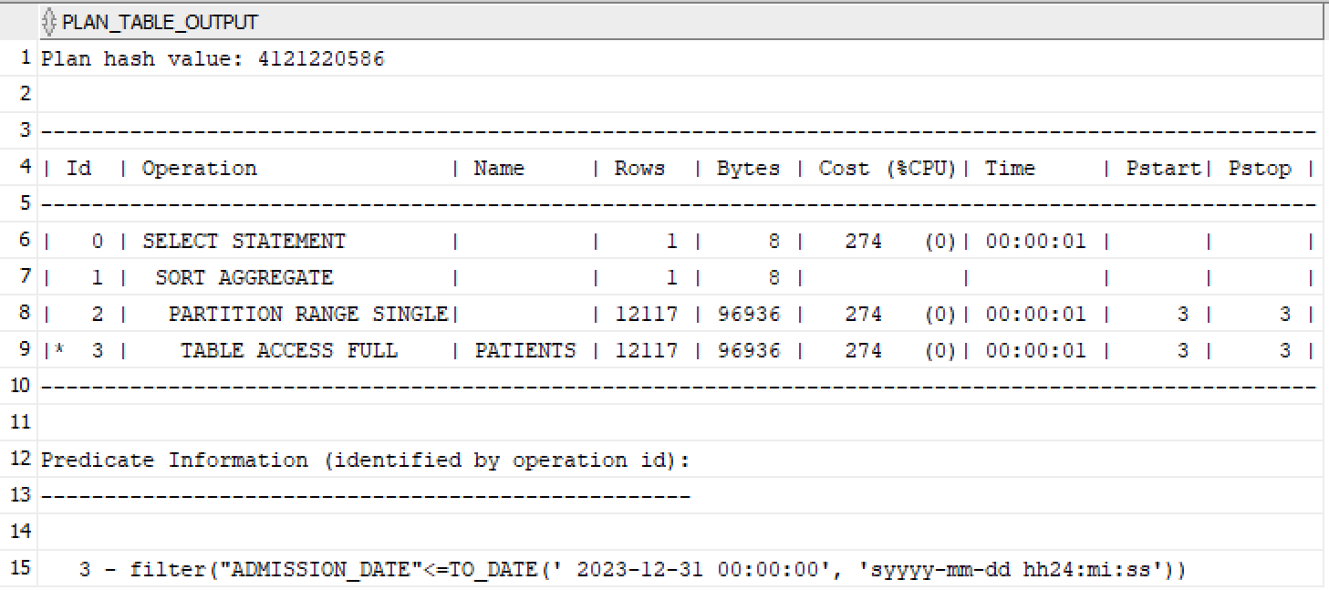

8.8 Index-Organised Table (MEDICAL_RECORDS)
-- Confirm MEDICAL_RECORDS is an IOT
SELECT table_name, iot_type, row_movement
FROM user_tables
WHERE table_name = 'MEDICAL_RECORDS';

-- Query works just like a normal table
SELECT record_id, patient_id, diagnosis, severity
FROM medical_records
WHERE patient_id = 1
ORDER BY visit_date DESC
FETCH FIRST 10 ROWS ONLY;
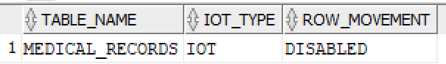
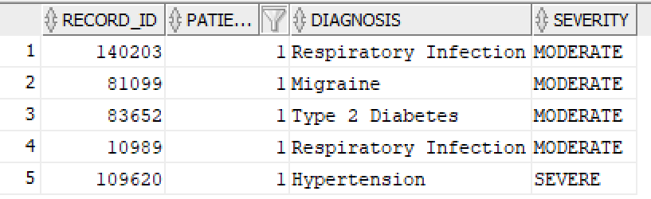

9. Privileges Granted to lkpeter
The following grants were issued to allow the professor (lkpeter) to query and use all database objects:
-- Tables
GRANT SELECT ON departments TO lkpeter;
GRANT SELECT ON doctors TO lkpeter;
GRANT SELECT ON patients TO lkpeter;
GRANT SELECT ON appointments TO lkpeter;
GRANT SELECT ON medications TO lkpeter;
GRANT SELECT ON prescriptions TO lkpeter;
GRANT SELECT ON medical_records TO lkpeter;
GRANT SELECT ON patient_audit_log TO lkpeter;
-- Views
GRANT SELECT ON vw_patient_details TO lkpeter;
GRANT SELECT ON vw_todays_appointments TO lkpeter;
GRANT SELECT ON vw_department_stats TO lkpeter;
GRANT SELECT ON vw_low_stock_medications TO lkpeter;
GRANT SELECT ON vw_prescription_history TO lkpeter;
-- PL/SQL objects
GRANT EXECUTE ON fn_doctor_appt_count TO lkpeter;
GRANT EXECUTE ON fn_patient_age TO lkpeter;
GRANT EXECUTE ON fn_last_diagnosis TO lkpeter;
GRANT EXECUTE ON sp_register_patient TO lkpeter;
GRANT EXECUTE ON sp_update_severity TO lkpeter;
GRANT EXECUTE ON sp_issue_prescription TO lkpeter;

10. Language Model Usage
As required by the language model usage policy, the following documents how AI assistance was used in this project.

Item | Details
Model name | Claude Sonnet 4.6 (claude-sonnet-4-6) by Anthropic
Version | claude-sonnet-4-6
Prompts used | 1. Draft the technical documentation for an Oracle hospital database project including sections for Possible tools to use for test data documentation and generation, IOT, and PL/SQL logic.  2. How to fix ORA-04091 mutating table error in a compound trigger  3. How to fix appt_date format mismatch in SQL Developer import wizard  4. How to add partitioning and IOT after Data Modeler DDL export strips them.  5. Provide SQL examples to test and document the functionality of triggers, functions, and procedures.
How output was used | The generated text was used as a template. I manually corrected errors, updated specific schema details, and integrated my own SQL Developer screenshots to prove the objects worked. I also revised the PL/SQL code for sp_update_severity to handle multi-level upgrades based on my own logical requirements.
Validation method | All drafted documentation was verified by executing the associated SQL code in Oracle SQL Developer. Results were confirmed via the DBMS Output panel and the Explain Plan utility (F10) to ensure the descriptions matched the actual database performance.

11. Appendix — Full SQL Scripts

11.1 Schema Creation Order
- Step 1: Create sequences (all 7)
- Step 2: Create tables in FK dependency order
- Step 3: Add deferred FK (departments.head_doctor_id → doctors)
- Step 4: Create indexes
- Step 5: Create triggers
- Step 6: Create views
- Step 7: Create functions and procedures
- Step 8: Grant privileges to lkpeter

11.2 Tables Creation DDL
-- Generated by Oracle SQL Developer Data Modeler 24.3.1.347.1153
-- at: 2026-04-14 17:03:49 CEST
-- site: Oracle Database 11g
-- type: Oracle Database 11g

-- predefined type, no DDL - MDSYS.SDO_GEOMETRY

-- predefined type, no DDL - XMLTYPE

CREATE TABLE appointments (
appt_id NUMBER PRIMARY KEY,
patient_id NUMBER NOT NULL REFERENCES patients(patient_id),
doctor_id NUMBER NOT NULL REFERENCES doctors(doctor_id),
appt_date DATE NOT NULL,
appt_duration NUMBER DEFAULT 30
CHECK (appt_duration IN (15, 30, 45, 60)),
status VARCHAR2(20) DEFAULT 'SCHEDULED'
CHECK (status IN ('SCHEDULED','COMPLETED','CANCELLED','NO_SHOW')),
reason VARCHAR2(200),
notes VARCHAR2(500),
created_at DATE DEFAULT SYSDATE
);

ALTER TABLE appointments
ADD
CHECK ( status IN ( 'CANCELLED', 'COMPLETED', 'NO_SHOW', 'SCHEDULED' ) );

ALTER TABLE appointments ADD CONSTRAINT appointments_pk PRIMARY KEY ( appt_id );

CREATE TABLE departments (
dept_id NUMBER NOT NULL,
dept_name VARCHAR2(50),
location VARCHAR2(50),
head_doctor_id NUMBER
);

ALTER TABLE departments ADD CONSTRAINT departments_pk PRIMARY KEY ( dept_id );

CREATE TABLE doctors (
doctor_id NUMBER NOT NULL,
first_name VARCHAR2(50) NOT NULL,
last_name VARCHAR2(50) NOT NULL,
specialization VARCHAR2(100),
dept_id NUMBER NOT NULL,
license_number VARCHAR2(30) NOT NULL,
hire_date DATE DEFAULT sysdate,
is_active CHAR(1) DEFAULT 'Y'
);

ALTER TABLE doctors
ADD CHECK ( is_active IN ( 'N', 'Y' ) );

ALTER TABLE doctors ADD CONSTRAINT doctors_pk PRIMARY KEY ( doctor_id );

ALTER TABLE doctors ADD CONSTRAINT doctors__un UNIQUE ( license_number );

CREATE TABLE medical_records (
record_id NUMBER PRIMARY KEY,
patient_id NUMBER NOT NULL REFERENCES patients(patient_id),
doctor_id NUMBER NOT NULL REFERENCES doctors(doctor_id),
visit_date DATE DEFAULT SYSDATE,
diagnosis VARCHAR2(500) NOT NULL,
treatment VARCHAR2(500),
severity VARCHAR2(20) DEFAULT 'MODERATE'
CHECK (severity IN ('MILD','MODERATE','SEVERE','CRITICAL')),
follow_up DATE,
notes VARCHAR2(1000)
)
ORGANIZATION INDEX;

CREATE TABLE medications (
medication_id NUMBER NOT NULL,
med_name VARCHAR2(150) NOT NULL,
category VARCHAR2(80),
unit VARCHAR2(20) DEFAULT 'mg',
unit_price NUMBER(10, 2),
stock_qty NUMBER DEFAULT 0,
updated_at DATE DEFAULT sysdate
);

ALTER TABLE medications ADD CHECK ( stock_qty > 0 );

ALTER TABLE medications ADD CONSTRAINT medications_pk PRIMARY KEY ( medication_id );

CREATE TABLE patients (
patient_id NUMBER PRIMARY KEY,
first_name VARCHAR2(50) NOT NULL,
last_name VARCHAR2(50) NOT NULL,
date_of_birth DATE NOT NULL,
gender CHAR(1) CHECK (gender IN ('M','F','O')),
blood_type VARCHAR2(5),
phone VARCHAR2(20),
email VARCHAR2(100),
address VARCHAR2(255),
admission_date DATE DEFAULT SYSDATE,
assigned_doctor NUMBER REFERENCES doctors(doctor_id),
is_active CHAR(1) DEFAULT 'Y' CHECK (is_active IN ('Y','N'))
)
PARTITION BY RANGE (admission_date) (
PARTITION p_before_2022 VALUES LESS THAN (DATE '2022-01-01'),
PARTITION p_2022 VALUES LESS THAN (DATE '2023-01-01'),
PARTITION p_2023 VALUES LESS THAN (DATE '2024-01-01'),
PARTITION p_2024 VALUES LESS THAN (DATE '2025-01-01'),
PARTITION p_2025_plus VALUES LESS THAN (MAXVALUE)
);

ALTER TABLE patients
ADD
CHECK ( gender IN ( 'F', 'M', 'O' ) );

ALTER TABLE patients
ADD CHECK ( is_active IN ( 'N', 'Y' ) );

ALTER TABLE patients ADD CONSTRAINT patients_pk PRIMARY KEY ( patient_id );

CREATE TABLE prescriptions (
prescription_id NUMBER NOT NULL,
patient_id NUMBER NOT NULL,
doctor_id NUMBER NOT NULL,
medication_id NUMBER NOT NULL,
prescribed_date DATE,
dosage_qty NUMBER NOT NULL,
duration_days NUMBER NOT NULL,
instructions VARCHAR2(300)
);

ALTER TABLE prescriptions ADD CHECK ( dosage_qty > 0 );

ALTER TABLE prescriptions ADD CHECK ( duration_days > 0 );

ALTER TABLE prescriptions ADD CONSTRAINT prescriptions_pk PRIMARY KEY ( prescription_id );

ALTER TABLE appointments
ADD CONSTRAINT appointments_doctors_fk FOREIGN KEY ( doctor_id )
REFERENCES doctors ( doctor_id );

ALTER TABLE appointments
ADD CONSTRAINT appointments_patients_fk FOREIGN KEY ( patient_id )
REFERENCES patients ( patient_id );

ALTER TABLE doctors
ADD CONSTRAINT doctors_departments_fk FOREIGN KEY ( dept_id )
REFERENCES departments ( dept_id );

ALTER TABLE medical_records
ADD CONSTRAINT medical_records_doctors_fk FOREIGN KEY ( doctor_id )
REFERENCES doctors ( doctor_id );

ALTER TABLE medical_records
ADD CONSTRAINT medical_records_patients_fk FOREIGN KEY ( patient_id )
REFERENCES patients ( patient_id );

ALTER TABLE patients
ADD CONSTRAINT patients_doctors_fk FOREIGN KEY ( assigned_doctor )
REFERENCES doctors ( doctor_id );

ALTER TABLE prescriptions
ADD CONSTRAINT prescriptions_doctors_fk FOREIGN KEY ( doctor_id )
REFERENCES doctors ( doctor_id );

ALTER TABLE prescriptions
ADD CONSTRAINT prescriptions_medications_fk FOREIGN KEY ( medication_id )
REFERENCES medications ( medication_id );

ALTER TABLE prescriptions
ADD CONSTRAINT prescriptions_patients_fk FOREIGN KEY ( patient_id )
REFERENCES patients ( patient_id );

CREATE SEQUENCE appointments_appt_id_seq START WITH 1 NOCACHE ORDER;

CREATE OR REPLACE TRIGGER appointments_appt_id_trg BEFORE
INSERT ON appointments
FOR EACH ROW
WHEN ( new.appt_id IS NULL )
BEGIN
:new.appt_id := appointments_appt_id_seq.nextval;
END;
/

CREATE SEQUENCE departments_dept_id_seq START WITH 1 NOCACHE ORDER;

CREATE OR REPLACE TRIGGER departments_dept_id_trg BEFORE
INSERT ON departments
FOR EACH ROW
WHEN ( new.dept_id IS NULL )
BEGIN
:new.dept_id := departments_dept_id_seq.nextval;
END;
/

CREATE SEQUENCE doctors_doctor_id_seq START WITH 1 NOCACHE ORDER;

CREATE OR REPLACE TRIGGER doctors_doctor_id_trg BEFORE
INSERT ON doctors
FOR EACH ROW
WHEN ( new.doctor_id IS NULL )
BEGIN
:new.doctor_id := doctors_doctor_id_seq.nextval;
END;
/

CREATE SEQUENCE medical_records_record_id_seq START WITH 1 NOCACHE ORDER;

CREATE OR REPLACE TRIGGER medical_records_record_id_trg BEFORE
INSERT ON medical_records
FOR EACH ROW
WHEN ( new.record_id IS NULL )
BEGIN
:new.record_id := medical_records_record_id_seq.nextval;
END;
/

CREATE SEQUENCE medications_medication_id_seq START WITH 1 NOCACHE ORDER;

CREATE OR REPLACE TRIGGER medications_medication_id_trg BEFORE
INSERT ON medications
FOR EACH ROW
WHEN ( new.medication_id IS NULL )
BEGIN
:new.medication_id := medications_medication_id_seq.nextval;
END;
/

CREATE SEQUENCE patients_patient_id_seq START WITH 1 NOCACHE ORDER;

CREATE OR REPLACE TRIGGER patients_patient_id_trg BEFORE
INSERT ON patients
FOR EACH ROW
WHEN ( new.patient_id IS NULL )
BEGIN
:new.patient_id := patients_patient_id_seq.nextval;
END;
/

CREATE SEQUENCE prescriptions_prescription_id START WITH 1 NOCACHE ORDER;

CREATE OR REPLACE TRIGGER prescriptions_prescription_id BEFORE
INSERT ON prescriptions
FOR EACH ROW
WHEN ( new.prescription_id IS NULL )
BEGIN
:new.prescription_id := prescriptions_prescription_id.nextval;
END;
/

