prtGen Installation Instructions

Windows Operating System

# Installation of Python

The PRT generation application is written in Python 2.7 and this must be installed in order to run the setup scripts which install and run the app (Python 3 will not work). Python is not included with Windows and must be installed manually. If you already have Python 2.7 installed, then you can skip this section.

The easiest way to get a complete working installation of Python 2.7 on the Windows operating system (which will also be useful for many other things) is with the Anaconda project.

Follow the instructions below to complete your Python installation.

1. Navigate to <https://www.continuum.io/downloads#windows>
   * You will see a download link for a Python 3.6 version and a Python 2.7 version
   * Click the download button for the Python 2.7 version and save somewhere on your computer
2. Navigate to your download folder (or the alternative download location you selected) and double-click the Anaconda application installer (it will be named something like Anaconda2-4.4.0-Windows-x86_64.exe)
3. Click "Next"
   * 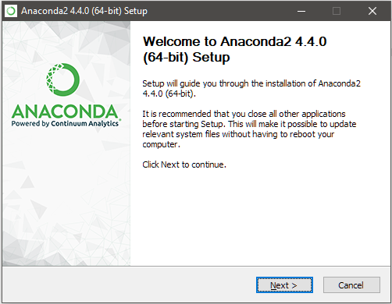
4. Read the terms, and if you agree, click "I Agree"
   * 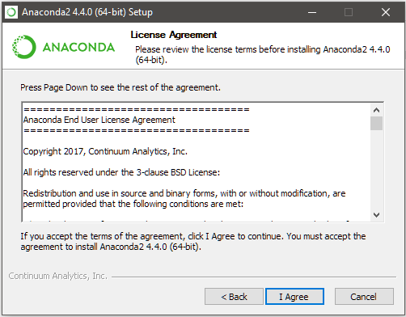
5. Install for "Just Me" should be selected by default. Leave this selected as the installation type and click "Next"
   * 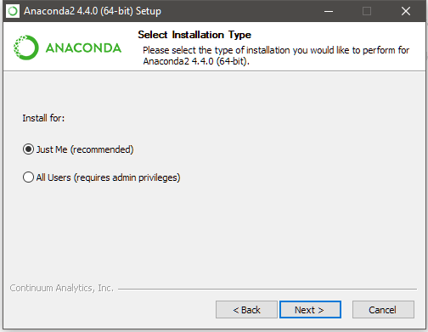
6. It is easiest to just leave the default installation path as it is. This will be something like "C:\Users\YourName\Anaconda2". If you wish to change the directory where Anaconda will be installed, you may do so. When ready, click "Next".
   * 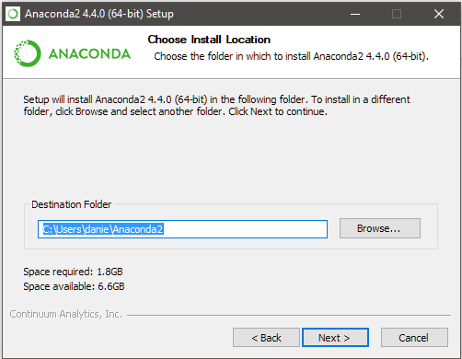
7. The Advanced Option "Add Anaconda to my PATH environment variable" will NOT be selected by default. **Please select this option** as it will make installation easier. Anaconda may present a warning that this is not recommended; for most users, there will be no problems in selecting this. If you do encounter difficulties, it is easy to remove Anaconda from the PATH later. Once selected, please click "Install"
   * 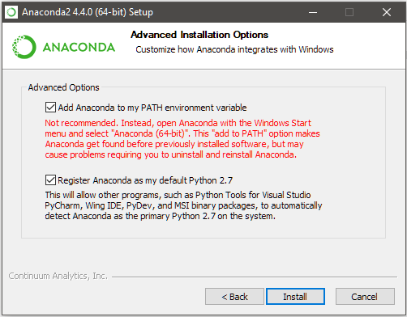
8. The installation will now proceed. It may take anywhere from 5-30min depending on your CPU and hard drive speed.
9. After the installation is complete, you may click "Next". Uncheck the boxes before clicking finish if you do not want to receive communications from Anaconda.
10. To test if the installation was successful, you can open a Command Prompt by searching for "cmd" in the Windows search bar and clicking the Command Prompt icon. Then type "python" without quotes into the Command Prompt and press enter. If the installation was successful, the Python interpreter should open and you will see the version number on the first line. If the installation was not successful, you will receive an error message. You may then close the Command Prompt.
    * 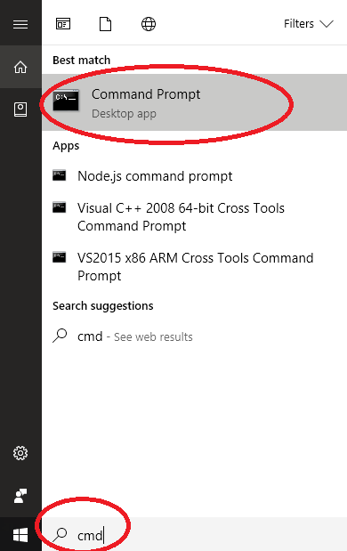

# Installation of the PRT Generation App

The PRT Generation App installation has been automated using python and batch scripts and should proceed without any issues. If you encounter problems, you can contact me for instructions on manual installation.

1. Once you have downloaded the application .zip file from your preferred location, move it into the directory you wish it to be stored.
2. Unzip the file
3. Within the folder you should see one folder (prtApp), and five files.
4. Since you have probably just installed Python, .py files will not yet be associated with the Python interpreter and Windows will not know how to open them. If you are comfortable using the command line, you can run the setup.py script from there to complete the installation and then skip to step X. If you are not comfortable using the command line, proceed to the next step.
5. Right click on setup.py and click "Properties".
6. Near the top you will see "Opens with: Unknown application". Click on "Change"
   * 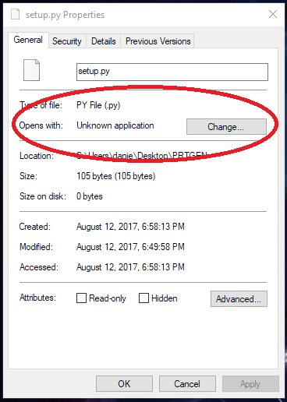
7. On Windows 10, click on "More apps", then scroll down and click "Look for another app on this PC"
8. Navigate to the folder where Anaconda was installed (If default, then "C:\Users\YourName\Anaconda2") and click on python.exe, then click "Open".
   * 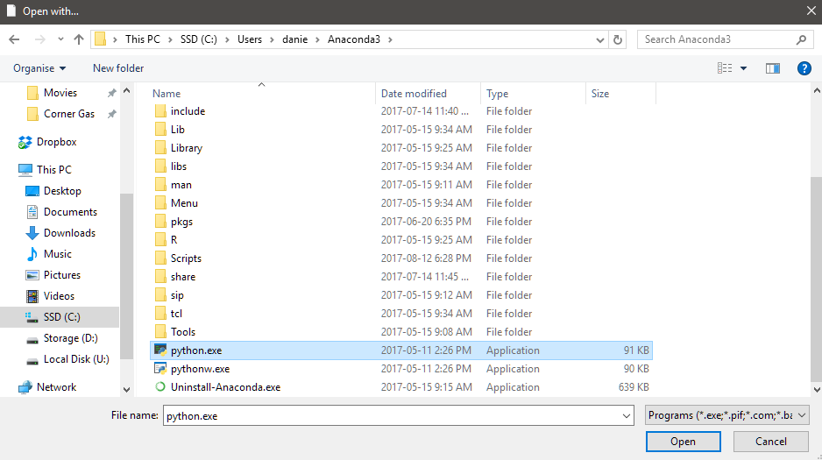
9. Then press "OK". All .py files should now automatically be run with the Anaconda Python interpreter when opened.
10. Double-click on setup.py. You will see a command prompt open, and a list of installation actions being performed. Note that if you did not select "Just Me" for the Anaconda installation and do not have Administrator privileges on your account, this installation may fail. Once the script is complete, you may close the command prompt.
11. The app is now installed. You may now place a shortcut to "prtgen.py" contained within the same folder to somewhere convenient for you to run the application itself.
    * You can do this by right clicking and going to "Send to", then select "Desktop (create shortcut)"
12. To run the application, simply double-click on your shortcut!