prtGen Installation Instructions

Mac OS X Operating System

# Installation of Python

The PRT generation application is written in Python 2.7 and this must be installed in order to run the setup scripts which install and run the app (Python 3 will not work). Python is included with Mac but it is recommended to use the Anaconda Python manager. If you already have Python 2.7 installed, then you can skip this section; however, the automated install script requires an Anaconda environment to be your default Python so please make sure this is the case.

The easiest way to get a complete working installation of Python 2.7 on the Mac (OS X) operating system (which will also be useful for many other things) is with the Anaconda project.

Follow the instructions below to complete your Python installation.

1. Navigate to <https://www.continuum.io/downloads#macos>
   * You will see a download link for a Python 3.6 version and a Python 2.7 version
   * Click the download button for the Python 2.7 version and save somewhere on your computer
2. Navigate to your download folder (or the alternative download location you selected) and double-click the Anaconda application installer (it will be named something like Anaconda2-4.4.0-MacOSX-x86_64.pkg)
3. Click "Continue" on this screen, and the following screen.
   * 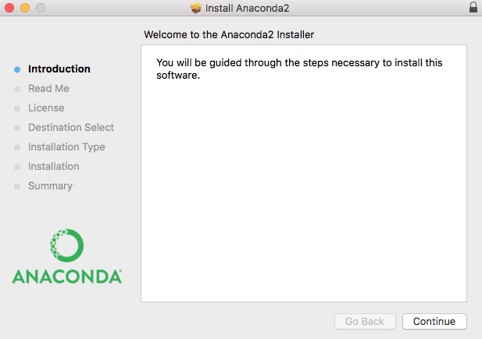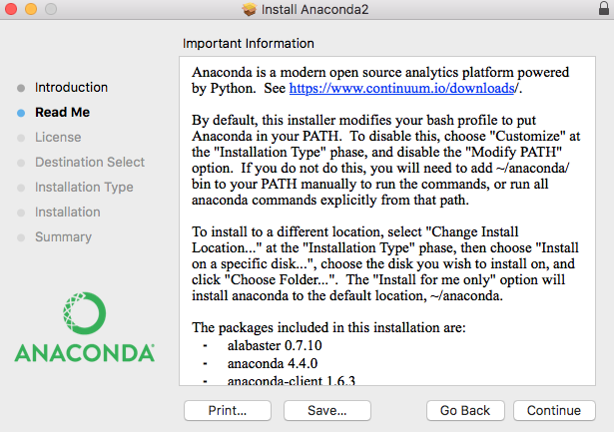
4. Read the terms, and if you agree, click "Continue" and then “I Agree”
   * 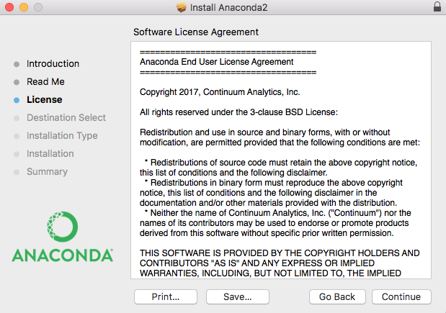
5. Click “Install” – if you wish you can click “Change Install Location” to specify a custom install folder but it is recommended to leave this as the default.
   * 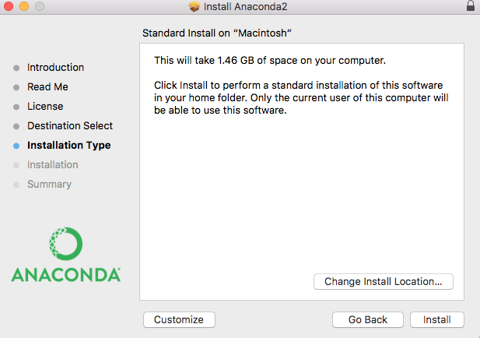
6. The installation will now proceed. It may take anywhere from 5-30min depending on your CPU and hard drive speed.

# Installation of the PRT Generation App

The PRT Generation App installation has been automated using python and batch scripts and should proceed without any issues. If you encounter problems, you can contact me for instructions on manual installation.

1. Once you have downloaded the application .zip file from your preferred location, move it into the directory you wish it to be stored.
2. Unzip the file
3. Within the folder you should see one folder (prtApp), and several files.
4. Double click on setup.command to install the required components
5. Once the install is complete, you may close the terminal window that popped open (It will say [Process Completed])
6. On Mac, now all you have to do to run the program is double click on “run.command” to start the application.
7. If you wish, you can make a shortcut by right clicking on “run.command” and clicking “Create Alias”. You may move this wherever you want and double-clicking it will also start the application.