prtGen Manual

Any Operating System

# Notes

Note that this application works off of .csv format files; it cannot work directly off of e-prime files as they are a proprietary file format but they can be converted first to csv files.

The .csv files generated when exporting from E-data aid contain an extra header row above the column names that must be removed for the app to work properly.

Have fun!

# Home Screen

When you first start the application, you will see a home screen with the laboratory logo, title, and two large buttons on the bottom of the screen.

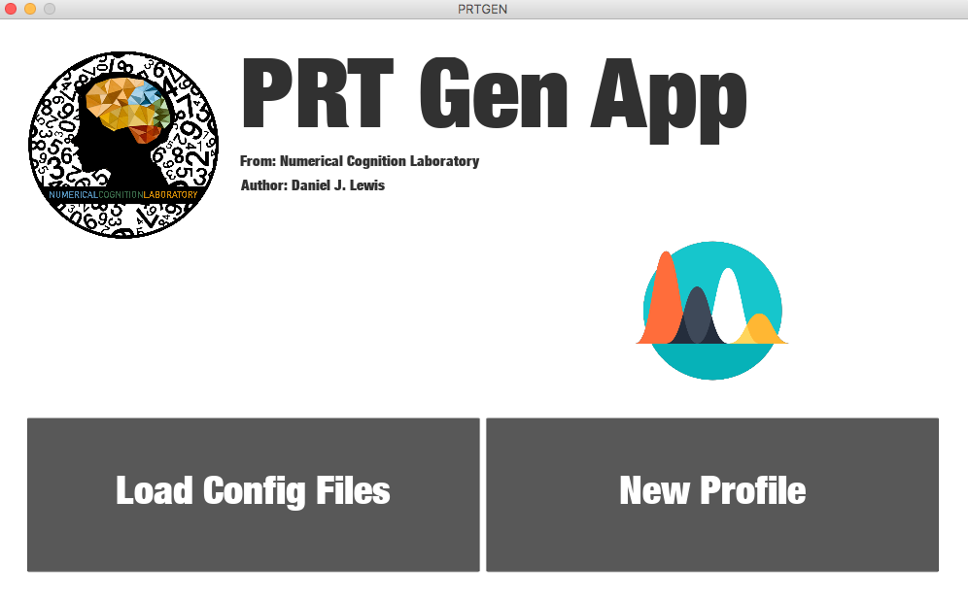

You have the option to use an existing configuration file (left button) or to set-up a new profile. A “profile” is a set of parameters that specify the details of your experimental design and how they relate to the relevant columns in the generated E-Prime file (and subsequent .csv file).

If you have already used the app once and simply want to re-run the PRT generation process on more files, you can click on Load Config Files, otherwise, click on New Profile.

If you click on Load Config Files you will then be presented with a file selection dialog where you can choose the previously saved configuration file.

After clicking on either of these buttons, you will automatically proceed to the settings screen.

# Settings Screen

The settings screen consists of several tabs that contain all of the settings necessary to specify a variety of experimental designs. If you previously selected Load Config Files and chose a file to load, these fields will be automatically populated with your previously chosen settings.

The two buttons at the bottom of the screen will remain there as you switch between tabs. Once you are happy with the settings you have chosen, you can click on the Save Config button to save a configuration file so that you will not have to re-enter the settings every time.

If you hover your mouse over any of the settings fields, a pop-up will appear describing the field and its contents.

Example configuration of Basic Settings:

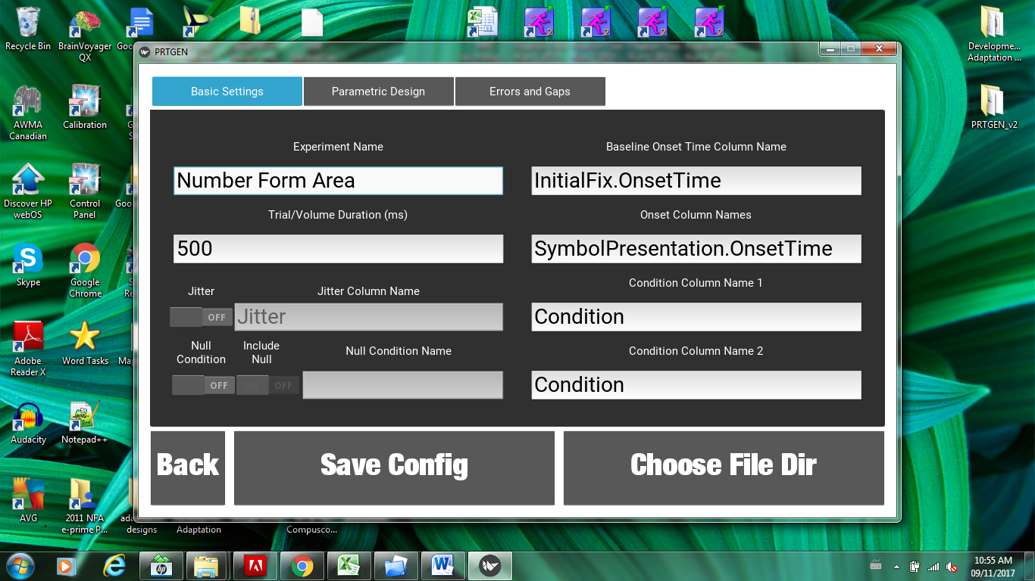

You will see three tabs that contain the relevant settings for their headings:

## Basic Settings

* Experiment Name
  + This is where you specify a title for your experiment. You can make any title you wish. Often, PRT files contain the title wrapped in triangle brackets, such as <Adaptation>.
* Trial/Volume Duration (ms)
  + This is the duration of volumes to model in milliseconds (you enter only the number). A typical duration would be ~1000ms.
  + In the example configuration, the duration is 500ms, because that was the duration of each trial

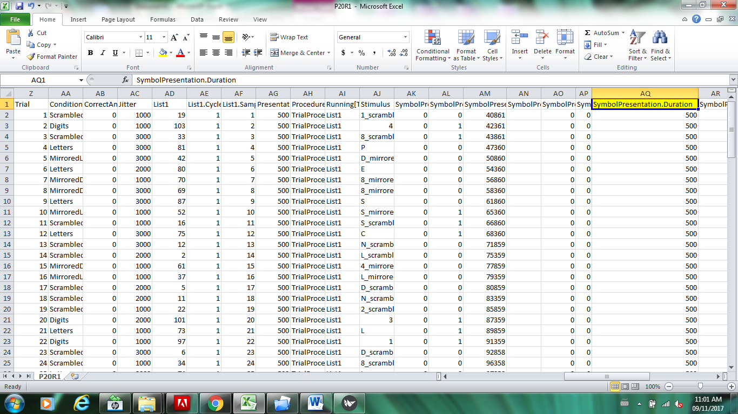

* Jitter and Jitter Column Name
  + This setting allows for the inclusion of “jitter” if you wish to vary the trial/volume duration. By default this setting is off but can be turned on with the toggle switch. If your experiment contains a column that specifies a jitter value, this value will be added to the trial volume duration when creating the prt row for the corresponding row in the experiment file. This column can contain both positive and negative values. For the name, simply enter the name of the column.
  + Note that many experiments will not use jitter in this way. You may be varying the time between trials, or rest periods, or not varying anything at all. In either case, simply leave this setting off. In the example configuration, there was a jitter variable used to jitter the inter-trial interval, but this should not be modeled in the PRT so Jitter is left OFF.

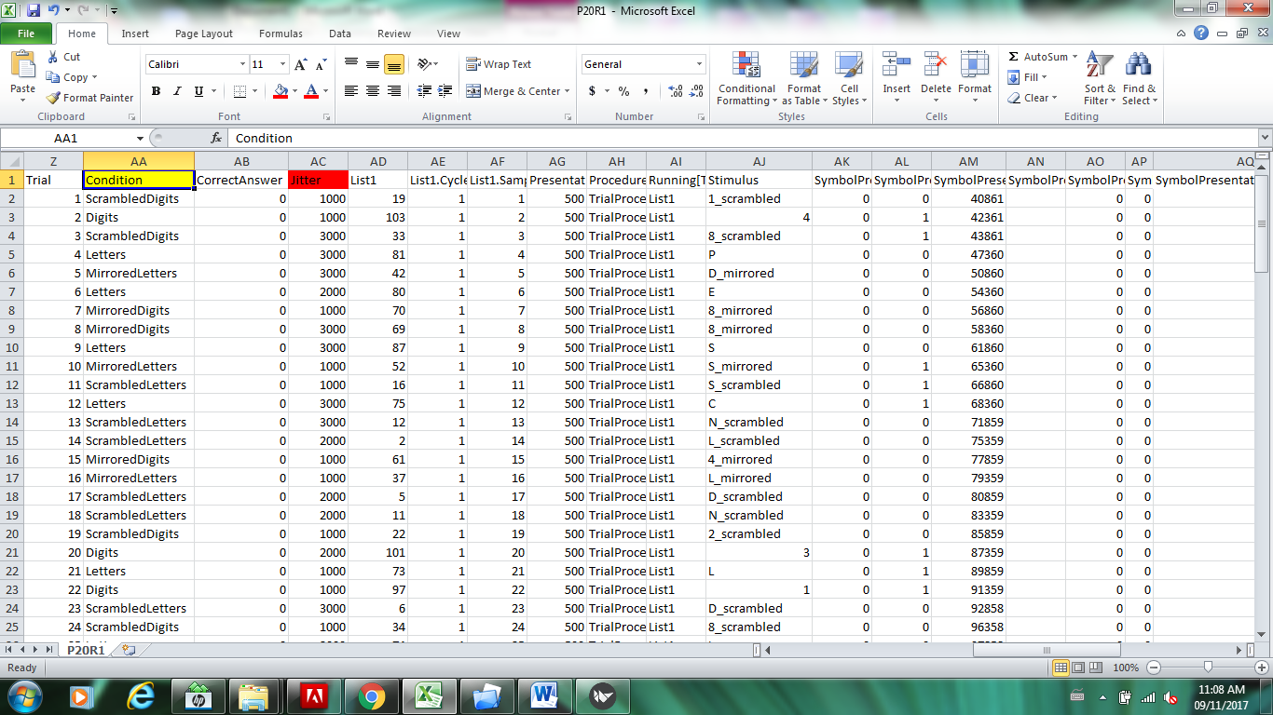

* Null Condition / Include Null and Null Condition Name
  + This is an optional setting. Here you can specify if your experiment contains a null condition and if you wish to include the null values in your results. For the null condition name, enter the name that would be shown within your condition columns that would indicate that row should be excluded. As an example, say you had a condition column which contained: Numbers 1, Numbers 2, Numbers 3, and Numbers Null and you specified the Null Condition Name as “Null”, then Numbers Null would not be included in the PRT file.
* Baseline Onset Time Column Name
  + This is the name of the column that contains your baseline onset time. The baseline onset time is the time stamp of the first event in your experiment once the scanner has triggered it. This baseline time is subtracted from each of your condition onset times, so that you generate a PRT file with times relative to the start of the scanner.
  + In the example configuration, the first event in the experiment is a fixation screen, so the Baseline Onset is the timestamp for the onset of that event.

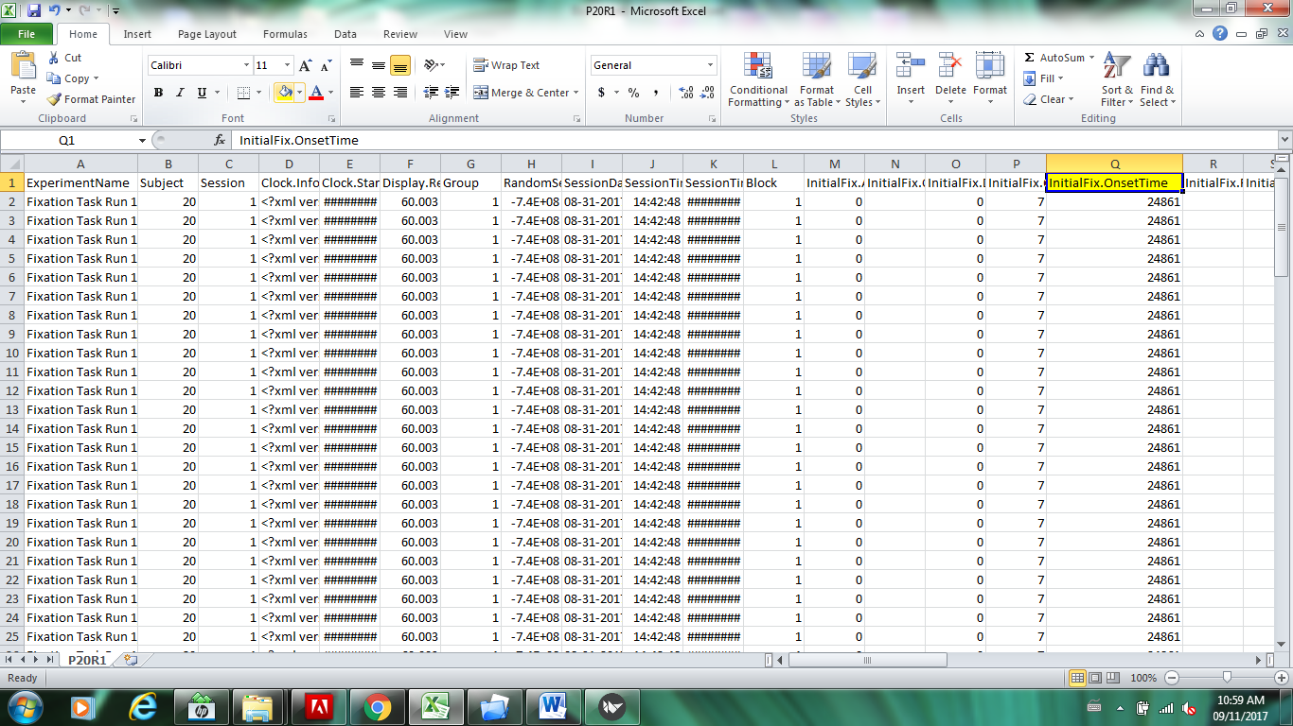

* Onset Column Names
  + This is a list of names (separated by commas) of columns that contain the onset times for each of your conditions.
  + In the example configuration, the trial event slide is called Symbol Presentation so the SymbolPresentation.OnsetTime has the timestamp for the onset of each trial.

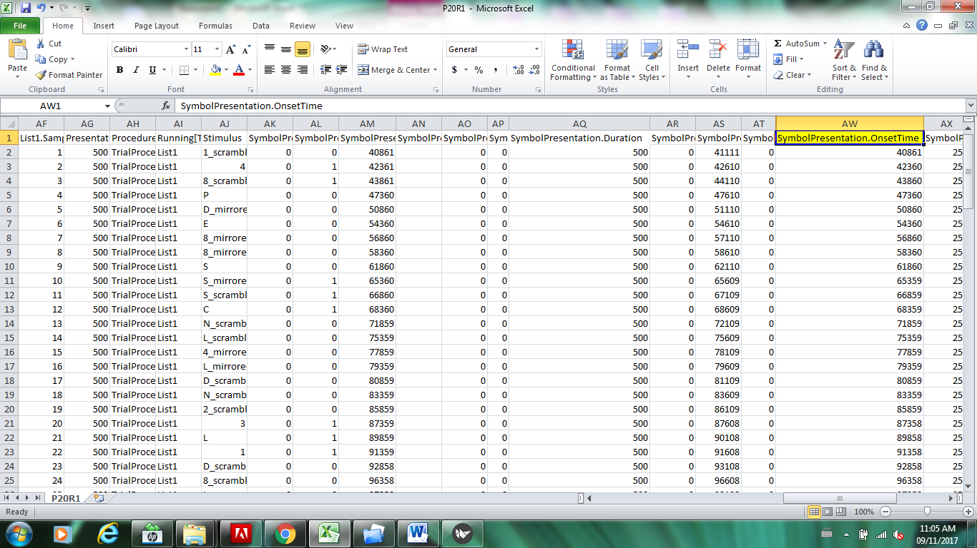

* Condition Column Name 1
  + The program requires two condition column names, which enables nested and block designs. You can enter the first column name here (e.g. Stimuli). If you only have one condition column from a simpler experimental design, you can create an empty dummy column for condition column name 2 or simply refer to the same column as condition column one.
  + In the example condition, the column called ‘Condition’ lists the condition for each trial.



* Condition Column Name 2
  + The program requires two condition column names, which enables nested and block designs. You can enter the second column name here (e.g. Trial). If you only have one condition column from a simpler experimental design, you can create an empty dummy column for condition column name 2 or simply refer to the same column as condition column one. This has been done in the example configuration.

## Parametric Design

A parametric design is used when the data is expected to follow a particular slope or graduated pattern. For example, parametric designs are used to model adaptation effects where a stimulus dimension is expected to modulate neural activation recovery. To model a slope pattern, the user assigns weights to stimuli when creating the PRT file. The obtained data is compared to the expected data pattern. Brain regions that follow the predicted parametric pattern will be identified.

If you do not have a parametric design, you can simply leave the toggle switch in the off position. If you do have such a design, switch the toggle switch to the on position, and enter the column name that contains the parametric stimuli. In the box on the right, you should enter the stimuli labels and their associated weights with one pair per line, separated by a colon, with the stimuli on the left, and the weight on the right, such as:

A:0  
B: 1  
C:2

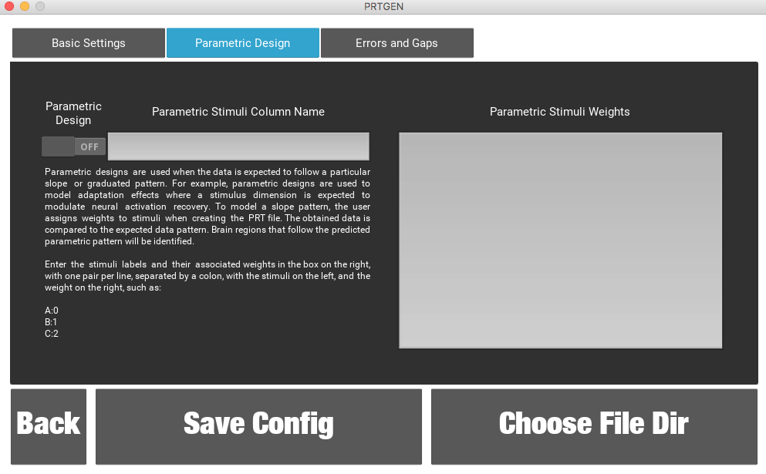

## Errors and Gaps

The application also allows for modelling errors and gaps.

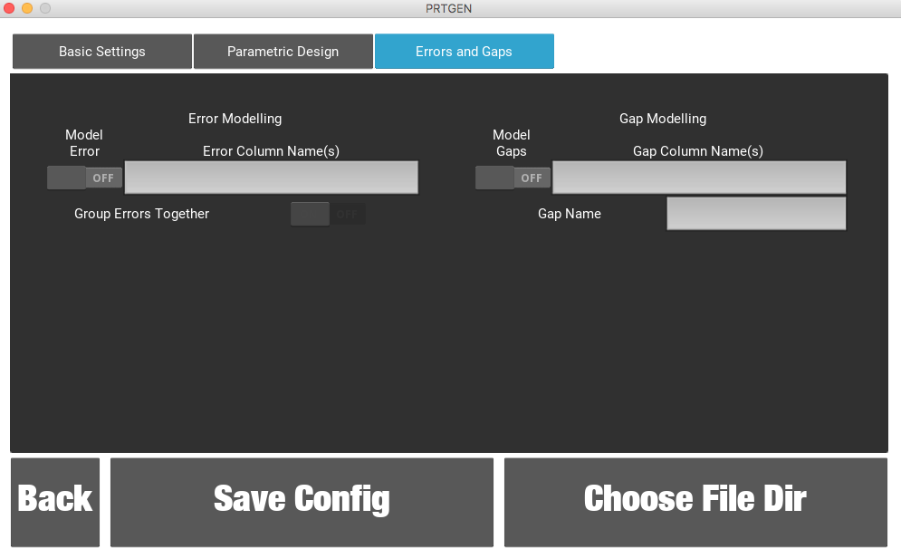

If you do not have either or do not wish to model them, then you can simply leave the toggle switches in the off position.

If your experiment includes a column that indicates whether the participant’s answer was correct or incorrect, then enter that name in the Error Column Name(s) column. If you have more than one column you can enter all of the names separated by columns. Underneath this entry box is another switch that allows you to group the errors together. For example, instead of having a separate category for each error type (such as number vs. letter errors) if you select this switch then all errors would be grouped under a generic errors category.

Gap modelling allows for breaks or intermissions in the experimental design, if you want to include these in your model. Simply switch the model gaps button to the on position and enter the gap column name or names separated by commas. You may then specify a name you wish to assign to these gaps.

# Running the Script

When you are done entering all of the settings, you may click on the Save Config button to save a configuration file for future use.

When you are ready to generate the PRT files from your .csv files, you may click on the Choose File Dir button. Here you will be prompted to select the directory that contains your .csv files. Once you have done so, the application will automatically start loading these files into memory and begin the PRT generation progress. You will see a progress bar on the screen that shows the percentage completed. Note, if the progress bar freezes, this suggests that the app is unable to read one or more of your .csv files. For example, if you did not remove the E-Prime generated header row above your column names, the application will not be able to read the column names from your .csv file to generate the PRT.