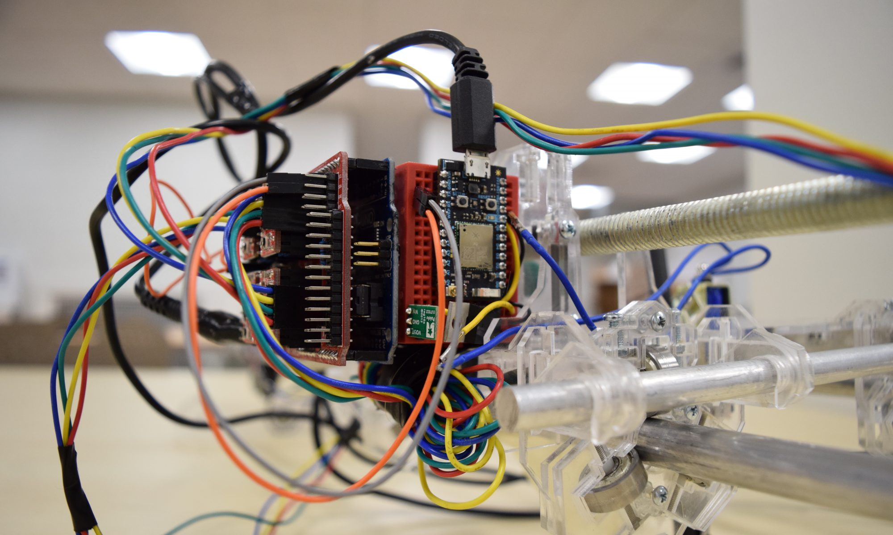



IMAGE

**DMS 550: Physical Computing: speculative circuits, critical objects, and the electrosphere**

Professor Jason Geistweidt

Fall 2019

Credit Hours: 4

Class Hours: Thu 9:00 – 12:20

This course introduces basic concepts and techniques for designing, constructing, and programming objects, spaces, and media that sense and respond to their physical surroundings. Incorporating presentations, discussions on the history of computer enabled art forms, and a series of hands-on technical workshops in programming methods and techniques, the course provides a critical context for emerging forms of experimental practice. Topics include physical computing, interaction design, practical components of hardware design (electricity, electronics, microprocessors, components, sensors and actuators), and programming (variables, datatypes, control structures, functions, objects, communication protocols).

Students will engage in a critical design practice which recognizes the extent to which electronic devices mediate our everyday experience and investigate how the implementation and dissemination of these devices reveals cultural narratives, assumptions, and expectations embedded within. Participants are encouraged to adopt a speculative design practice which recognizes the aesthetic potential of electronic products outside of the commercial context. By adopting such an approach, we hope to uncover the social, cultural, and ethical implications of the technologies that comprise our current electrosphere.