When Foundation Models Only Look Better: Three Evaluation Pitfalls in Fine-Grained String Articulation Classification

Abstract
Self-supervised audio foundation models are increasingly assumed to outperform handcrafted acoustic features on music understanding tasks. We test this assumption on fine-grained string articulation classification (five techniques — ordinario, pizzicato secco, tremolo, sul ponticello, col legno battuto — on OrchideaSOL, evaluated leave-one-instrument-out). An initial pipeline suggested a foundation-model (MERT) advantage under limited labels. Auditing our own protocol, we find this advantage is an artifact of three evaluation pitfalls: (i) selection-time test-set leakage in self-training, (ii) backbone undertuning, and (iii) a mismatched resampling unit in uncertainty quantification. Removing the first two flips the conclusion twice; the third, left uncorrected, would flip it a third time. After correction, a tuned MERT head and a tuned SVM over 245-dimensional descriptors are statistically indistinguishable across 5–50% label budgets (all gaps within ±0.7 fold-std, n=4). A layer-wise descriptor probe explains why: the discriminative low-level cue (onset-strength envelope) is already linearly recoverable at MERT's convolutional front-end (R²=0.77, before any transformer layer), and depth adds mainly harmonic abstraction this task does not require. The conclusion holds even when the backbone itself is fine-tuned: a larger tuning budget does not improve MERT. Our contribution is not a new state-of-the-art model but a reproducible account of three pitfalls, a practical checklist, and a scoped negative result: for low-dimensional strong-signal, small-data fine-grained tasks, heavy models offer no practical gain.

1. Introduction
Automatic recognition of instrumental playing techniques is a core problem in music information retrieval, with applications in performance analysis, music education, and expressive-content indexing. String articulations in particular carry fine acoustic distinctions — the bow striking the string (col legno), bowing near the bridge (sul ponticello), rapid re-bowing (tremolo). As self-supervised audio foundation models (e.g., MERT) achieve strong results across MIR benchmarks, a common expectation is that such models also dominate fine-grained technique classification, rendering handcrafted acoustic features obsolete.
We show this expectation is easy to manufacture and hard to verify. Small, individually reasonable evaluation choices can inflate an apparent foundation-model advantage without any real modeling gain. We isolate three such choices that arose in our own pipeline and quantify each with a before/after comparison.
(i) Selection-time test-set leakage. Choosing the self-training iteration (or a decision threshold) by test-set F1 leaks the target into model selection; removing it drops self-training macro-F1 by up to 0.107 at the 5% label budget and erases an apparent SVM–MERT crossover. (ii) Backbone undertuning. A single linear head on the last hidden state understates the backbone; a convention-matched search (MLP / layer-weighted head, disjoint selection val) raises tuned MERT by 0.025–0.046. (iii) Resampling unit in uncertainty quantification. A BCa bootstrap that resamples only test clips — holding folds fixed — reports SVM as significantly ahead at 5% and 20%; resampling at the correct unit (instruments/folds, the dominant variance component for a cross-instrument claim) returns confidence intervals that cover zero everywhere. Pitfalls (i) and (ii) each flipped our conclusion — first toward, then away from the foundation model; (iii) was caught before it flipped it a third time.
With all three controlled, and under equal training data, tuned MERT and a tuned 245-dimensional SVM are indistinguishable across label budgets (5–50%; all gaps within ±0.7 fold-std). A layer-wise descriptor probe locates the reason: the onset-strength envelope that separates these techniques is already linearly present at MERT's convolutional front-end (R²=0.77, pre-transformer), and the twelve transformer layers add almost nothing to its band average (+0.008, peaking only +0.083 above the front-end); the only descriptor that gains with depth is chroma — harmonic abstraction this articulation task does not need. The heavy model has nothing task-relevant to add that the front-end has not already exposed.
Our contributions are: (1) a reproducible account of three evaluation pitfalls in fine-grained audio classification, each with a before/after quantification on the same data; (2) a practitioner checklist for avoiding them; and (3) a scoped negative result — on low-dimensional, strong-signal, small-data fine-grained tasks, self-supervised foundation models yield no practical advantage over well-tuned handcrafted features — supported by a mechanistic layer-wise analysis rather than accuracy alone.

2. Related Work
We organize prior work along two axes: what is classified (§2.1, the feature/model lineage of string playing-technique recognition) and how it is evaluated (§2.2, the SSL/semi-supervised evaluation-pitfalls literature). §2.3 bridges them with a coding of prior technique-classification work along evaluation-practice axes, exposing the gap our three pitfalls occupy.

2.1 Playing-technique classification
Handcrafted acoustic features on bowed strings. The task closest to ours is instrument playing-technique (IPT) classification on bowed strings from audio. Su et al. [1] classify nine techniques on exactly the four instruments we use (violin, viola, cello, contrabass), showing that phase-derived features (group-delay, instantaneous-frequency) with sparse coding lift macro-F1 from 0.835 (magnitude-only) to 0.915 — but also that cross-corpus transfer (RWC → real recordings) collapses to 0.547. Kruger & Jacobs [2] classify up to eleven techniques with an SVM over handcrafted features on RWC under a random 70/30 split. Barbancho et al. [3] detect six violin techniques with a hand-built decision flowchart (no learning). These establish that (a) fine articulation distinctions are carried by low-level spectral/temporal cues, and (b) generalization across recording sources is the hard part — the tension our leave-one-instrument-out protocol targets.
Scattering-transform and multi-scale lineage. A second line argues MFCCs miss the amplitude/frequency modulation that defines many techniques (tremolo, vibrato), and replaces them with (joint time-frequency) scattering transforms. Lostanlen et al. [4] introduce this on SOL — the dataset underlying our OrchideaSOL — and frame IPT as harder than instrument recognition. Wang et al. extend adaptive scattering to Chinese bamboo flute [5, 6], reporting macro-F1 79.9% vs 35.9% for MFCCs. Ducher & Esling [7] decompose cello IPT into orthogonal axes and cross-validate over five soundbanks (their minus-1db protocol), showing a flat 18-way classifier fails (41.5%) where a taxonomy-aware CQT-RCNN reaches 57.6%. This lineage motivates our Chroma-as-control ablation and our reading of col legno battuto as a technique that moves several acoustic axes at once.
Spectrogram-CNN and onset-fusion. On the deep-learning side, frame-level detectors on Guzheng and Erhu [8, 9, 10] show that fusing note-onset information roughly doubles note-level F1 (39.5% → 80.8%), directly evidencing that attack/onset cues dominate IPT — consistent with our SHAP finding that the onset-strength envelope is the single most important feature. CNN-on-spectrogram studies on violin bowing [11] and electric guitar [12] report >90% accuracy but under evaluation designs (mixed-source random 5-fold; same-data testing) that their own authors flag as generalization-weak, with accuracy dropping to ~70% on held-out real recordings.
Self-supervised pretraining on IPT. Closest to the "foundation model" question, MERTech [13] fine-tunes MERT-v1-95M — the same backbone we use — for multi-task IPT/pitch/onset, reaching SOTA on Guzheng (MI-F1 90.0%) yet only 53.36% on violin RWC technique classification; VioPTT [14] surpasses it (77.22%) via synthetic augmentation but covers only four techniques (excluding col legno, tremolo, sul ponticello). Both report accuracy on a single task and do not compare the SSL model against a tuning-matched handcrafted baseline — precisely the comparison our audit isolates.
Motion / multimodal (context). A distinct branch classifies bowing gestures from IMU/MOCAP/EMG rather than audio [15, 16], often exceeding 99% but typically with a single performer (N=1) and fixed 80/20 splits, and with motion dominating audio. We note these only to bound scope: our claim is about audio-only classification, where the technique boundary is acoustically — not kinematically — defined.

2.2 Evaluation pitfalls, semi-supervised learning, and SSL probing
Tuned baselines and realistic SSL evaluation. Our central methodological ancestor is Oliver et al. [17], who show in the image domain that once baselines are properly tuned, the apparent benefit of semi-supervised learning shrinks dramatically. We port this warning to audio/MIR in the foundation-model era and add a failure mode they do not treat: selection-time leakage from choosing the self-training iteration / confidence threshold by test performance. Musgrave et al. [18] make a parallel "reality check" for metric learning, attributing inflated gains to weak baselines and flawed protocols.
Leakage as a general failure mode. Kapoor & Narayanan [19] document leakage across 294 papers in 17 fields and propose a reporting taxonomy; our pitfall (i) is an instance of their "test-set information used in model selection" category, localized to self-training and quantified with a before/after table. We adopt their model info sheet as the template for our §6 checklist.
Resampling unit and variance decomposition. Bouthillier et al. [20] argue that a valid benchmark must model all sources of variance; fixing some (e.g., data split) while resampling others fabricates significance. This is the general theory behind our pitfall (iii): a bootstrap that resamples only test clips while holding folds fixed narrows the interval 2.6–5.0× and reports a difference that vanishes once the dominant cross-instrument variance component is resampled at the fold unit.
Layer-wise probing and control tasks. Pasad et al. [21] show, layer-by-layer, that a wav2vec2-style speech model's early layers mirror low-level acoustics (mel-filterbank-like) while upper layers encode global/semantic structure. As MERT is architecturally the same family, this is the direct precedent for our descriptor probe, where the onset-strength envelope saturates at the convolutional front-end (R²=0.77) before any transformer layer. Hewitt & Liang [22] justify pairing probes with control tasks so a probe reads representations rather than learning the task itself — the rationale for keeping our probes low-capacity and our Chroma control in place.
Probing conventions in music SSL benchmarks. Standardized SSL benchmarks — MARBLE [23] for music, USB [24] for SSL broadly — matter to our pitfall (ii) in a specific way: MARBLE's probing head is an MLP (hidden 512), not a single linear layer. Thus the "convention" does not undertune the backbone; we did, by starting from a last-layer single-linear head. Pitfall (ii) is therefore not "the field undertunes SSL" but "probe design (head capacity, layer selection) can flip the conclusion, and we fooled ourselves once by sitting below convention." MERT itself [25] is the backbone under test. Fine-tuning under distribution shift is treated by Kumar et al. [26], whose LP-FT effect we invoke in §4.4.

2.3 Positioning: an evaluation-practice coding of prior IPT work
We code the §2.1 studies along three evaluation-practice axes: (A) source/instrument-disjoint evaluation (random splits invite optimism), (B) comparison of a heavy model against a tuning- and budget-matched cheap baseline, and (C) uncertainty reported at the unit of the generalization claim. As the table shows, some studies satisfy (A) well, but none satisfies (B) and (C) together — the gap our three pitfalls occupy.
Prior work | Domain | (A) Source/instr.-disjoint | (B) Heavy vs tuned cheap, equal budget | (C) Uncertainty at claim's unit
Su et al. 2014 [1] | violin/viola/cello/CB | ~ cross-corpus (RWC→real) | ✗ (no deep/SSL) | ✗
Barbancho 2009 [3] | violin | ✗ (pooled) | ✗ (rule-based) | ✗
Kruger & Jacobs 2020 [2] | bowed string | ✗ random 70/30 | ✗ (SVM only) | ✗
Lostanlen 2018 [4] | SOL (all fam.) | ~ held-out | ✗ (scattering vs MFCC only) | ✗
Ducher & Esling 2019 [7] | cello | ✓ 5 soundbanks (minus-1db) | ✗ (no cheap baseline audit) | ✗
Wang 2020/2022 [5, 6] | CBF | ~ held-out | ✗ (scattering+SVM) | ✗
Guzheng/Erhu 2019–2023 [8, 9, 10] | Chinese strings | ✓ VSB→RW (synth→real) | ✗ | ✗
Alar 2021 [11] | violin bowing | ✗ mixed-source random 5-fold | ✗ | ✗
MERTech 2024 [13] | multi (incl. violin) | ~ dataset-standard | ✗ (SSL only, no tuned SVM) | ✗
VioPTT 2025 [14] | violin | ~ synth→RWC | ✗ (SSL/CRNN only) | ✗
SpectroFusionNet 2025 [12] | e-guitar | ✗ same-data test | ✗ | ✗
This work | violin/viola/cello/CB | ✓ LOSO (instrument-grouped) | ✓ tuned MERT vs tuned 245-d SVM, matched budget | ✓ 2-level BCa (instrument-resampled)
✗ = not met, ~ = partial/implicit, ✓ = explicitly met. A ~ in (A) denotes source separation weaker than our LOSO, or a synthetic→real special case.

3. Data and Method

3.1 Data
We use the string subset of OrchideaSOL [27], a library of isolated instrumental notes. We retain five bowed-string articulation classes — ordinario, pizzicato secco, tremolo, sul ponticello, col legno battuto — across four instruments (violin, viola, violoncello, contrabass), yielding 3,402 clips with the class distribution in Table 3.1. The set is imbalanced (ordinario 1,193 to col legno battuto 227), motivating macro-F1 as the primary metric.
Class | n | mean dur (s)
ordinario | 1,193 | 7.16
tremolo | 1,041 | 7.25
pizzicato secco | 639 | 1.36
sul ponticello | 302 | 7.61
col legno battuto | 227 | 2.71
We deliberately do not use TinySOL (ordinario only) and note that clip duration itself carries class information (§4.4/§5); durations are reported for transparency, not used as a feature except in the confound-control baseline.

3.2 Evaluation protocol: leave-one-instrument-out
All models are evaluated under instrument-grouped GroupKFold (leave-one-instrument-out, LOSO): four folds, each holding out one instrument entirely for testing. This prevents notes from the same instrument/recording appearing in both train and test — the optimistic bias random splits incur on this data. Grouping keys are the recording identifiers parsed by features.py::parse_recording_id. Because the generalization claim is across instruments, the instrument/fold is the correct unit for both training splits and uncertainty (§3.5).
To study limited-label regimes we sample labeled seed budgets of 5/10/20/50% (per fold, 3 random trials, averaged). To avoid selection-time leakage (§4.1), each seed is split three ways:
labeled seed ─┬─ val_select 20% → hyperparameter/config selection ONLY (disjoint, fixed)
└─ seed_core 80% ─┬─ tr 80% → training
└─ es_val 20% → early-stopping ONLY
val_select ∩ es_val = ∅, and both are disjoint from the LOSO test fold. Model selection (config, iteration, threshold) touches only val_select; early stopping touches only es_val; nothing touches test. For the SVM (no early stopping) we report the equal-training-data condition (tr, 64% of labeled) as the primary comparison and the seed_core condition (80%) as a sensitivity variant.

3.3 Features and models
Handcrafted (v1). We extract a 245-dimensional descriptor vector per clip (features.py). Frame-level descriptors are aggregated over time by four statistics — mean, std, Q25, Q75 — to preserve temporal variation a mean alone discards. The vector comprises MFCC+Δ+ΔΔ (156), Chroma (48), spectral contrast (28), onset-strength envelope (4), RMS energy (4), zero-crossing rate (4), and log-first-onset-time (1). Chroma (pitch-class) is retained deliberately as a negative control. Classifiers: SVM (RBF) — the primary model — with XGBoost and random forest as alternates; XGBoost additionally serves as the SHAP surrogate (§3.6).
Spectrogram CNN (v2). As a deep baseline on the same LOSO protocol, we train a small CNN (model.py) on log-mel spectrograms (dataset.py), with SpecAugment and an asymmetric (2,1) pooling that halves only the frequency axis to preserve temporal resolution.
Self-supervised backbone (MERT). We use MERT-v1-95M [25] via HuggingFace transformers (AutoModel, trust_remote_code), resampling audio to 24 kHz. Embeddings are the mean-pooled hidden states over time (batch=1, no padding, matching the cached-embedding pipeline exactly); all 13 hidden states are retained for the probe and the layer-weighted head — in HuggingFace hidden_states indexing, L0 is the feature-projection output following the convolutional feature encoder (before the first transformer block) and L1–L12 are the twelve transformer layers. Throughout, "convolutional front-end (L0)" refers to this pre-transformer state. On top we train a classification head — a single linear layer, an MLP-256, or a learned convex combination over layers ("layer-weighted"). A CLAP zero-shot classifier (laion/clap-htsat-unfused) provides a no-label reference point. The heaviest tuning point, LoRA (r=8, α=16, on q/v projections), adapts the backbone itself (§4.4). All models run on Apple-Silicon MPS with CPU fallback; no CUDA, no bitsandbytes.

3.4 Tuning budgets
To make the SVM-vs-MERT comparison fair, both are tuned on val_select (never on test). The SVM searches 12 configurations (C ∈ {0.1,1,10,100} × γ ∈ {scale,0.01,0.001}); the MERT head searches 24 (arch ∈ {linear, mlp256} × lr × weight-decay × dropout) — a larger budget for the backbone, guarding against undertuning it (§4.2).

3.5 Uncertainty quantification
We report a BCa bootstrap (B=2,000, 95%). Because clips from one recording are strongly correlated, we resample at the recording-cluster level rather than the clip level. Critically, since the claim generalizes across instruments, we also report a two-level bootstrap that resamples the instrument/fold unit — the dominant variance component — and treat its zero-coverage as the significance test (§4.3). With four instruments these intervals are necessarily wide; that width is the honest answer, not a defect to hide.

3.6 Interpretability: descriptor probe and SHAP
Two analyses explain why (§5). (a) Layer-wise descriptor probe: for each MERT layer we ridge-regress each handcrafted descriptor from the 768-d embedding (LOSO, out-of-fold R², RidgeCV per target on train only), reading each layer as "how linearly available is this descriptor here." Chroma serves as a control, following the control-task rationale of Hewitt & Liang [22]. (b) SHAP: we compute SHAP values on the XGBoost surrogate, report dimensionality-corrected (per-feature) group importances, and validate the surrogate against the MERT head out-of-sample (Cohen's κ), reporting fidelity honestly rather than the misleading in-sample agreement.

4. Results
We report each pitfall as a before/after pair on the same data, in the order we encountered it. Pitfalls (i) and (ii) each reversed our working conclusion; pitfall (iii) would have reversed it a third time but was caught before it entered any reported result. §4.4 states the corrected, stable conclusion. Throughout, macro-F1 is averaged over four instrument-grouped folds (LOSO; violin / viola / cello / contrabass) across label budgets of 5/10/20/50%. Unless noted, MERT and SVM are trained on identical data (the 64% tr partition); a sensitivity variant (seed_core, 80%) is reported where the two differ.

4.1 Pitfall (i): selection-time test-set leakage — first reversal
Our initial self-training pipeline selected the iteration (and confidence threshold τ) by test-set macro-F1. Removing this — selecting on a disjoint held-out split instead — lowers self-training macro-F1 across every budget, most at low label counts (Table 4.1):
Label budget | Leaked (selected on test) | De-leaked | Δ
5% | 0.745 | 0.638 | −0.107
10% | 0.817 | 0.739 | −0.078
20% | 0.837 | 0.798 | −0.039
50% | 0.857 | 0.829 | −0.028
cross-domain (Phase 4) | 0.461 | 0.449 | −0.012
The first four rows (5–50%) are the same-domain seed-budget condition. The final "cross-domain" row is a different setting — the same de-leaking audit applied to Phase 4's off-domain pool (Philharmonia transfer) — placed alongside for reference; it shows the direction of the de-leaking effect (negative) is consistent across domains.
The drop grows as labels shrink (−0.107 at 5%), showing the "iteration-selection gain" was largely leaked test signal, worst where the selection split is tiny (~25 samples). Crucially, the leak had produced an apparent crossover: in the leaked pipeline MERT+self-training exceeded the SVM at the 5–10% budgets, supporting a "foundation models win under limited labels" reading. After de-leaking, the SVM matches or exceeds MERT+self-training at every budget, and self-training no longer beats even its own MERT baseline at 5% (0.638 vs 0.726). The crossover — and the conclusion resting on it — disappears. For reference, the no-label baseline of §3.3 — the CLAP zero-shot classifier — stays at macro-F1 0.363 (constant across seeds), far below every trained model; it fixes the "zero-label" floor and confirms the numbers above come from actual learning.

4.2 Pitfall (ii): backbone undertuning — second reversal
The de-leaked result above used a single linear head on MERT's last hidden state — below common probing convention (e.g., MARBLE's MLP-512). Matching convention with a proper head search (arch ∈ {linear, mlp256} × lr × weight-decay × dropout = 24 configs, all selected on a disjoint val_select split, giving MERT a larger search budget than the SVM's 12) raises tuned MERT over its default by +0.025 to +0.046. Under equal training data, tuned MERT and tuned SVM become statistically indistinguishable — every gap falls within ±0.7 fold-std (Table 4.2):
Label budget | SVM (tuned, tr) | MERT (frozen-tuned head, tr) | MERT − SVM | in fold-std
5% | 0.6613 ± 0.053 | 0.6714 ± 0.040 | +0.0101 | +0.21σ
10% | 0.7542 ± 0.078 | 0.7477 ± 0.037 | −0.0065 | −0.11σ
20% | 0.8316 ± 0.039 | 0.8074 ± 0.030 | −0.0242 | −0.69σ
50% | 0.8681 ± 0.040 | 0.8593 ± 0.025 | −0.0088 | −0.26σ
The MERT here is a head on the frozen backbone (the per-fold best of the linear/mlp256 search) and is identical to the "frozen-tuned" column of Table 4.4 in §4.4; at this point MERT sits just below the SVM at 20% and 50%. §4.4 extends the same tuning-budget spectrum to a layer-weighted head — MERT's fair ceiling — where MERT instead matches or slightly exceeds the SVM (Table 4.4). That is, as head capacity rises toward convention the gap narrows from an SVM tilt to a tie, and at no point does it exceed ±0.7 fold-std.
This reverses the §4.1 verdict a second time: the "SVM wins everywhere" conclusion was itself an artifact — of undertuning the backbone, not of the data. Two points guard against over-claiming. First, the correct head is budget-dependent: at low labels the search prefers a plain linear head (5%: 9/12 folds linear; 10%: 8/12), splits evenly at 20%, and prefers mlp256 only at 50%. The lesson is not "convention undertunes SSL" but "probe design can flip the conclusion, and we sat below convention and fooled ourselves once." Second, if the SVM is allowed its structural advantage — it needs no early-stopping split and can train on the full seed_core 80% — it edges ahead everywhere (up to −1.04σ at 10%), but still within ~1σ at n=4, a tilt rather than a reversal.

4.3 Pitfall (iii): resampling unit in uncertainty quantification — a near-miss
Having landed on parity, we quantified it with a BCa bootstrap (B=2000). Resampling at the recording-cluster level while holding the four instrument folds fixed, the paired MERT−SVM interval excludes zero at the 5% and 20% budgets (−0.027 [−0.044, −0.012] and −0.026 [−0.043, −0.011]), reading as "SVM significantly ahead" — in tension with the parity of §4.2. But this interval models only test-clip sampling variance; the folds — the axis our leave-one-instrument-out claim generalizes over — are fixed. A generalization claim across instruments must resample at the instrument/fold unit. Doing so (a two-level bootstrap) widens the intervals 2.6–5.0× and every paired interval now covers zero (Table 4.3):
Label budget | MERT − SVM | 1-level CI (clip) | 0? | 2-level CI (fold) | 0?
5% | −0.027 | [−0.044, −0.012] | no | [−0.107, +0.050] | yes
10% | −0.000 | [−0.016, +0.015] | yes | [−0.071, +0.069] | yes
20% | −0.026 | [−0.043, −0.011] | no | [−0.074, +0.035] | yes
50% | −0.007 | [−0.021, +0.006] | yes | [−0.046, +0.025] | yes
Had we reported the clip-level interval, we would have flipped the conclusion a third time — back to "SVM significantly wins." Unlike (i) and (ii), this pitfall never entered a reported result: we caught it before publication. We flag it precisely because it is harder to catch — it arises from adopting a more rigorous method (a cluster bootstrap) and stopping one level too shallow. The wide fold-level intervals (n=4 instruments) are not a weakness to hide but the honest answer to "would this hold on other instruments?"

4.4 Landing: conditional parity
Removing all three pitfalls, the corrected picture is conditional parity: a tuned 245-dimensional SVM and a tuned MERT head are statistically indistinguishable across 5–50% label budgets (all gaps within ±0.7 fold-std, §4.2; all fold-level intervals cover zero, §4.3). We rule out a duration confound — that the SVM merely exploits clip-length differences — with a length-only baseline (single duration feature), which reaches only macro-F1 0.400 under LOSO versus 0.906 for the full 245-dimensional feature set (a 0.506 gap). Moreover, regressing the duration component out of the features leaves performance essentially intact (0.906 → 0.893), and the onset-family features actually rise after residualization (0.673 → 0.694); a mere length proxy would have collapsed.
Does a larger tuning budget rescue the backbone? A natural objection to §4.2 is that we only tuned a frozen head — perhaps adapting the backbone itself would open a gap for MERT. It does not; it does the opposite. We place five points on a single tuning-budget spectrum (Table 4.4): SVM → frozen-linear head → frozen-tuned head → learned layer-weighting → LoRA adaptation of the backbone (r=8, q/v projections).
seed | SVM (tuned) | frozen-linear | frozen-tuned | layer-weighted | LoRA
20% | 0.832 | 0.776 | 0.807 | 0.855 | 0.804
50% | 0.868 | 0.814 | 0.859 | 0.900 | 0.775
Two readings follow. First, the fair ceiling for MERT is the tuned frozen probe (layer-weighted): it matches or slightly exceeds the SVM (0.855 vs 0.832 at 20%; 0.900 vs 0.868 at 50%) — the same "convention-matched probing reaches parity" result as §4.2, now at the top of the spectrum. Second, adapting the backbone with LoRA does not continue the climb; it regresses — below even the frozen-tuned head, and worse with more data (0.804 at 20% → 0.775 at 50%), while its early-stop-val F1 stays high (0.90–1.0). This is the signature of fine-tuning distorting pretrained features under distribution shift: our LOSO protocol tests on an unseen instrument, exactly the out-of-distribution regime where full fine-tuning underperforms linear probing (the LP-FT effect, Kumar et al. [26]). So the "you simply did not fine-tune hard enough" objection is answered in the strongest form: fine-tuning harder makes MERT worse here, not better. We report a single LoRA configuration, not a grid — a limitation noted in §6 — but we read this regression as a consistent directional signal of the LP-FT effect under OOD evaluation, not an artifact of one setting: both the inverted data-scaling (worse with more data) and the wide train–test gap are exactly the direction that feature distortion predicts.
The parity is conditional, not universal: a claim about tasks whose discriminative signal is concentrated in a few low-level acoustic descriptors, not about MIR at large. §5 explains, mechanistically, why depth adds nothing here.

5. Discussion
§4 established that a tuned MERT head and a tuned SVM are indistinguishable on this task. This section asks why, and reports two honest negative results that bound the claim.

5.1 Why depth does not help: a layer-wise descriptor probe
To locate what the backbone contributes, we regress handcrafted acoustic descriptors from each MERT layer's embedding (ridge, LOSO, out-of-fold R²) — reading each layer as "how linearly available is this descriptor here." The pattern explains the parity (Table 5.1):
Descriptor (role) | R² at L0 (conv front-end) | peak layer | R² at peak | high−low band
Onset-strength envelope (core cue) | 0.767 | L8 | 0.850 | +0.008
Spectral contrast (mid) | 0.709 | L5 | 0.751 | −0.009
MFCC (mid) | 0.585 | L2 | 0.638 | −0.086
Chroma (negative control) | 0.506 | L9 | 0.604 | +0.023
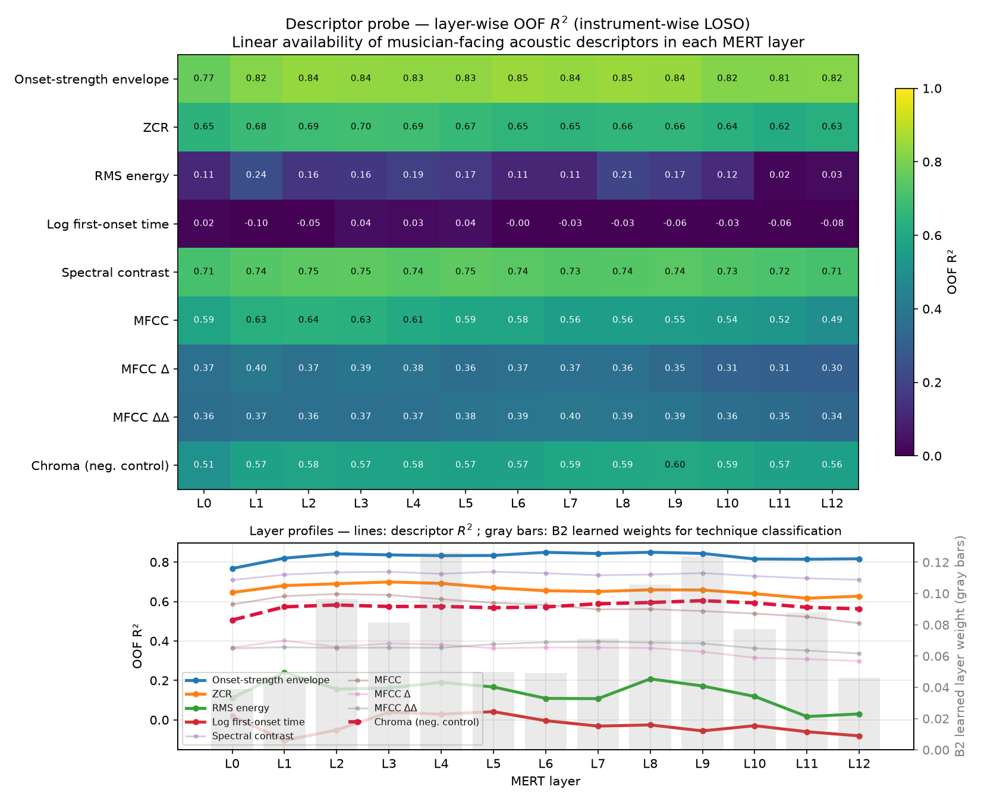
Figure 1. Layer-wise descriptor probe (LOSO out-of-fold R²). Top: heatmap of how linearly available each acoustic descriptor is at each MERT layer (L0–L12). Bottom: the same values as line profiles (gray bars = learned layer weights for technique classification, §5.3). The task's core cue, the onset-strength envelope, already saturates at L0 (the convolutional front-end) at R²=0.77; the only descriptor that consistently gains with depth is the chroma negative control.
Three things stand out (Figure 1). (1) The task's dominant cue — the onset-strength envelope — is already almost fully linearly present at the convolutional front-end (R²=0.767 at L0, before any transformer layer), and the twelve transformer layers add essentially nothing to the band average (+0.008); its peak (0.850 at L8) exceeds L0 by only +0.083. (2) MFCC — timbral detail — actually degrades with depth (−0.086). (3) The only descriptor that consistently gains with depth is Chroma (+0.023), i.e. pitch-class / harmonic abstraction — and Chroma is our negative control, near-zero in SHAP importance (§5.2) because articulation is pitch-invariant. So the representational work the transformer stack performs is largely orthogonal to what this task needs: the discriminative signal sits at the front-end that any mel-style feature extractor (including our SVM's inputs) also sees, while depth buys harmonic abstraction the task discards. This is the audio-articulation counterpart to Pasad et al.'s [21] layer-wise finding in speech, and the mechanistic reason a heavy backbone offers no practical gain here.
A companion probe-configuration analysis reinforces this from the modeling side: matching probing convention (best-layer / layer-weighted head vs a last-layer linear head) raises MERT by a consistent +0.039–0.047, whereas the model-family effect at equal budget is only −0.002 to +0.035 (sign-inconsistent). Probe design moves the number more than the choice of model family does — the MIR instance of Musgrave et al.'s [18] "tuning-budget effects exceed method effects," and a direct quantification of why pitfall (ii) was able to flip the conclusion.
The same mechanism explains why deeper adaptation backfires (§4.4). If the task-relevant signal is already exposed at the front-end and the depth encodes abstraction the task discards, then fine-tuning the backbone on a small in-distribution training set has little useful signal to sharpen and ample opportunity to overfit — distorting the very front-end features the frozen probe relied on. Under our cross-instrument (out-of-distribution) LOSO test this manifests as LoRA falling below the frozen-tuned probe and degrading with more data, the LP-FT effect of Kumar et al. [26]. The probe result is thus not just descriptive: it predicts that parameter-efficient fine-tuning cannot help — and can hurt — on this task.

5.2 What the cheap features encode: SHAP against musician knowledge
If depth inside MERT is unnecessary, what physical substance of the sound do the handcrafted features — the ones that matched MERT — actually grasp? To answer this we interpret them through a fidelity-checked surrogate (XGBoost, §3.6), which lets us read feature attributions we cannot read off the SVM directly. A dimensionality-corrected SHAP analysis (per-feature mean over the surrogate) ranks the onset-strength envelope first by a wide margin (0.481 per feature vs 0.046 for the next group, RMS), with Chroma second-to-last (0.004) — exactly the ordering the probe predicts, and what a string player would expect: articulation is defined by how the note begins and evolves, not by which pitch it is. The direction of the top flux feature aligns with physical intuition per class: col legno battuto occupies low flux variance (a single dry wood-on-string strike, median flux_std 0.18), tremolo occupies high flux variance (rapid re-bowing, high flux_q75), and ordinario sits at a medium level near sul ponticello — the very adjacency that makes those two the hardest to separate (Figures 2 and 3).
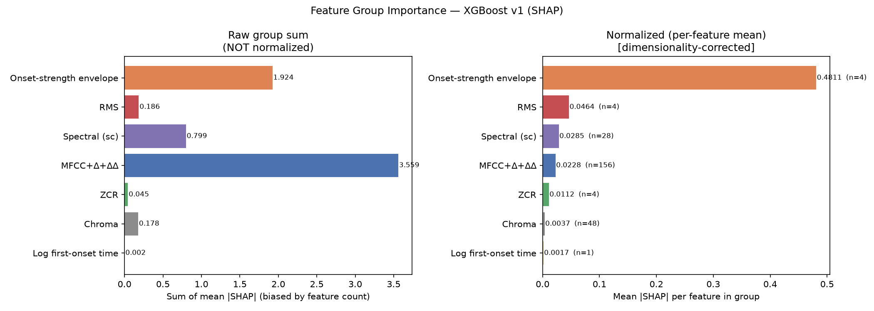
Figure 2. Dimensionality-corrected SHAP group importance (XGBoost surrogate). Left: raw sum (biased by feature count, inflating the MFCC family); right: per-feature mean (dimensionality- corrected). The onset-strength envelope leads by a wide margin (0.481 per feature); chroma is near the bottom (0.004).
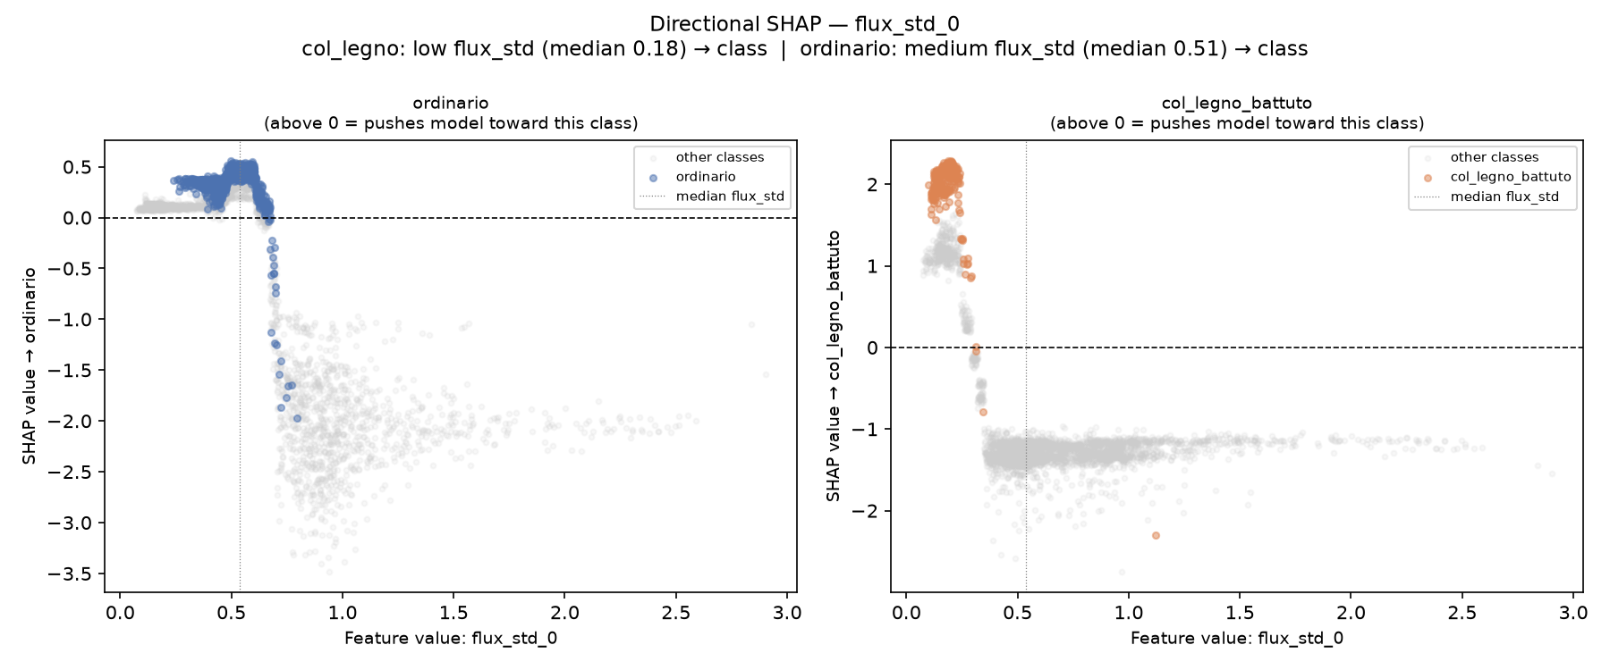
Figure 3. Directional SHAP for flux_std_0. col legno battuto is pushed toward its class at low flux variance (median 0.18), ordinario at a medium level (median 0.51) — the SHAP direction matches per-class physics.
We report surrogate fidelity honestly. Measured out-of-sample (instrument-grouped), the XGBoost surrogate agrees with the MERT head on 91.4% of held-out clips (Cohen's κ=0.882) — substantial, but not the near-perfect in-sample 0.998 an earlier version mistakenly reported. Fidelity is weakest precisely on the rare classes, sul ponticello (κ=0.74) and col legno battuto (κ=0.71); SHAP explanations for those two transfer to MERT only with caution. And when either model errs, they agree on only 16% of the error cases — the two families fail on different clips. SHAP thus explains the XGBoost decision faithfully and the MERT decision only approximately; we do not overstate it as a single mechanism for both (Figure 4).
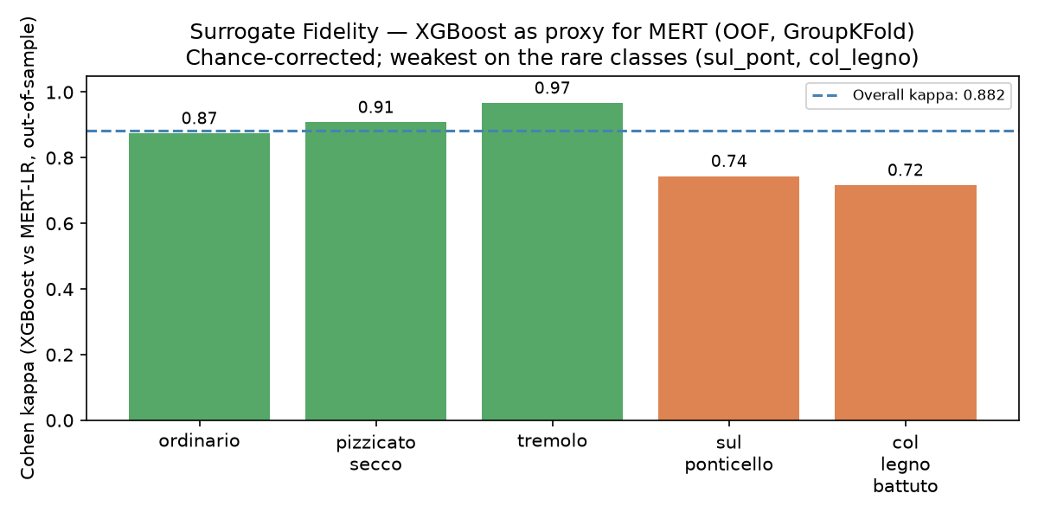
Figure 4. Surrogate fidelity (out-of-sample Cohen's κ). Per-class agreement between the XGBoost surrogate and the MERT head. Overall κ=0.882, weakest on the rare classes sul ponticello (0.74) and col legno battuto (0.72) — SHAP explanations for those two transfer only with caution.

5.3 Two honest negative results
Descriptor–layer alignment is not supported. A tempting story is that MERT's learned layer weights concentrate where the core descriptor is most available. They do not: the correlation between the learned layer-weight profile and per-layer descriptor availability is higher for the Chroma control (ρ=0.73) than for the onset-strength core cue (ρ=0.42). With only 13 layers this comparison is underpowered, and the control out-aligning the target is the opposite of what an alignment claim needs. We therefore drop the alignment narrative and report the correlation table as a null result rather than dress it as confirmation.
The ALM→SHAP causal link is observational only. Evaluating an audio language model (Qwen2-Audio-7B-Instruct) on 125 clips × two question types (yes/no, open-ended), overall accuracy is only 50.4% yes/no (near chance for a binary question) and 20.0% open-ended. Its failures correlate suggestively with SHAP structure — it is 100% correct (open-ended) on the acoustically isolated pizzicato secco yet 0% on ordinario and tremolo, whose top cues place them near neighbors in flux space. Moreover, the two classes the ALM fails most (ordinario, tremolo) are disjoint from the two rare classes our classifiers find hardest (sul ponticello, col legno battuto, §5.2) — suggesting the ALM's errors stem not from acoustic subtlety but from other factors (label wording / language). But all of this is correlation; confirming it would require an intervention (e.g., synthetically varying flux_std on ordinario clips and re-querying the ALM), which we did not run. We present it as a hypothesis-generating observation, not a mechanism.

5.4 Robustness and scope
The parity and its mechanism are consistent under an ordinario-excluded 4-class variant and across the cross-domain Philharmonia transfer, where we additionally localize the fragile classes (col legno, sul ponticello collapse to F1≈0 off-domain) — a robustness boundary rather than a counterexample. The scope condition is explicit: our claim concerns tasks whose discriminative signal is low-dimensional and front-end-accessible. Where the signal instead requires the harmonic abstraction that only depth supplies, we would expect the gap to reopen — a prediction our probe makes testable.

6. Limitations and Future Work
We state the boundaries of the claim plainly; several are direct consequences of the honest protocol this paper argues for.
Statistical power (n=4). Our generalization claim is across four instruments, so the fold-level unit has n=4 — the honest but low-powered unit (§3.5). No paired test can reach p<0.05 at this size (the two-sided Wilcoxon floor is p=0.125), and the two-level bootstrap intervals are correspondingly wide. We therefore frame the central result as statistical indistinguishability, not as a proven equality, and do not promote any within-std directional tilt to a conclusion. Relatedly, the "within ±0.7 fold-std" band used throughout is a descriptive summary of the largest observed gap (0.69σ at 20%), not a pre-registered equivalence margin (as in a formal equivalence test such as TOST): it states that no gap exceeded this band, not that equivalence was tested. More instruments (or families) would both enable a formal equivalence test and tighten this interval.
Single-dataset scope. All results are on OrchideaSOL. The parity is conditional — it concerns tasks whose discriminative signal is low-dimensional and front-end-accessible (§5.4), and we do not claim it for MIR at large. Cross-domain transfer to Philharmonia probes robustness but is not an independent replication of the pitfalls. A second, independent task is the highest-value extension.
A single LoRA configuration. §4.4 reports one LoRA setting (r=8, fixed lr), not a grid — in contrast to the 12/24-config searches we gave the SVM and frozen head. We therefore do not claim LoRA was optimally tuned, and are careful not to commit the very undertuning we critique. The finding we stand behind is directional and mechanistic: LoRA regresses below the frozen-tuned probe and worsens with more data, matching the LP-FT feature-distortion effect under our out-of-distribution (LOSO) evaluation. A LoRA hyperparameter sweep would strengthen this from a consistent signal to a tuned lower bound.
Pitfall (iii) observed once, one-sided fix. The resampling-unit pitfall (§4.3) is a near-miss caught in this study; we did not replicate it across datasets, and we apply the two-level bootstrap as a correction rather than deriving a full BCa two-level interval with acceleration at both levels. The variance-decomposition framing (Bouthillier et al. [20]) is the natural formalization we leave to future work.
Interpretability transfers only approximately. SHAP explains the XGBoost surrogate, which agrees with the MERT head out-of-sample at κ=0.88 and less on the two rare classes (§5.2), so mechanistic claims for sul ponticello / col legno battuto carry more uncertainty. The descriptor–layer alignment and the ALM→SHAP causal link are reported as null / observational respectively (§5.3).
Reproducibility note. The MERT remote code ran under a newer transformers than the project originally targeted; we pin versions in the release and cache all embeddings and splits for exact reproduction.
Future work. (1) Independent second task (highest priority) — replicating the three pitfalls on a separate articulation dataset (e.g., Erhu playing techniques) would turn "a pitfall we hit" into "a pattern," and directly address the single-dataset limit; it requires a performer/session grouping key to avoid re-introducing leakage. (2) Reverse and broader cross-domain — train-on-Philharmonia / test-on-OrchideaSOL and other instrument families, to map where front-end-accessible parity holds and where depth begins to pay. (3) From checklist to formal variance model — promote the practitioner checklist into a variance-decomposition procedure that names the correct resampling unit for a given generalization claim. (4) Practitioner-facing tool — the mechanistic account (SHAP ↔ bowing physics) points toward a lightweight, interpretable feedback tool for string pedagogy, a separate applied paper.

7. Reproducibility
Code, cached MERT embeddings, split configurations, and the pre-extracted 3,402×245 feature matrix are released with fixed seeds and the LOSO grouping keys. build_dataset.py regenerates features_full.csv exactly (full, no downsampling; scan order and the [245 features + label_id + instrument] schema verified against the released matrix), with grouping keys preserved in a sidecar features_full_groups.csv (recording_id). All experiments run on Apple-Silicon MPS with CPU fallback; no CUDA, no bitsandbytes; quantization, where used, via optimum-quanto int8. Package versions (notably transformers) are pinned in the release.

References
[1] L. Su, H.-M. Lin, and Y.-H. Yang, "Sparse modeling of magnitude and phase-derived spectra for playing technique classification," IEEE/ACM Transactions on Audio, Speech, and Language Processing, vol. 22, no. 12, pp. 2122–2132, 2014.
[2] A. Kruger and J. Jacobs, "Playing technique classification for bowed string instruments from raw audio," Journal of New Music Research, vol. 49, no. 4, pp. 320–333, 2020.
[3] I. Barbancho, C. de la Bandera, A. M. Barbancho, and L. J. Tardón, "Transcription and expressiveness detection system for violin music," in Proc. IEEE Int. Conf. Acoustics, Speech and Signal Processing (ICASSP), Taipei, 2009, pp. 189–192.
[4] V. Lostanlen, J. Andén, and M. Lagrange, "Extended playing techniques: The next milestone in musical instrument recognition," in Proc. 5th Int. Conf. Digital Libraries for Musicology (DLfM), Paris, 2018. arXiv:1808.09730.
[5] C. Wang, E. Benetos, V. Lostanlen, and E. Chew, "Playing technique recognition by joint time–frequency scattering," in Proc. IEEE ICASSP, 2020.
[6] C. Wang, E. Benetos, V. Lostanlen, and E. Chew, "Adaptive scattering transforms for playing technique recognition," IEEE/ACM Transactions on Audio, Speech, and Language Processing, vol. 30, pp. 1407–1421, 2022.
[7] J.-F. Ducher and P. Esling, "Folded CQT RCNN for real-time recognition of instrument playing techniques," in Proc. Int. Society for Music Information Retrieval Conf. (ISMIR), 2019, pp. 708–714.
[8] Z. Wang, J. Li, X. Chen, Z. Li, S. Zhang, B. Han, and D. Yang, "Musical instrument playing technique detection based on FCN: Using Chinese bowed-stringed instrument as an example," arXiv:1910.09021, 2019.
[9] D. Li, M. Che, W. Meng, Y. Wu, Y. Yu, F. Xia, and W. Li, "Playing technique detection by fusing note onset information in Guzheng performance," in Proc. ISMIR, 2022. arXiv:2209.08774.
[10] D. Li, M. Che, W. Meng, Y. Wu, Y. Yu, F. Xia, and W. Li, "Frame-level multi-label playing technique detection using multi-scale network and self-attention mechanism," in Proc. IEEE ICASSP, 2023. arXiv:2303.13272.
[11] H. S. Alar, R. O. Mamaril, L. P. Villegas, and J. R. D. Cabarrubias, "Audio classification of violin bowing techniques: An aid for beginners," Machine Learning with Applications, vol. 4, art. 100028, 2021.
[12] G. K. Chellamani, A. N., C. C., K. Kaur, and R. T. S. Babu, "SpectroFusionNet: A CNN approach utilizing spectrogram fusion for electric guitar play recognition," Scientific Reports, vol. 15, art. 16842, 2025.
[13] D. Li, Y. Ma, W. Wei, Q. Kong, Y. Wu, M. Che, F. Xia, E. Benetos, and W. Li, "MERTech: Instrument playing technique detection using self-supervised pretrained model with multi-task finetuning," in Proc. IEEE ICASSP, 2024. arXiv:2310.09853.
[14] T.-K. Wang, Y.-P. Peng, L. Su, and V. K. M. Cheung, "VioPTT: Violin technique-aware transcription from synthetic data augmentation," arXiv:2509.23759, 2025.
[15] D. Dalmazzo, S. Tassani, and R. Ramírez, "A machine learning approach to violin bow technique classification: a comparison between IMU and MOCAP systems," in Proc. 5th Int. Workshop on Sensor-based Activity Recognition and Interaction (iWOAR), Berlin, 2018.
[16] D. Dalmazzo and R. Ramírez, "Bowing gestures classification in violin performance: A machine learning approach," Frontiers in Psychology, vol. 10, art. 344, 2019.
[17] A. Oliver, A. Odena, C. Raffel, E. D. Cubuk, and I. J. Goodfellow, "Realistic evaluation of deep semi-supervised learning algorithms," in Advances in Neural Information Processing Systems (NeurIPS), 2018, pp. 3239–3250.
[18] K. Musgrave, S. Belongie, and S.-N. Lim, "A metric learning reality check," in Proc. European Conf. Computer Vision (ECCV), 2020. arXiv:2003.08505.
[19] S. Kapoor and A. Narayanan, "Leakage and the reproducibility crisis in machine-learning-based science," Patterns, vol. 4, no. 9, art. 100804, 2023.
[20] X. Bouthillier, P. Delaunay, M. Bronzi, et al., "Accounting for variance in machine learning benchmarks," in Proc. Machine Learning and Systems (MLSys), 2021. arXiv:2103.03098.
[21] A. Pasad, J.-C. Chou, and K. Livescu, "Layer-wise analysis of a self-supervised speech representation model," in Proc. IEEE Automatic Speech Recognition and Understanding Workshop (ASRU), 2021. arXiv:2107.04734.
[22] J. Hewitt and P. Liang, "Designing and interpreting probes with control tasks," in Proc. Conf. Empirical Methods in Natural Language Processing (EMNLP-IJCNLP), 2019, pp. 2733–2743.
[23] R. Yuan, Y. Ma, Y. Li, et al., "MARBLE: Music audio representation benchmark for universal evaluation," in Advances in NeurIPS (Datasets and Benchmarks Track), 2023. arXiv:2306.10548.
[24] Y. Wang, H. Chen, Y. Fan, et al., "USB: A unified semi-supervised learning benchmark for classification," in Advances in NeurIPS (Datasets and Benchmarks Track), 2022. arXiv:2208.07204.
[25] Y. Li, R. Yuan, G. Zhang, et al., "MERT: Acoustic music understanding model with large-scale self-supervised training," in Proc. Int. Conf. Learning Representations (ICLR), 2024. arXiv:2306.00107.
[26] A. Kumar, A. Raghunathan, R. Jones, T. Ma, and P. Liang, "Fine-tuning can distort pretrained features and underperform out-of-distribution," in Proc. ICLR, 2022. arXiv:2202.10054.
[27] C. E. Cella, D. Ghisi, V. Lostanlen, F. Lévy, J. Fineberg, and Y. Maresz, "OrchideaSOL: A dataset of extended instrumental techniques for computer-aided orchestration," in Proc. Int. Computer Music Conf. (ICMC), 2020. arXiv:2007.00763.

