String Playing Technique Classification with Limited Labels: Comparing Acoustic Features and Pretrained Representations under Instrument-Type Holdout
Full English manuscript v2 · Translation of the Korean manuscript prepared on 2026-10-03 and reviewed on 2026-10-05 · English version prepared on 2026-10-07 · Internal review draft. Author details, affiliations, and final author declarations are pending.

Abstract
String playing technique classification requires distinguishing excitation mechanisms and timbral differences while accounting for variation across instrument types. Assessing pretrained music representations under limited labels requires examining instrument- and technique-specific errors alongside average performance and evaluation conditions. We compare a classification head on frozen MERT representations with an SVM on 245 acoustic features using 3,402 OrchideaSOL clips from four bowed-string instrument types and five techniques. One entire instrument type is held out for testing; 5%, 10%, 20%, or 50% of the remaining data form the observed-label budget. Each budget is sampled three times, with separate labels for training, early stopping, and configuration selection. Instrument-type mean macro F1 scores for MERT/SVM are 0.6655/0.6613, 0.7634/0.7542, 0.8242/0.8316, and 0.8599/0.8681, respectively. The direction of the mean difference varies with the budget, and relative performance also differs across instrument types and techniques within a budget. A separate self-training comparison with matched settings yields lower mean F1 for pseudo-label training than for the supervised control at 5%, and slightly higher values at the other budgets. We compare selected checkpoints with saved predictions and perform paired resampling of those predictions at the clip, filename-derived group, and instrument-type levels. All MERT−SVM difference intervals include zero; we do not interpret this as evidence of equivalence. The study provides traceable performance and error comparisons under limited-label instrument-type holdout, with conclusions restricted to the four observed instrument types.
Keywords: string playing technique classification; acoustic features; pretrained music representations; limited labels; self-training; instrument-type holdout.

1. Introduction
Even on the same string instrument and at the same pitch, sustained bowing, finger plucking, and striking the string with the wood of the bow produce different excitation patterns and temporal developments. Playing techniques change timbre and expression in ways that instrument identity alone cannot explain. Recognizing techniques from audio therefore addresses a finer level of musical information than instrument recognition. Previous work has treated these distinctions as an expressive level of timbre and studied technique classification in isolated notes and actual performance recordings (Su et al., 2014; Lostanlen et al., 2018). Technique-based audio retrieval and performance analysis are possible applications, but educational benefits or performance in actual playing environments require separate validation.
Differences among string techniques cannot readily be reduced to one acoustic dimension. Plucking or striking a string can change the onset and decay; bow contact position can influence the timbre of a sustained sound; and rapid repeated bowing introduces temporal variation. The same technique can also produce different signals depending on instrument range and resonance, playing dynamics, and recording conditions. Whether a classifier can transfer distinctions learned on one instrument type to another must be examined separately from its average timbre classification performance.
One approach is to design acoustic features and train a classifier. MFCCs, spectral contrast, energy, and onset-related statistics explicitly summarize particular aspects of the input signal. Another approach extracts representations from a model pretrained on large music collections and trains a classifier using the target technique labels. MERT is a representative pretrained model for music understanding (Li et al., 2024). However, its performance in pretraining evaluations does not determine its advantage on a specific technique subset under instrument-type holdout. A comparison must specify the layer, temporal aggregation, classification head, and label budget.
Label availability is an important condition of this comparison. Here, we simulate observing only some labels in an already labeled dataset. Observed labels are required for early stopping and configuration selection as well as training. Reserving validation labels within a small budget further reduces the number of direct training examples. Self-training, which assigns model predictions to unlabeled examples and trains again, may alleviate this constraint, but it can be affected by errors and class distributions in the selected pseudo-labels. Its effect should therefore be compared with a supervised control under the same conditions (Oliver et al., 2018).
Our central question is: With limited labels, what performance and error patterns do an acoustic-feature SVM and a classifier on frozen MERT representations exhibit when evaluated on an instrument type held out from technique-classifier training? We study four bowed-string instrument types and five techniques in OrchideaSOL. The main comparison is between the MERT head and SVM at each observed-label budget. Self-training is a supplementary comparison concerning the use of unlabeled data. We report instrument-specific differences, per-class F1, and confusion matrices alongside average performance to examine outcomes hidden by the overall mean.
Interpreting this comparison requires establishing the training and selection path behind each result. We connect observed-label and pseudo-target transfer, preprocessing quantities fitted on the training partition, validation-selected checkpoints, saved predictions, and result tables. This connection was verified after correcting implementation issues found in earlier exploratory runs. Multiple settings and implementation details changed together, so differences from historical results are not presented as causal effects of individual defects. Observations from four instrument types also do not establish model equivalence or generalization to a new population of performers.
The contribution is a set of recomputable comparative observations under these conditions. First, scores and error directions show how small MERT/SVM mean differences under shared observed-label budgets and direct training examples can conceal differences in relative performance by instrument type and technique (Sections 4.1–4.3). Second, matched supervised, pseudo-label, and oracle diagnostics show that self-training outcomes vary with the label budget (Section 4.4). Third, checkpoint–prediction links, resampling sensitivity on the same predictions, and a statistical recomputation path make these observations traceable (Sections 4.5 and 7). The first two contributions are empirical results for this subset and execution policy; the third is the supporting research material. We do not present a new classification method or general evaluation theory.

2. Related Work

2.1 Acoustic features and string technique classification
Su et al. (2014) studied sparse modeling of magnitude spectra and phase-derived features for bowed-string playing technique classification. They considered both isolated notes and actual violin performance recordings, discussing the importance of acoustic representations for subtle technique differences such as bow contact position. Kruger and Jacobs (2020) combined traditional acoustic and Hartley-transform features with SVMs for technique classification and joint instrument–technique classification across several string instruments. These studies motivate a feature-based classifier as a comparison baseline. Our 245-dimensional features are not a direct reproduction of their feature sets, and the datasets and class definitions differ.
Other work addresses the temporal structure of techniques. Lostanlen et al. (2018) examined acoustic representations for retrieval and classification using data containing varied extended techniques. Ducher and Esling (2019) proposed a multidimensional description of cello techniques and Folded CQT models, with sound-bank holdout evaluation. These studies motivate considering both time–frequency structure and the provenance of evaluation data. Our instrument-type holdout differs from sound-bank holdout; we do not rank one as uniformly more stringent.
We restrict the task to clip classification into five techniques. We do not detect frame-level technique onsets and offsets or decompose compound techniques into multiple attributes. Published scores from different datasets, splits, and class sets are not directly ranked against our scores. Related work explains our feature and evaluation choices.

2.2 Using pretrained music representations
MERT learns music audio representations using acoustic and music-related objectives (Li et al., 2024). Freezing a pretrained encoder and learning a downstream classifier is one way to use its representations when target labels are scarce. The original MERT paper does not use a single linear classifier as its sole standard: it employs downstream architectures including MLPs and validation-based search. Frozen-representation performance consequently depends on the classifier and selection procedure as well as the representation.
A directly relevant technique-recognition study is MERTech (D. Li et al., 2023). It studies MERT-based technique detection with multitask fine-tuning using pitch and technique-onset auxiliary tasks, and includes a frozen-MERT probing comparison. It evaluates frame- and event-level detection for guzheng, guitar, and Chinese bamboo flute. Applying MERT to technique recognition is therefore not itself our novelty. Our scope is isolated-note classification using the temporal mean of a frozen final layer, with four bowed-string instrument types, instrument-type holdout, and comparison with a feature SVM across observed-label budgets. Differences in tasks, datasets, and output units prevent direct ranking against MERTech’s published scores.
We use temporally averaged final-layer MERT-v1-95M representations and select linear or MLP head settings using validation. Comparing this configuration with the feature SVM evaluates two executed classification configurations. We do not apply the same classifier to both representations in a crossed experiment, so differences cannot be attributed to representation alone. The experiment does not cover every layer-weighting or encoder fine-tuning strategy, and its conclusions are not extended to foundation models as a whole.

2.3 Limited-label evaluation and validity
Oliver et al. (2018) discuss supervised baselines, the amounts and distributions of observed and unobserved labels, and validation conditions in semi-supervised evaluation. Musgrave et al. (2020), in another domain, demonstrate that implementation and tuning conditions can affect reported model differences. We match the observed labels and direct training indices between the two main configurations and do not use test predictions for configuration selection. Search counts and computation differ, however, so we do not describe the comparison as equal in every resource.
Leakage and confounding research provides criteria for tracing results. Kapoor and Narayanan (2023) review leakage and reproducibility in machine-learning-based science. Rodríguez-Algarra et al. (2019) study controlled interventions to distinguish factors in music classification. In this context, we verify implementation boundaries without assigning the effects of multiple simultaneous changes to a single cause. Intervals obtained by changing the resampling unit are reported as sensitivity results conditional on fixed predictions. This literature review connects our task and methods; it is not a systematic review establishing a field-wide first.

3. Data and Methods

3.1 Dataset and five techniques
OrchideaSOL contains isolated instrument sounds and provides public metadata and splits for tasks including technique recognition (Cella et al., 2020). We select the five techniques in Table 1 from the local Violin, Viola, Violoncello, and Contrabass folders. We do not add separate mute folders or other techniques, or downsample classes. The final subset contains 3,402 clips. We use the dataset’s technique labels without independent listener reannotation.
Table 1. Techniques and sample counts. Descriptions explain the class meanings; they do not establish that the models use these particular cues.
Technique | Playing action | Clips
ordinario | Ordinary bowing | 1,193
pizzicato secco | Short, dry finger plucking | 639
tremolo | Rapid repeated bowing | 1,041
sul ponticello | Bowing close to the bridge | 302
col legno battuto | Striking the strings with the wood of the bow | 227
Total | Isolated notes from four instrument types | 3,402
The subset contains 879 violin, 933 viola, 757 cello, and 833 double-bass clips. Figure 1 shows the distribution by technique and instrument type. All five classes occur in every instrument type, but counts differ; sul ponticello and col legno battuto are particularly small. Because of this imbalance, we use macro F1, the average of class F1 scores, as the primary metric rather than summarizing performance through accuracy alone.
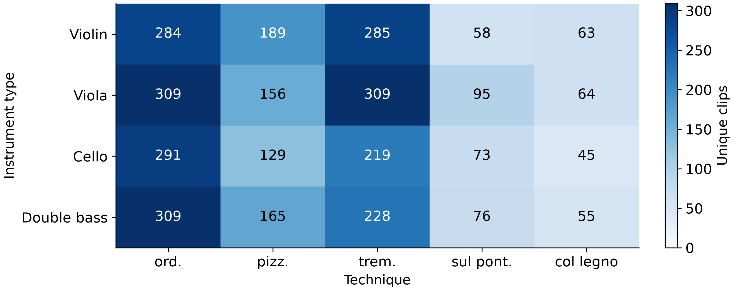
Figure 1. Unique clips by instrument type and technique, aggregated from metadata for 3,402 clips. The abbreviations ord., pizz., trem., sul pont., and col legno follow the class order in Table 1. Colors and cell labels represent the same counts; repeated predictions are not included.
Official OrchideaSOL provides five splits accounting for instrument, pitch, and dynamics. Our question concerns classifying an instrument type excluded from training, so we use four custom instrument-type holdouts. These are not benchmark scores on the official splits. The official metadata description also includes tuning and pitch transformations of some sounds. We record filename-derived groups without independently verifying original recording lineages, performers, or sessions. Section 5.4 discusses this limitation.

3.2 Outer evaluation and observed-label budgets
Outer evaluation comprises four folds: each holds out one entire instrument type for testing and uses the other three as training and validation candidates. The grouping key is instrument type. Within each outer training candidate set, we sample observed-label seeds by class to create 5%, 10%, 20%, and 50% budgets. Remaining examples form the unlabeled pool. Three samplings per budget yield 12 splits per budget and 48 overall. The three trials share the same instrument-type test clips; they are not three independent test datasets.
Approximately 20% of the observed-label seed is reserved for configuration-selection validation. The remaining approximately 80% is split again into 80% direct training and 20% early-stopping validation. Direct training, early stopping, and configuration selection thus use approximately 64%, 16%, and 20% of the full seed. Splitting is class-wise; minimum validation counts and rounding make these proportions approximate. The three label partitions and outer test set are disjoint. The main MERT/SVM comparison uses identical direct training indices for SVM. We do not give SVM the early-stopping examples as additional training data simply because SVM has no early-stopping stage.
At 5%, direct training contains 78–85 examples across folds, early-stopping validation 20–21, and configuration-selection validation 25–26. The phrase “5% label budget” therefore includes observed labels assigned to validation rather than training. Appendix B reports the actual ranges at all budgets. These small validation sets preserve the boundaries but leave potential variation in configuration selection. Budget comparisons concern an execution policy that includes this validation allocation.
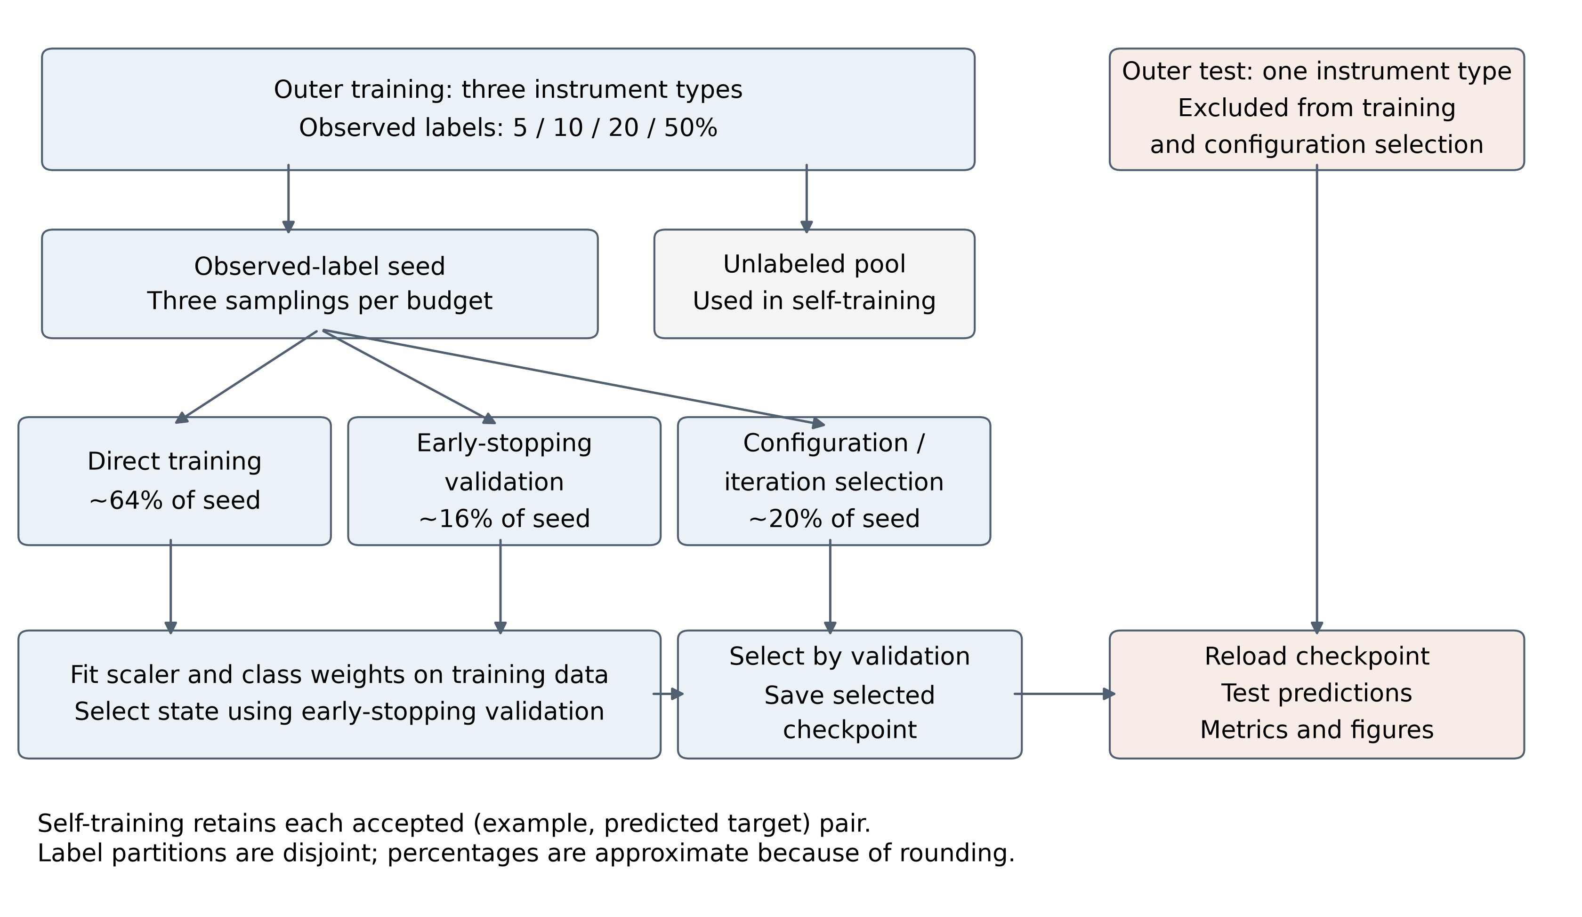
Figure 2. Evaluation and model-selection boundaries. Percentages are approximate proportions within the observed-label seed. Rotating the held-out instrument type gives four outer folds. The main MERT/SVM comparison shares direct training and configuration-selection indices; SVM has no early-stopping stage. Self-training retains each predicted target together with its accepted unlabeled example. This is a procedural schematic, not a measurement of performance effects.

3.3 Acoustic features and MERT representations
The feature-based configuration extracts 245 statistical acoustic features from mono audio at 22,050 Hz. For each channel of multidimensional frame features, we calculate the mean, standard deviation, 25th percentile, and 75th percentile, producing a fixed-length vector per clip. Table 2 summarizes the feature groups and dimensions. Clip-local feature extraction without class labels or test-set distributions is distinct from fitting standardization on training examples. The SVM input’s standardization means and variances are fitted only on each run’s direct training examples.
Table 2. Feature-SVM input. Four statistics aggregate frames within each clip.
Feature group | Channels and aggregation | Dimensions
MFCC and first/second-order deltas | 13 channels × 3 types × 4 statistics | 156
Spectral contrast | 7 channels × 4 statistics | 28
Onset-strength envelope | 1 channel × 4 statistics | 4
Zero-crossing rate | 1 channel × 4 statistics | 4
RMS energy | 1 channel × 4 statistics | 4
Chroma | 12 channels × 4 statistics | 48
log1p of first detected onset time | 1 value per clip | 1
Total |  | 245
Columns beginning with flux in the code aggregate librosa’s onset-strength envelope. We use that name to distinguish onset strength, based on positive changes between mel-spectral frames, from the generic term spectral flux. The final dimension is also the log1p-transformed time of the first detected onset, not the rise time from onset to maximum amplitude. Chroma is retained. Because the canonical comparison contains no removal experiment, we do not conclude that chroma contributes nothing.
The MERT configuration inputs mono audio at 24,000 Hz to m-a-p/MERT-v1-95M and averages the final hidden layer’s time frames into a 768-dimensional vector. Encoder weights remain frozen; only the classification head is trained. External pretraining data and computation are outside our observed-label budget. Both configurations aggregate audio at the clip level, but they use different transformations and classifiers. This performance comparison alone cannot isolate which representation better preserves specific physical technique cues.

3.4 Training and validation-based selection
The MERT head uses either a linear output architecture with LayerNorm and dropout or an MLP with a 256-dimensional hidden layer. The MLP includes ReLU and additional dropout. Each configuration is trained with weighted cross-entropy and AdamW; class weights are computed from class frequencies in the direct training examples. Early-stopping validation macro F1 selects the training state within each configuration, and configuration-selection validation macro F1 selects the final configuration. Ties follow a fixed search order.
SVM uses an RBF kernel, with StandardScaler and SVC fitted as one training pipeline. Standardization and balanced class weights are derived only from training indices. C and γ are selected on the same configuration-selection validation set as MERT. Table 3 lists the main search settings. Separate validation prevents test-based selection, but 24 versus 12 configurations does not establish equal computation or optimal tuning for either model family.
Table 3. Training settings for the main MERT/SVM comparison and self-training.
Configuration | Training and search settings | Selection criterion
MERT head | Linear/MLP-256; learning rate 0.0003/0.001/0.003; weight decay 0.0001/0.001; dropout 0.1/0.3; 24 configurations | Separate validation F1 after early stopping per configuration
MERT head training | Full-batch AdamW; up to 200 epochs; patience 20 | Early-stopping validation F1
Feature SVM | RBF; C=0.1/1/10/100; γ=scale/0.01/0.001; 12 configurations | Same configuration-selection validation F1
Self-training head | LayerNorm–dropout(0.3)–linear; AdamW; learning rate 0.001; weight decay 0.0001 | Observed-label validation F1 after early stopping per iteration
Self-training iterations | Up to 150 epochs per fit; patience 15; τ=0.8; at most 5 fits | Iteration selection on fixed observed-label validation
After final configuration selection, the selected MERT and SVM checkpoints are saved and reloaded to generate test predictions. Test F1 is not an input to selection. Subsequent verification regenerates predictions from selected files and is distinct from consulting the test set to choose new settings. Reloaded predictions, test indices, model-file hashes, and metrics are linked through a manifest for each run.

3.5 Self-training and oracle diagnostics
The self-training comparison uses a separate fixed head configuration for supervised learning, pseudo-label learning, and an oracle diagnostic. These conditions share the observed-label seed, internal training/validation partitions, random seeds, and selection rules. The supervised control is fitted once using observed labels. Pseudo-label training accepts examples whose maximum predicted class probability in the unlabeled pool is at least τ=0.8, retaining the predicted class at acceptance as the target for subsequent training. Accepted examples leave the unlabeled pool. Early-stopping and configuration-selection validation examples never enter the pseudo-label pool.
Each iteration fits a new model using the corresponding seed and accumulated training pool; class weights are recomputed from that pool’s explicit targets. At most five model fits are performed, with no new examples added after the last fit. The process stops early if there are no eligible examples or the pool is exhausted. Fixed observed-label validation F1 selects the final iteration. “Five iterations” therefore does not necessarily mean five pseudo-label additions. The initial supervised state is also a selection candidate.
The historical implementation increased the indices of accepted pseudo-labeled examples but subsequently read targets from the full ground-truth array. The corrected path maintains (sample index, target) pairs and passes the actual pseudo-targets to training. Accepted indices and targets and training-pool hashes are saved at every iteration to trace this path. Historical self-training scores were produced under different boundaries and training settings and are not used to calculate causal before/after effects in this manuscript.
The oracle condition explicitly supplies hidden ground-truth labels for accepted unlabeled examples. It is a separate diagnostic with privileged information, not an unlabeled learning method. Later models and accepted examples may differ, and validation selects the final state, so this procedure does not guarantee higher test performance than pseudo-label training. Lower oracle performance is not attributed to a particular causal factor.
The self-training supervised control differs from the tuned MERT model in Section 3.4 in its head, internal split seeds, and training settings. Self-training effects are compared within the three matched conditions; their supervised scores are not interchangeable with the main comparison. The unlabeled pool comes from the three outer training instrument types, so self-training is not transductive learning using audio from the held-out test instrument type.

3.6 Metrics and aggregation
The primary metric is macro F1, the equal-weight mean of F1 across the five classes. Let $TP_{c}$, $FP_{c}$, and $FN_{c}$ denote true positives, false positives, and false negatives for class $c$:
$$F1_{c}=\frac{2TP_{c}}{2TP_{c}+FP_{c}+FN_{c}}, F_{macro}=\frac{1}{5}\sum_{c=1}^{5}{F}1_{c}.$$
A score with a zero denominator is set to zero. Let $F_{m,r,g,t}$ be macro F1 for model $m$, budget $r$, instrument-type fold $g$, and trial $t$. The reported mean is:
$${\overset{‾}{F}}_{m,r}=\frac{1}{4}\sum_{g=1}^{4}{\left(\frac{1}{3}\sum_{t=1}^{3}{F_{m,r,g,t}}\right)}.$$
Class F1 is averaged in the same order. Instrument types with more examples do not receive greater weight. In contrast, confusion matrices pool predictions from three trials in each of the four folds, then normalize by true-class row. Each budget/model matrix contains three predictions for each of 3,402 unique clips, or 10,206 prediction events. Its diagonal represents pooled class recall, which differs from the instrument-type mean class F1 reported in tables.

3.7 Resampling sensitivity and result provenance
We perform 1,000 paired percentile resamples of fixed predictions for the MERT−SVM difference. Clip-level resampling draws test positions with replacement within each instrument type, applying the same positions to both models and all three trials of that type. Filename-proxy resampling draws groups derived from instrument abbreviations, pitch, and dynamics. Instrument-type resampling draws the four instrument-type scores with replacement while holding clip predictions fixed. Point estimates follow Section 3.6, and intervals use the 2.5th and 97.5th percentiles.
The three procedures vary different factors. In particular, instrument-type resampling recombines four observed types. The folds share overlapping training data and do not sample new performers or sessions, so these intervals do not represent uncertainty for a broader population. Filename proxies are also not verified independent recording-session IDs. This analysis shows sensitivity to the resampling unit; it is not a retraining bootstrap that repeats training seeds and hyperparameter selection in every draw.
Provenance verification reloaded 100 checkpoints from 48 MERT/SVM pairs and four CNN folds, plus 144 checkpoints from the three self-training conditions, and compared them with saved predictions. Self-training pools were reconstructed from iteration-wise indices and targets to verify their hashes. Manuscript values and figures use CSVs derived from predictions that passed these checks. Section 7 describes a separate path for recomputing tables from saved predictions alone.

4. Results

4.1 Average performance across observed-label budgets
Table 4 reports the main MERT/SVM comparison. Mean macro F1 increases with the observed-label budget for both configurations: from 0.6655 to 0.8599 for MERT and from 0.6613 to 0.8681 for SVM between 5% and 50%. Within-budget mean differences have absolute magnitude below 0.01, but their direction is not constant. MERT has the higher point estimate at 5% and 10%, and SVM at 20% and 50%. These results do not identify one model as superior at every budget.
Table 4. Main limited-label comparison. Three trials are averaged within each instrument type, then the four types receive equal weight. Intervals describe instrument-type resampling sensitivity on fixed predictions, not an equivalence test.
Observed labels | MERT head | Feature SVM | MERT−SVM | 95% resampling interval for difference
5% | 0.6655 | 0.6613 | +0.0042 | [−0.0544, +0.0451]
10% | 0.7634 | 0.7542 | +0.0092 | [−0.0514, +0.0698]
20% | 0.8242 | 0.8316 | −0.0074 | [−0.0515, +0.0403]
50% | 0.8599 | 0.8681 | −0.0082 | [−0.0345, +0.0179]
Figure 3(a) shows the two means across budgets. Increasing the budget adds validation labels as well as direct training labels, so we do not isolate the rising curves as the effect of direct training sample count alone. Class-wise seeds at different budgets are not constructed to be necessarily nested. Connecting lines simply make the four evaluated conditions easier to read.
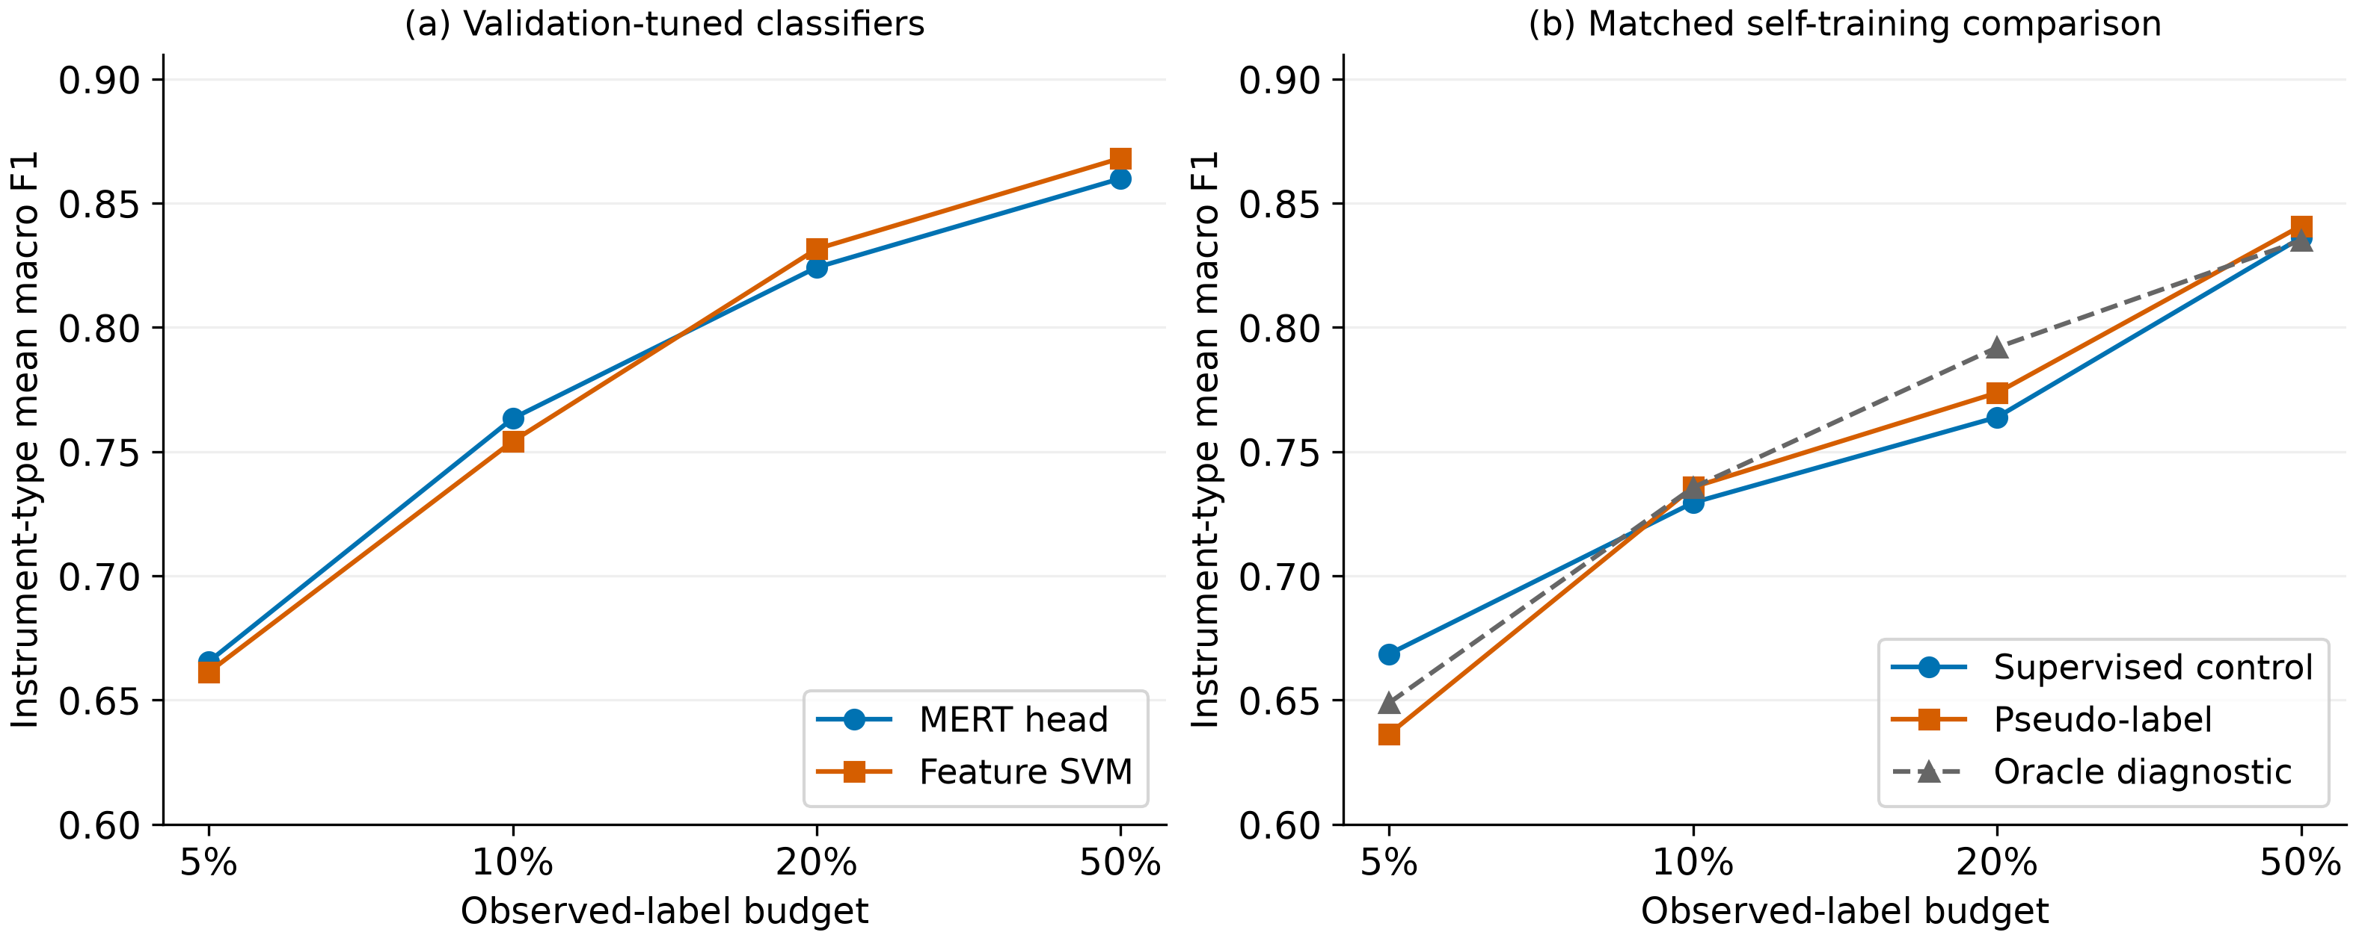
Figure 3. Instrument-type mean macro F1 by observed-label budget. Panel (a) compares validation-selected MERT/SVM configurations; (b) compares self-training conditions with a fixed head. Internal split seeds and training settings differ across panels, so their supervised values are not the same control. Both panels share the vertical range, starting at 0.60. The horizontal axis has four categories; spacing does not represent differences in label counts. Lines connect observations rather than estimating performance at intermediate budgets.

4.2 Differences by instrument type and technique
Small overall mean differences do not imply similar scores on every instrument type. At 50%, Figure 4(a) shows MERT−SVM differences of +0.0213 for violin, −0.0468 for viola, −0.0218 for cello, and +0.0146 for double bass. Direction can also change with the budget within an instrument type. For example, MERT scores higher on viola at 5%, but SVM scores higher at the other budgets. An overall difference cannot substitute for the result on a specific instrument type. Each point averages three observed-label samplings, not three independent physical instruments.
Technique-specific differences also occur. At 50%, MERT’s class F1 scores are 0.9334 for ordinario, 0.8801 for pizzicato secco, 0.9760 for tremolo, 0.7678 for sul ponticello, and 0.7423 for col legno battuto. SVM’s corresponding values are 0.8969, 0.9197, 0.9606, 0.7386, and 0.8248. Both score highly on tremolo, but relative strengths differ by class. SVM scores higher on col legno battuto and MERT on sul ponticello. Even these two small classes have opposite relative rankings. This comparison does not separate class-frequency effects from acoustic difficulty.
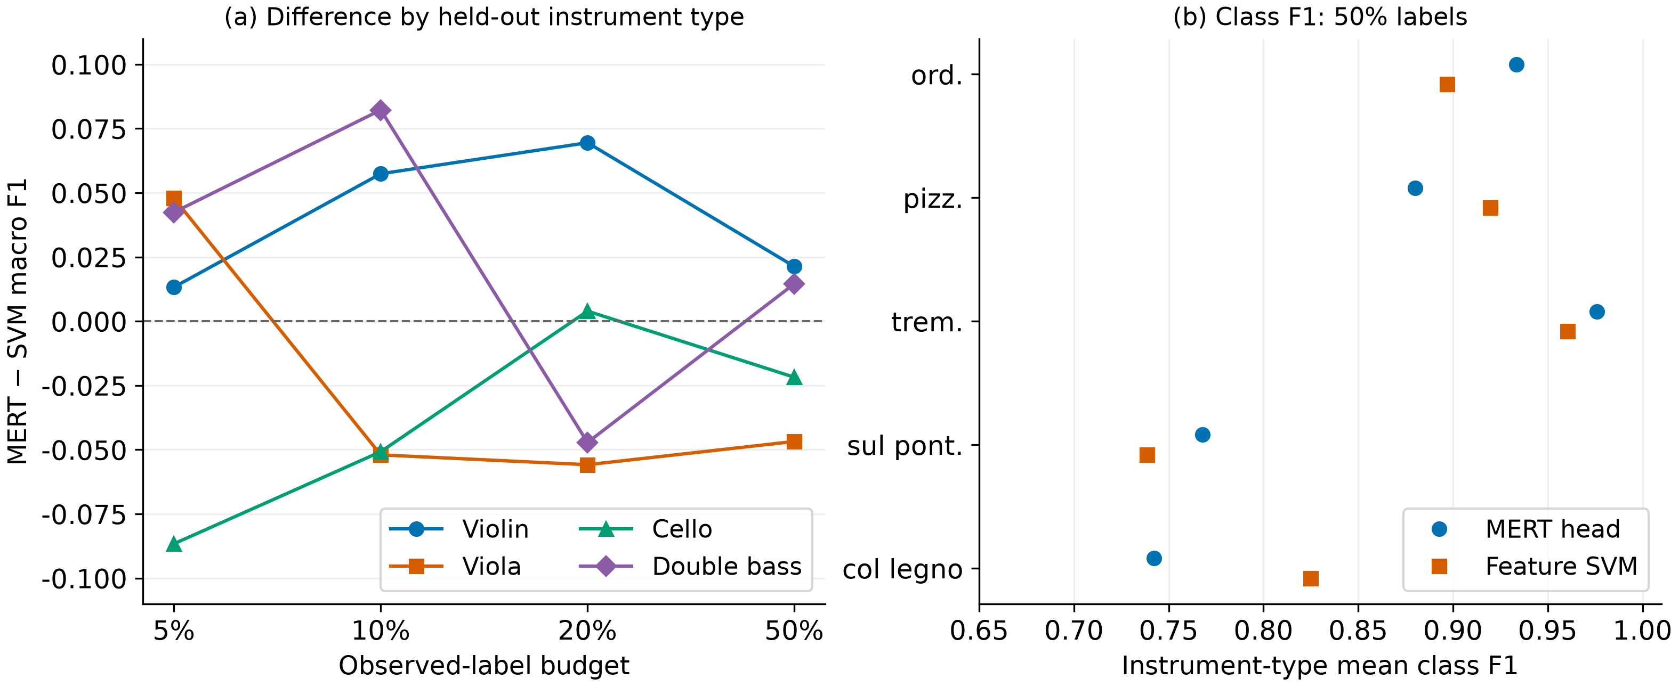
Figure 4. Condition-specific outcomes behind the overall mean. Panel (a) shows MERT−SVM differences by budget and held-out instrument type; positive values favor MERT. Points are three-trial means, not error bars or significance indicators. Panel (b) shows class F1 at 50%, averaged first over trials and then over the four instrument types. Its horizontal axis starts at 0.65. Colors and markers distinguish the models.

4.3 Class confusion structure
Figures 5(a,b) show confusion matrices at 50%. The pooled fractions of sul ponticello predicted as ordinario are approximately 0.21 for MERT and 0.24 for SVM. Reverse confusions from ordinario to sul ponticello are approximately 0.06 and 0.07. Confusion between these classes is therefore asymmetric. Col legno battuto is predicted as pizzicato secco at approximately 0.20 for MERT and 0.11 for SVM, whereas the reverse fractions are approximately 0.12 and 0.10. Error direction matters beyond describing two classes as close to each other.
These matrices help interpret Section 4.2 but do not express the same statistic in another form. Class F1 depends on false positives arriving from other classes as well as recall. Matrices also pool all predictions, whereas tabulated F1 gives equal weight to instrument-type scores. Consequently, changes in pooled diagonals need not coincide with changes in mean F1. We distinguish these aggregation levels throughout.
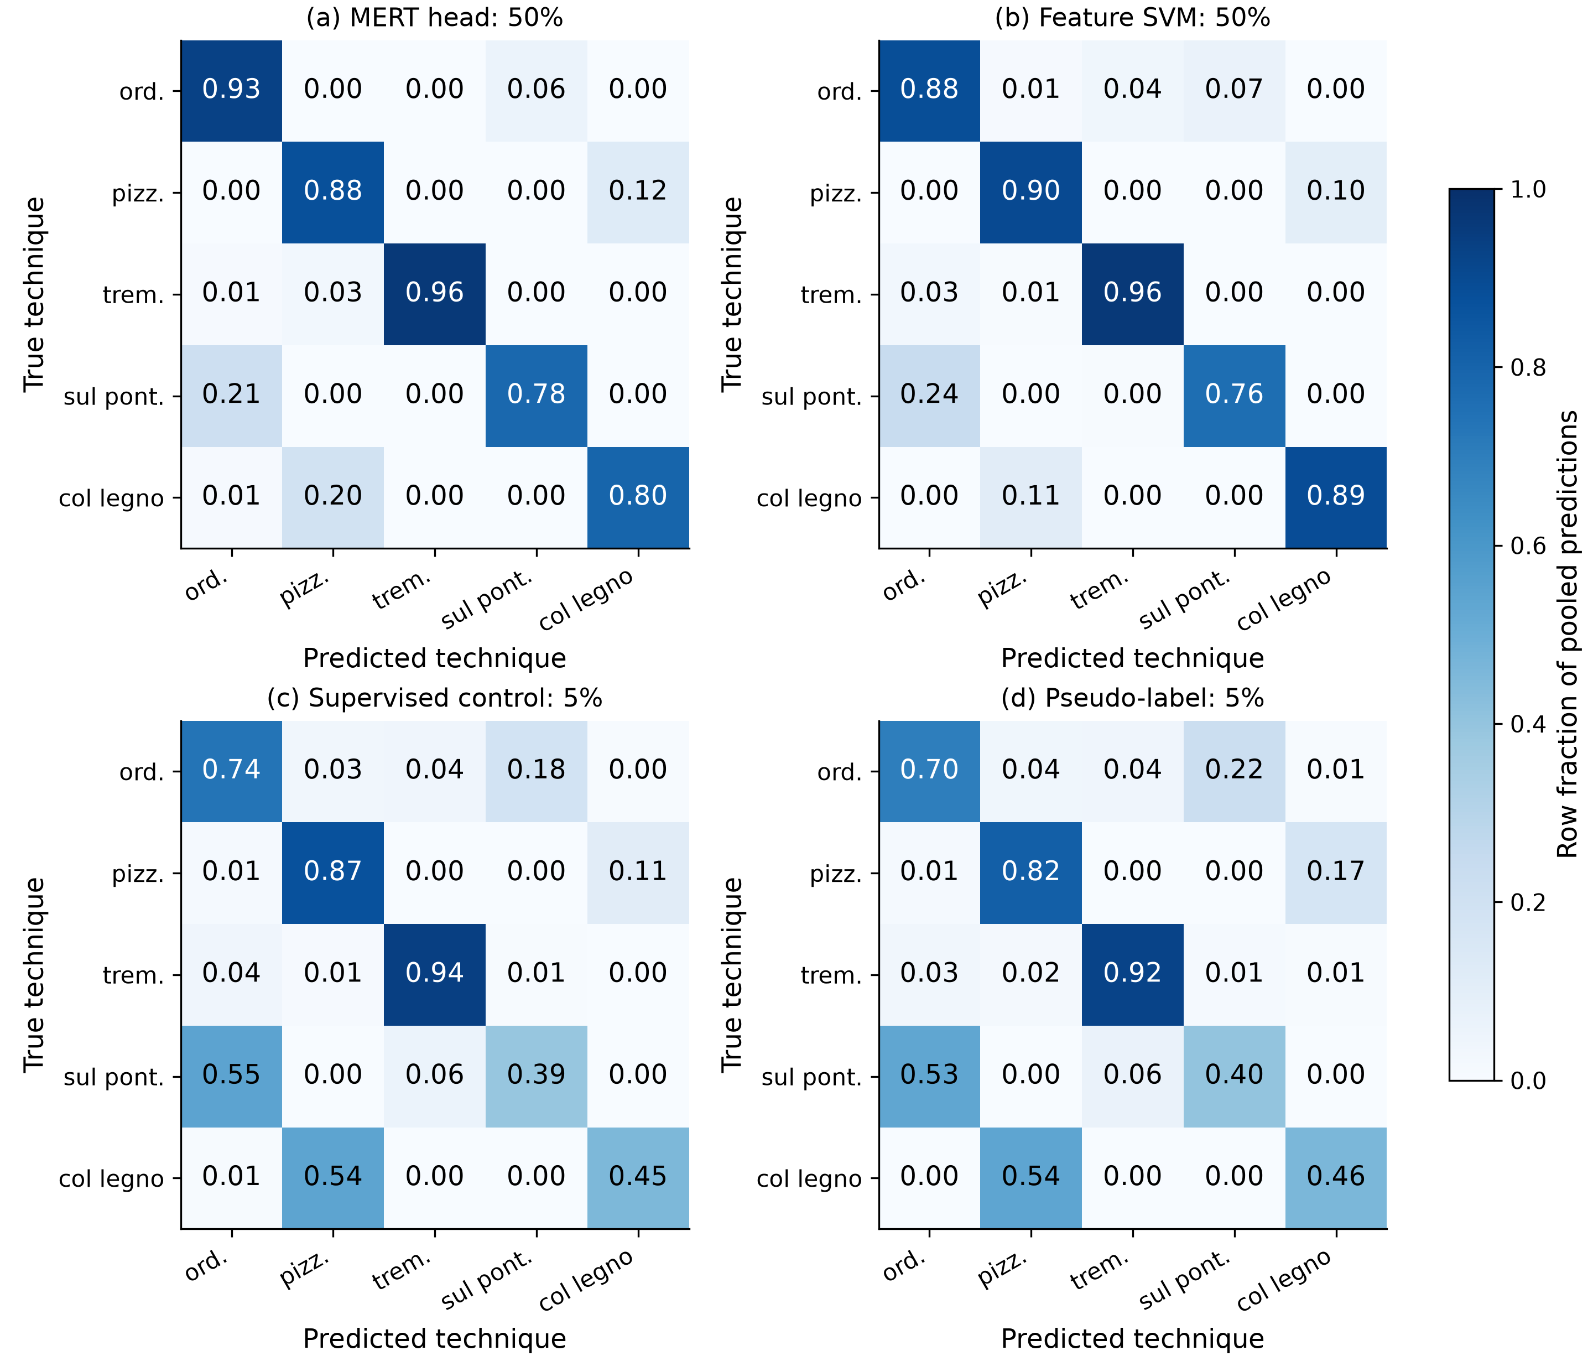
Figure 5. Row-normalized confusion matrices. Panels (a,b) show MERT/SVM at 50%; (c,d) show the self-training supervised control and pseudo-label condition at 5%. Each panel pools 10,206 predictions from three trials on 3,402 unique clips. All panels share a 0–1 color scale. Cells represent prediction fractions within each true class. Diagonals are pooled recall, not instrument-type mean class F1. Values of 0.00 are rounded to two decimal places and do not necessarily indicate no errors.

4.4 Self-training outcomes
Table 5 and Figure 3(b) compare the three matched self-training conditions. At 5%, pseudo-label macro F1 is 0.0322 below the supervised control; at 10%, 20%, and 50%, it is higher by 0.0062, 0.0098, and 0.0047, respectively. Thus this threshold, head, and selection procedure does not yield consistent improvement across all budgets. We have not performed a separate paired uncertainty test for these differences, so the slightly higher point estimates are not described as statistically established improvements.
Table 5. Self-training comparison with matched splits, seeds, and settings. The oracle supplies hidden ground truth for accepted examples and is a diagnostic, not a deployable semi-supervised method or performance ceiling.
Observed labels | Supervised control | Pseudo-label | Pseudo-label−supervised | Oracle diagnostic
5% | 0.6686 | 0.6364 | −0.0322 | 0.6489
10% | 0.7295 | 0.7357 | +0.0062 | 0.7356
20% | 0.7639 | 0.7737 | +0.0098 | 0.7919
50% | 0.8361 | 0.8409 | +0.0047 | 0.8350
At 5%, pseudo-label class F1 is low for sul ponticello (0.3324) and col legno battuto (0.4237). Figures 5(c,d) also show many examples of these true classes predicted as ordinario and pizzicato secco, respectively. The pseudo-label−supervised class F1 differences are −0.0242 for ordinario, −0.0502 for pizzicato secco, −0.0118 for tremolo, −0.0381 for sul ponticello, and −0.0367 for col legno battuto: all five are negative. Pizzicato secco has the largest F1 decrease, so the mean decline cannot be described as concentrated only in the two minority classes. Yet the diagonals for those two classes do not both decrease after pseudo-label training. Their recall losses alone cannot explain the overall F1 decline; false-positive changes and averaging across instrument types must also be considered.
The oracle is not highest at every budget. It is below the supervised control at 5% and below pseudo-label training at 50%. These observations rule out treating hidden-label provision as a guarantee of the best performance in this diagnostic. They also do not establish that providing ground truth itself harms performance. Fitting, subsequent acceptance, and validation selection form a linked procedure, and we did not isolate their effects through controlled experiments.

4.5 Sensitivity to the resampling unit
Figure 6 resamples MERT−SVM differences from the same saved predictions. Intervals include zero for all three units—clip, filename proxy, and instrument type—at every budget. Instrument-type intervals are wider than clip and proxy intervals. At 50%, for example, the difference of −0.0082 has intervals [−0.0212, +0.0054] for clips, [−0.0224, +0.0059] for proxies, and [−0.0345, +0.0179] for instrument types. All attach to the same point estimate but reflect different variation.
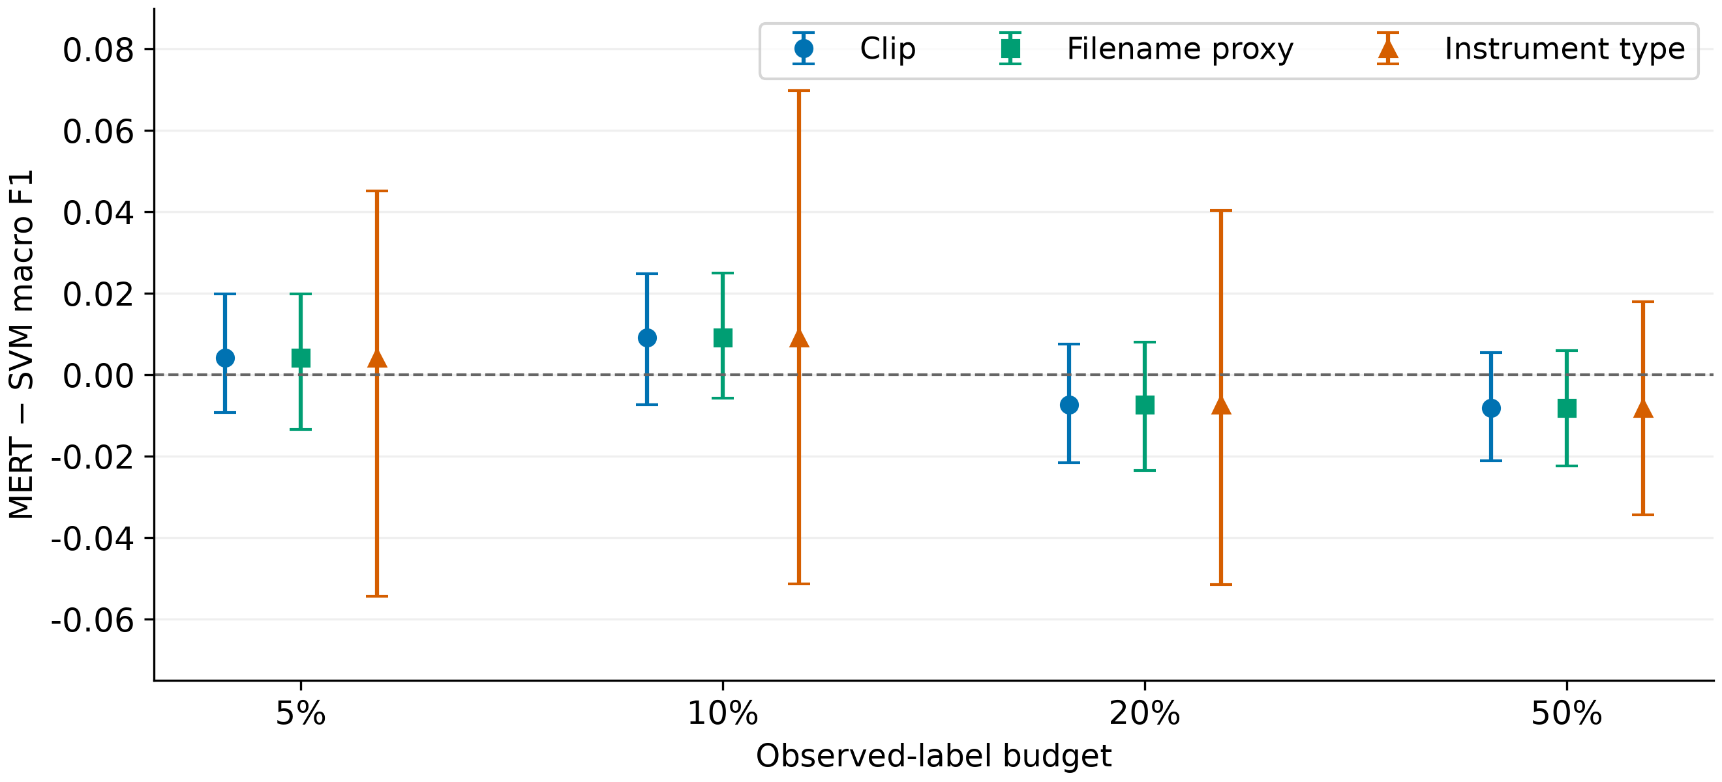
Figure 6. MERT−SVM differences and 95% percentile intervals by resampling unit. Each budget/unit uses 1,000 paired resamples of the same saved predictions. Horizontal offsets reduce overlap; point estimates within a budget are identical. Instrument-type intervals describe sensitivity to recombining four observed types, not uncertainty for a new performer population. Including zero does not establish model equivalence.
With the current predictions, changing the resampling unit does not reverse whether an interval supports a particular sign of the difference. We therefore do not combine historical intervals from other predictions with these results to claim that resampling units reversed a winner. An interval including zero also differs from establishing, with sufficient precision, that any practical difference is small. We lack a prespecified equivalence margin and an independent-group design for that question.

5. Discussion and Limitations

5.1 Reading average rankings alongside condition-specific performance
Both configurations improve in mean performance as the label budget increases, with small within-budget mean differences. Relative performance nevertheless varies with budget, instrument type, and technique. The practical information is that these results do not readily support choosing one default model for every condition. Performance should be examined for the relevant techniques and amount of labeled data. Results restricted to four instrument types do not guarantee the same choices will be optimal elsewhere.
Macro F1 reflects minority-class performance but cannot replace every class-specific objective. An application emphasizing col legno battuto detection, for example, should examine both false negatives and false positives for that class. A model with a higher overall mean may also score relatively lower on a specific instrument type. Figures 4 and 5 accompany the average curves to reveal such differences. No application-specific error costs were specified, so we do not quantify one error as more costly than another.
Shared labeled examples also have a limited interpretation. SVM and MERT differ in classifiers, pretraining experience, and computation as well as input representation. This is a comparison of two usable configurations, not an experiment isolating representation dimensionality or model size. We did not compare processing time, memory, or extraction cost on a common device, so no measured feature-model cost advantage is claimed.

5.2 Musical interpretation of errors
Relating technique definitions to observed errors highlights two distinctions. Ducher and Esling’s (2019) multidimensional taxonomy distinguishes exciters, temporal interactions, and contact positions, among other aspects; Su et al. (2014) discuss acoustic representations for bow contact differences. These sources explain class meanings but do not verify the cues used by our models.
First, ordinario and sul ponticello differ in contact position during sustained bowing. At 50%, pooled sul ponticello→ordinario confusions are approximately 0.21/0.24 for MERT/SVM, compared with reverse confusions of 0.06/0.07 (Section 4.3). Our observation is that errors more often read sul ponticello as ordinario. We did not establish whether this asymmetry arises from weak timbral distinctions, sample imbalance, or loss of particular features. Second, pizzicato secco uses finger plucking and col legno battuto uses the wood of the bow. Col legno battuto→pizzicato secco confusion is approximately 0.20/0.11 for MERT/SVM. Similarities in onset and decay are possible explanations, but we did not verify those similarities in these clips through listening or acoustic measurements. High tremolo F1 might likewise relate to repeated-bowing cues, but does not establish the effect of repetition itself.
Feature inputs aggregate frame statistics across a clip, and MERT also uses temporal averaging. This aggregation does not explicitly pass frame order to the classification head. However, features include MFCC temporal deltas, and MERT computes contextual frame representations before averaging. Temporal averaging alone therefore does not imply the complete absence of temporal information. Retained statistical or contextual cues may help distinguish some techniques, but attributing specific errors to temporal averaging or explaining high performance solely by onset cues requires separate intervention or ablation experiments. These confusion matrices cannot provide such evidence without controlled changes to the input transformation.
The two less frequent classes sometimes have low performance, but we did not separate sample scarcity from acoustic difficulty. We performed neither class-balanced sample-count experiments nor data-increase experiments, and did not measure inter-listener label agreement. “Inherently difficult to distinguish musically” must therefore be separated from “error-prone under the current training conditions.” We established the latter.
Historical exploratory SHAP and layer-wise descriptor probes are not included as evidence establishing mechanisms behind these results. That SHAP analysis explains a separate XGBoost model, not the decisions of the canonical MERT head or SVM. Recovering a descriptor from a layer representation also does not establish that a technique classifier uses it. Musical interpretation in v2 therefore rests on verified error patterns and documented technique meanings, with internal model causes left unverified.

5.3 Findings and remaining explanations for self-training
Pseudo-label training adds unlabeled examples, but more examples do not guarantee more useful learning information. At 5% it scores below the supervised control, whereas differences at the other budgets are slightly positive. This pattern motivates particular caution about self-training utility under the smallest label budget. It does not support a general negative conclusion about self-training, because thresholds, probability calibration, augmentation, and other semi-supervised methods were not compared.
Maximum predicted probability also has limitations as a confidence measure. No probability calibration was performed, so τ=0.8 does not mean an example has a verified 80% probability of being correct. Imbalanced accepted classes, accumulated target errors, changing pools, and recomputed class weights are possible influences. Saved records trace what was accepted and which target was passed to training, but do not automatically separate the factors’ effects. We therefore do not assign the observed mean decline definitively to error accumulation alone.
A useful reference is that the supervised control shares the initial self-training state and settings, and validation can select that initial state. Nevertheless, a validation-selected state need not be best on every held-out test instrument type. Potential variation remains particularly with small observed-label and selection-validation sets. Isolating its influence requires a separate controlled analysis; here it is stated as a condition of the results.

5.4 Generalization and uncertainty
Instrument-type holdout prevents the same instrument type from appearing in outer training and testing. Instrument type, physical instrument, performer, and recording session are different units, however. The latter identifiers were not verified in the current data, so this is not an independent evaluation of new performers or sessions. Shared dataset recording conditions, pitch and dynamics distributions, and digital transformations were not isolated. Filename proxies therefore cannot substitute for evidence of independent recordings.
Holdout also applies to our downstream technique-classifier training. We did not audit whether MERT pretraining data included these audio files or related recordings. Completely unobserved audio across pretraining as well as downstream training is consequently not guaranteed.
There are 3,402 clips but only four observed instrument types. Three label samplings and additional bootstrap draws do not expand that independence. Outer folds also share training examples, so their scores cannot be treated as four entirely independent studies. Intervals describe variation in fixed predictions, not every source of training, selection, and data-collection uncertainty.
These test folds were already used in exploratory work. Current runs restrict test information within training and selection functions, but do not retrospectively make the overall research process an independent preregistered confirmation. The threshold τ=0.8 and fixed training rules were fixed before canonical runs, not registered before the first inspection of the dataset. Independent confirmation data remain a limitation.
Isolated-note classification also differs from continuous technique detection in actual performances. Our design does not evaluate overlapping instruments, changing reverberation, or technique transitions within phrases. A final-layer MERT mean and a limited head search do not represent every use of pretrained representations. Applicability is restricted to this dataset, subset, and training policy; these restrictions matter when other researchers use the results.

6. Conclusion
We compared a feature SVM and a classifier on frozen MERT representations for five techniques across four bowed-string instrument types under limited-label instrument-type holdout. Both configurations’ mean macro F1 increased with the label budget, and relative rankings varied across budgets. Instrument- and technique-specific results revealed directional differences and class confusions obscured by the overall mean. Matched self-training scored below its supervised control at the smallest budget and did not improve consistently across all budgets.
These results establish neither model equivalence nor universal superiority of a model family. Our contribution is a conditional comparison showing small overall mean differences alongside instrument- and technique-specific differences, budget-specific matched self-training diagnostics, and research material traceable through saved predictions. Results support examining observed-label budgets, held-out instrument types, techniques of interest, and error directions together. Acoustic causes of observed errors and applicability to other performers, sessions, or actual performances were not established.

7. Reproducibility and Data Access
Original data remain subject to OrchideaSOL’s distribution conditions (Cella et al., 2020). Source audio is not redistributed in the manuscript’s research-material bundle. A local release candidate includes subset metadata with absolute audio paths removed, explicit partitions, saved predictions, execution manifests, recomputation code, and reference tables. A persistent public address, code license, and final author declarations have not yet been finalized. Local access during internal review is distinct from public release.
Reproducibility has two levels. The first reloads local checkpoints and verifies agreement with saved predictions. The second recomputes statistics and tables from predictions without audio, embeddings, or checkpoints. Using the candidate bundle in a separate virtual environment, we verified 244 model prediction vectors in 100 prediction files and confirmed that all 878 rows of 10 tables matched the references within an absolute tolerance of 10 to the power of −12. This second path does not claim reproduction through model retraining.
The Korean v2 figures were generated from canonical CSVs and path-sanitized metadata. Figure 2 is a schematic of implementation-defined splitting and selection; the other figures visualize numerical data. SHA-256 hashes for inputs, figures, and tables, generation scripts, and aggregation units are recorded. Instrument-type means in the text were reaggregated from existing per-run CSVs. No new model training was performed while preparing Korean v2. This English version translates those figures and the manuscript using the same numerical inputs.
The analysis environment was macOS arm64 with Python 3.14.5, NumPy 2.4.6, pandas 3.0.6, and Matplotlib 3.11.0. This record describes recomputation and figure generation, not a complete lockfile for the historical training environment. Actual retraining also requires original-data access, feature and representation extraction, and training dependencies. Code paths, input inventories, and verification outcomes are recorded in the accompanying reproduction and review documentation.

References
Cella, C.-E., Ghisi, D., Lostanlen, V., Lévy, F., Fineberg, J., & Maresz, Y. (2020). OrchideaSOL: An audio dataset of isolated musical notes, including mutes and extended playing techniques (Version 1.0) [Data set]. Zenodo. https://doi.org/10.5281/zenodo.3686252
Ducher, J.-F., & Esling, P. (2019). Folded CQT RCNN for real-time recognition of instrument playing techniques. Proceedings of the 20th International Society for Music Information Retrieval Conference, 708–714. https://archives.ismir.net/ismir2019/paper/000086.pdf
Kapoor, S., & Narayanan, A. (2023). Leakage and the reproducibility crisis in machine-learning-based science. Patterns, 4(9), 100804. https://doi.org/10.1016/j.patter.2023.100804
Kruger, A. B., & Jacobs, J. P. (2020). Playing technique classification for bowed string instruments from raw audio. Journal of New Music Research, 49(4), 320–333. https://doi.org/10.1080/09298215.2020.1784957
Li, D., Ma, Y., Wei, W., Kong, Q., Wu, Y., Che, M., Xia, F., Benetos, E., & Li, W. (2023). MERTech: Instrument playing technique detection using self-supervised pretrained model with multi-task finetuning [Preprint, arXiv:2310.09853v1]. https://arxiv.org/abs/2310.09853v1
Li, Y., Yuan, R., Zhang, G., Ma, Y., Chen, X., Yin, H., Xiao, C., Lin, C., Ragni, A., Benetos, E., Gyenge, N., Dannenberg, R., Liu, R., Chen, W., Xia, G., Shi, Y., Huang, W., Wang, Z., Guo, Y., & Fu, J. (2024). MERT: Acoustic music understanding model with large-scale self-supervised training. International Conference on Learning Representations. https://proceedings.iclr.cc/paper_files/paper/2024/hash/33dffa2e3d2ab74a783d1a8c292f66d9-Abstract-Conference.html
Lostanlen, V., Andén, J., & Lagrange, M. (2018). Extended playing techniques: The next milestone in musical instrument recognition. Proceedings of the 5th International Conference on Digital Libraries for Musicology. Author preprint consulted: https://arxiv.org/abs/1808.09730
Musgrave, K., Belongie, S., & Lim, S.-N. (2020). A metric learning reality check. European Conference on Computer Vision. Author manuscript: https://arxiv.org/abs/2003.08505
Oliver, A., Odena, A., Raffel, C. A., Cubuk, E. D., & Goodfellow, I. (2018). Realistic evaluation of deep semi-supervised learning algorithms. Advances in Neural Information Processing Systems, 31. https://proceedings.neurips.cc/paper/2018/hash/c1fea270c48e8079d8ddf7d06d26ab52-Abstract.html
Rodríguez-Algarra, F., Sturm, B. L., & Dixon, S. (2019). Characterising confounding effects in music classification experiments through interventions. Transactions of the International Society for Music Information Retrieval, 2(1), 52–66. https://doi.org/10.5334/tismir.24
Su, L., Lin, H.-M., & Yang, Y.-H. (2014). Sparse modeling of magnitude and phase-derived spectra for playing technique classification. IEEE/ACM Transactions on Audio, Speech, and Language Processing, 22(12), 2122–2132. https://doi.org/10.1109/TASLP.2014.2362006

Appendix A. Full-Label CNN Reference
CNN is a separate reference condition using all labels from the three outer training instrument types. Inputs are log mel-power spectrograms of 22,050 Hz audio, with FFT 2,048, hop 512, and 128 mel bands. The first 128 frames are retained; shorter inputs are zero-padded on the right. Per-image min–max normalization and training masks spanning up to 15 frequency bands and 20 time frames are applied. The network contains four blocks of 3×3 convolution, batch normalization, ReLU, and frequency-axis pooling, with channels 32/64/128/128, followed by global average pooling and a classifier with a 64-dimensional hidden layer; dropout is 0.5. It uses Adam with learning rate 0.001, weight decay 0.0001, batch size 32, and cosine learning-rate decay. Evaluation uses the final checkpoint after a fixed 30 epochs. Class weights are computed from the outer training fold.
Table A1. Full-label CNN macro F1 by held-out instrument type. Label budgets, input lengths, training, and selection procedures differ from limited-label MERT/SVM.
Held-out instrument type | Macro F1
Violin | 0.8402
Viola | 0.8183
Cello | 0.9272
Double bass | 0.9058
Four-type mean | 0.8729
These values are reported as a full-label mel-CNN reference. We do not combine them with 50% MERT/SVM in a single ranking to claim CNN superiority or interpret differences as solely architectural.

Appendix B. Actual MERT/SVM Partition Sizes
Table B1. Minimum–maximum partition sizes across the 12 runs at each budget. Outer test size ranges from 757 to 933 by instrument type. Endpoints need not come from the same run, so ranges should not be added together.
Observed-label budget | Direct training | Early-stopping validation | Configuration-selection validation
5% | 78–85 | 20–21 | 25–26
10% | 156–169 | 40–42 | 50–53
20% | 317–339 | 79–84 | 98–105
50% | 791–846 | 199–212 | 246–264
MERT/SVM share internal indices. The three self-training conditions also share internal partitions with each other, but their split seeds and head settings differ from the main MERT/SVM comparison. Per-run sizes, technique-specific F1, instrument-type means, and resampling results are retained in the accompanying CSVs.

