**Instructions of XD002**

**(If there are any differences between the manual and the actual software, please take the newest software as the standard.)**

**0. Preparation**

0.1 Plug the device, do not press any button at this time.

0.2 Open “HidRawTools.exe” software, click “Keyboard” on the menu bar and select “XD002”.( keyboard 🡪 XD002_ver1.0)

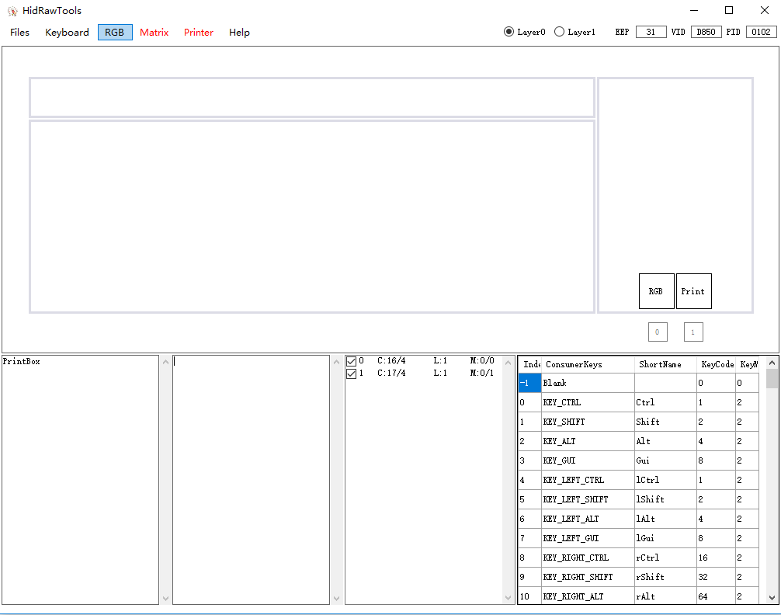

**1.Key values Setting**

1.1 The default setting of XD002 is “RGB on-off” and “Printer”. Click the key icon which you want to modify in the right column. When the icon’s colour gets changed, to select the key value you want to use from the chart of key values at the bottom right corner.

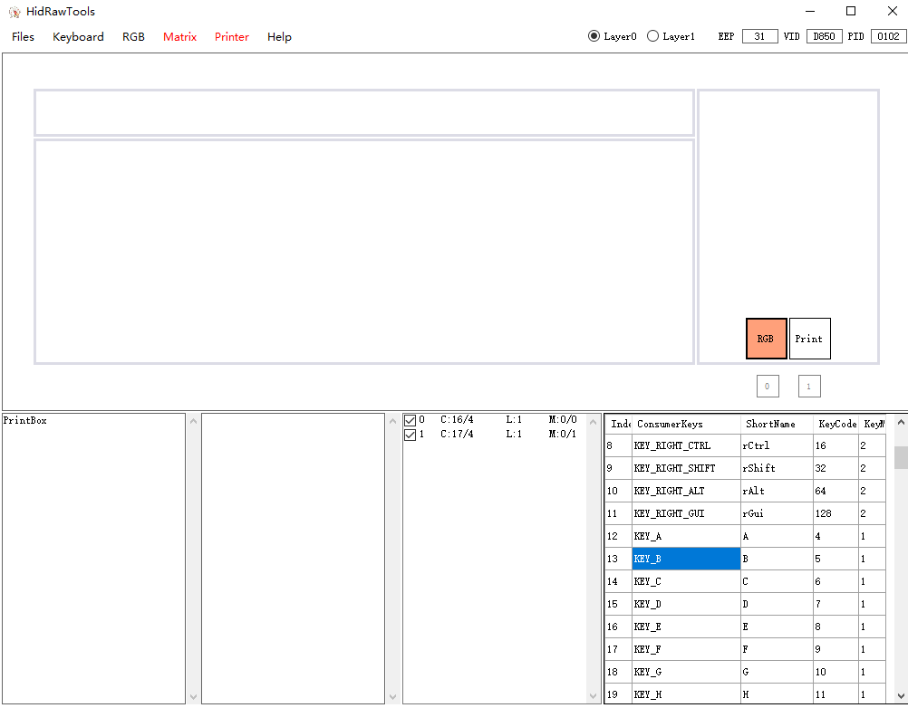

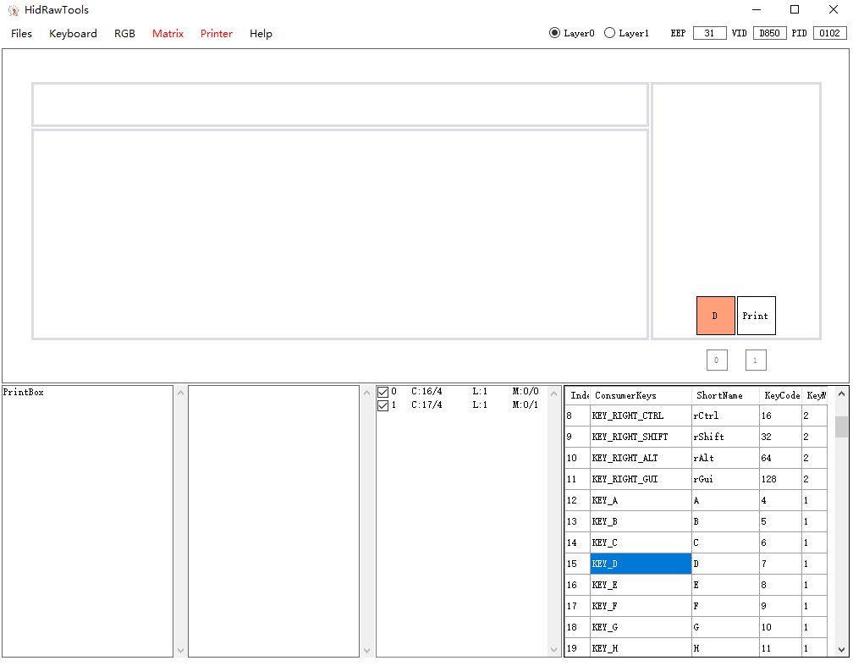

**2.RGB LED setting**

2.1 The default setting of LED is white. Click the square icon below the key icon, then select color from the pop-up. When the colour of square icon turns, the colour is set correctly.

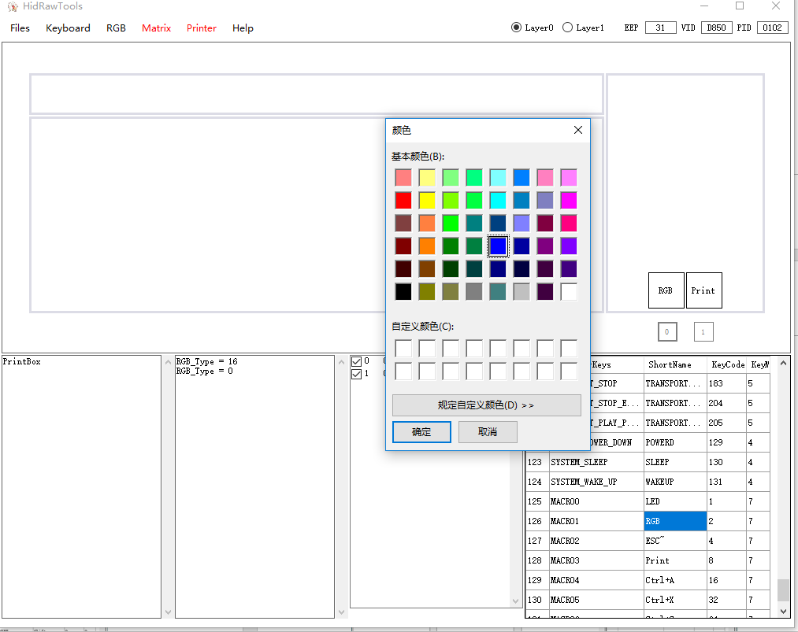

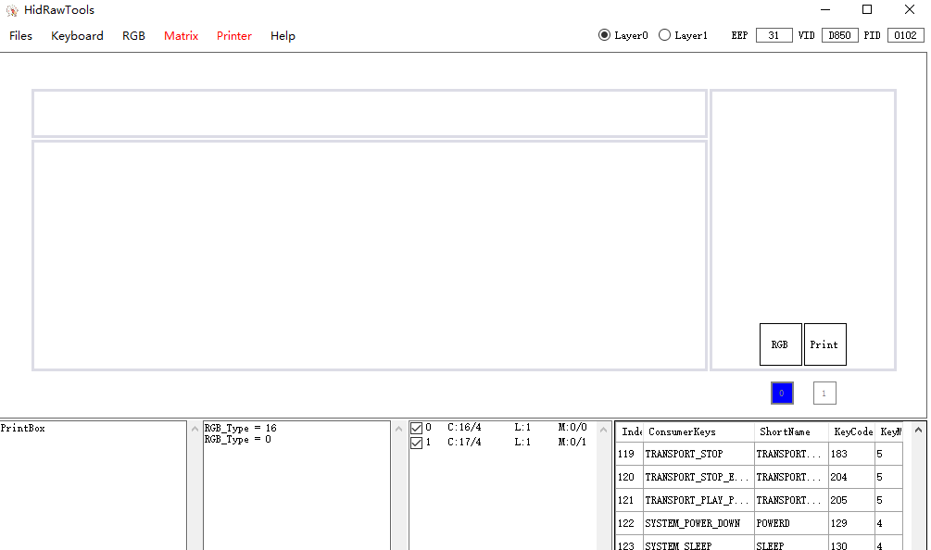

2.2 The default LED status of XD002 (when connected to PC) is off. You are able to turn it on/off through RGB setting. As the following image shows, the square icon is gray, which means the default LED is off.

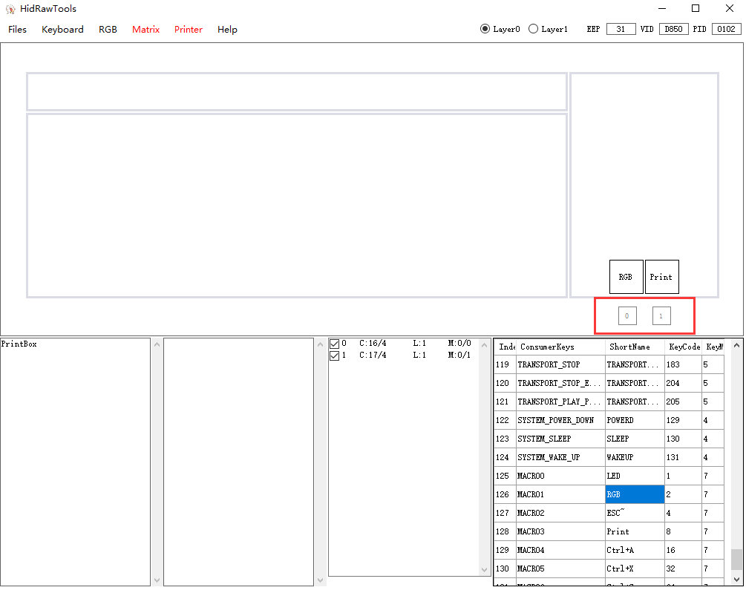

2.3 Click “RGB” on the menu bar and select Default ON (RGB 🡪Default ON), when the square icon turns to black, the default setting of LED is on. Click “RGB” again and select Default OFF (RGB 🡪Default OFF), the default LED is off.

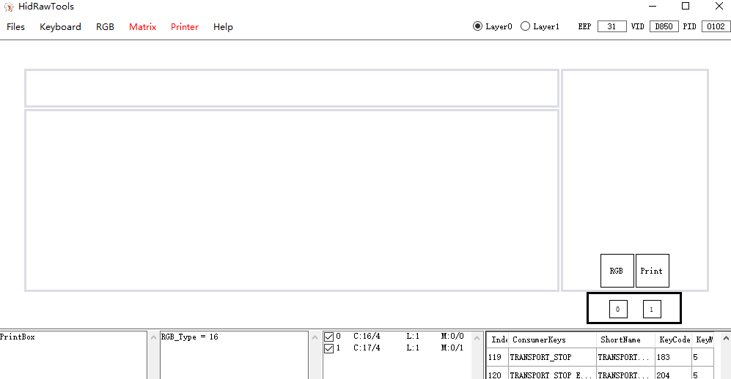

2.4 The default LED mode is static(white). If you want to use Rainbow LED, select RGB->Rainbow. A R letter will appear in the square icon. The colour cannot be changed under the Rainbow mode. Select RGB->Fixed color to turn back to the static mode.

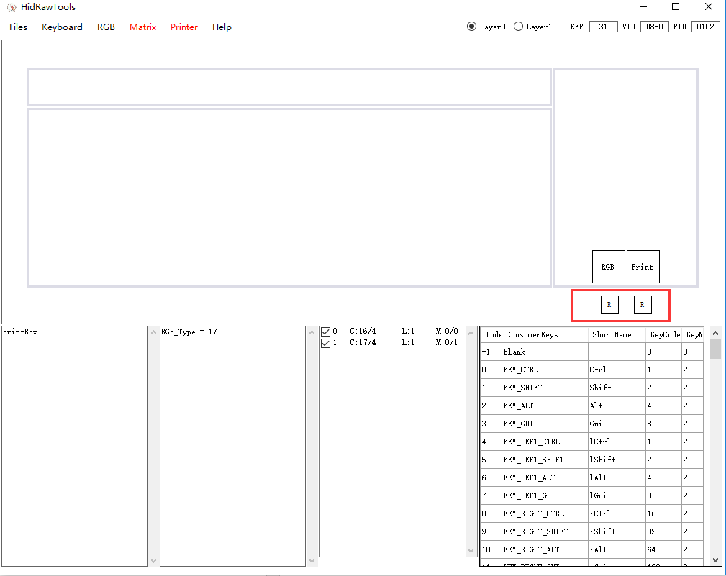

**3. Save layout and RGB status.**

3.1 Click “Matrix” and select “Upload Matrix” to save changes. When seeing ‘Upload Finish’, the keyboard is successfully flashed.

The device will automatically reboot when upload finished. If the automatic reboot failed, you can reboot manually by disconnecting and re-connecting the keyboard.

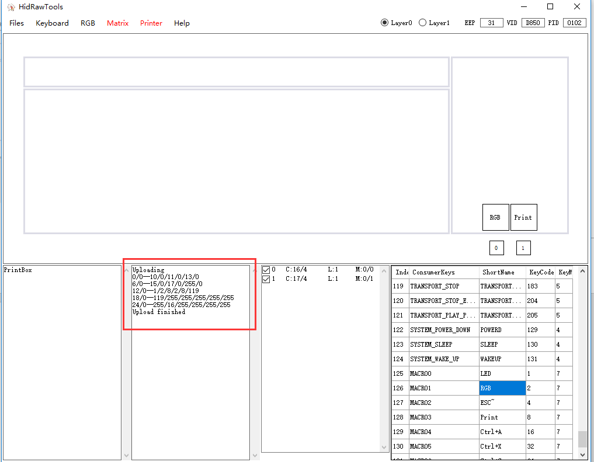

**4. Printer Function**

4.1 A key is defined as Print, the Printer function is on.

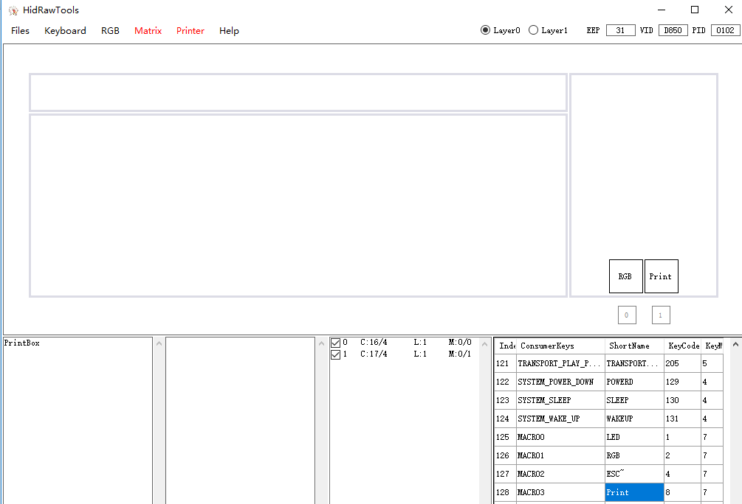

4.2 You can input texts in Printbox column at the bottom left corner, including Chinese, punctuation, space, carriage return etc. Attention that Printer function has length limitation. Approximately 460 bytes.

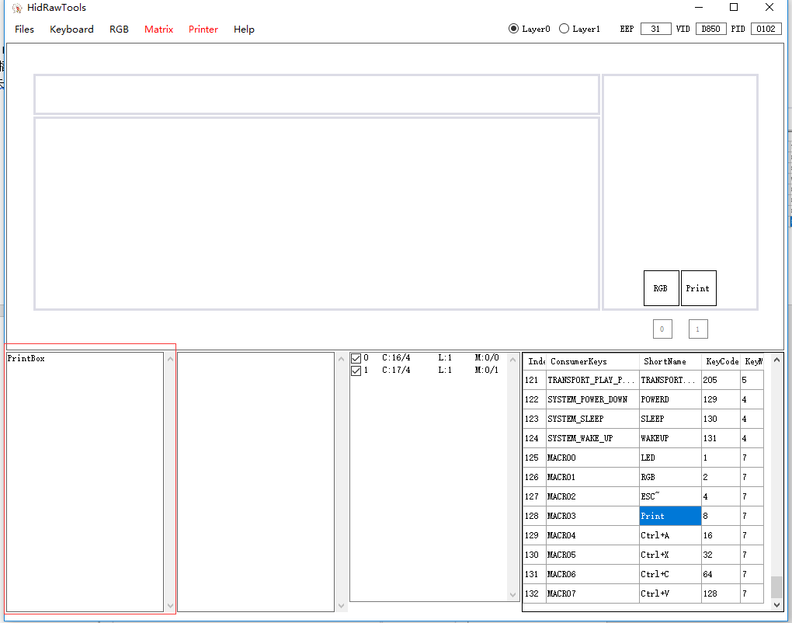

4.3 After the edit finished, click “Printer” on the menu bar, select “Upload with GBK” to save the changes. If you type in Chinese, please select “Upload with Unicode”. “Upload Finished” stands for successfully uploaded. The device will automatic reboot after upload finished. If the automatic reboot failed, you can unplug the device then plug in to manually reboot. (Sometimes multiple refreshment will cause some errors like unknown device. To re-plug device will solve these errors.)

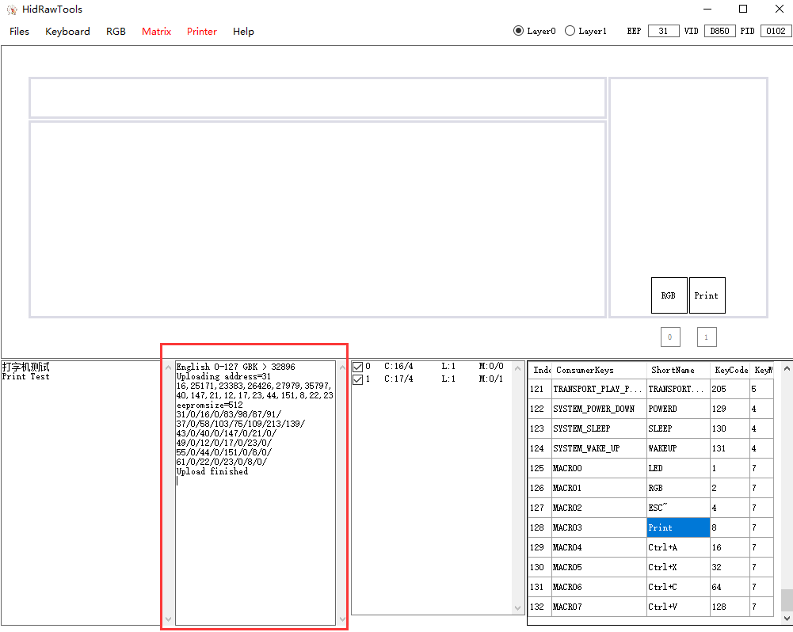

**5. Other Precautions**

5.1 Console of the software will prompt error such as connectionless device, unknown devices etc. Please DO TRY NOT to unplug the device when uploading, in case that the device turns bricked by suddenly interruption of uploading.

5.2 The “Matix” and “Printer” on the menu bar are separated functions. Matrix is for uploading layout and LED setting. Printer is for uploading stored text.

5.3 Printer function works no matter there is a key that is defined as Print or not. The text you uploaded can be used once the Print key is defined.

5.4 Some cables or system might cause errors such as poor connection, combo points and unknown devices, of which most can be solved by updating USB 3.0 driver or USB hub driver.

5.5 Printer will not store the text that is out of range. Please double check the letters in case of the awkward situation.

* 1. If you want to use Printer as auto log-in, please keep it safe to prevent financial loss.
  2. XD002 can set two layers of key values. When using FN to toggle layers, please make sure Fn keys are same in both layers. Though it only has two valid switches, it can present some useful functions such as only two switches click simultaneously the Printer can output text, the printer can be more covert than a single click.
  3. XD002 support ArduinoIDE development and flash, Digispark compatible, you can search it via google. The specific tutorial will release later (or not).
  4. Please not set LED color as black, in case you doubt your own eyesight.
  5. If you lose your instructions, click help. Console will show a simple instruction.
  6. XD60 and bface in this software does not support XD002. Please DO NOT modify EEP, VID, PID files. If you have changed it, click Keyboard->XD002_ver1.0 to rest.
  7. XD002 has been tested under windows7，windows8.1，windows10，Raspbian. Other OS include unofficial lite version or ghost system does not guarantee the stability of XD002. If there is unknown device error or repeated hits error, check HID driver first.
  8. If you cannot open the software, search and install Microsoft .NET Framework 4.5.
  9. Please prevent static electricity while using.
  10. The hardware of XD002 is developed by Xiudi and the software is developed by Zian1. The final interpretation of firmware and software belongs to Zian1.