Задание 1

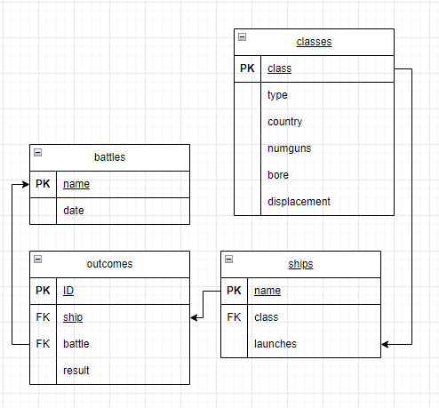

Задание 2

create table "MY_POKEMON" (

name character varying not null,

type_1 character varying,

attack character varying,

protection character varying

)

Задание 3

insert into "MY_POKEMON"

SELECT "Pokemon_name", "Type_1", "Attack","Defense" FROM "Pokemon"

Задание 4

DELETE

FROM (SElECT * FROM (SELECT AVG("Speed") FROM "Pokemon" Group by "Type_1"))

Задание 5

WITH "pocemon_rating" AS (

SELECT "Pokemon_name",

CASE

WHEN "Defense" > 100 AND "Attack" > 100 THEN 'Сильный'

WHEN "Defense" >= 100 OR "Attack" >= 100 AND ("Defense" + "Attack" < 200) THEN 'Средний'

ELSE 'Слабый'

END AS rating

FROM "Pokemon"

)

SELECT *,

COUNT(rating) OVER(PARTITION BY rating) AS count_pocemon

FROM "pocemon_rating";